 

# Placement Empowerment Program

***Cloud Computing and DevOps Centre***

Set Up a Cloud-Based Monitoring ServiceEnable basic cloud monitoring (e.g., CloudWatch on AWS). View metrics like CPU usage and disk I/O for your cloud VM.

Name: Mohamad riyas P Department : IT



# Introduction and Overview

The objective of setting up CloudWatch monitoring for your EC2 instances is to enable effective monitoring, logging, and alerting of your cloud resources. This allows you to keep track of the performance and health of your instances, ensuring optimal operation and timely identification of any issues. Specifically, the objectives include:

Collecting and visualizing key metrics (e.g., CPU utilization, disk I/O, memory usage).

Setting up alarms to notify you of critical issues (e.g., high CPU usage, low available memory).

Analyzing logs to identify and troubleshoot problems

# Importance

The objective of setting up CloudWatch monitoring for your EC2 instances is to enable effective monitoring, logging, and alerting of your cloud resources. This allows you to keep track of the performance and health of your instances, ensuring optimal operation and timely identification of any issues. Specifically, the objectives include:

Collecting and visualizing key metrics (e.g., CPU utilization, disk I/O, memory usage).

Setting up alarms to notify you of critical issues (e.g., high CPU usage, low available memory).

Analyzing logs to identify and troubleshoot problems.

# Step-by-Step Overview

## Step1:

**Go to the IAM Console**: Search for "IAM" in the AWS Management Console search bar and click on it.

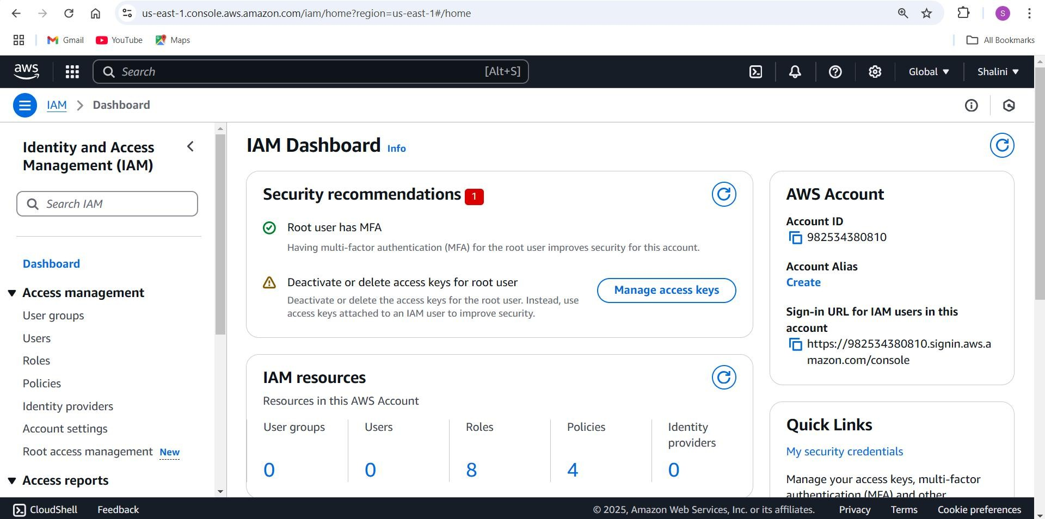

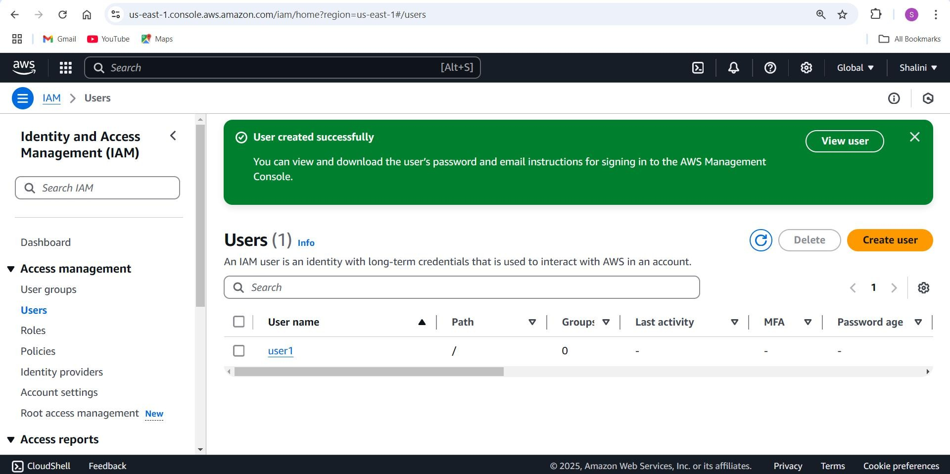

## Step 2 :

**Go to the EC2 Console**: Search for "EC2" in the AWS Management Console search bar and click on it.

Launch an Instance:

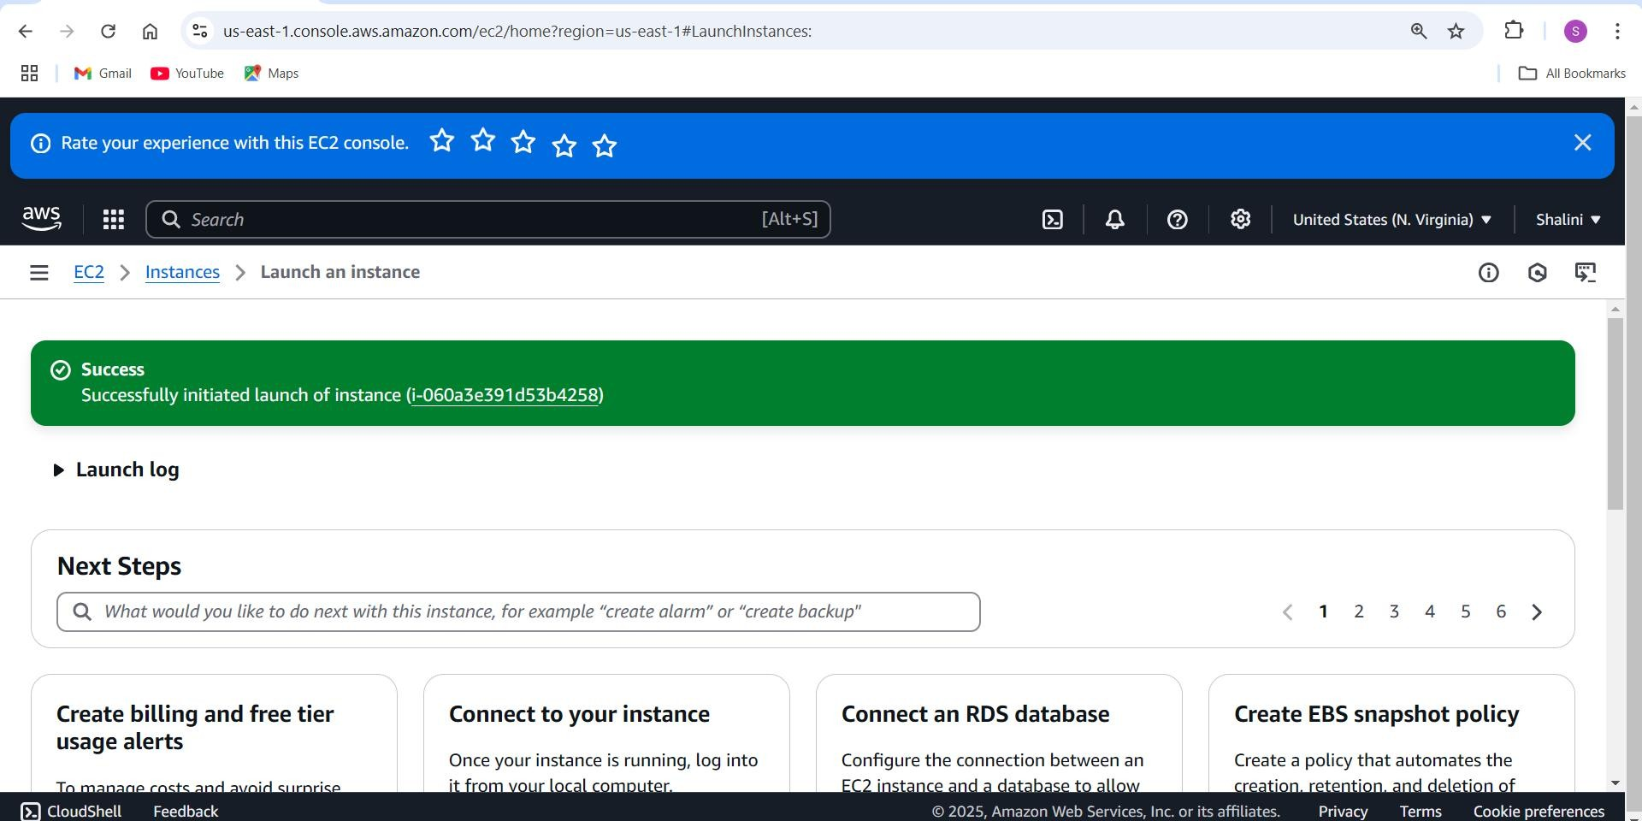

## Step 3 :

SSH to connect to your instance with the key pair you created. **Install the CloudWatch Unified Agent**

For Amazon Linux 2, use the command:

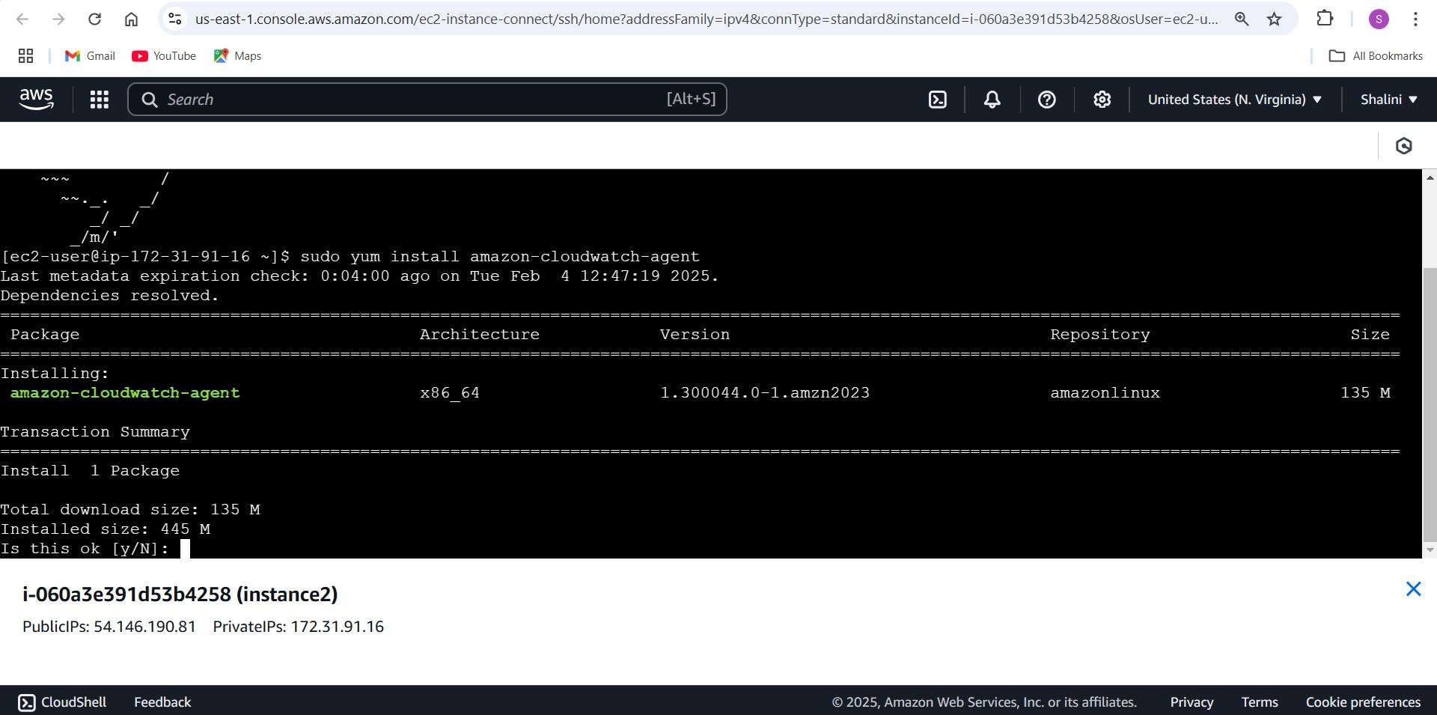

## Step 4 :

### Go to the CloudWatch Console:

Search for "CloudWatch" in the AWS Management Console search bar and click on it.

### Navigate to Metrics

Click on "Metrics" in the left-hand menu.

Choose "All Metrics" to see available namespaces and metrics.

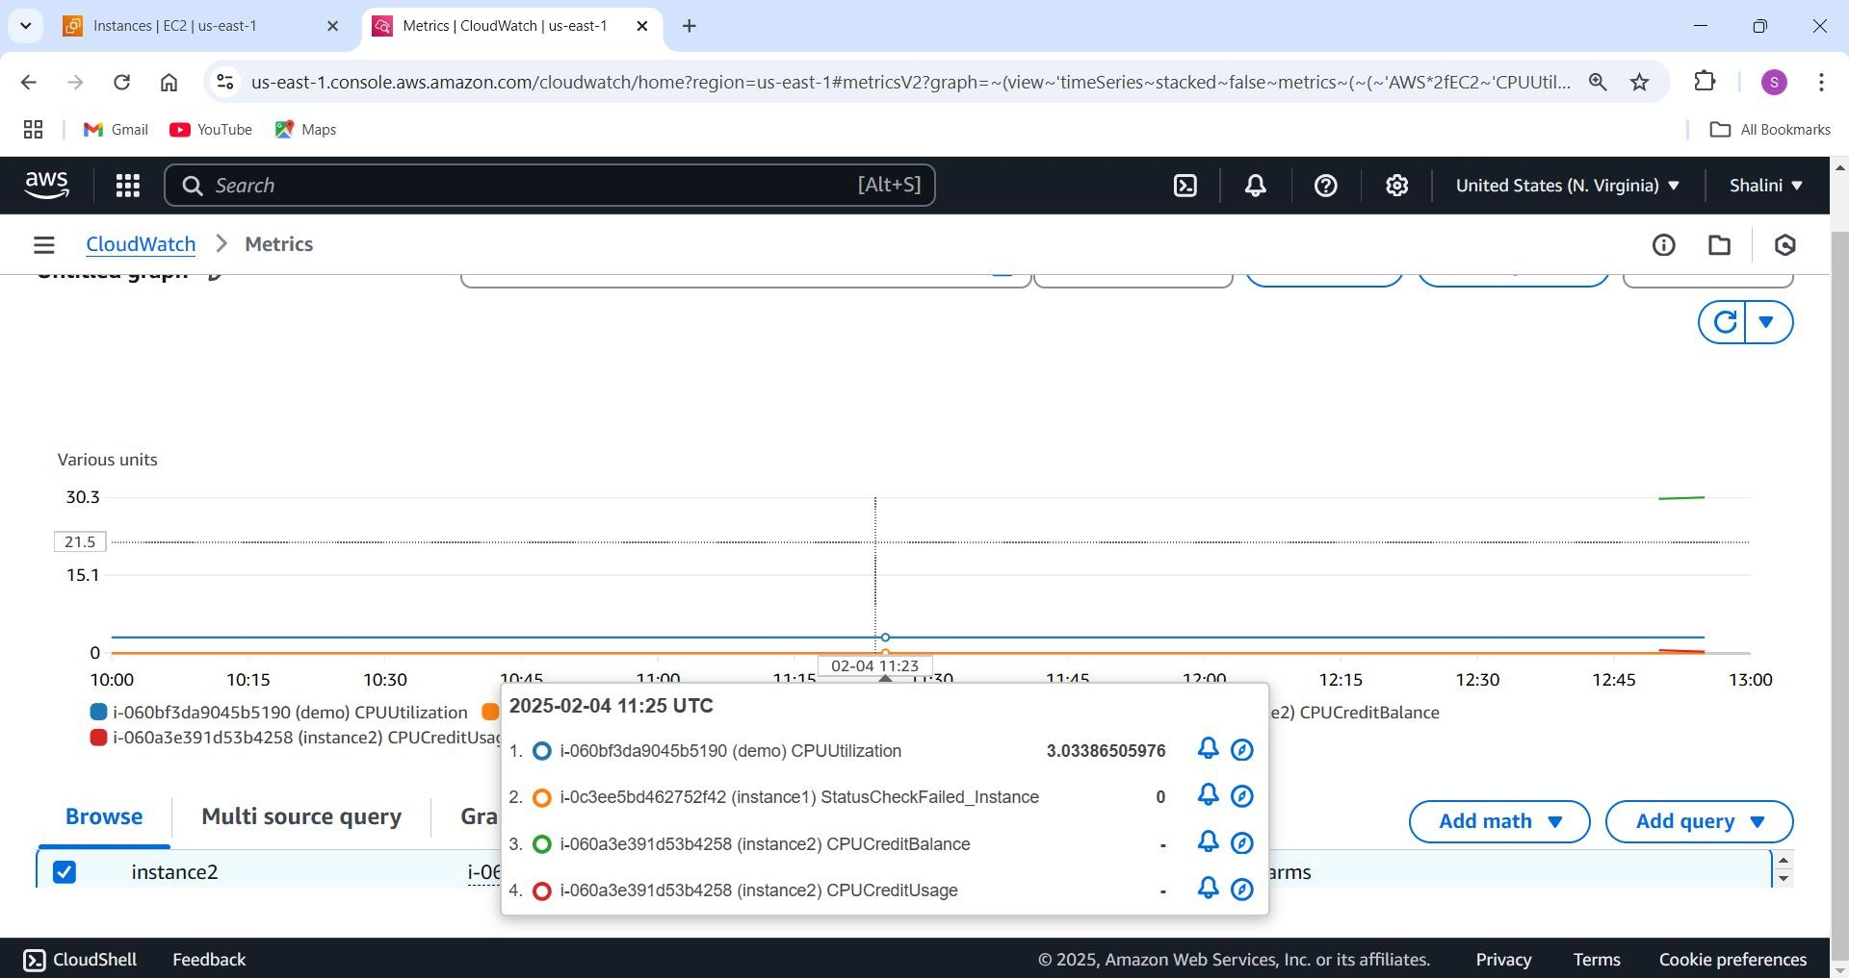

**Expected Outcome**

By following the steps to set up CloudWatch monitoring for your EC2 instance, you should achieve the following outcomes:

**Effective Monitoring**: You will have real-time visibility into key performance metrics of your EC2 instances, such as CPU utilization, disk read/write operations, and memory usage.

**Proactive Alerts**: Alarms will notify you when specific thresholds are exceeded, allowing you to take immediate action to address potential issues before they escalate.

**Optimized Resource Utilization**: Insights from the metrics will enable you to optimize the resource allocation of your EC2 instances, potentially leading to cost savings and improved performance.

**Enhanced Troubleshooting**: Access to detailed metrics and logs will help you diagnose and resolve issues more quickly and effectively, minimizing downtime and maintaining service quality.

**Improved Performance Tuning**: By analyzing performance data, you can fine-tune your applications and infrastructure to achieve better efficiency and user experience.