

**PLACEMENT EMPOWERMENT PROGRAM**

**Cloud Computing & DevOps Center**

**Write the shell Script to Monitor logs:** Create a script that monitors server logs for errors and alerts you.

**Name**: Mohamad Riyas P

**Dept**: IT

**INTRODUCTION**

To ensure the smooth operation of a server, it’s crucial to regularly monitor log files for errors or unusual activity. Writing a shell script to automate this task can help system administrators identify and address potential issues before they impact performance. The script can be configured to monitor specific log files, such as system logs or application logs, and search for predefined error patterns or keywords. Upon detecting any anomalies, the script can send an alert to notify the administrator, enabling quick response and troubleshooting. This approach helps maintain server health and improves overall system reliability.

**OBJECTIVE OF THIS TASK**

The objective of creating a shell script to monitor server logs is to automate the process of error detection and alert generation. By continuously scanning server logs for specific error patterns or unusual events, the script helps system administrators proactively identify potential issues. The goal is to ensure that any critical problems are immediately flagged and communicated, allowing for timely intervention and minimizing the risk of downtime or performance degradation. This script enhances system reliability, reduces manual monitoring efforts, and contributes to the overall efficiency of server management.

**Step-by-step process:**

**Step 1:** Create a folder in your desktop or wherever you like to.

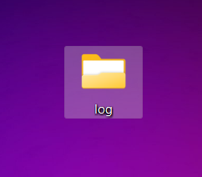

Step 2: Open “NOTEPAD” and type the following lines and save it as .log extension.

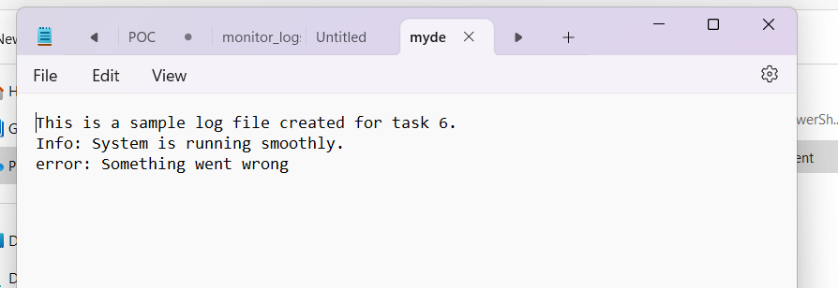

**Step 3:** Open the “NOTEPAD” again and type the following powershell cmd, and save it as .ps1 extension.

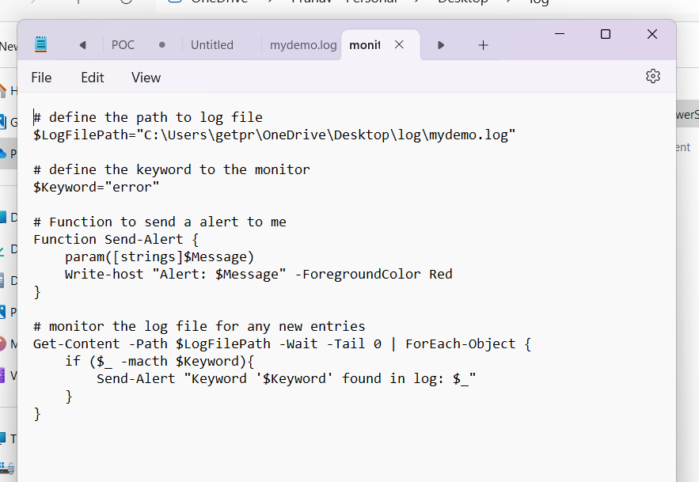

**Step 4:** Open Windows “POWESHELL” and run it as administrator.

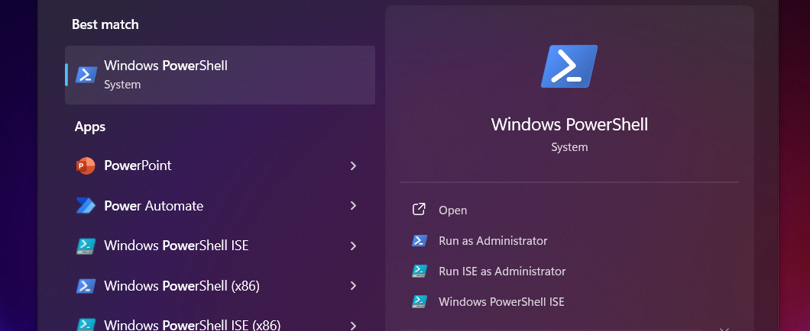

**Note: Run the following Powershell cmd.**

Set -ExecutionPolicy -Scope CurrentUser -ExecutionPolicy RemoteSigned and press Y to continue.

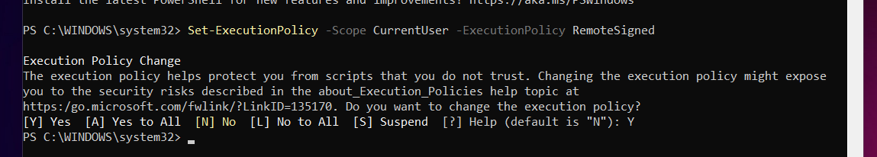

**Step 5:** Open the log folder.



**Step 6:** Run the following in the powershell .\monitor.ps1

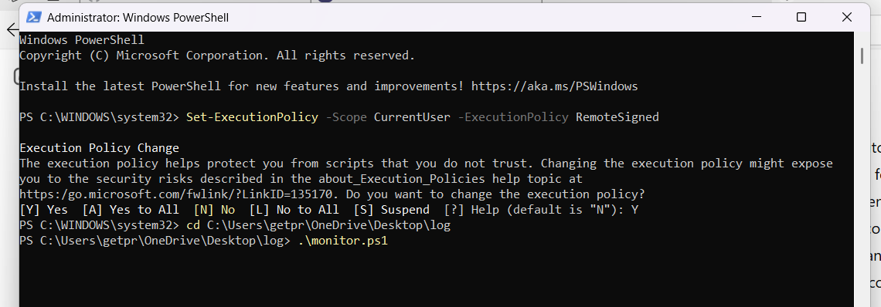

**Step 7:** Add a new issue line to the mydemo.log file.

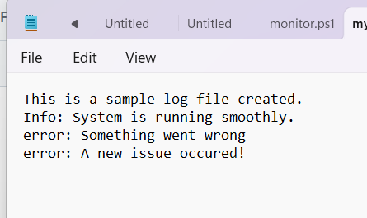

Step 8: You will get an Alert msg.

