TASK 3
FACULTY OF COMPUTERS & INFORMATION
Prepared By: Eng. Mohamed Abdelghany
Supervised By: Eng. Mohamed Shosha
QUESTIONS & ANSWERS
Question 1
1-What will be the output?
2-Explain why the Value of num did not change?
3-Did the method modify the original variable? Why or why not?

Answer:
^Solution^
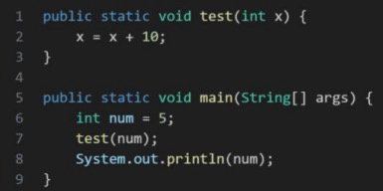
^Answer^
- 5
- The method worked with a copy of the value, so the original variable num stayed the same.
- No. Only the local variable x was changed, while the original variable num remained unchanged.

