**MOHAMED HASHEEM N**

**727721EUIT092**

**IT – “B”**

**CC-1**

**CLOUD COMPUTING**

1. **EC2**

Create an EC2 Instance in the us-east-1 region with the following requirements

1. **Give the Name tag of both EC2 instance & keypair as "ec2usecase1"(Name)**

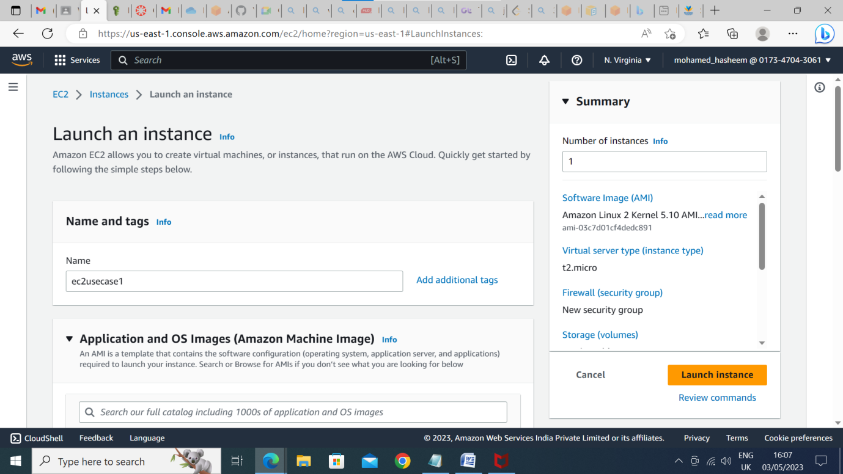

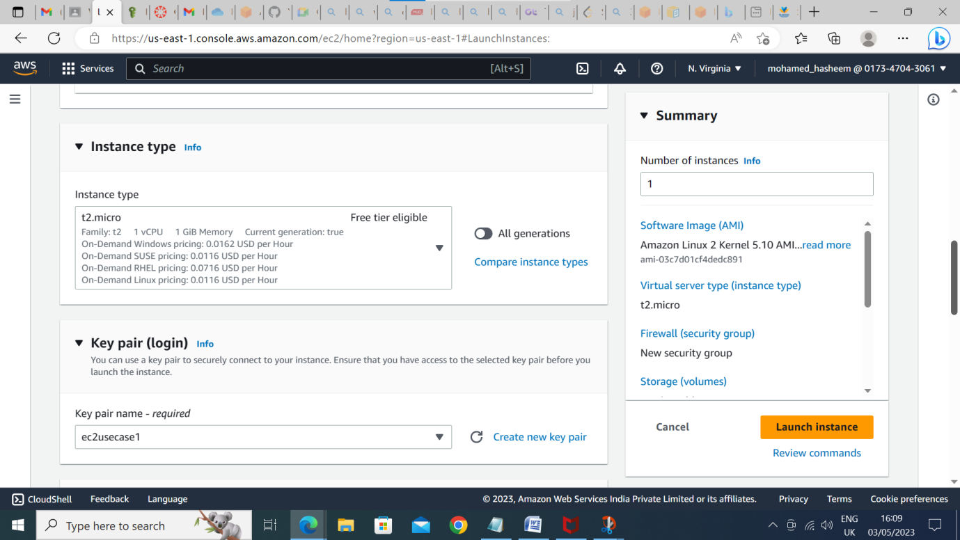

1. **EC2 instance AMI should be "Amazon Linux 2"**

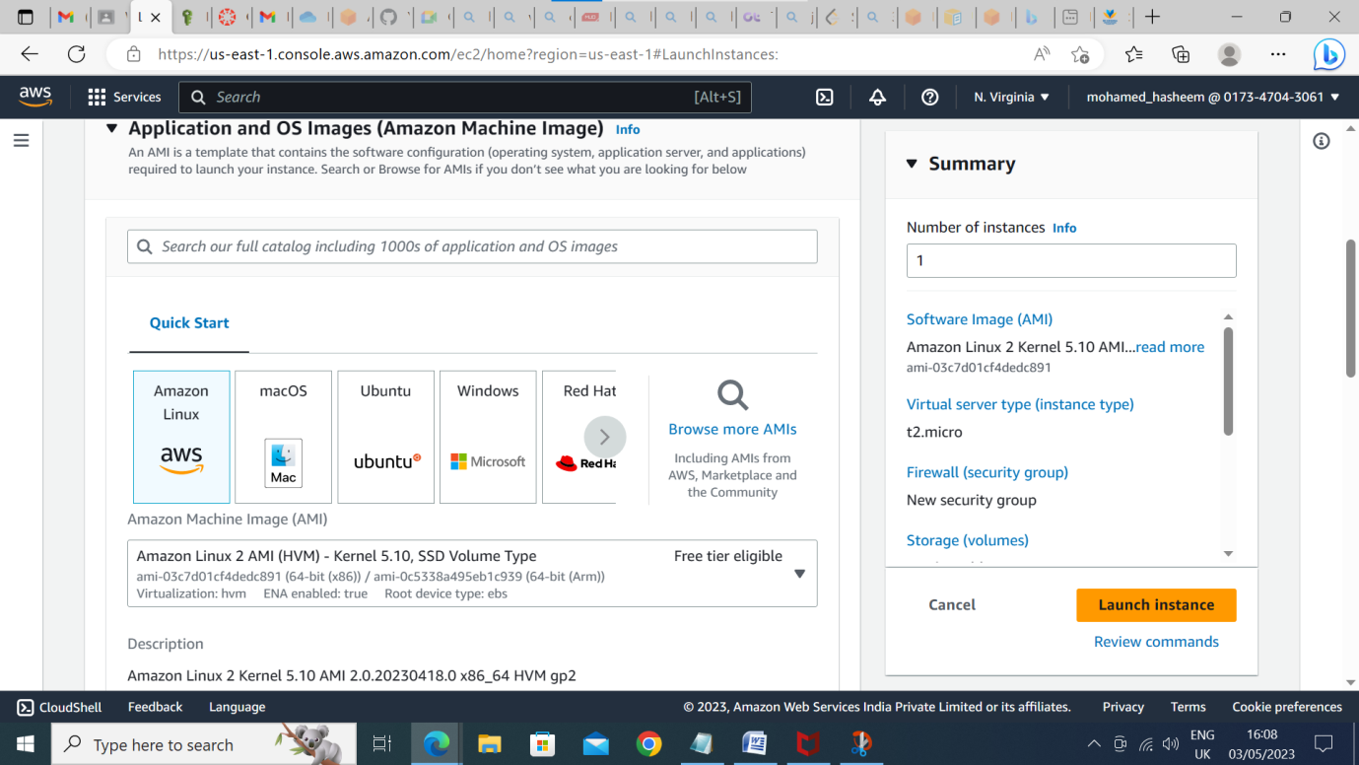

1. **Allow SSH traffic for taking putty remote connection**
2. **Allow HTTP traffic from the internet for reaching webs**

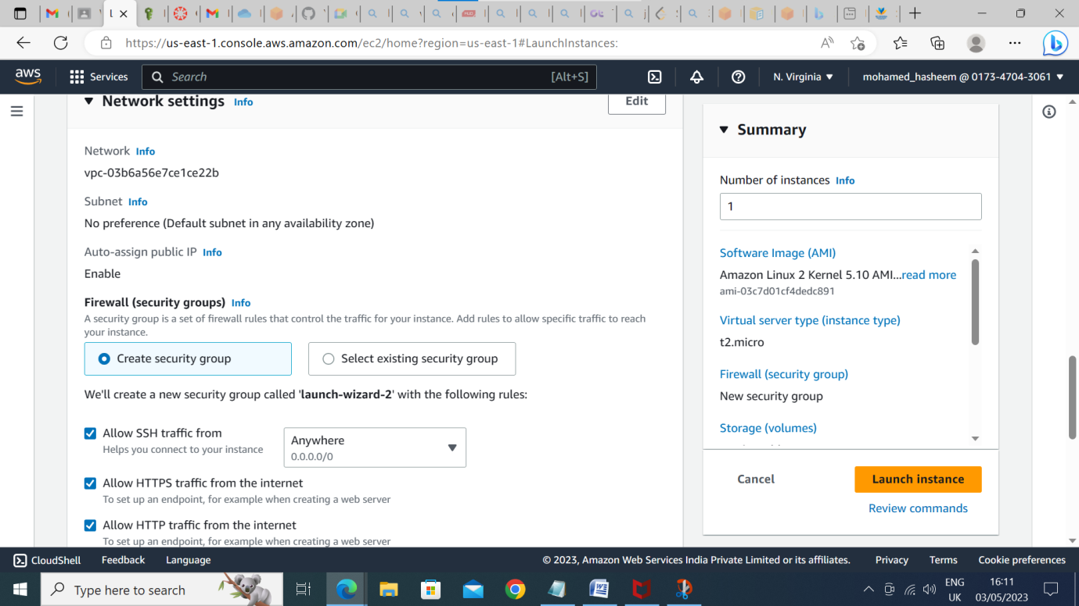

**2. IAM**

Create an IAM group called 'Network-L1-Team' with'AmazonVPCReadOnlyAccess'and ‘AWSNetworkManagerReadOnlyAccess' policies, then add an IAM user called 'Network-L1-User1' to the group

**1. The name of the IAM group should be 'Network-L1-Team’**

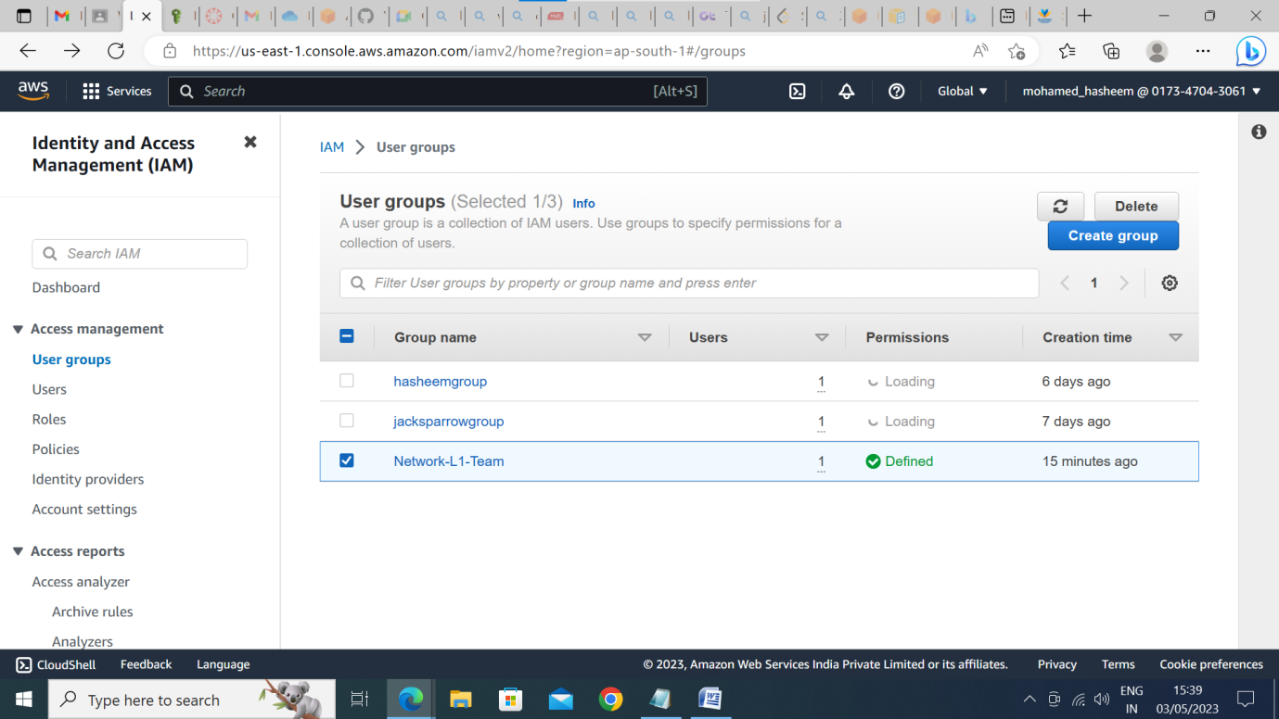

**2. The name of the IAM user should be 'Network-L1-User1'**

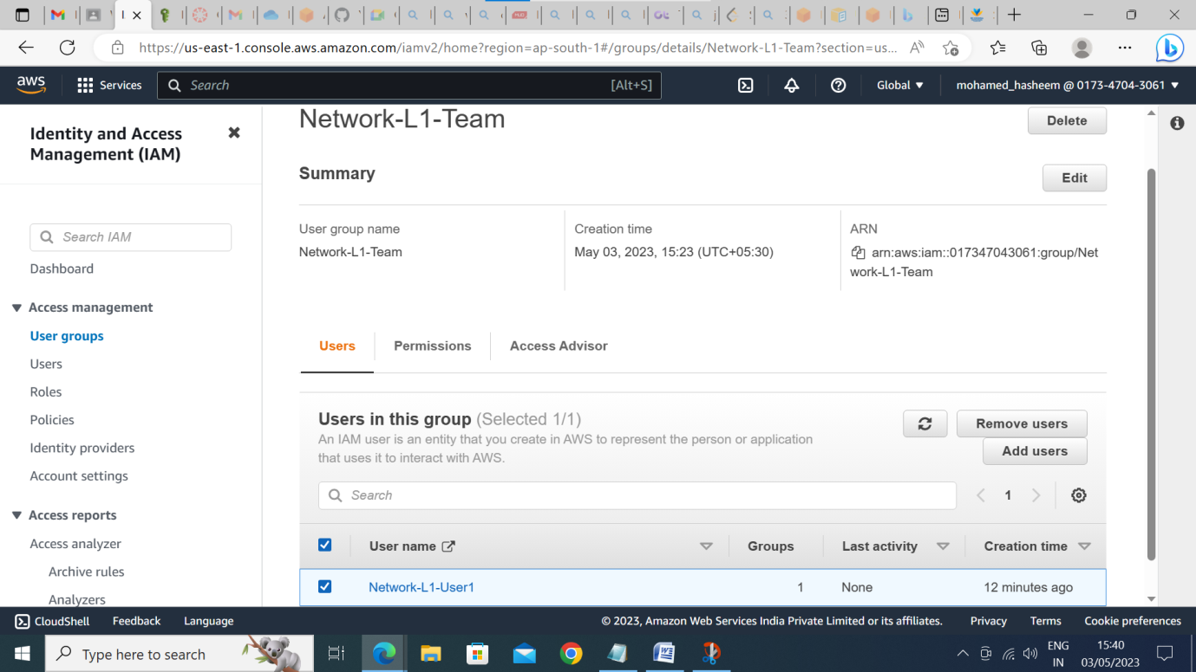

**3. The 'AmazonVPCReadOnlyAccess' policy should be attached**

**4.** **The 'AWSNetworkManagerReadOnlyAccess' policy should be attached**

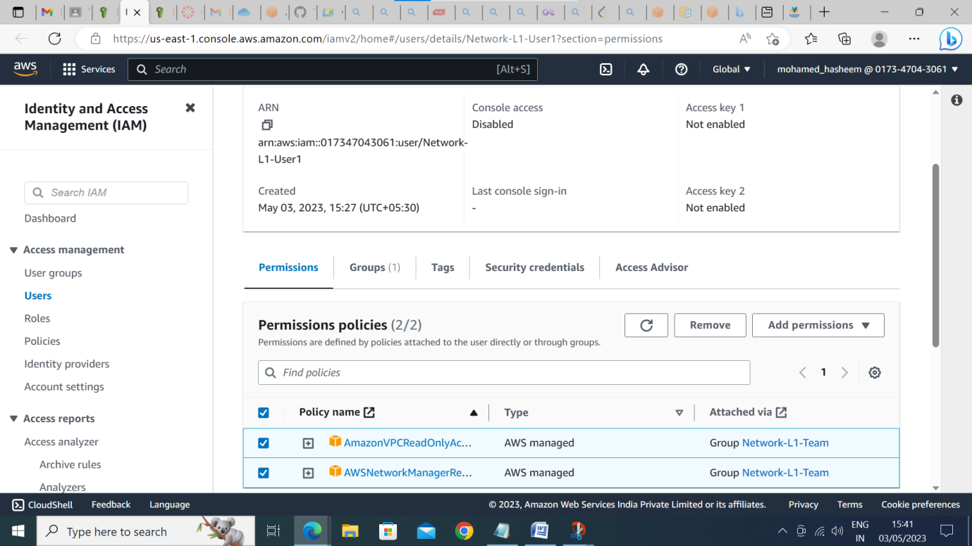

1. **S3**

Create a S3 bucket for the following requirements

1. **Create a new S3 bucket in the region of "Stockholm"**

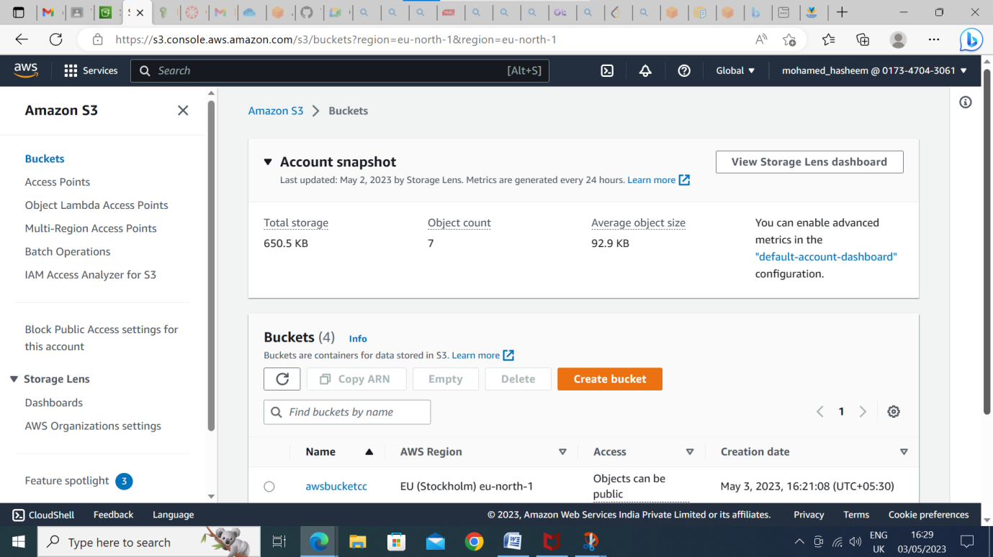

1. **Make the bucket accessible to everyone(publicly) via Bucket ACL**

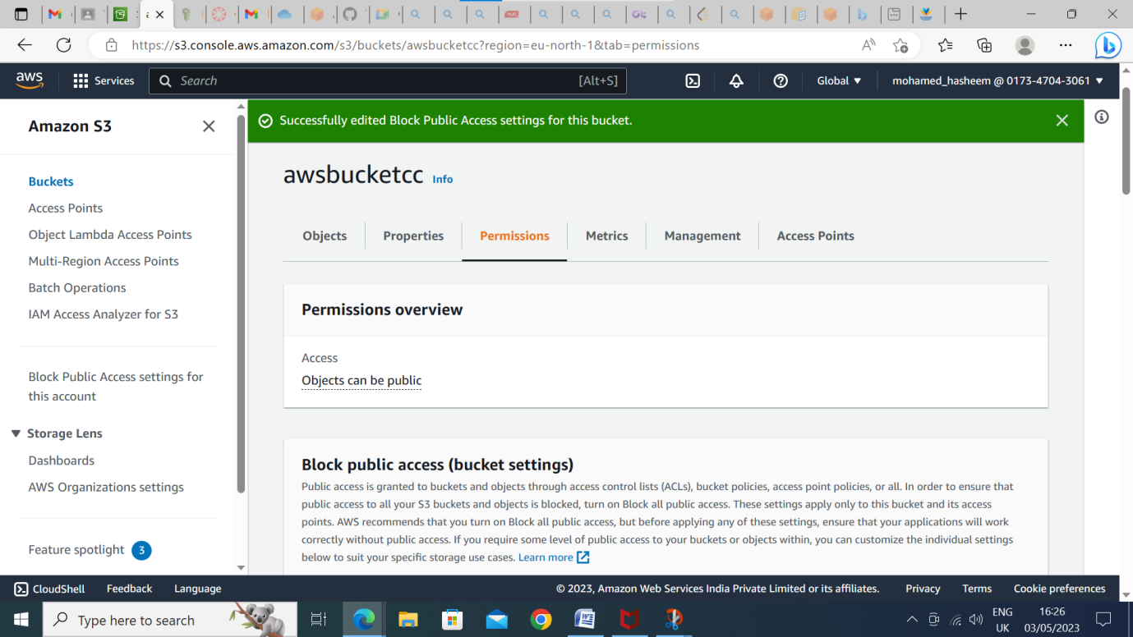

1. **Upload a text file in the name of 'accounts.txt'**

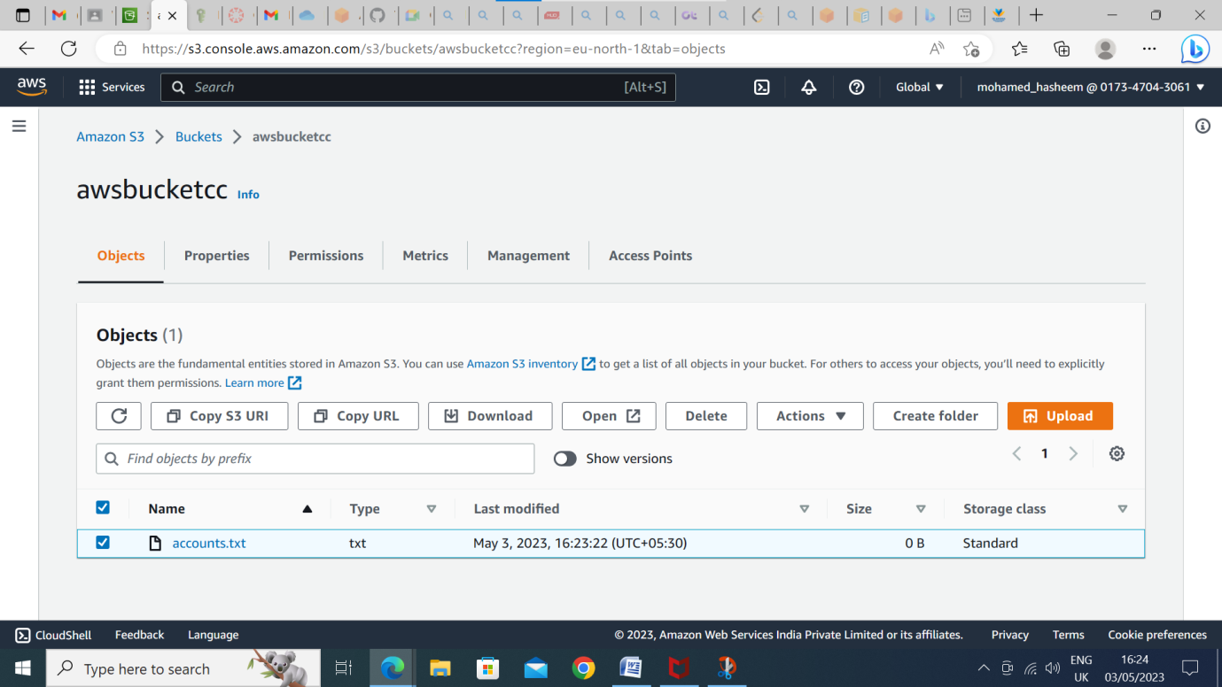

1. **Make the object 'accounts.txt' file accessible to everyone(publicly)**

