**CONTINUOUS ASSESSMENT 1**

**727721EUIT092**

**MOHAMED HASHEEM N**

1.

package com.selenium.test.NewTest2.SelTest;

import org.openqa.selenium.By;

import org.openqa.selenium.JavascriptExecutor;

import org.openqa.selenium.WebDriver;

import org.openqa.selenium.chrome.ChromeDriver;

import org.openqa.selenium.chrome.ChromeOptions;

import org.openqa.selenium.support.ui.Select;

import io.github.bonigarcia.wdm.WebDriverManager;

public class App

{

public static void main( String[] args ) throws InterruptedException

{

WebDriverManager.chromedriver().setup();

ChromeOptions co = new ChromeOptions();

co.addArguments("--remote-allow-origins=*");

WebDriver driver=new ChromeDriver(co);

driver.get("https://www.amazon.in/ASUS-15-6-inch-Integrated-Transparent-X515MA-BR011W/dp/B09SGGB687?ref_=Oct_DLandingS_D_2c2d3a50_61&th=1");

driver.manage().window().maximize();

String title=driver.getTitle();

System.out.println(title);

if(title.equals("Amazon.in: Buy ASUS VivoBook 15 (2021), 15.6-inch (39.62 cm) HD, Dual Core Intel Celeron N4020, Thin and Light Laptop (4GB RAM/256GB SSD/Integrated Graphics/Windows 11 Home/Transparent Silver/1.8 Kg), X515MA-BR011W Online at Low Prices in India | ASUS Reviews & Ratings")) {

System.out.println("Verified title of the page");

}else {

System.out.println("Title not matched");

}

JavascriptExecutor js=(JavascriptExecutor) driver;

js.executeScript("window.scrollBy(0,1000)","");

driver.findElement(By.id("add-to-cart-button")).click();

System.out.println("Verified Add to Cart button");

String lnk=driver.findElement(By.id("//*[@id=\"authportal-main-section\"]/div[2]/div/div[1]/form/div/div/div/h1")).getText();

if(lnk.equals("Sign in")) {

System.out.println("Sign in page landed");

}else {

System.out.println("Wrong page landed");

}

driver.quit();

}

}

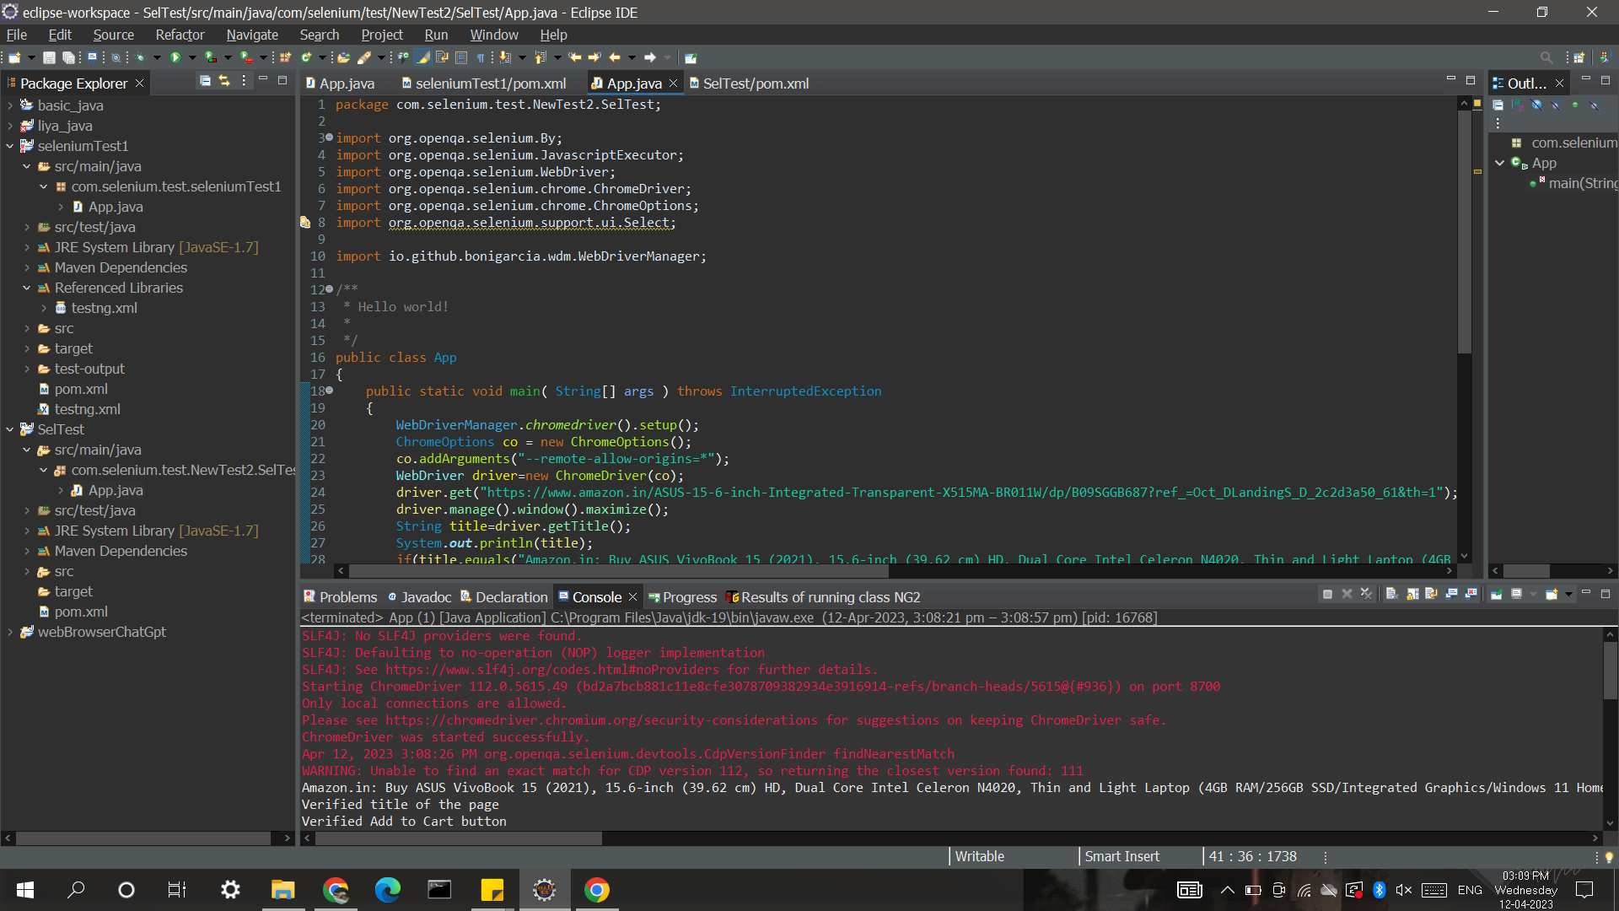

2.

package com.selenium.test.NewTest2.SelTest;

import java.util.List;

import org.openqa.selenium.By;

import org.openqa.selenium.JavascriptExecutor;

import org.openqa.selenium.Keys;

import org.openqa.selenium.WebDriver;

import org.openqa.selenium.WebElement;

import org.openqa.selenium.chrome.ChromeDriver;

import org.openqa.selenium.chrome.ChromeOptions;

import org.openqa.selenium.support.ui.Select;

import io.github.bonigarcia.wdm.WebDriverManager;

public class App

{

public static void main( String[] args ) throws InterruptedException

{

WebDriverManager.chromedriver().setup();

ChromeOptions co = new ChromeOptions();

co.addArguments("--remote-allow-origins=*");

WebDriver driver=new ChromeDriver(co);

driver.get("https://www.amazon.in/ref=nav_logo");

driver.manage().window().maximize();

String title=driver.getTitle();

System.out.println(title);

if(title.equals("Online Shopping site in India: Shop Online for Mobiles, Books, Watches, Shoes and More - Amazon.in")) {

System.out.println("Verified title of the page");

}else {

System.out.println("Title not matched");

}

driver.findElement(By.id("twotabsearchtextbox")).sendKeys("phone");

driver.findElement(By.id("twotabsearchtextbox")).sendKeys(Keys.ENTER);

System.out.println("Searched Item successfully");

driver.findElement(By.id("a-autoid-0-announce")).click();

List<WebElement>li=driver.findElements(By.xpath("//*[@id=\"octopus-dlp-asin-stream\"]/ul/li[2]/span/div/div[2]/div[1]/a"));

for(WebElement link:li) {

System.out.println(link.getText());

}

System.out.println("User is able to filter by search");

System.out.println("Testing Ended");

driver.quit();

}

}

OUTPUT

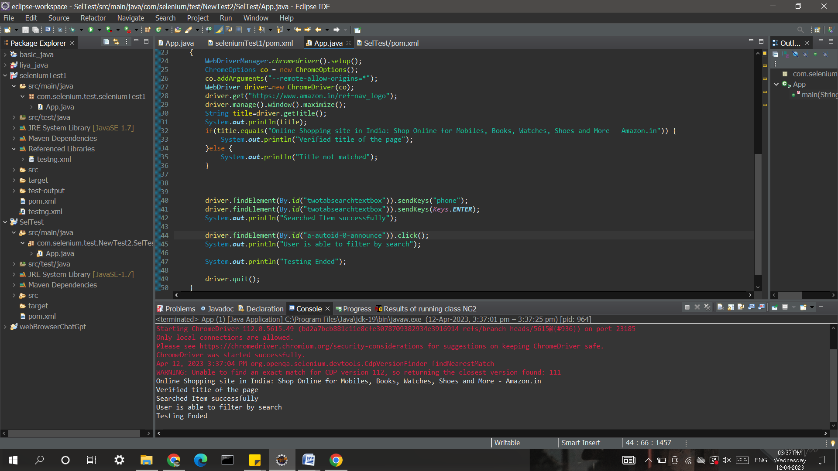

3.

package com.selenium.test.NewTest2.SelTest;

import java.util.List;

import org.openqa.selenium.By;

import org.openqa.selenium.JavascriptExecutor;

import org.openqa.selenium.Keys;

import org.openqa.selenium.WebDriver;

import org.openqa.selenium.WebElement;

import org.openqa.selenium.chrome.ChromeDriver;

import org.openqa.selenium.chrome.ChromeOptions;

import org.openqa.selenium.support.ui.Select;

import io.github.bonigarcia.wdm.WebDriverManager;

/**

* Hello world!

*

*/

public class App

{

public static void main( String[] args ) throws InterruptedException

{

WebDriverManager.chromedriver().setup();

ChromeOptions co = new ChromeOptions();

co.addArguments("--remote-allow-origins=*");

WebDriver driver=new ChromeDriver(co);

driver.get("https://www.amazon.in/ref=nav_logo");

driver.manage().window().maximize();

String title=driver.getTitle();

System.out.println(title);

if(title.equals("Online Shopping site in India: Shop Online for Mobiles, Books, Watches, Shoes and More - Amazon.in")) {

System.out.println("Verified title of the page");

}else {

System.out.println("Title not matched");

}

driver.findElement(By.id("nav-link-accountList")).click();

driver.findElement(By.id("ap_email")).sendKeys("12HGG@HHCG.COM");

driver.findElement(By.id("ap_email")).sendKeys(Keys.ENTER);

driver.findElement(By.id("ap_password")).sendKeys(“1256*");

driver.findElement(By.id("ap_password")).sendKeys(Keys.ENTER);

Thread.sleep(2000);

String name=driver.findElement(By.id("nav-link-accountList-nav-line-1")).getText();

if(name.equals("Hello")) {

System.out.println("Successfully, signed in");

}else {

System.out.println("Sign in failed");

}

System.out.println("Testing Ended");

driver.quit();

}

}

OUTPUT

