Project Design Phase-II
Data Flow Diagram & User Stories

Date | 04 AUGUST 2026
Team ID | NA
Project Name | Online Complaint Website
Maximum Marks | 4 Marks

Data Flow Diagrams:
A Data Flow Diagram (DFD) is a traditional visual representation of the information flows within a system. A neat and clear DFD can depict the right amount of the system requirement graphically. It shows how data enters and leaves the system, what changes the information, and where data is stored.
Example: DFD Level 0 (Industry Standard)
(Simplified)
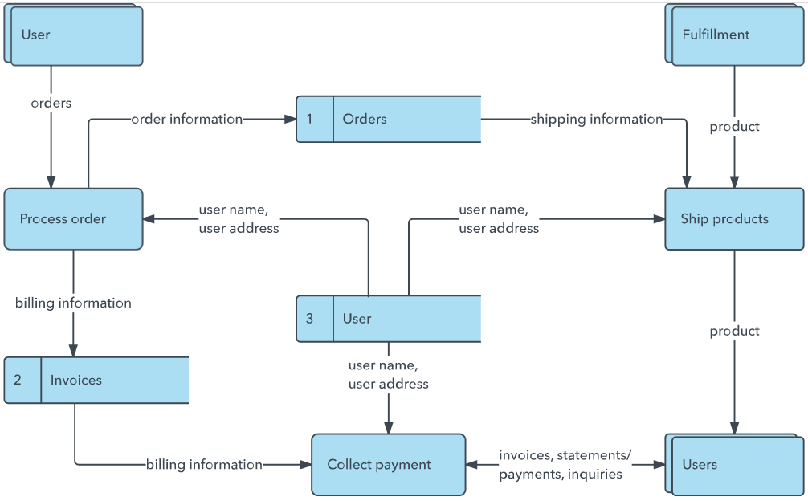


User Stories
Use the below template to list all the user stories for the product.
User Type | Functional Requirement (Epic) | User Story Number | User Story / Task | Acceptance criteria | Priority | Release
Customer (Web user) | Registration | USN-1 | As a user, I can register an account using my email and password. | User account is created successfully. | High | Sprint-1
 |  | USN-2 | As a user, I can log in securely to the complaint portal. | User can access dashboard. | High | Sprint-1
 |  | USN-3 | As a user, I can submit an online complaint with details and attachments. | Complaint is submitted and complaint ID is generated. | High | Sprint-1
 |  | USN-4 | As a user, I can track the status of my complaint. | Complaint status is displayed. | High | Sprint-2
Customer Care Executive | Complaint Management | USN-5 | As an executive, I can review and update complaint status. | Status updates are saved. | High | Sprint-2
Administrator | User & System Management | USN-6 | As an administrator, I can manage users and complaints. | Admin can view and manage all records. | High | Sprint-3
Customer (Web user)
Customer Care Executive
Administrator

