Project Design Phase
Solution Architecture
Date | 04 August 2026
Team ID | NA
Project Name | Online Complaint Management Website
Maximum Marks | 4 Marks
Solution Architecture — Online Complaint Management Website
The architecture bridges the business problem — complaints scattered across phone, email, and in-person channels — with a single web platform that captures, routes, tracks, and resolves every complaint with full accountability.
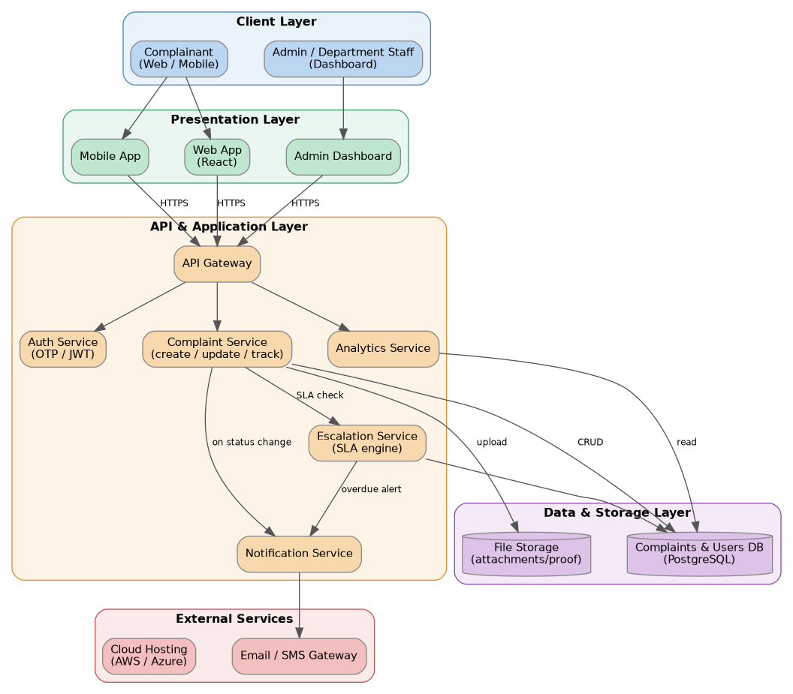
Figure 1: Solution architecture of the Online Complaint Management Website
Component Overview
Component | Role
Client Layer | Complainants use the site via web or mobile; admin/department staff use the same site through a role-based dashboard.
Presentation Layer | React web app, mobile app, and an admin dashboard render the UI and talk to the backend only through the API Gateway.
API Gateway | Single entry point for all requests; handles routing, rate-limiting, and request validation over HTTPS.
Auth Service | Handles sign-up/login via OTP or email, and issues JWT tokens; enforces role-based access (user vs. staff vs. admin).
Complaint Service | Core service — creates, updates, and tracks complaints; assigns a unique tracking ID and routes to the right department.
Escalation Service | Monitors SLA timers on open complaints and automatically escalates overdue ones to the next authority level.
Notification Service | Triggers email/SMS alerts on status changes, assignment, and escalation.
Analytics Service | Aggregates data from the database to power the admin dashboard's trends, hotspots, and resolution-time reports.
Data & Storage Layer | PostgreSQL database for complaints/users/departments; separate file storage for attachments and proof documents.
External Services | Third-party Email/SMS gateway for notifications; the entire stack is deployed on a cloud provider (AWS/Azure) for scalability.
Key Data Flow
- Complainant submits a complaint via the web/mobile app → API Gateway → Auth Service verifies identity → Complaint Service creates a ticket with a unique tracking ID, storing data in the database and any attachments in file storage.
- Complaint Service notifies the Notification Service on every status change, which emails/texts the complainant.
- Escalation Service continuously checks SLA timers in the database and auto-escalates overdue complaints, alerting the next authority via the Notification Service.
- Admin/staff use the Admin Dashboard to assign, update, and resolve complaints, and the Analytics Service surfaces trends and hotspots from the same database.

