**CC1**

**727721EUIT091**

**MOHAMED ASHIF A**

**QNO:3**

**1.CREATE A NEW S3 BUCKET IN THE REGION OF “STOCKHOLM”**

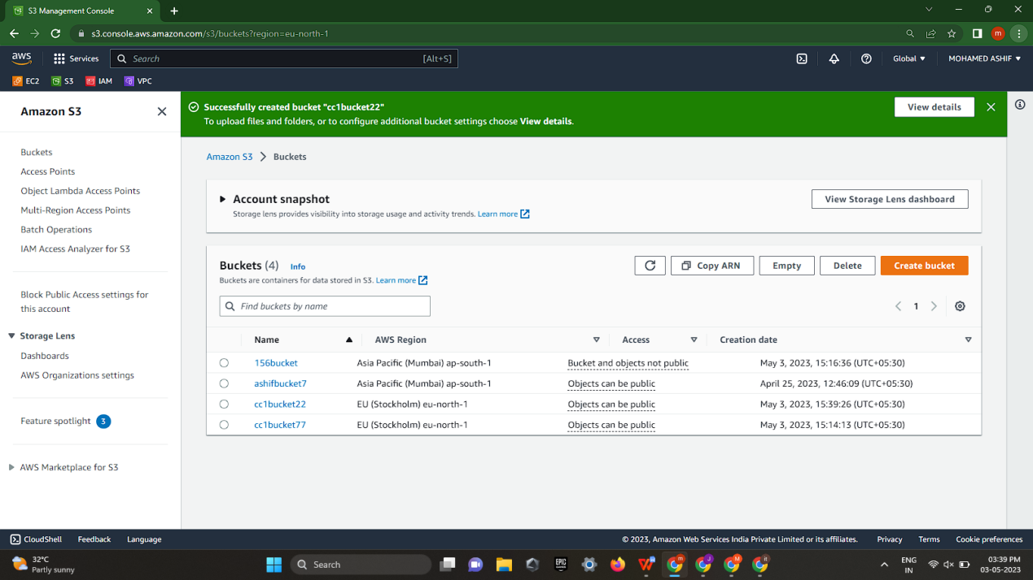

1. **MAKE THE BUCKET ACCESSIBLE TO EVERYONE(PUBLICLY) VIA BUCKET ACL**

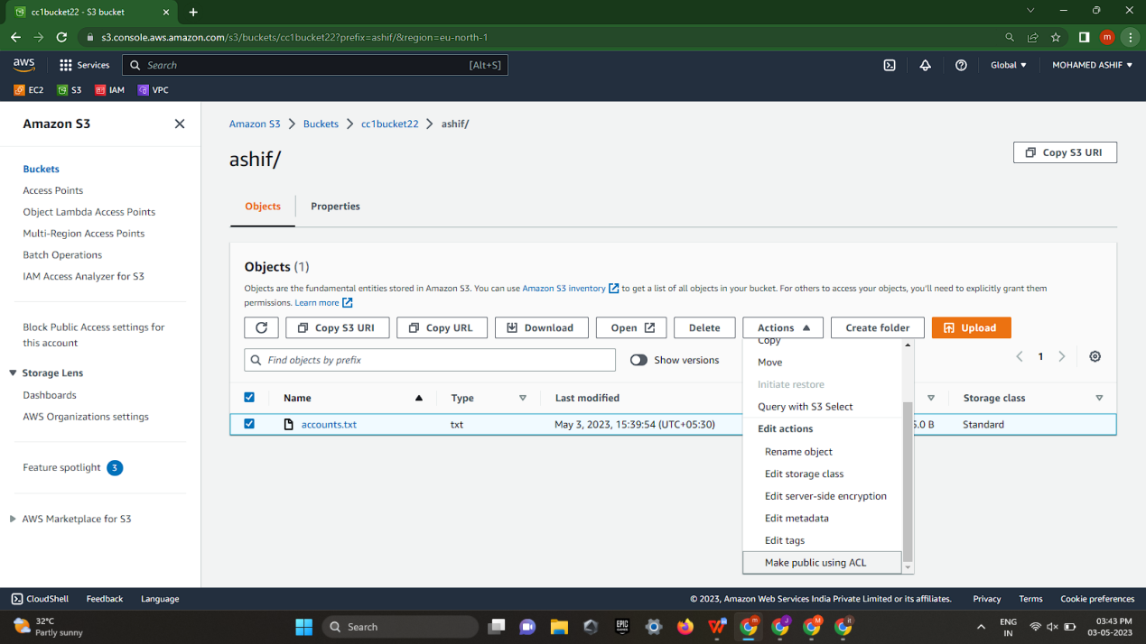

**3.UPLOAD A TEXT FILE IN THE NAME OF ‘ACCOUNTS.TXT’.**

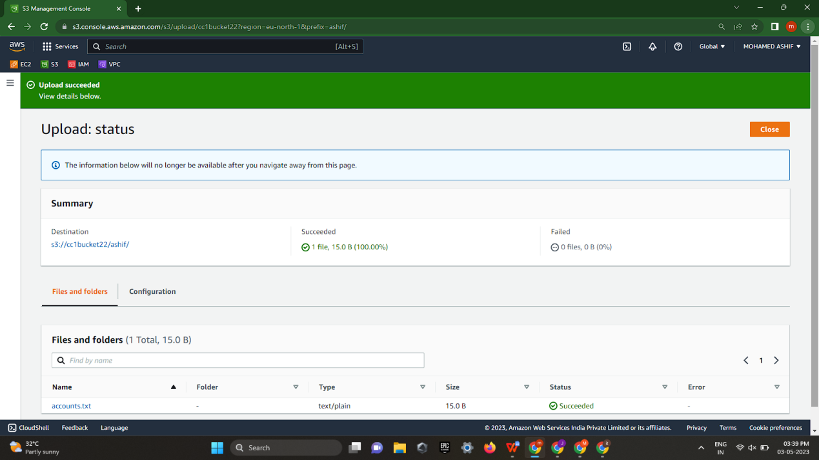

**4.MAKE THE OBJECT ‘ACCOUNT.TXT’ FILE ACCESSIBLE TO EVERYONE(PUBLICLY).**

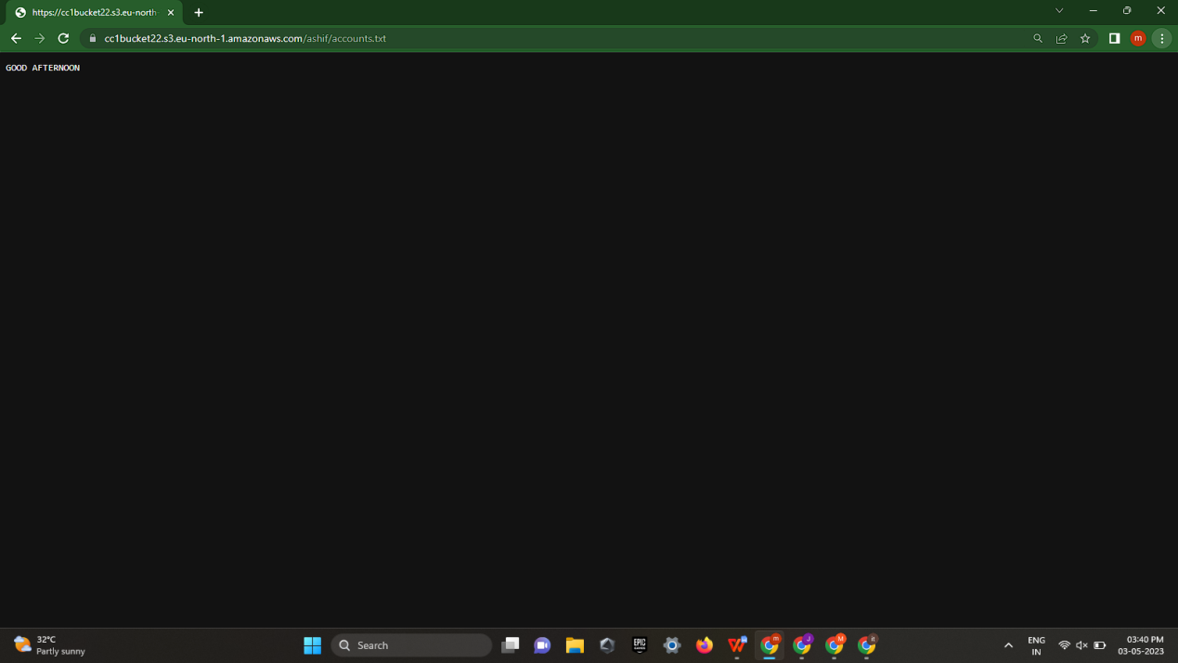

**QNO:2**

1. **Create an IAM group called 'Network-L1-Team**

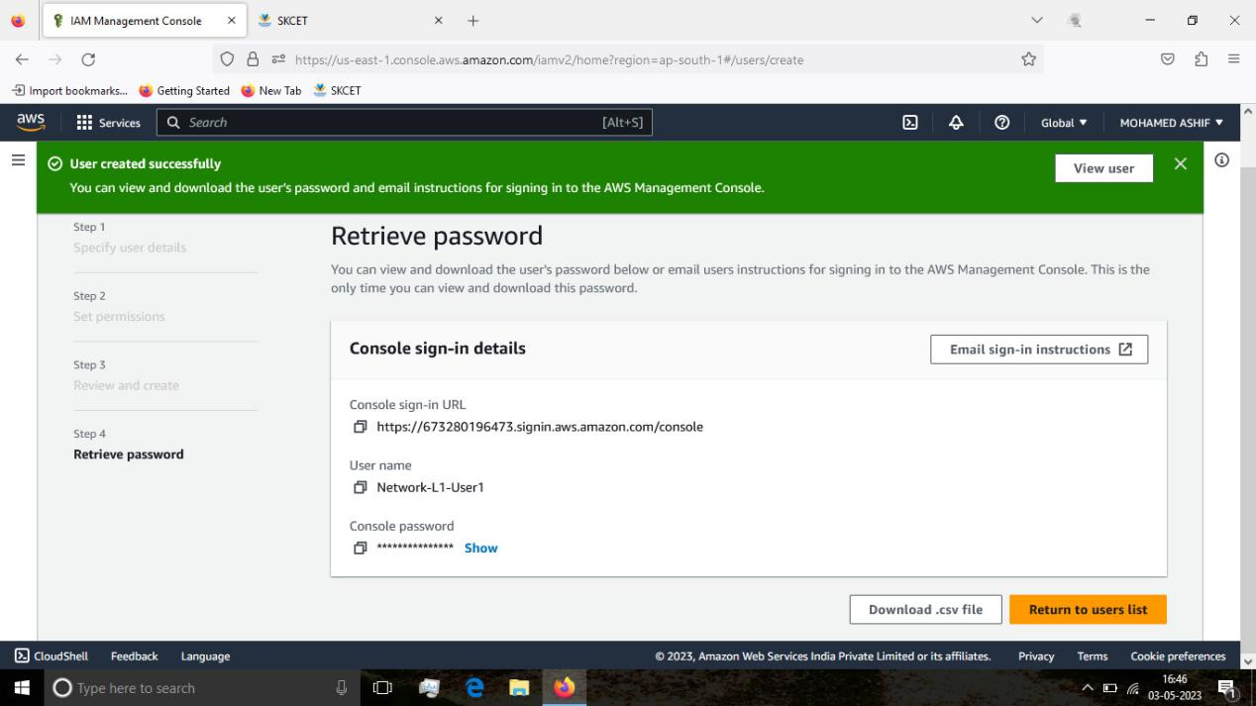

1. **The name of the IAM group should be 'Network-L1-Team**

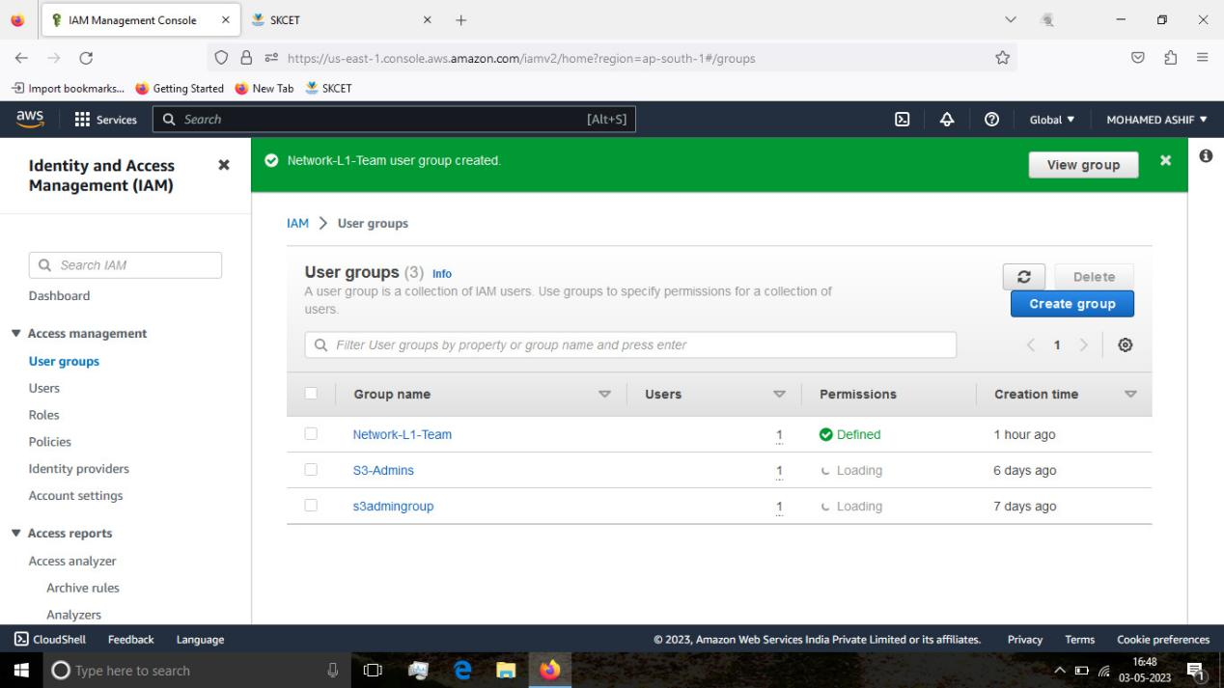

1. **The 'AmazonVPCReadOnlyAccess' policy should be attached.**

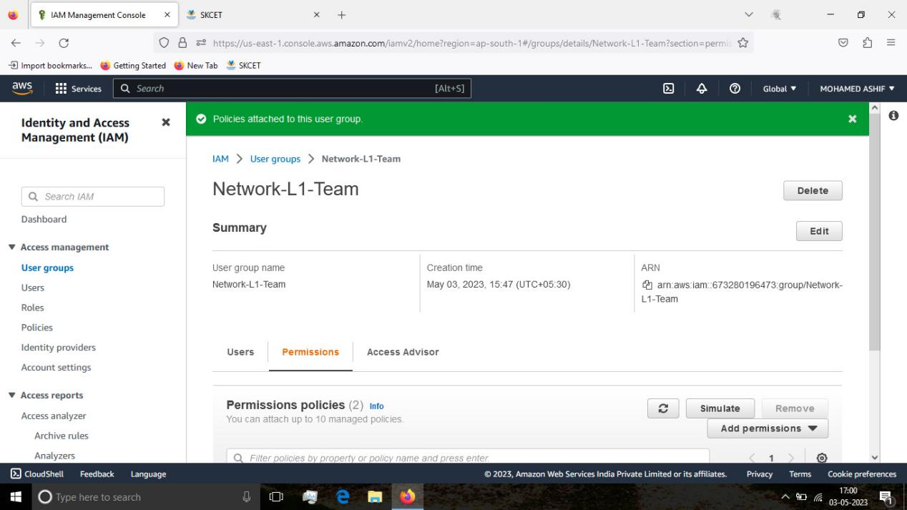

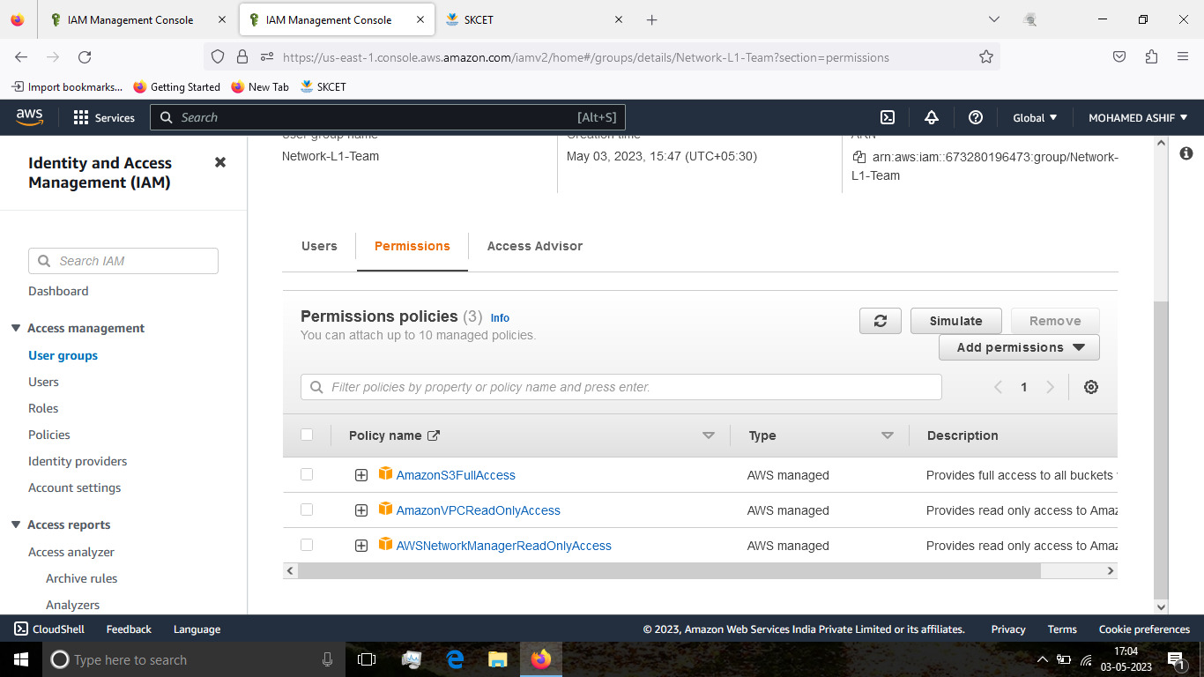

**4.The 'AWSNetworkManagerReadOnlyAccess' policy should be attached.**

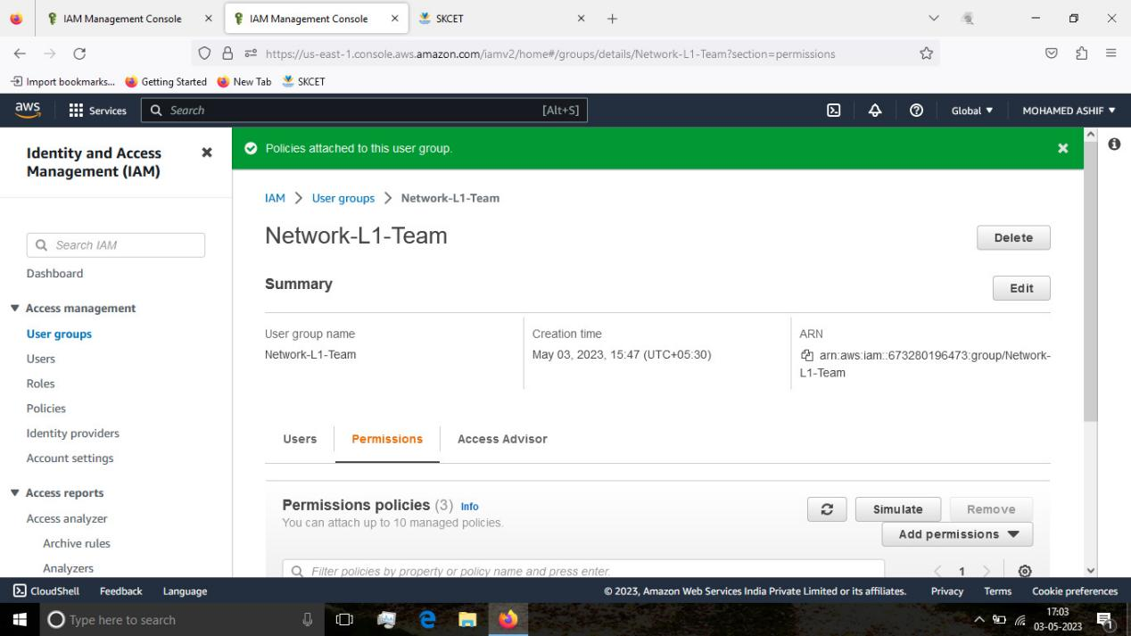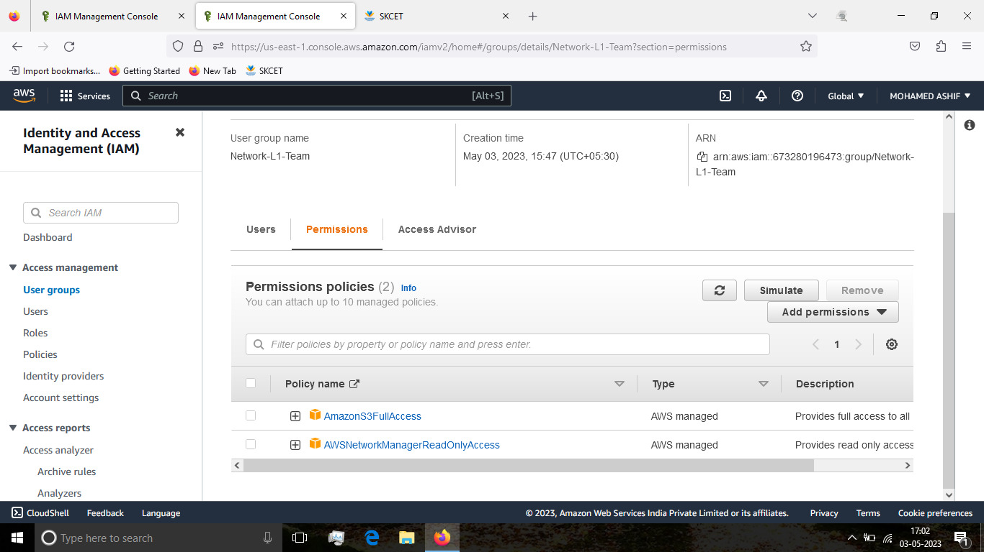

**QNO:1**

1. **Give the Name tag of both EC2 instance & keypair as "ec2usecase1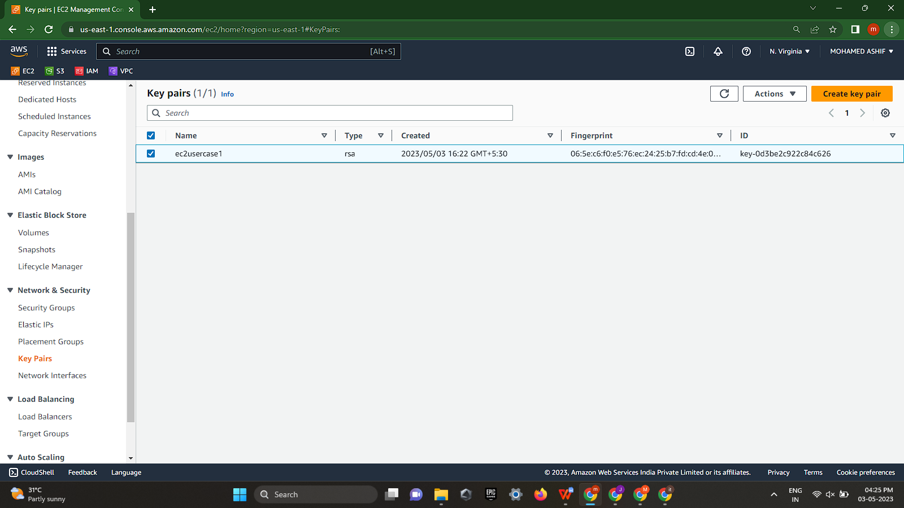"**

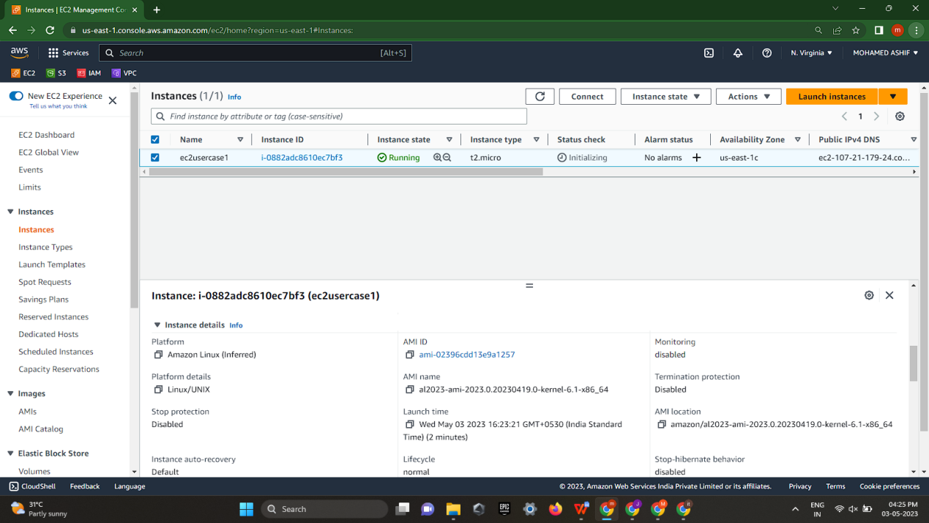

1. **EC2 instance AMI should be "Amazon Linux 2"**

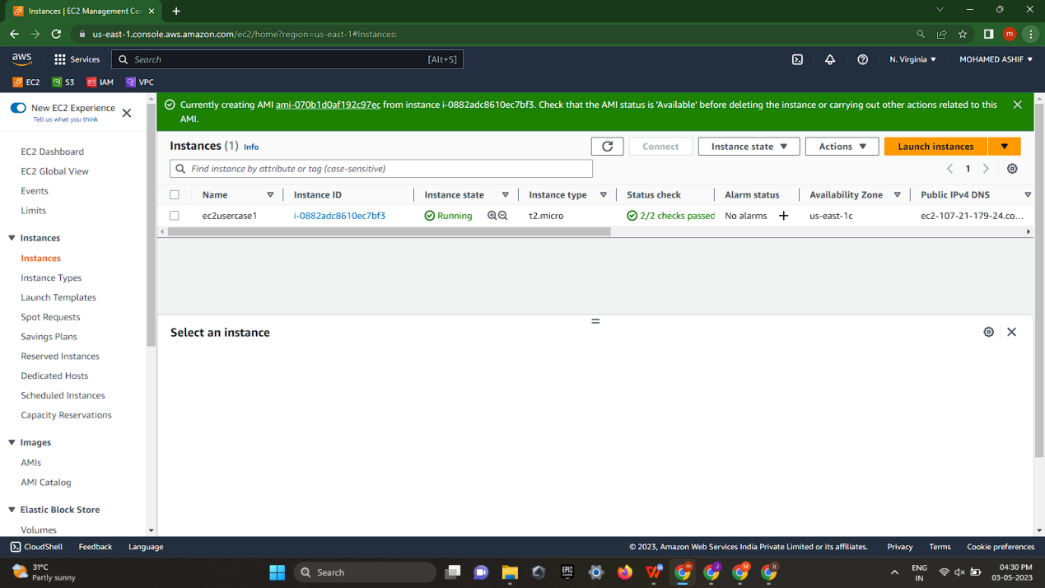

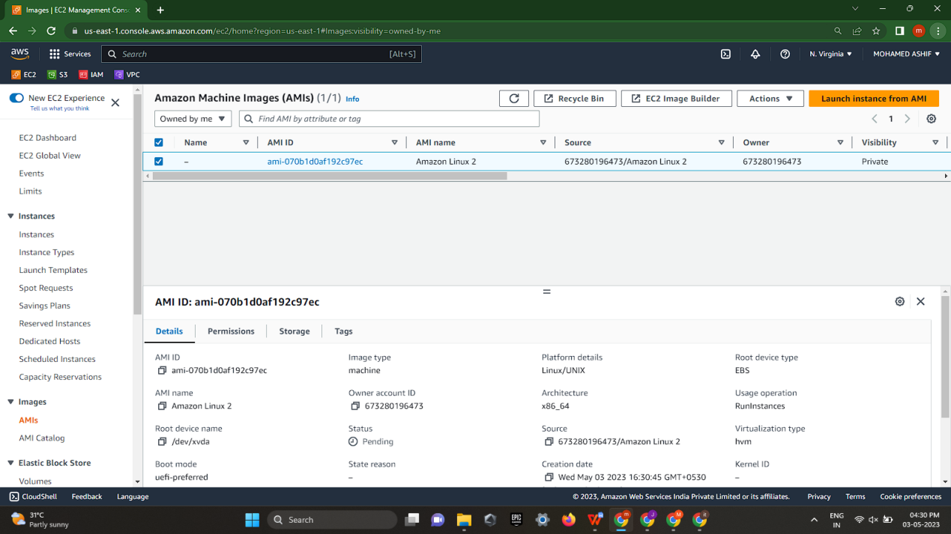

1. **Allow SSH traffic for taking puttyremote connection.**

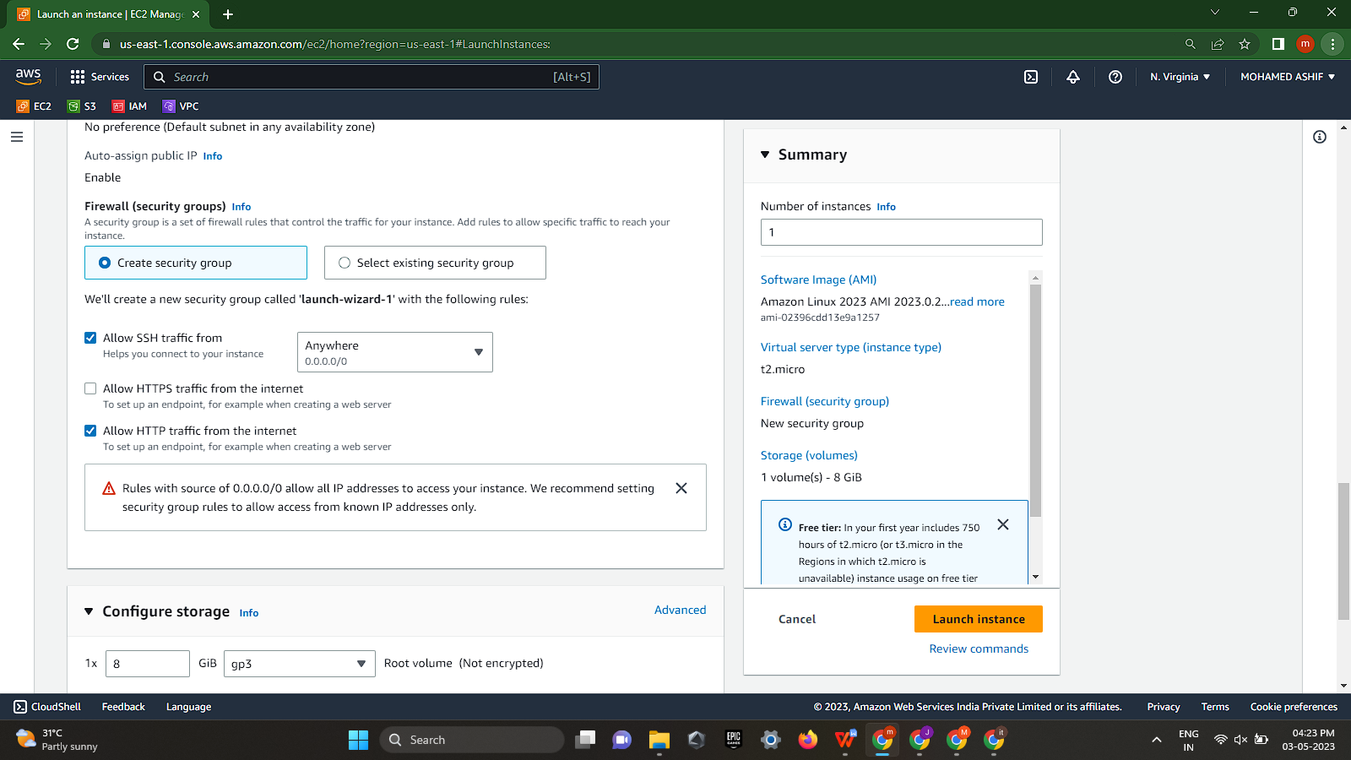

**4.Allow HTTP traffic from the internet for reaching website requests.**