**Prior Solution**

Itaipu hydroelectric project is located on the parana river on the border between Brazil and Paraguay. It is considered the second largest hydroelectric power plant in the world. it can produce 14,000MW of power. It is started to construct in 1975 and the project was officially released in October 1984. The project was supplying more than 13% of Brazilian electricity and 90% of Paraguayan electricity consumption in the last 10 years.

**Itaipu Project History**

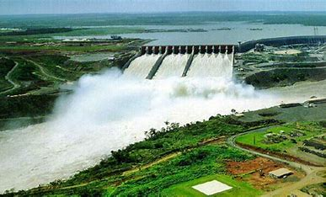In April 1973, Brazil and Paraguay started to think how to use parana river to produce hydroelectric power. Brazil and Paraguay paid the last loan taken for the construction of Itaipu hydroelectric power was paid in February 2023. On November 10, 2023, Itaipu Binacional announced that the project has exceeded the 2022 production of 69.9 million MWh.

**Project development:**

The reservoir was formed in 1982 and was 170 km length and 1350 km² area.