**Micro hydro power:**

Hydropower is generating electricity that uses water to produce electricity. There is a small scale of hydropower that has been used to generate electricity in isolated areas since end of 19th century. Small hydropower can be used in rivers, streams or in existing water supply networks. Due to its versatility, low investment costs, and as a renewable energy source, small-scale hydropower is an option for producing sustainable, inexpensive energy in rural or developing areas.

**Advantages:**

* Small hydropower is a clean energy resource, which don’t produce water or air pollution.
* Small hydropower is renewable energy source which help to reduce greenhouse gases emissions which have a positive impact on the environment.
* Long life time of systems which can reach 25 hours or more.
* Low maintenance and cost.

**Disadvantages:**

* energy consumers need to be near to the hydropower place which limit the use of energy in stream side communities.
* The stream flow determine how much energy can the hydropower produce, so if the stream flow is low the energy produced will be low which put a maximum capacity to the hydropower.

**Main topic:**

* Hydropower schemes can be small-scale or large-scale, depending on the conditions and the energy which people want. And represent a renewable energy that can be implemented whenever there is a running water As running water is a resource that is globally available and renewable, perform its power to generate electricity can provide a sustainable source of energy to improve the way of living and increase working productivity.

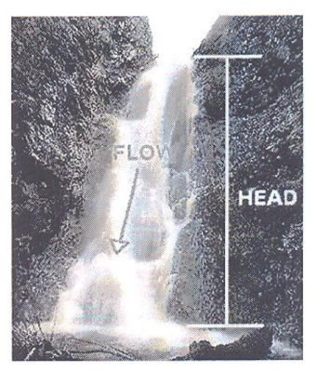**How Does it Work?**

* The main terms in hydropower generation are “head” and “flow” as shown in (fig 1). “head” refers to the height of gradient over which the water falls. While “flow” refers to volume of water per unit time. To maximize energy production both “head” and “flow” should be high.

**Power and Energy:**

* The power available in hydropower scheme is proportional to the product of head and flow rate.

Figure 1

* The general formula for any hydropower system output is: P = ηρgQH , where P, is the mechanical power produced at the turbine shaft in watts, η is the hydraulic efficiency of the turbine, ρ is the density of water (1000 Kg/m³), g is the acceleration due to gravity (9.81m/s²), Q is the volume flow rate passing through the turbine (m³/s) and H is the effective pressure head of water across the turbine (m).

**Solar chimney:**

* solar chimney is known as solar updraft tower which is a type of renewable energy technology that uses the power of the sun to generate electricity. It consists of tall chimney with a large green house at its base. The greenhouse absorbs solar radiation, heating the air inside and causing it to rise up the chimney. As the hot air moves upwards, it drives turbines located at the base of the chimney, generating electricity in the process.

**Working principal:**

* 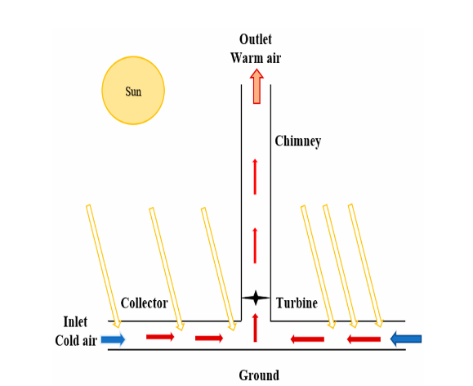solar updraft towers convert solar radiation into electricity by combining three principals: greenhouse effect, the tower and wind turbines. Hot air is produced by the effect of the sun under a glass roof Direct and diffuse solar radiation strikes the glass roof, where specific fractions of the energy are reflected, absorbed and transmitted. The quantities of these fractions are measured depending on the solar incidence angle and optical identities of the glass. The mechanism starts to function when it is transmitted to the ground. The solar radiation transferred to the system causes the air to heat because the collector acts as a cover. The decrease in the density of the heated air causes the air under the collector to move towards the collector, the solar radiation reaching the ground from the semi-permeable collector causes an increase in the temperature on the ground due to the opaque structure. All these forces push the air under the collector to the center of the collector. There is a difference in temperature between the entrance and exit of chimney which forces the system’s air to be drawn up through the chimney. There is a turbine in the chimney at a specific height from the ground. The kinetic energy of the system’s air hitting the turbine blades is converted into electrical energy, and power output is obtained from the system as shown in fig (2).

Figure 2

**Advantages:**

* **Energy efficient:** which is the main use of it, thermal rays are useful energy conservation feature in building because if any one wants to reduce using of electricity in his home the thermal chimney is the best choice and it also works as a lower heat device in summer.
* **Cost effective:** solar chimney reduces the value of bills in homes because the electricity bills can be hundred of pounds especially during summer.
* **Environmentally friendly:** solar chimney is used instead of other electricity source as oil or gas because it doesn’t exit any greenhouse gases like caron dioxide (Co2) in air so it is very clean energy resource.

**Disadvantages:**

* **High cost:** the construction of the solar chimney needs special materials and design which are expensive.
* **Limited electricity:** controlling how much electricity will be difficult because it depends on weather and rays of sun light so its efficiency will decrease on cloudy days and at night.
* **Space requirement:** solar chimneys need large space to work efficiently which isn’t appropriate to all buildings.

**Liquid fuel cells:**

Fuel cells are considered one of the key elements of hydrogen economy. Hydrogen is generated from