WeRateDogs

***Act Report***

ــــــــــــــــــــــــــــــــــــــــــــــــــــــــــــــــــــــــــــــــــــــــــــــــــــــــــــــــــــــــــــــــــــــــــــــــــــــــــــــــــــــــــــــــــــــــــــــــــــــــ

Introduction

This report shows by insights and visualizations the variation between types of dogs

And answer the following questions:

1. Which type of dogs took the highest rate?
2. Which type of dogs took the lowest rate?
3. Which type of dogs is the most common?
4. Which type of dogs is the lowest common?
5. Which had more retweets?
6. Which had little retweets?
7. Which one liked more?
8. Which one liked little?
9. What is the relation between favorites and retweets?
10. ***highest average rating***

**soft-coated_wheaten_terrier** a type took the highest average rating (20.8)

it's so Cute!

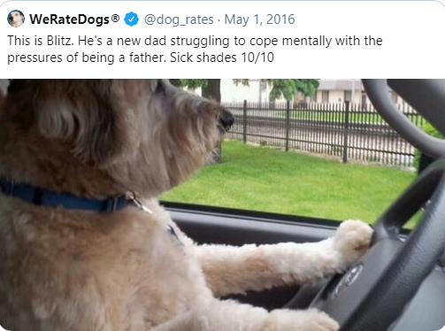

1. ***Lowest average rating***

**Japanese spaniel** has the lowest average rating. It took just (5.0)



1. ***The most and the lowest common types***

**Golden retriever** is the most common one . it's mentioned 158 time.

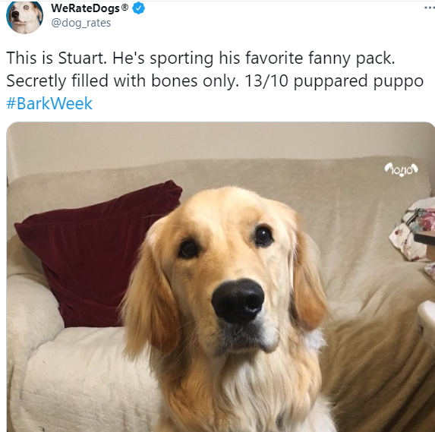

Many types of dogs took the lowest mentions like **Clumber and silky terrier**

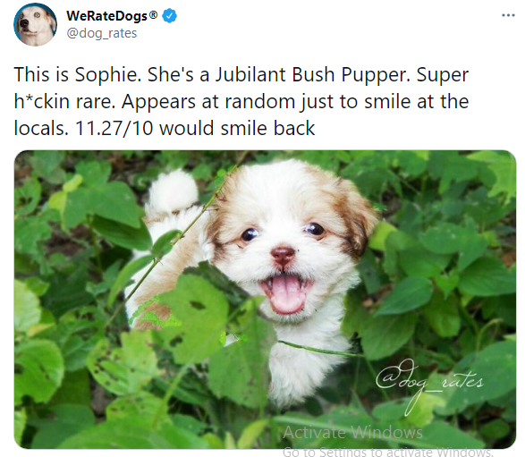

We can see this in visualization as plot

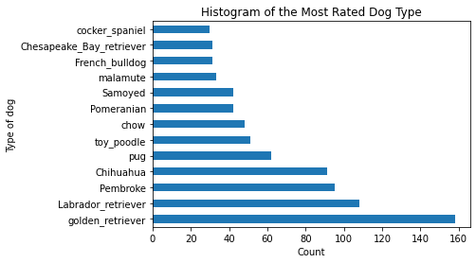

It's shown that Golden retriever mentioned than others .

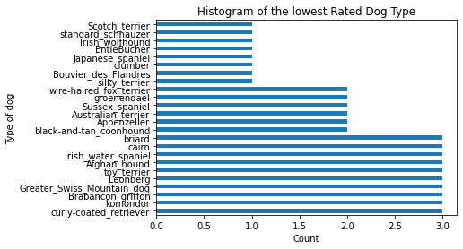

In this plot we can see all types mentioned just one time .

1. ***the most and the lowest retweet count***

**groenendael** took the lowest retweet counts . It's just took average (276) retweets

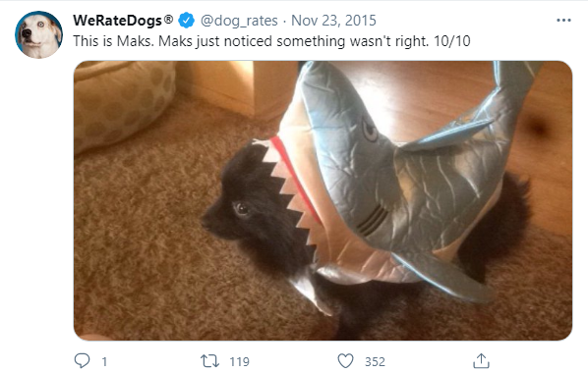

**Bedlington terrier** is the highest retweet count. It's took average (7510) retweets



1. ***which type is lovely more and which one isn't lovely ?***

**Brabancon_griffon** this type is token the lowest favorite count . it's just took (885) likes

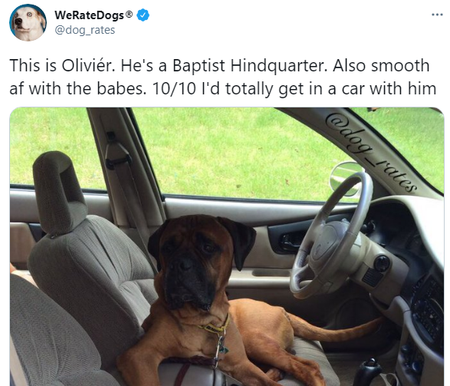

**Saluki** this beauty one took the most favorite count. It's took

(24060) likes

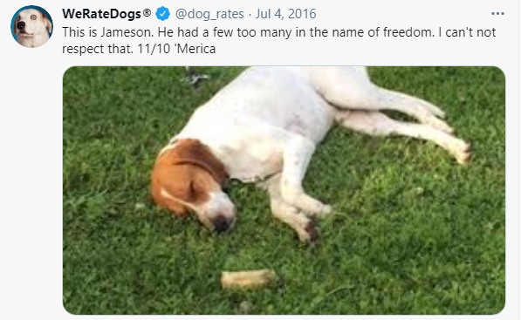

1. ***the relation between favorite count and retweet count***

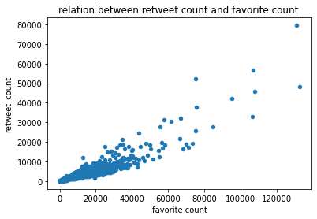

From this plot there exist positive relation between favorite count and retweet count