UNILAK
Database Programming
Coffee Shop Management System
30837/2025

Introduction
The Coffee Shop Management System is a database project developed to help manage the daily activities of a coffee shop. The system stores information about customers, employees, products, suppliers, orders, payments, and inventory. It helps organize data, improve accuracy, and make daily operations easier. This project was developed using Oracle SQL and PL/SQL.

Problem Statement

Coffee shops often face problems in managing customer orders, products, inventory, and payments manually. This may cause mistakes and waste time. The Coffee Shop Management System provides a simple database to organize all information and improve daily business operations.

Objectives
- To manage customer information.
- To store product and category details.
- To manage customer orders and payments.
- To monitor inventory and supplier information.
- To generate sales reports.
- To improve the efficiency of coffee shop operations.
Database Design
1. Customer
Stores customer information such as name, phone number, email, and address.
2. Employee
Stores employee details including name, role, phone number, and email.
3. Category
Stores product categories such as Hot Drinks, Cold Drinks, and Pastries.
4. Supplier
Stores supplier information including contact details and address.
5. Product
Stores product information such as product name, description, price, and category.
6. Inventory
Stores the available quantity of each product and helps monitor stock levels.
7. Orders
Stores customer order information, including order date, total amount, and order status.
8. Order_Details
Stores the products included in each order, with quantity and unit price.
9. Payment
Stores payment information, including payment method, amount, and payment date.
10. Sales_Report
Stores sales summary information, including total sales and total orders for reporting purposes.

Sample Data
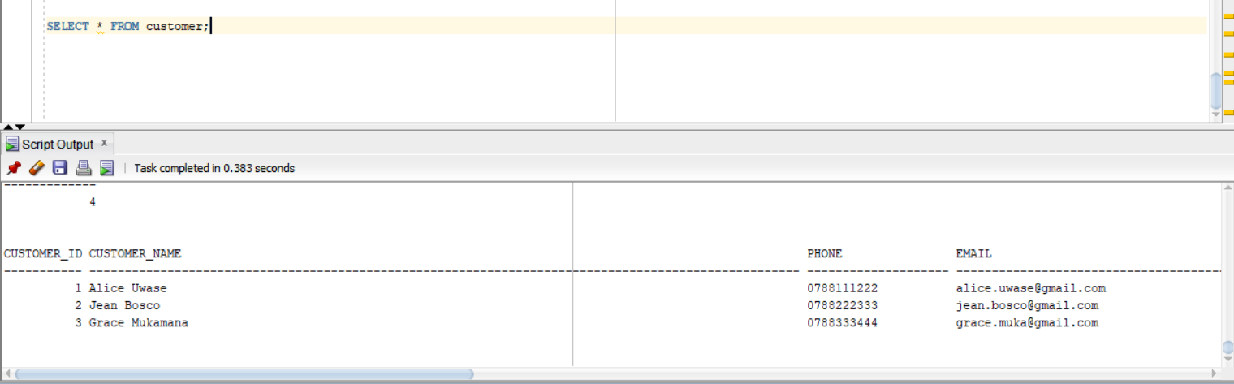
Sample data was successfully inserted into the database tables using SQL INSERT INTO statements. The SELECT queries confirmed that all records were stored correctly and that the database was functioning as expected

PL/SQL Implementation

- Procedure

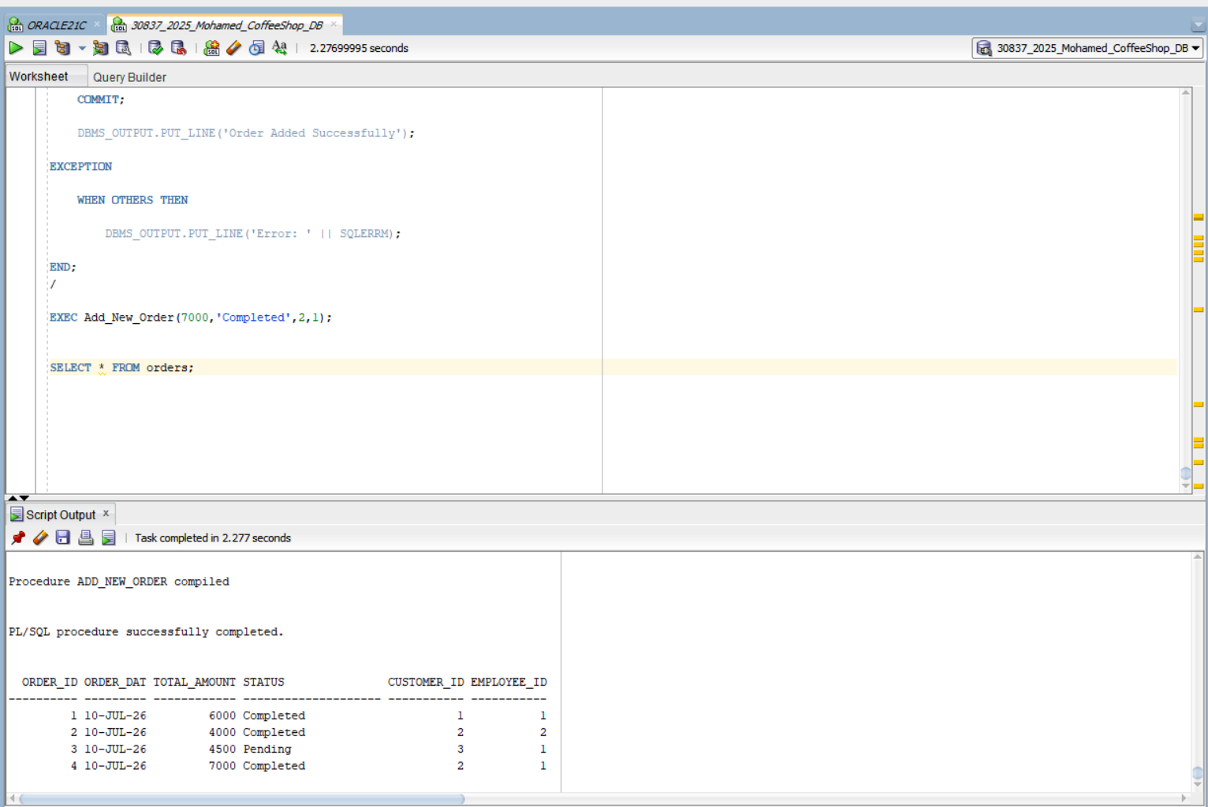 A Procedure is a PL/SQL program used to perform a specific task. In this project, the procedure Add_New_Order was created to insert a new customer order into the database.

- Function
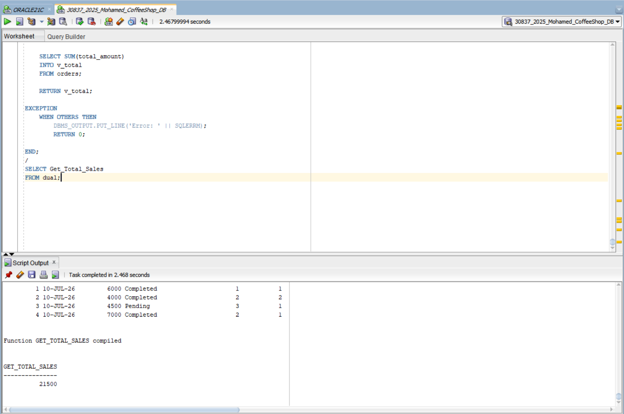

A Function performs a calculation and returns a value. In this project, Get_Total_Sales calculates the total sales amount and returns it as a NUMBER.
- Cursor
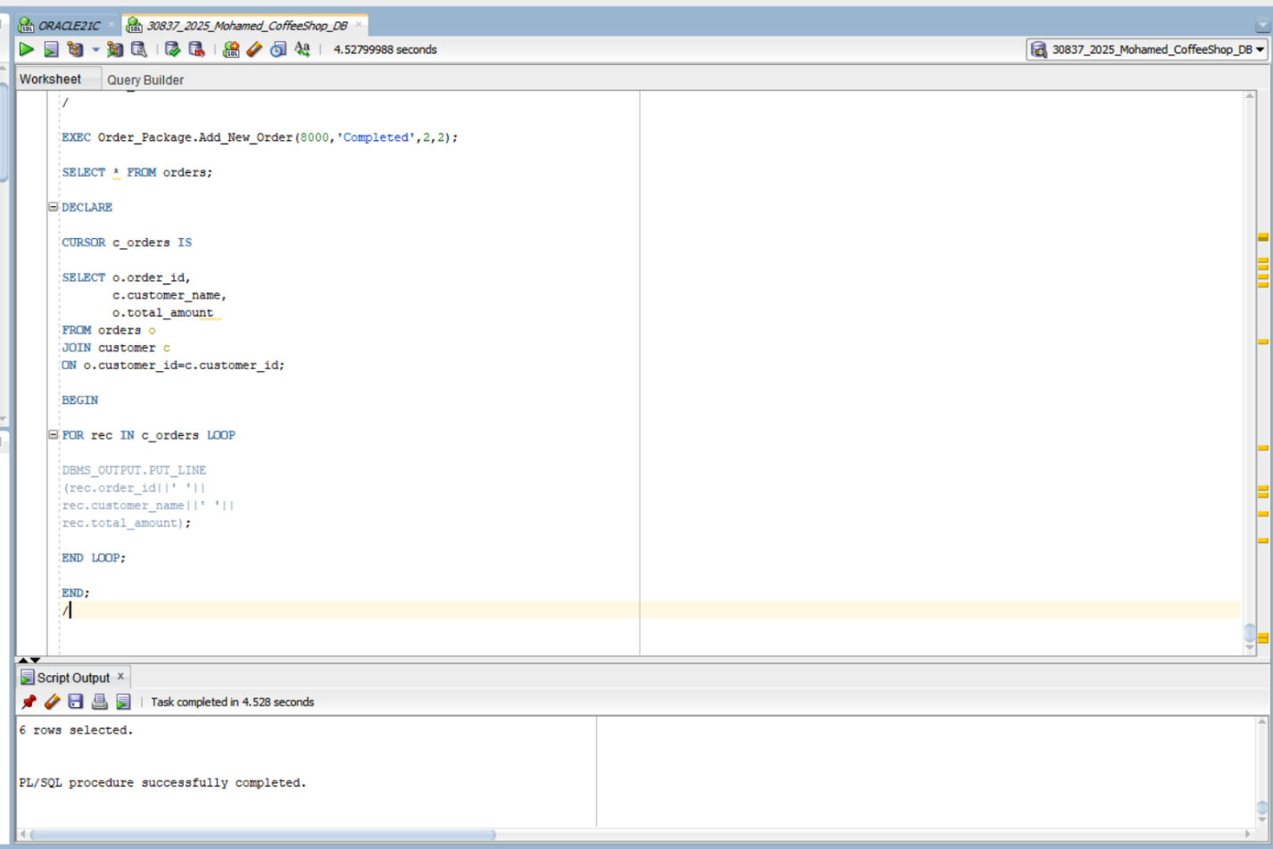
A Cursor is used to retrieve multiple rows from a query. It processes each row one by one for further operations.

- Exception Handling
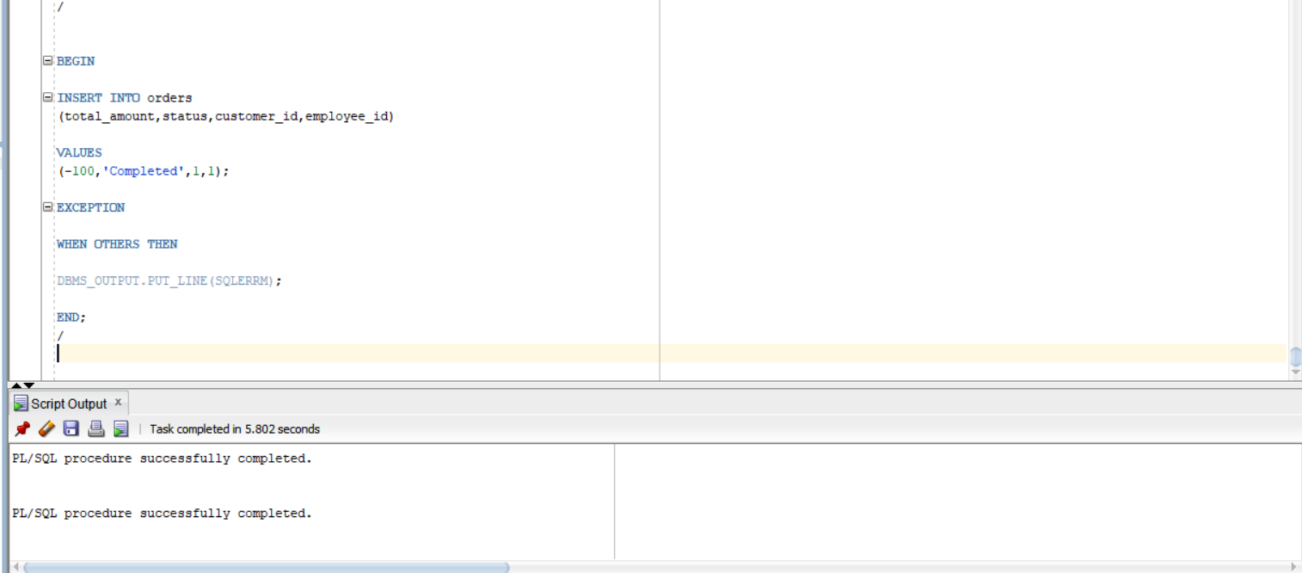

Exception Handling is used to catch and manage runtime errors. It prevents the program from stopping unexpectedly and displays meaningful error messages.

- Trigger
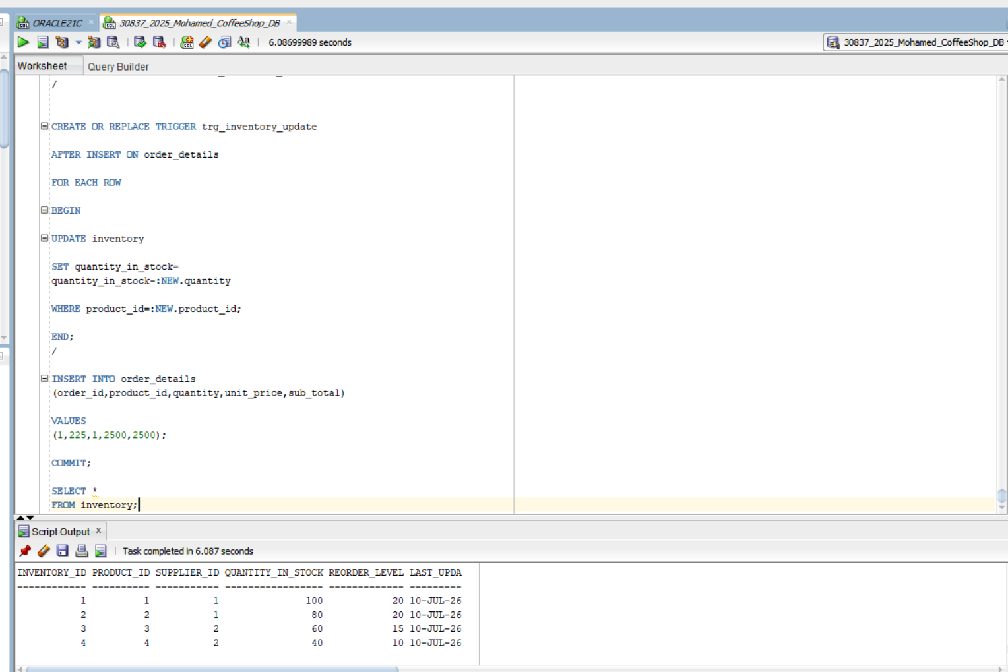

A Trigger is executed automatically when data is inserted, updated, or deleted. It helps enforce business rules and automate database operations.
- Audit System
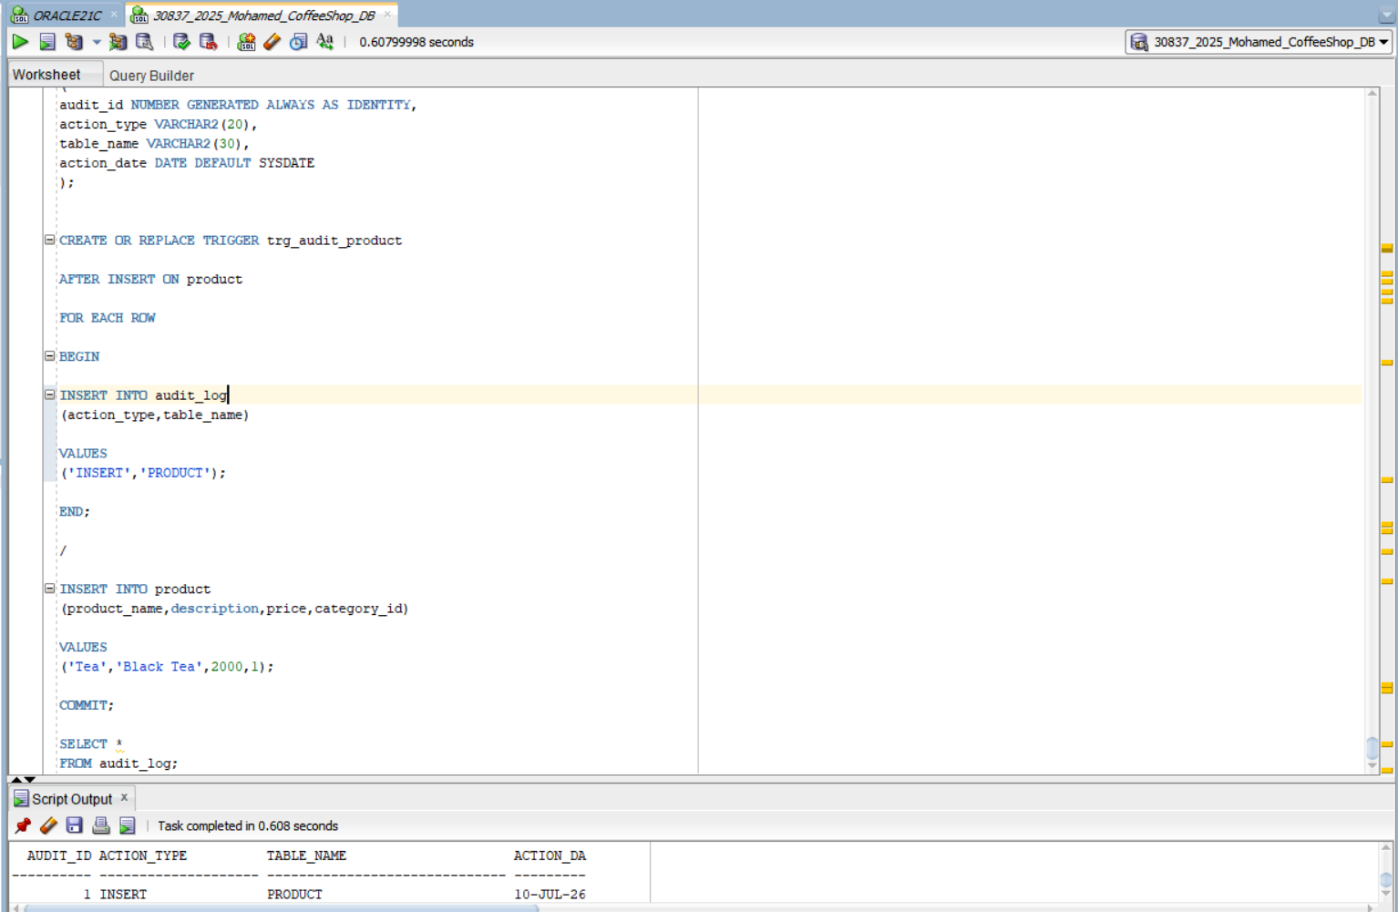
The Audit System records important database activities such as inserts, updates, and deletions. It helps monitor user actions and maintain data integrity.

- Security
Security was implemented by creating database users and assigning privileges. This ensures that only authorized users can access or modify the database.

- Security
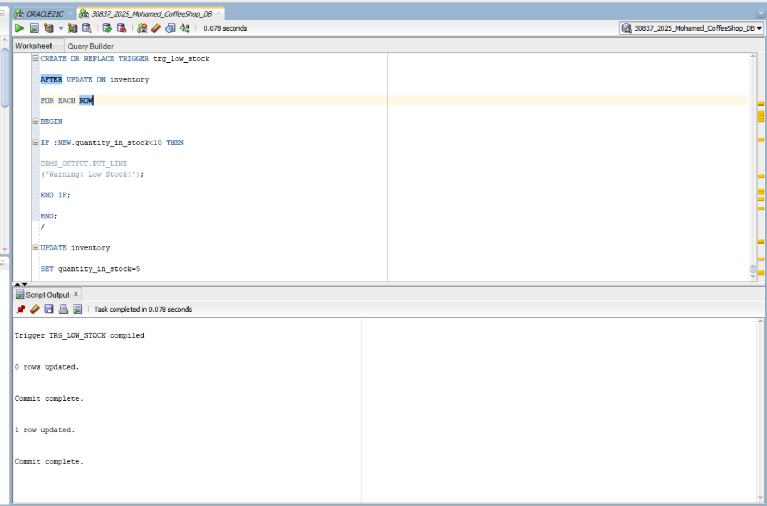
Security was implemented by creating database users and assigning privileges. This ensures that only authorized users can access or modify the database.

- Conclusion

This project successfully developed a Coffee Shop Management System using Oracle Database and PL/SQL. The database was designed and implemented with SQL tables, Procedures, Functions, Packages, Cursors, Triggers, Audit System, and Security features. Through this project, I improved my practical skills in database design, SQL programming, PL/SQL development, testing, and database management
Finally, I would like to express my sincere gratitude and appreciation to my instructor for the guidance support and valuable knowledge provided throughout this course. This project was a valuable learning experience that enhanced both my technical skills and practical understanding of database programming.

