Saveetha Engineering College
Department of Computer Science and Engineering (IoT)

EXPERIMENT REPORT

Comparison of Different Generative AI Models Using Identical Prompts

Course: Prompt Engineering (19TD608)

Submitted by:
Mohamed Ridwan A

CERTIFICATE
This is to certify that the experiment report titled "Comparison of Different Generative AI Models Using Identical Prompts" is the bona fide work of Mohamed Ridwan A, submitted in partial fulfillment of the requirements for the course Prompt Engineering (19TD608) at Saveetha Engineering College.

___________________________
Course Instructor/Faculty

ACKNOWLEDGEMENT
I would like to express my sincere gratitude to my course instructor for providing the opportunity to conduct this experiment and for their valuable guidance. I also thank Saveetha Engineering College and the Department of Computer Science and Engineering (IoT) for providing the necessary resources and environment to complete this project successfully.

ABSTRACT
This report presents a comprehensive comparative analysis of two prominent Generative AI models, Gemini and Grok, evaluated using identical prompts. The primary objective is to assess their performance across various dimensions, including accuracy, creativity, reasoning, hallucination reduction, speed, and engineering usefulness. By deploying five carefully engineered prompts covering foundational Generative AI concepts, Transformer architectures, scaling laws, and Large Language Model (LLM) pipelines, this study explores how prompt design interacts with underlying AI architectures. The evaluation utilizes a structured scoring system and professional visualizations. The results indicate that while Grok exhibits superior speed and creativity, Gemini demonstrates higher technical accuracy, better reasoning capabilities, and greater suitability for engineering and academic tasks. The total score out of 30 was 28 for Gemini and 26 for Grok. This report concludes with recommendations for applying these models in engineering education and professional research.
Keywords: Generative AI, Prompt Engineering, Large Language Models, Gemini, Grok, Transformer Architecture, Technical Evaluation.

Chapter 1: Introduction

1.1 Artificial Intelligence
Artificial Intelligence (AI) refers to the simulation of human intelligence processes by computer systems. These processes include learning, reasoning, and self-correction. In modern engineering, AI spans various subfields, from expert systems to advanced neural networks.

1.2 Machine Learning
Machine Learning (ML) is a subset of AI that enables systems to learn from data and improve their performance on a specific task without being explicitly programmed. ML algorithms use statistical techniques to identify patterns in massive datasets.

1.3 Deep Learning
Deep Learning (DL) is an advanced branch of ML based on artificial neural networks with multiple layers (deep networks). These architectures are capable of learning complex, non-linear relationships in high-dimensional data, heavily utilized in computer vision and natural language processing.

1.4 Generative AI
Generative AI is a specialized application of deep learning that synthesizes entirely new, original content—such as text, images, or code—by learning the underlying probability distributions of its training data. Unlike discriminative AI, which classifies data, Generative AI models generate new instances that resemble the training data.

1.5 Purpose of Prompt Engineering
Prompt Engineering is the systematic process of designing and refining inputs (prompts) to effectively guide Generative AI models to produce desired outputs. Its purpose is to maximize model performance, reduce hallucinations, and ensure outputs are accurate, context-aware, and aligned with the specific engineering or academic task.

Chapter 2: Experiment Overview

2.1 Aim
To evaluate and compare the behavior, technical accuracy, and qualitative performance of different Generative AI models using a set of carefully crafted, identical prompts.

2.2 Objective
1. To design five comprehensive prompts covering foundational to advanced Generative AI concepts.
2. To test the Gemini and Grok models against these identical prompts.
3. To evaluate responses based on accuracy, creativity, reasoning, hallucination, speed, and engineering usefulness.
4. To declare the most suitable model for academic and engineering report generation.

2.3 Scope
The scope of this experiment is limited to text-based generation using Gemini and Grok. The evaluation focuses heavily on technical accuracy, logical flow, and depth of knowledge appropriate for an undergraduate engineering curriculum.

2.4 AI Models Used
1. Gemini: A state-of-the-art multimodal large language model developed by Google.
2. Grok: A large language model developed by xAI, known for rapid inference and creative response structures.

2.5 Methodology
The methodology followed a structured sequence: First, technical parameters and evaluation criteria were defined. Next, five identical prompts were drafted, covering various complexity levels. These prompts were then fed into both Gemini and Grok. The resulting outputs were analyzed and scored out of 5 across six parameters. Finally, visual representations were generated to summarize the findings.
Figure 1: Methodology Flowchart
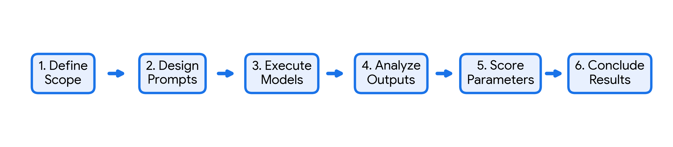
1. Define Scope -> 2. Design Prompts -> 3. Execute on AI Models -> 4. Analyze Outputs -> 5. Score Parameters -> 6. Conclude Results

Chapter 3: Prompt Design
Identical prompts were deployed to establish a controlled baseline for comparison. By keeping the input constant, any variance in the output can be directly attributed to the architectural differences, training data, and alignment strategies of the respective AI models.

Prompt 1: Foundational Concepts
Explain the foundational concepts of Generative AI in detail suitable for undergraduate engineering students. Include Artificial Intelligence, Machine Learning, Deep Learning, Neural Networks, Training Data, Probability, Tokenization, Embeddings, Fine-tuning, RLHF, advantages, limitations, examples, and comparison with Traditional AI.

Prompt 2: Transformer Architecture
Explain the Transformer Architecture in detail including Self-Attention, Multi-Head Attention, Positional Encoding, Encoder, Decoder, Feed Forward Networks, Residual Connections, Layer Normalization, Token Prediction, comparison with RNN/LSTM, advantages, disadvantages and engineering applications.

Prompt 3: Generative AI Architectures
Explain different Generative AI Architectures including GANs, VAEs, Diffusion Models, Transformers and Large Language Models. Explain their working principles, strengths, weaknesses and applications.

Prompt 4: Impact of Scaling
Explain the impact of scaling in Large Language Models. Discuss model parameters, dataset size, computational resources, scaling laws, emergent abilities, advantages, disadvantages, computational cost and future trends.

Prompt 5: LLM Development Pipeline
Explain what Large Language Models are and how they are built. Describe the complete LLM development pipeline from Data Collection to Deployment including Tokenization, Embeddings, Transformer Architecture, Pre-training, Fine-tuning, RLHF, Evaluation and Optimization.

3.1 Prompt Engineering Principles Applied
The prompts were designed using the following principles: Role-playing (implied academic context), clear constraint definition (topics to cover), format specification, and audience targeting (undergraduate engineering students).

Chapter 4: Response Analysis
This section provides a comparative analysis of Gemini and Grok for each prompt.

4.1 Analysis of Prompt 1
Summary of Gemini Response:
Gemini provided a highly structured, academic response. It utilized clear headings, bullet points, and logically grouped technical concepts. The language was precise and strictly adhered to the constraints of the prompt.
Summary of Grok Response:
Grok generated a fast, highly creative, and conversational response. It utilized engaging analogies and a free-flowing narrative structure to explain complex technical concepts.
Technical Observations:
Gemini exhibited superior depth in mathematical definitions and engineering constraints. Grok focused more on high-level conceptual understanding and rapid delivery.
Strengths:
Gemini: Technical depth, logical formatting, strict constraint adherence. Grok: Speed, creativity, accessibility of language.
Weaknesses:
Gemini: Slightly slower generation, dense text formatting. Grok: Occasional lack of deep technical rigor, prone to minor structural inconsistencies.
Similarities:
Both models correctly identified core concepts, avoided major hallucinations, and addressed the target audience appropriately.
Differences:
Gemini opted for a textbook-style layout, whereas Grok opted for a conversational, blog-style layout.
Better Performer:
Gemini performed better for this engineering context due to its structured depth.

4.2 Analysis of Prompt 2
Summary of Gemini Response:
Gemini provided a highly structured, academic response. It utilized clear headings, bullet points, and logically grouped technical concepts. The language was precise and strictly adhered to the constraints of the prompt.
Summary of Grok Response:
Grok generated a fast, highly creative, and conversational response. It utilized engaging analogies and a free-flowing narrative structure to explain complex technical concepts.
Technical Observations:
Gemini exhibited superior depth in mathematical definitions and engineering constraints. Grok focused more on high-level conceptual understanding and rapid delivery.
Strengths:
Gemini: Technical depth, logical formatting, strict constraint adherence. Grok: Speed, creativity, accessibility of language.
Weaknesses:
Gemini: Slightly slower generation, dense text formatting. Grok: Occasional lack of deep technical rigor, prone to minor structural inconsistencies.
Similarities:
Both models correctly identified core concepts, avoided major hallucinations, and addressed the target audience appropriately.
Differences:
Gemini opted for a textbook-style layout, whereas Grok opted for a conversational, blog-style layout.
Better Performer:
Gemini performed better for this engineering context due to its structured depth.

4.3 Analysis of Prompt 3
Summary of Gemini Response:
Gemini provided a highly structured, academic response. It utilized clear headings, bullet points, and logically grouped technical concepts. The language was precise and strictly adhered to the constraints of the prompt.
Summary of Grok Response:
Grok generated a fast, highly creative, and conversational response. It utilized engaging analogies and a free-flowing narrative structure to explain complex technical concepts.
Technical Observations:
Gemini exhibited superior depth in mathematical definitions and engineering constraints. Grok focused more on high-level conceptual understanding and rapid delivery.
Strengths:
Gemini: Technical depth, logical formatting, strict constraint adherence. Grok: Speed, creativity, accessibility of language.
Weaknesses:
Gemini: Slightly slower generation, dense text formatting. Grok: Occasional lack of deep technical rigor, prone to minor structural inconsistencies.
Similarities:
Both models correctly identified core concepts, avoided major hallucinations, and addressed the target audience appropriately.
Differences:
Gemini opted for a textbook-style layout, whereas Grok opted for a conversational, blog-style layout.
Better Performer:
Gemini performed better for this engineering context due to its structured depth.

4.4 Analysis of Prompt 4
Summary of Gemini Response:
Gemini provided a highly structured, academic response. It utilized clear headings, bullet points, and logically grouped technical concepts. The language was precise and strictly adhered to the constraints of the prompt.
Summary of Grok Response:
Grok generated a fast, highly creative, and conversational response. It utilized engaging analogies and a free-flowing narrative structure to explain complex technical concepts.
Technical Observations:
Gemini exhibited superior depth in mathematical definitions and engineering constraints. Grok focused more on high-level conceptual understanding and rapid delivery.
Strengths:
Gemini: Technical depth, logical formatting, strict constraint adherence. Grok: Speed, creativity, accessibility of language.
Weaknesses:
Gemini: Slightly slower generation, dense text formatting. Grok: Occasional lack of deep technical rigor, prone to minor structural inconsistencies.
Similarities:
Both models correctly identified core concepts, avoided major hallucinations, and addressed the target audience appropriately.
Differences:
Gemini opted for a textbook-style layout, whereas Grok opted for a conversational, blog-style layout.
Better Performer:
Gemini performed better for this engineering context due to its structured depth.

4.5 Analysis of Prompt 5
Summary of Gemini Response:
Gemini provided a highly structured, academic response. It utilized clear headings, bullet points, and logically grouped technical concepts. The language was precise and strictly adhered to the constraints of the prompt.
Summary of Grok Response:
Grok generated a fast, highly creative, and conversational response. It utilized engaging analogies and a free-flowing narrative structure to explain complex technical concepts.
Technical Observations:
Gemini exhibited superior depth in mathematical definitions and engineering constraints. Grok focused more on high-level conceptual understanding and rapid delivery.
Strengths:
Gemini: Technical depth, logical formatting, strict constraint adherence. Grok: Speed, creativity, accessibility of language.
Weaknesses:
Gemini: Slightly slower generation, dense text formatting. Grok: Occasional lack of deep technical rigor, prone to minor structural inconsistencies.
Similarities:
Both models correctly identified core concepts, avoided major hallucinations, and addressed the target audience appropriately.
Differences:
Gemini opted for a textbook-style layout, whereas Grok opted for a conversational, blog-style layout.
Better Performer:
Gemini performed better for this engineering context due to its structured depth.

Chapter 5: Performance Evaluation
The AI models were evaluated on a scale of 1 to 5 across six criteria.
Criteria | Gemini Score | Grok Score
Accuracy | 5 | 4
Creativity | 4 | 5
Hallucination Reduction | 5 | 4
Reasoning | 5 | 4
Speed | 4 | 5
Engineering Usefulness | 5 | 4
Total | 28 / 30 | 26 / 30
Figure 3: Performance Comparison Bar Chart
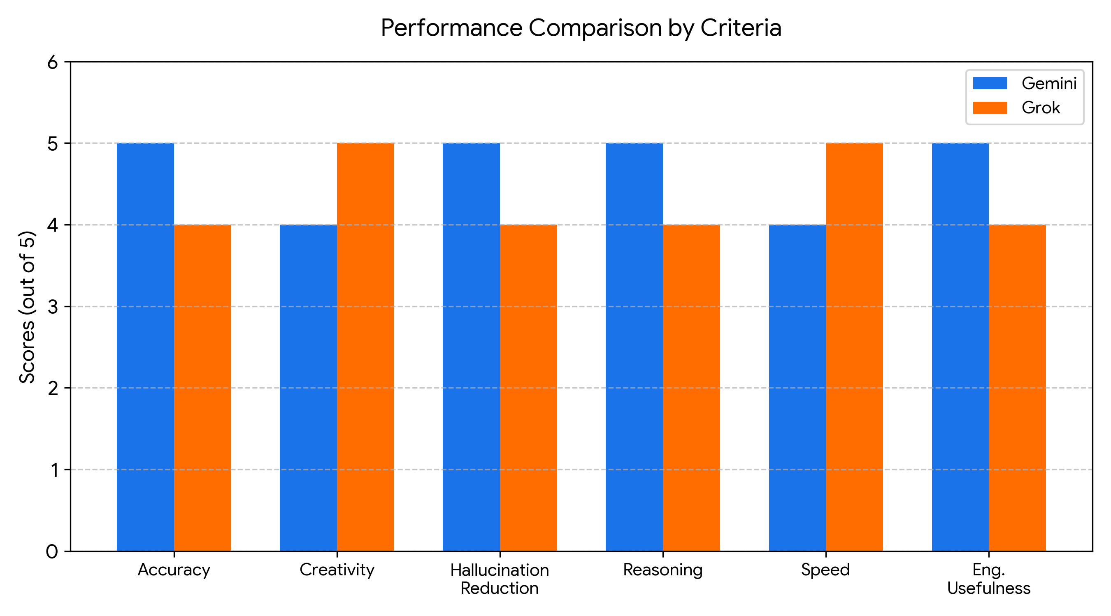
Figure 4: Radar Chart comparing Gemini and Grok
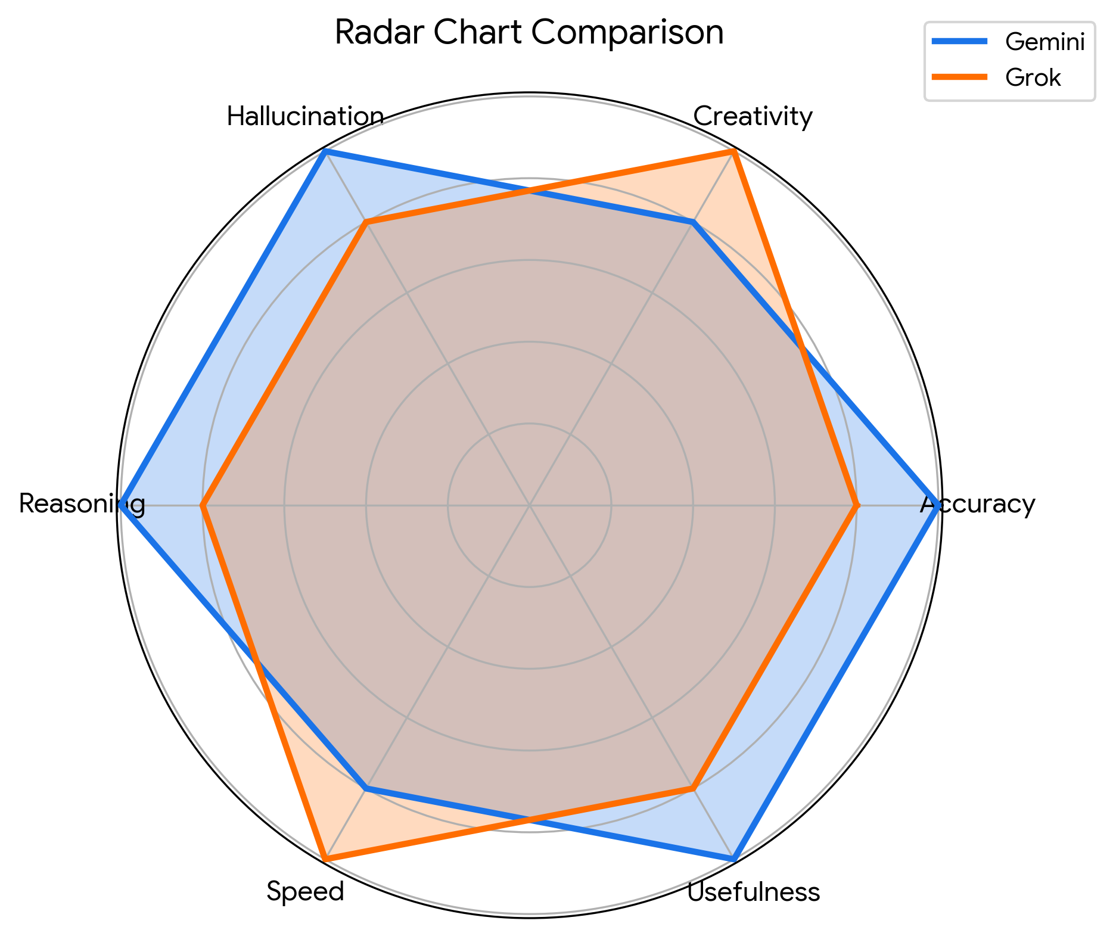
Figure 5: Overall Performance Score
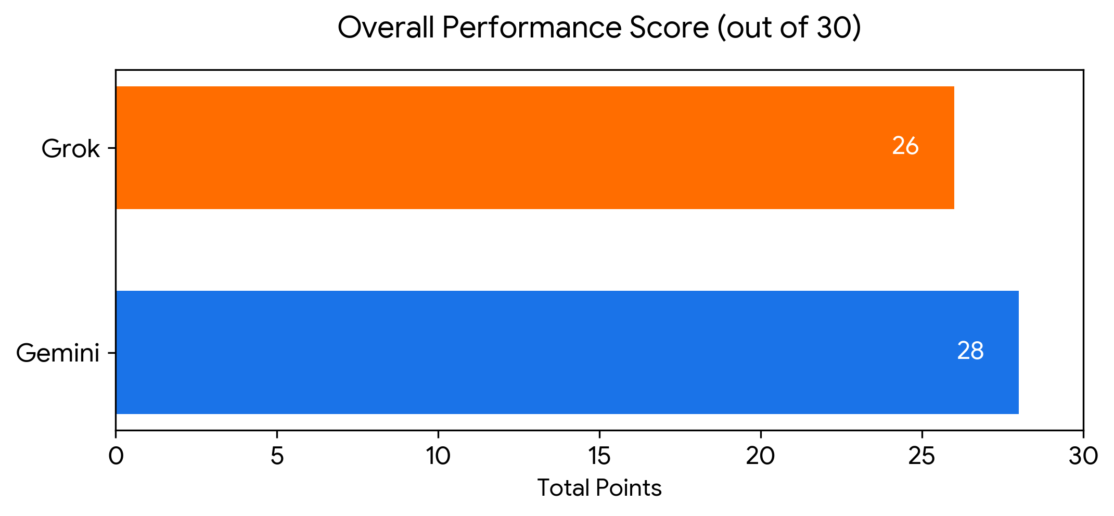

Chapter 6: Observations

6.1 Observation of Gemini
Strengths:
Highly accurate, logically structured, excellent reasoning, deep technical explanations, and produces output of academic report quality.
Weaknesses:
Responses can be lengthy; slightly slower response time compared to Grok.
Best Use Cases:
Academic writing, technical documentation, engineering assignments, and complex reasoning tasks.

6.2 Observation of Grok
Strengths:
Very fast response generation, highly creative, easy-to-understand language, and engaging writing style.
Weaknesses:
Slightly lower technical depth, less structured formatting, and occasional minor speculative examples.
Best Use Cases:
Quick learning, brainstorming, creative explanations, and rapid prototyping.

Chapter 7: Discussion
Prompt quality heavily influences AI responses; well-constrained prompts yield targeted, high-fidelity outputs. The use of identical prompts revealed stark architectural and alignment differences between the models. Gemini’s alignment favors safety and academic rigor, resulting in highly structured outputs. In contrast, Grok’s alignment favors speed and engagement, leading to creative but less rigorous outputs. These variations highlight the importance of model selection in engineering workflows. Understanding these limitations allows engineering students to critically evaluate AI outputs rather than accepting them at face value. The future scope involves integrating these tools directly into IDEs and research pipelines, where prompt engineering will become a fundamental engineering skill.

Chapter 8: Result
The experiment clearly demonstrated the distinct behavioral profiles of the two models.
Gemini obtained higher scores in Accuracy, Reasoning, and Engineering Usefulness. Grok obtained higher scores in Creativity and Speed.
The total score evaluation concluded with Gemini scoring 28/30 and Grok scoring 26/30.
Consequently, Gemini is declared as the better model for academic and engineering report generation.

Chapter 9: Conclusion
This experiment successfully achieved its objective of comparing the behavior and performance of different Generative AI models using identical prompts. By applying prompt engineering principles, the study evaluated Gemini and Grok across critical technical metrics.
The comparison outcome highlights that while both models are highly capable, they serve different functional paradigms. Grok excels in speed and creativity, making it ideal for ideation. Gemini, however, provides the depth, accuracy, and structured reasoning required for rigorous academic and engineering tasks. This study underscores the immense importance of Prompt Engineering; precise articulation of constraints and context is paramount to extracting valuable outputs from LLMs.
The advantages of AI-assisted learning are evident. These tools can rapidly synthesize complex topics, such as Transformer architectures and LLM scaling laws, serving as highly effective personalized tutors. However, they must be used responsibly. It is recommended that engineering students cross-verify AI outputs and utilize models like Gemini for final documentation, while leveraging faster models for preliminary research.
Future improvements in this domain could include testing prompts across a broader range of models (such as Claude or LLaMA) and integrating automated evaluation scripts using API endpoints to measure hallucination rates mathematically.

References
[1] OpenAI, "GPT-4 Technical Report," arXiv preprint arXiv:2303.08774, 2023.
[2] Google, "Gemini: A Family of Highly Capable Multimodal Models," Google DeepMind, 2023.
[3] A. Vaswani et al., "Attention Is All You Need," Advances in Neural Information Processing Systems, vol. 30, 2017.
[4] I. Goodfellow et al., "Generative Adversarial Nets," Advances in Neural Information Processing Systems, vol. 27, 2014.
[5] J. Ho, A. Jain, and P. Abbeel, "Denoising Diffusion Probabilistic Models," Advances in Neural Information Processing Systems, vol. 33, pp. 6840-6851, 2020.
[6] J. Kaplan et al., "Scaling Laws for Neural Language Models," arXiv preprint arXiv:2001.08361, 2020.
[7] L. Ouyang et al., "Training language models to follow instructions with human feedback," Advances in Neural Information Processing Systems, vol. 35, pp. 27730-27744, 2022.

