Share this link

[0](https://twitter.com/share?original_referer=https%3A%2F%2Fwww.certdepot.net%2F&source=tweetbutton&text=RHEL8+Identity&url=https%3A%2F%2Fwww.certdepot.net%2Frhel8-identity%2F&via=CertDepot)

[0](https://www.linkedin.com/cws/share?url=https://www.certdepot.net/rhel8-identity/)

**SSSD**

* **SSSD** connects Linux system to central identity stores (**IdM**, **AD**, **LDAP**)
* All information is cached locally for offline use
* Advanced integration with **IdM** and **AD**, integration with **Linux** (**SUDO**, **SELinux**, **2FA**)

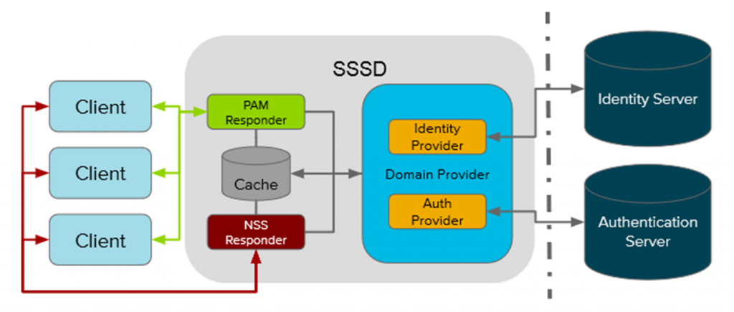

**Modules Evolution**

* **pam_pkcs11** is abandoned (upstream decision)
* **nss_ldap** & **pam_ldap** will be removed in next major release, bug fix only in **RHEL 8**
* **SSSD** introduces **Kerberos Credential Manager** service

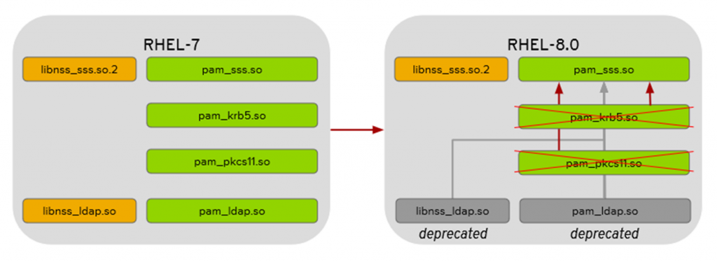

**Authselect**

* Brand new tool replacing **authconfig**
  + Main motivation: administrator no longer builds a PAM stack by a tool (potentially ending with broken configuration), but rather selects a tested PAM profile
  + Other motivations: authconfig was a dated component (initiated back in 1999), with no Python 3 support and deprecated GUI (Python 2.7 will EOL support in 2020)

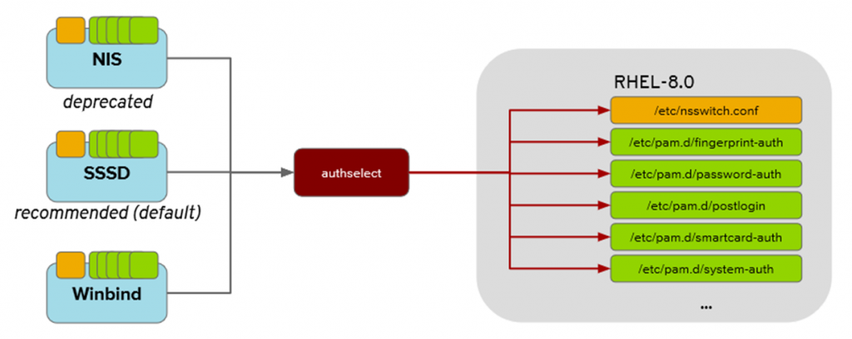

* Benefits
  + Properly tested profiles – lower risk of lock out
  + Clarity and quality – profiles are easy to read, modify and test
  + Custom profiles – allows administrator to create and ship own profiles in /etc/authselect/custom
  + Smaller footprint, written in C
* Scope: configures authentication and identity resources
  + Generates /etc/nsswitch.conf and PAM configuration from selected profile
  + Does not configure actual PAM modules, done by ipa-client-install, realmd, Ansible
* Compatibility: for applications, scripts and kickstarts that were relaying on the **authconfig**, there is now a wrapper around **authselect**
  + It is translating calls to authconfig into calls to **authselect**
  + Not all options are supported but the main ones are

1 Star2 Stars3 Stars4 Stars5 Stars (No Ratings Yet)

**https://www.certdepot.net/wp-content/plugins/calpress-event-calendar/img/widget_icon.png Upcoming Events (Local Time)**

1. **JAN**

**31**

**Fri**

* 1. [**9:00 am** - View Details  
     CentOS: Dojo, Brussels, Belgium.](https://www.certdepot.net/calendar/#action=calp_agenda&calp_item_id=151)

**RHCSA7: Task of the day**

Allowed time: 10 minutes.  
Create two new user accounts "steve" and "oliver".  
Create a group "team". Create a directory "shared".  
All files put into the "shared" directory by "steve" or "oliver" should belong to the "team" group and be only visible by them.

**RHCE7: Task of the day**

Allowed time: 10 minutes.  
Configure a system to forward all email to a central mail server at 192.168.1.1 (change the IP address accordingly).

**Recent Comments**

* Sam on [RHEL7: Configure IPv4 addresses and perform basic IPv4 troubleshooting.](https://www.certdepot.net/rhel7-configure-ipv4-addresses/#comment-44589)
* Donzello on [RHEL7: Configure IPv4 addresses and perform basic IPv4 troubleshooting.](https://www.certdepot.net/rhel7-configure-ipv4-addresses/#comment-44587)
* blumeout86 on [RHEL7: Produce and deliver reports on system utilization (processor, memory, disk, and network).](https://www.certdepot.net/rhel7-produce-deliver-reports-system-utilization-processor-memory-disk-network/#comment-44586)
* smstong on [RHEL7: Configure a system to authenticate using Kerberos.](https://www.certdepot.net/rhel7-configure-system-authenticate-using-kerberos/#comment-44582)
* CertDepot on [RHEL7: Produce and deliver reports on system utilization (processor, memory, disk, and network).](https://www.certdepot.net/rhel7-produce-deliver-reports-system-utilization-processor-memory-disk-network/#comment-44581)

**Recently Updated Pages**

* [OpenShift Articles](https://www.certdepot.net/openshift-articles/)
* [RHEL8 RHCSA (EX200)](https://www.certdepot.net/rhel8-rhcsa-ex200/)
* [RHEL8 RHCE (EX294)](https://www.certdepot.net/rhel8-rhce-ex294/)
* [RHEL8 Articles and videos.](https://www.certdepot.net/rhel-8-articles-and-videos/)
* [RHEL7: How to increase your typing speed.](https://www.certdepot.net/rhel7-increase-typing-speed/)
* [RHEL7: Configure a FreeIPA server.](https://www.certdepot.net/rhel7-configure-freeipa-server/)
* [RHEL8 RHCE What's new?](https://www.certdepot.net/rhel8-rhce-whats-new/)
* [RHEL8 RHCSA What’s new?](https://www.certdepot.net/rhel8-rhcsa-whats-new/)
* [RHEL7 Available online trainings](https://www.certdepot.net/rhel7-available-online-trainings/)
* [RHEL8 Changes](https://www.certdepot.net/rhel8-changes/)

**Follow me on Twitter**