1- Install CentOS /RHEL

2- What is the difference between cat and more command?

- Cat: Read files content

- More: The more command is a pager utility that allows you to view the contents of a file one screen at a time. It pauses after displaying one screenful of text, and you can navigate through the content using keyboard shortcuts.

3- The Difference between rm & rmdir:

- rm: to remove files or directories

- rmdir: to remove empty directories.

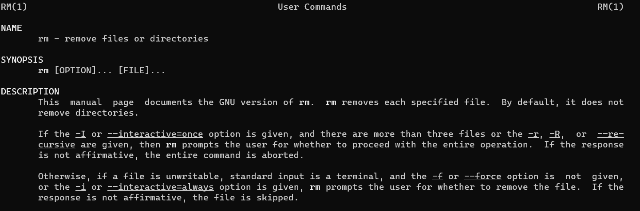

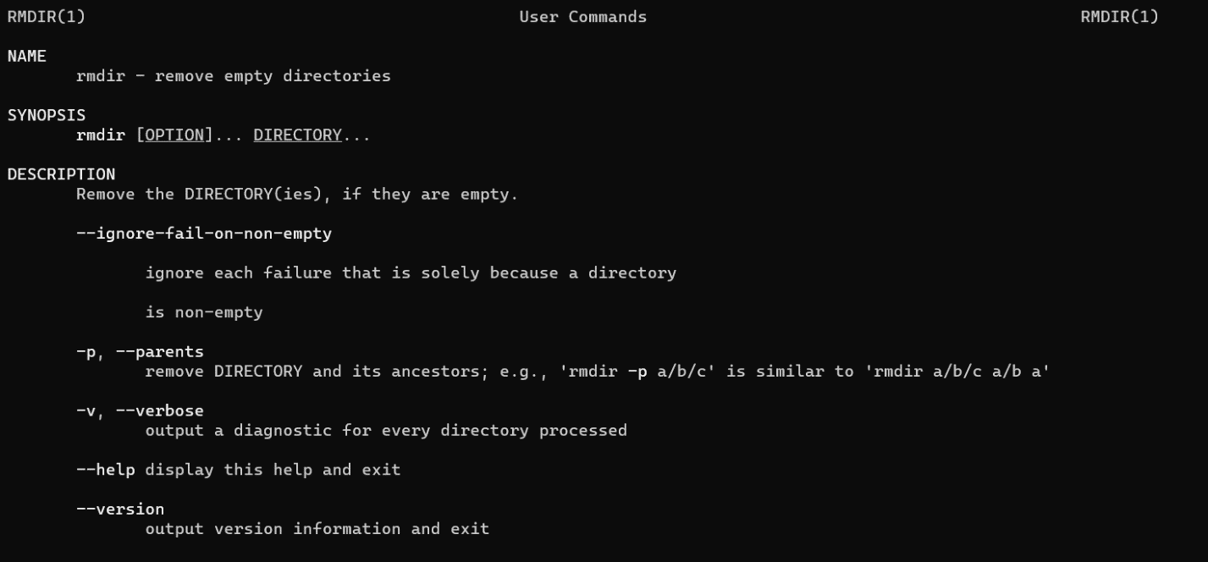

4- Create the following hierarchy:

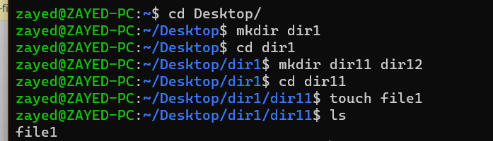

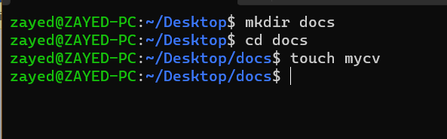

a- can't remove directory direct when it has files in, we can remove files inside first or use rm -r for recursive removing files and directory.

b- rmdir -p removed the dir12 directory along with it's parent (dir1) because it became empty after the removal of dir12.

c-

1- the absolute path: /home/zayed/Desktop/docs

2- relative path: /Desktop/docs

5- cp /etc/passwd /home/zayed/Desktop/mypasswd

6- mv mypasswd oldpasswd

7-

- cd

- cd ~

- cd $HOME

- cd -

8-

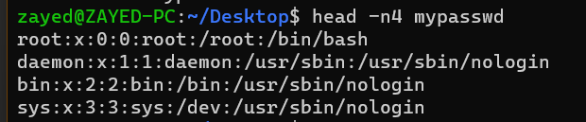

9-

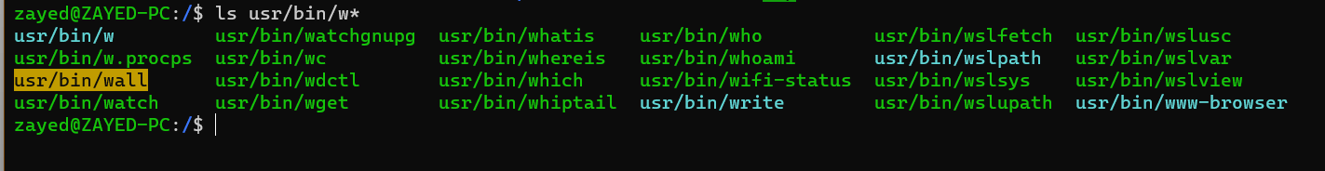

10-

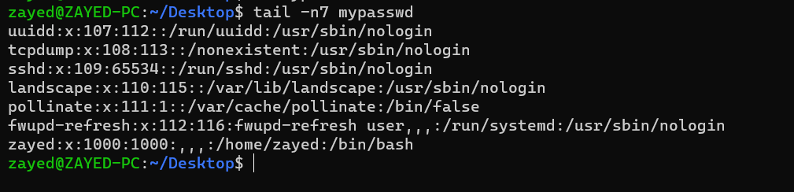

11- man passwd; man /etc/passwd

12- man /etc/passwd

13- man -K /etc/passwd