**1-** Write your CV:

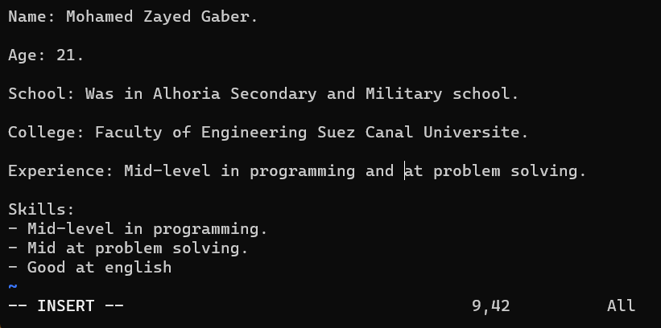

**2-**

**A- In command mode inside mycv we use [/Experience]**

**B- Esc + yy + p**

**c- i + [any words] + Esc + u**

**d- i + [your lines] + Esc + :q!**

**e- Esc + D**

**3-**

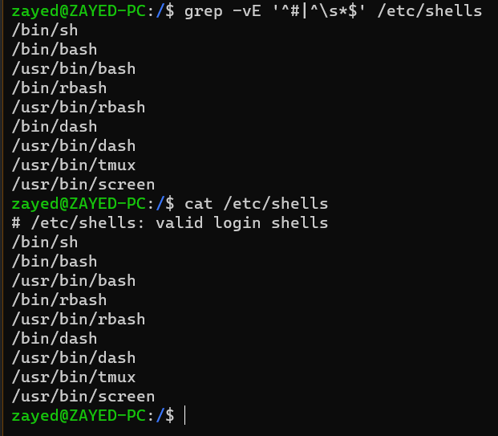

**4-** **printenv**

**5-**

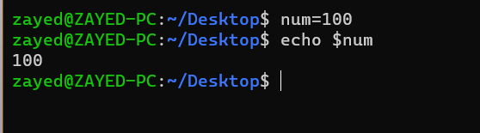

**7-** **history > /tmp/commands.list**

**9-** **!2033 > lastcommand**

**10-**

* **1- I used “find ~ -type f -name ".bash*” (because “.bash_profile” didn’t exist in my shell).**

2.1- **ls -R | sort 2> sorted_list1.txt --> expected error.**

2.2- **ls -R | sort &> sorted_list2.txt --> unexpected error.**

**11-** **id**

**12-**

* 1- **cat file1 | cat file2 --> the content of file 2 is displayed.**

* 2- **Error, must declare the operant**

* 3- **an error happened --> instead I used (wc -l /etc/passwd) and it printed 32.**