Assignment



Course Code: CSE 307

Course Title: Internet & Web Programming

Date: August 20, 2020

|  |  |
| --- | --- |
| Submitted to :   DR. TUSHAR KANTI SAHA Associate Professor,  Department of Computer Science &  Engineering  Jatiya Kabi Kazi Nazrul Islam University Trishal, Mymensingh-2220. | Submitted by :    Md. Zawharul Islam    B.Sc.(Eng.) in CSE  ID: 17102014  Session: 2016-17  Department of Computer Science &  Engineering  Jatiya Kabi Kazi Nazrul Islam University Trishal, Mymensingh-2220. |

**Jatiya Kabi Kazi Nazrul Islam University**

**Trishal, Mymensingh-2220**

**Bangladesh**

Work : Using foreach loop to show table rows.

Code:

<?php

$cars=array(

array("Volvo",22,18),

array("BMW",15,13),

array("Saab",5,2),

array("Land Rover",17,15)

);

echo"<table border='1px' cellpadding='10px' cellspacing='0px'>

<tr>

<th>Name</th>

<th>Stock</th>

<th>Sold</th>

</tr>";

foreach($cars as list($Name,$Stock,$Sold)){

echo"<tr>

<td>$Name</td>

<td> $Stock</td>

<td> $Sold</td>

</tr>";

}

echo"</table>";

?>

Notepad++ file :

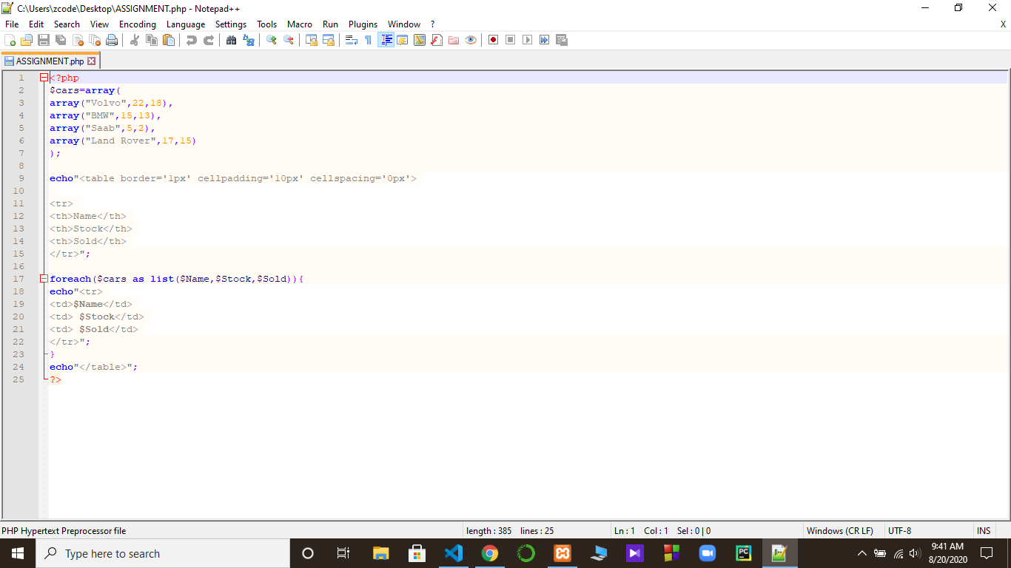

Output :

