Software Test Specification (STS)
Based on IEEE 829 – Adapted for Student Projects
Project Title: [University Lost and Found System]
Team Name & Members:
[Wesam Jaber Mohammed Almalki
Faris Mohammed Saeed Alshahrani
Ahmed Mohammed Ibrahim Albouainain
Fawaz Mohammed Saeed Alshahrani
Jaber Saleh Mohammed Alsaikhan
Mohammed Talal Hussain Altuwairqi
Fahad Nawar Mohammed Alotaibi]
Version: [1.0]
Date: [22-11-2025]

Table of Contents
- 1. Introduction
- 2. Test Items
- 3. Features to Be Tested
- 4. Features Not to Be Tested
- 5. Test Approach
- 6. Test Cases
- 7. Test Data
- 8. Test Environment
- 9. Responsibilities & Schedule
- 10. Deliverables
- 11. Appendices

1. Introduction
1.1 Purpose
The purpose of this Software Test Specification (STS) is to prescribe the scope, approach, resources, and schedule of the testing activities for the University Lost and Found System. This document serves as a guide for the testing team to verify that the system functions securely and effectively for the Imam Abdulrahman Bin Faisal University (IAU) community, ensuring it meets the requirements defined in the Software Requirements Specification (SRS).

It is intended for the following audience:
Testers/QA Engineers: To design and execute test cases.
Developers: To understand the testing criteria and fix defects.
Project Managers/Advisors: To monitor testing progress and quality assurance.

1.2 Scope of Testing
This STS covers the verification of the web-based platform, including the frontend interface, backend logic (Python/Flask), and database interactions (MySQL/SQLite/). The testing phases included in this scope are:

Unit Testing: Testing individual components and functions ( password hashing, category selection logic) to ensure code-level correctness.

Integration Testing: Verifying the interfaces between internal modules ( the interaction between the Reporting Form and the Database, or the Authentication System and the User Dashboard).

System Testing: Validating the complete, integrated application against the functional requirements, such as "Submit Lost Report," "Search for Item," and "Approve Item Report".

Acceptance Testing: Ensuring the system meets the needs of the user classes (Student, Employee, Administrator) and fulfills the project objectives.

Out of Scope:

Testing of third-party external integrations or payment gateways, as these are not part of the current system scope.

Physical security or hardware handling of lost items.

2. Test Items
The following software items and subsystems, defined in the Software Requirements Specification (SRS), are scheduled for testing:
2.1 Authentication Module:
The mechanism for user registration using university email addresses.
Secure login functionality for students, employees, and administrators.
Password hashing and secure session management.

2.2 Item Management Subsystem:
Lost Item Reporting: The interface and logic for submitting lost item details (description, category, location, date).
Found Item Reporting: The interface and logic for submitting found item details.
Image Upload Handling: The functionality to upload, store, and display item photos.
User Dashboard: The personal area for users to manage their own submitted reports.
2.3 Search and Discovery Module:
Public Dashboard: The main interface for viewing active lost and found listings.
Search Engine: The filtering logic allowing Guest and Authenticated users to search by item name, category, or date.
Category Filtering: The logic to group and retrieve items by defined categories (Electronics, Documents).
2.4 Claim and Verification Subsystem:
Secret Detail Verification: The logic that matches owners to finders using hidden verification details to prove ownership.
Claim Processing: The workflow for submitting a claim and tracking its status (pending, approved, rejected).
2.5 Communication Module:
Internal Chat Interface: The private, end-to-end messaging system connecting a verified Owner and Finder.
Notification System: Internal alerts informing users of status updates ( "claim initiated").
2.6 Administrator Subsystem:
Content Moderation: The interface for approving or rejecting new item reports before they go public.
Claim Review: The functionality for administrators to review and adjudicate claims if necessary.
2.7 Database Interface:

The persistent storage layer (MySQL/SQLite) managing records for Users, Items, Claims, and Messages.
.

3. Features to Be Tested
The following functionalities, derived from the Software Requirements Specification (SRS), will be tested to ensure compliance with the system design and user needs:
3.1 User Account Management
User Registration: Validation of university email format and unique user ID generation.
User Login: Authentication of Students, Employees, and Administrators using credentials.
Password Reset: Functionality to request a password reset via registered email.
Session Security: Verification of secure session handling and data encryption (SSL/TLS) during login.
3.2 Item Reporting & Management
Submit Lost Item: Validating inputs for item name, description, category, location, and date.
Submit Found Item: Validating inputs for found items, including contact information.
Image Upload: Verifying the ability to upload images and enforcing the 5MB size limit per image.
My Dashboard: Functionality for users to view and manage their own submitted reports (Lost/Found).
3.3 Search & Discovery
Guest Search: Ability for unauthenticated users to search and view public item listings.
Advanced Filtering: Searching items by specific criteria (Name, Category, Location, Date).
Category Display: ensuring items appear under correct categories ( Electronics, Documents).
3.4 Claims & Verification
Claim Submission: Process for an Owner to submit a claim for a Found item.
Secret Detail Verification: Logic to match the Owner’s "Secret Detail" with the Finder’s hidden information.
Claim Status: Tracking the status of a claim (Pending, Approved, Rejected).
3.5 Communication System
Internal Chat: Private messaging functionality between a verified Finder and Owner.
Notifications: System alerts for new claims, status changes, or received messages.
3.6 Performance & Reliability
Response Time: Verification that key actions (search, upload) complete within 3 seconds.

4. Features Not to Be Tested
The following features and functionalities are considered out of scope for this phase of testing and will not be verified:
Physical Logistics: The physical storage, custody, handling, or return of lost items is not part of the software testing scope.
External System Integrations: Integration with third-party marketplaces, external mobile applications, or campus security/surveillance systems.
External Notifications: Real-time email notifications or integration with external communication apps (Telegram bots).
Commercial Transactions: Any financial or payment-related features.
Advanced Administration: Comprehensive content moderation tools or monitoring dashboards beyond basic report approval.
Report Credibility: Verification of the accuracy or truthfulness of user-submitted reports regarding lost or found items.
Data Synchronization: Sharing or syncing data with external platforms or university databases beyond basic authentication.
Support Services: Dedicated help desk or support ticketing systems for lost items.

5. Test Approach
The testing strategy for the University Lost and Found System will utilize a combination of manual and automated testing methods to ensure the Python/Flask backend and the web-based frontend function correctly.
5.1 Testing Strategy
Black-Box Testing: This will be the primary strategy for System and Acceptance testing. Testers (QA Engineers) will validate the application against the specific requirements and Use Cases ("Submit lost report", "Search for item") without referencing the internal code structure.
White-Box Testing: This will be performed by the Lead Developer during Unit Testing to verify the internal logic of the Python code, such as the "Secret Detail" verification algorithm and password hashing functions.
Manual Testing: The majority of the User Interface (UI) testing will be manual, focusing on the responsiveness of the web portal and user workflows (Login, Dashboard navigation, Chat interface).
5.2 Levels of Testing
Unit Testing:
Focus: Verification of individual Python functions and classes within the Flask application.
Scope: Testing database models (Items, Users, Claims), utility functions (security hashing), and form validation logic.
Responsibility: Lead Developer.
Integration Testing:
Focus: Verifying the interaction between the Flask application logic and the MySQL/SQLite database.
Scope: Ensuring data is correctly created, read, updated, and deleted (CRUD) across the interface layers (e.g., submitting a report effectively updates the items table).
Responsibility: Developers and System Designer.
System Testing:
Focus: Validating the complete, integrated web portal against the Functional Requirements.
Scope: End-to-end scenarios such as "A user registers, logs in, posts a found item, and receives a claim request."
Responsibility: Tester/QA Engineer.
Performance Testing:
Focus: validating the Non-Functional Requirements.
Scope: Ensuring the system handles up to 200 concurrent users and responds within 3 seconds for fundamental functions.
5.3 Tools Used
The following tools will be utilized to support the testing activities, aligned with the project's development environment:
Test Management: Microsoft Excel / Word (for maintaining Test Case documents and Defect Logs).
Unit Testing Framework: Python unittest or pytest (standard libraries for testing Flask applications).
API Testing: Postman (to verify backend routes and HTTP responses before UI integration).
Database Verification: MySQL Workbench or DB Browser for SQLite (to verify data integrity directly in the database).
Web Automation (Optional): Selenium WebDriver (for automating repetitive UI login and search tests).
Performance Testing: Apache JMeter (to simulate 200 concurrent users for load testing).

6. Test Cases
Test Case  ID | Feature | Input | Expected Output | Actual Result | Pass/Fail
TC-01 | Login | Username=jaber, Password=jaber | User logged in | User logged in | Pass

Test Case  ID | Feature | Input | Expected Output | Actual Result | Pass/Fail
TC-02 | Login | Username=jaber, Password=1a2s3d | User logged in | User logged in | Fail

7. Test Data
The testing process will utilize the following datasets to verify functional and non-functional requirements:
7.1 User Account Data A set of mock user credentials will be created in the SQLite/MySQL database to test authentication and role-based access .
Valid Users: 5 dummy accounts representing Students and Employees with valid university email formats (e.g., 218000XXXX@iau.edu.sa) to test successful login and report submission .
Invalid Users: 3 accounts with incorrect password formats, unregistered emails, or locked statuses to test login error handling .
Administrator Account: 1 dedicated Admin account to test the "Approve/Reject Report" dashboard functions .
7.2 Item Report Data A collection of sample item records to populate the "Lost" and "Found" lists:
Lost Items: 10 sample reports including varied categories (Electronics, Documents, Accessories) with valid locations and dates .
Found Items: 5 sample found items that include the "Secret Detail" field ("Serial number on back") to test the ownership verification process .
Search Queries: A list of keywords ( "iPhone", "Blue ID Card") to verify the search algorithm's accuracy .
7.3 File Artifacts (Image Uploads) To verify the Non-Functional Performance Requirement regarding storage and upload limits :
Valid Images: A set of .jpg and .png images with file sizes below 5 MB ( 2MB, 4.5MB).
Invalid Images: A test file exceeding 5 MB ( 10MB) to verify that the system rejects the upload and displays an error message .
Unsupported Formats: A non-image file ( .pdf or .docx) to ensure the system restricts uploads to image formats only.

8. Test Environment
This section describes the hardware and software resources required to conduct the testing activities for the University Lost and Found System.
8.1 Hardware Requirements
The testing will be conducted on devices that represent the typical user environment, ensuring responsiveness and compatibility.
Client Devices:
Desktop/Laptop: Standard PC or Mac with a monitor capable of varying resolutions.
Mobile Devices: Smartphones or tablets (Android/iOS) to test the responsive mobile interface and touchscreen inputs.
Peripherals: Keyboard and mouse for desktop testing; integrated cameras or webcams for testing image uploads.
Server/Hosting:
The system will be hosted and tested on Localhost during development and PythonAnywhere for deployment testing.
8.2 Software Requirements
The following software configurations are necessary to run and test the application.
Operating Systems:
Windows, macOS, or Linux (the system is cross-platform compatible).
Web Browsers:
Current versions of major browsers: Google Chrome, Mozilla Firefox, or Microsoft Edge.
Database:
MySQL or SQLite (configured for the Flask backend).
Development & Testing Tools:
IDE: Visual Studio Code (VS Code) for code review and unit testing.

Framework: Python 3.x with Flask framework installed.
Libraries: Required Python libraries as defined in requirements.txt ( Flask-SQLAlchemy, Flask-Login).
8.3 Network & Connectivity
Internet Connection: Required for accessing the PythonAnywhere deployment and conducting end-to-end testing.
Authentication Simulation: A mock mechanism or simulated secure protocol to replicate the university login API for verification purposes.

9. Responsibilities & Schedule
Team Member | Project Role | STS Responsibility | Specific Testing Tasks
Jaber Alsaikhan | Tester/QA Engineer | Test Lead | Coordination of the STS, System Testing, and maintaining the Defect Log.
Ahmed Albouainain | Lead Developer | Unit Tester | Writing unit tests for backend logic (Python/Flask) and database connections⁴.
Fawaz Alshahrani | System Analyst | Test Design | Ensuring test cases cover all Use Cases (e.g., Login, Submit Report) defined in the SRS⁵⁵.
Wesam Almalki | Team Leader | Integration Tester | Verifying that the User Interface interacts correctly with the Database and Authentication APIs⁶.
Fahad Alotaibi | System Designer | UI Tester | Verifying the responsiveness of the front-end interface on mobile and desktop⁷.
Faris Alshahrani | Project Manager | Progress Tracker | Monitoring the testing schedule and ensuring the "Evaluation" deliverables are met⁸⁸⁸⁸.

Task ID | Task Description | Target Features | Responsibility | Status
T-01 | Unit Testing | Authentication (Login/Signup), Password Hashing, Database connectivity. | Ahmed & Fahad | Completed
T-02 | Integration Testing | ensuring "Submit Lost/Found Report" saves correctly to the MySQL/SQLite database¹³. | Wesam | Pending
T-03 | System Testing (User) | Testing the "Search" function and "Private Chat" interface between Finder and Owner¹⁴. | Jaber | Pending
T-04 | System Testing (Admin) | Testing the "Administrator" dashboard for approving/rejecting reported items¹⁵. | Jaber | Pending
T-05 | Performance Testing | Verifying the system handles image uploads (up to 5MB) and responds within 3 seconds¹⁶¹⁶¹⁶¹⁶. | Jaber & Fawaz | Pending
T-06 | Regression Testing | Re-testing fixed bugs (e.g., ensuring login works after password reset fixes)¹⁷. | All Members | Pending
T-07 | Final Report | Compiling the Test Cases Document and Defect Log for the final submission. | Jaber (QA) | Pending

10. Deliverables
The testing phase for the University Lost and Found System will produce the following documents and artifacts:

Test Cases Document (Specification):
A comprehensive document detailing inputs, execution steps, and expected results for all functional requirements and non-functional requirements
Test Execution Report:
A summary report showing the Pass/Fail status of executed tests. This will include screenshots of the Dashboard and Chat Interface as proof of testing.
Defect (Incident) Log:
A record of all bugs found during testing, including their severity, priority, and resolution status.
Test Data:
The set of dummy data used for testing, including:
Mock User Accounts: Student and Employee credentials for authentication testing.
Sample Images: Image files (under and over 5MB) to test the upload limits.
Secret Details: Sample hidden verification codes to test the claim validation process.
Test Summary Report:
A final evaluation report summarizing the quality of the software, total defects found/fixed, and the recommendation for release.

11. Appendices
Glossary
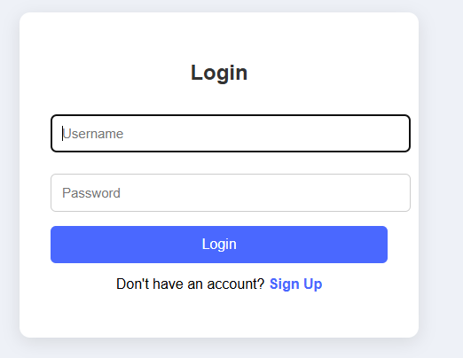
Login
from flask import Blueprint, render_template, request, redirect, url_for, flash, session
from werkzeug.security import check_password_hash
from database import db_connect
login_bp = Blueprint('login', name)
@login_bp.route('/login', methods=['GET', 'POST'])
def login():
if request.method == 'POST':
username = request.form['username']
password = request.form['password']
conn = db_connect()
c = conn.cursor(dictionary=True)
c.execute("SELECT * FROM users WHERE username=%s", (username,))
user = c.fetchone()
conn.close()
if user and check_password_hash(user['password_hash'], password):
session['user_id'] = user['user_id']
session['username'] = user['username']
return redirect(url_for('select_role'))
else:
flash("Invalid username or password")
<!DOCTYPE html>
<html lang="en">
<head>
<meta charset="UTF-8">
<title>Login</title>
<style>
body {
margin: 0;
font-family: 'Arial';
background: #eef1f7;
display: flex;
justify-content: center;
align-items: center;
height: 100vh;
}
.card {
background: white;
width: 380px;
padding: 35px;
border-radius: 12px;
box-shadow: 0 5px 20px rgba(0,0,0,0.1);
text-align: center;
}
h2 {
margin-bottom: 25px;
color: #333;
}
input {
width: 100%;
padding: 12px;
margin: 8px 0 16px;
border: 1px solid #ccc;
border-radius: 6px;
font-size: 15px;
}
button {
width: 100%;
padding: 12px;
background: #4a68ff;
color: white;
border: none;
border-radius: 6px;
font-size: 16px;
cursor: pointer;
}
button:hover {
background: #3d55d1;
}
p a {
color: #4a68ff;
font-weight: bold;
text-decoration: none;
}
p a:hover {
text-decoration: underline;
}
</style>
</head>
<body>
<div class="card">
<h2>Login</h2>
<form method="POST">
<input type="text" name="username" placeholder="Username" required>

<input type="password" name="password" placeholder="Password" required>
<button type="submit">Login</button>
</form>
<p style="margin-top: 15px;">Don't have an account?
<a href="/signup">Sign Up</a>
</p>
</div>
</body>
</html>
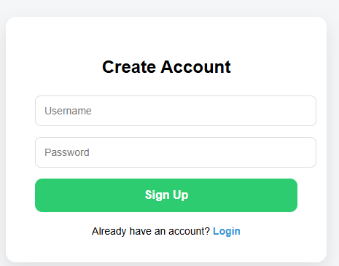
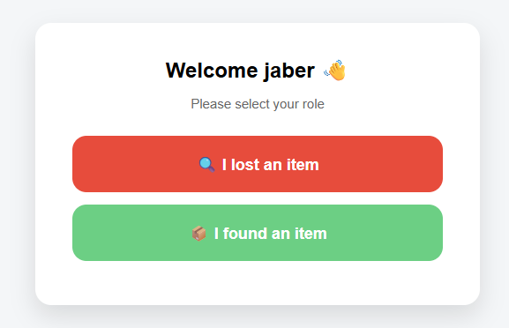
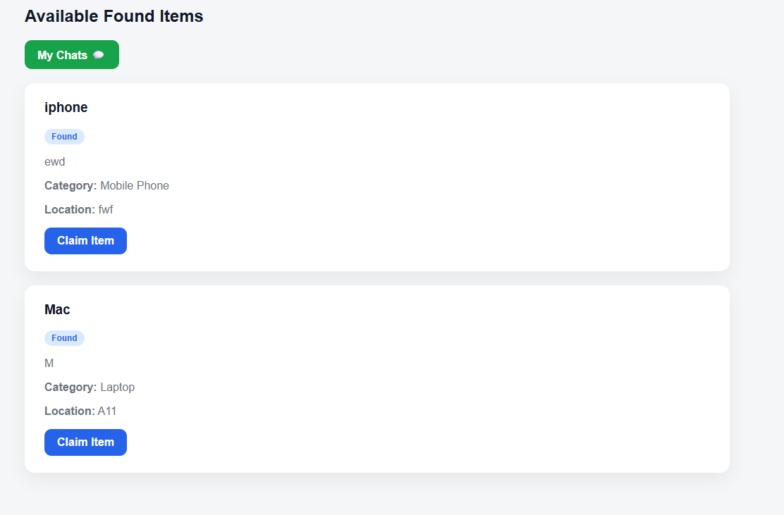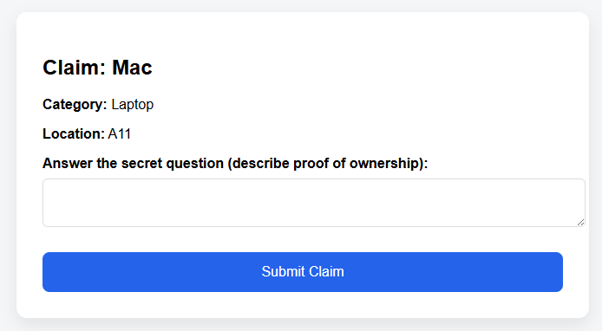
References
- IEEE Standard for Software Test Documentation (IEEE Std 829-1998).
- Sommerville, Ian, "Software Engineering," 10th Edition.

Evaluation

To be completed by the instructor or supervisor.
7. Project STS Report (12 points / 2 marks) – Week 15

Section | Excellent (Full Points) | Good (75%) | Fair (50%) | Poor (25% or below) | Points
1. Introduction (1 pt) | Purpose, scope, and references clearly stated. | Covers most but vague. | Minimal explanation. | Missing. | /1
2. Test Items (1 pt) | All modules/features listed clearly. | Most features listed. | Few features listed. | Missing. | /1
3. Features to Be Tested (1.5 pts) | Comprehensive list mapped to SRS/SDS. | Most key features covered. | Few features listed; weak traceability. | Missing. | /1.5
4. Features Not to Be Tested (0.5 pt) | Clearly explains out-of-scope features. | Partially explains. | Vague or incomplete. | Missing. | / 0.5
5. Test Approach (1.5 pts) | Clear strategy (levels, tools, methods). | Mostly clear, some gaps. | Very limited explanation. | Missing. | /1.5
6. Test Cases (3 pts) | Well-structured test case table with inputs, expected/actual outputs, pass/fail. Covers positive & negative tests. | Several test cases included, some incomplete. | Few test cases, weak structure. | Missing. | /3
7. Test Data (1 pt) | Relevant datasets defined (valid & invalid). | Some datasets defined. | Minimal test data. | Missing. | /1
8. Test Environment (1 pt) | Hardware/software clearly described. | Partial description. | Very minimal. | Missing. | /1
9. Responsibilities & Schedule (1 pt) | Clear team roles & testing timeline. | Some roles/schedule mentioned. | Very vague or incomplete. | Missing. | /1
10. Deliverables & Appendices (1.5 pts) | All deliverables listed; glossary & references included. | Most listed, minor gaps. | Minimal mention of deliverables. | Missing. | /1.5

Note: If a student is listed as a project member at the beginning of the STS but their contributions are not reflected (e.g., no assigned test cases, no role in responsibilities/schedule), that student will not be awarded the same score as contributing members.

