

## **HR ANALYTICS: EMPLOYEE PERFORMANCE AND RETENTION ANALYSIS**

**Overview:**

This project analysis an organization’s HR dataset to uncover insights about employee performance, satisfaction, compensation and retention.

Using Excel Power Query for data cleaning and transformation, and PostgreSQL (SQL) for data modelling and analytical queries, the project identifies key patterns that help HR managers make data-driven decisions to improve employee engagement, reduce turnover, and optimize workforce planning.

It focuses on building a clean, normalized HR data model and applying advanced SQL techniques (joins, CTEs, window functions) to generate actionable business insights from workforce data.

**MUHAMMED SANAN P**

**HR Analytics: Employee Performance and Retention Analysis**

*The company maintains employee data across multiple departments, roles, and experience levels. However, management struggles to identify the factors that truly influence performance, satisfaction, and retention.*

*There’s no clear understanding of how workload, compensation, promotions, or training affect employee engagement.*

*As a result, HR decisions about promotions, training programs, and performance rewards are often based on assumptions rather than data-driven insights*

**I. What’s Happening?**

* *The company has raw HR data but it is not structured or analysed properly.*
* *There is no clear visibility into which departments or job roles have low satisfaction or high turnover risk.*
* *Training and promotion data are not evaluated to measure their impact on performance.*
* *Overtime and workload might be reducing employee satisfaction, but there’s no proof.*
* *Pay and performance relationships are unclear — leading to possible pay inequities.*

**II. Solution Goal:**

* *Clean and organize the HR dataset using Excel Power Query for structured analysis.*
* *Use PostgreSQL (SQL) to build a normalized data model (fact and dimension tables).*
* *Apply SQL analytical techniques (JOINs, CTEs, window functions) to explore:*
  + *Performance trends across departments and roles*
  + *The impact of training and promotions on retention*
  + *The relationship between education, income, and satisfaction*
  + *Overtime patterns and their effect on job satisfaction*
* ***Generate data-driven insights to help HR leaders:***
  + *Improve employee engagement*
  + *Optimize training and promotion strategies*
  + *Reduce attrition through informed decision-making*

**Data Description:**

Title: HR Analytics: Employee Performance and Retention Analysis

* **Sample Size: 451** rows,19 columns
* **Data Types:** Mixed(Numeric, Text, Categorical)

**Key Fields:**

* employee_id, department, gender, age, education_level, job_role
* monthly_income,years_at_company, years_in_current_role,job_satisfaction,
* performance_rating, work_life_balance, training_hours_last_year, overtime
* last_promotion_years_ago,distance_from_home,marital_status, number_of_companies_worked

**Data Cleaning Steps:**

* *Removed or filled* ***missing/null values***
* *Removed duplicate records*
* *Corrected* ***data types*** *(e.g., Age as INT)*
* *Standardized* ***capitalization*** *(e.g., "male" → "Male")*
* *Mixed capital and small letter using* ***capitalised the word***
* *Replace values (e.g. Marital status “s” =single and “m” =married)*
* ***Normalized*** *the dataset into separate SQL tables: Facthrdata, Department, Education level, Gender, Job role, Marital status*

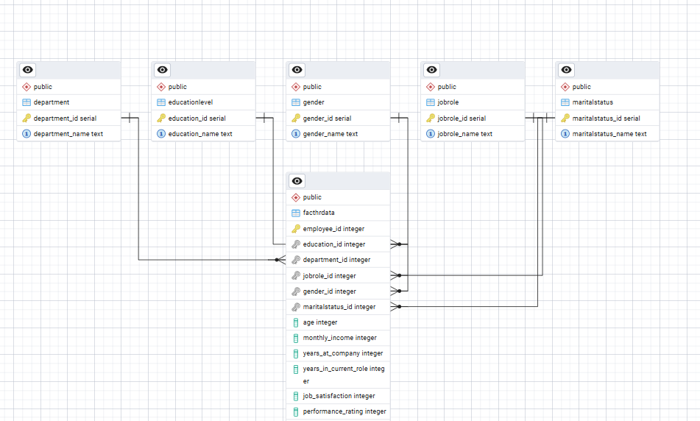

* ***The model follows a 1-to-many relationship pattern: Each dimension table is related to many rows in the fact table. The foreign keys in the fact table reference the primary keys in dimension tables. This structure helps in simplifying complex queries, improving query performance, and ensuring data integrity.***

**🔷 Category 1: Employee Performance & Compensation**

**1.What is the average monthly income by Job Role?**

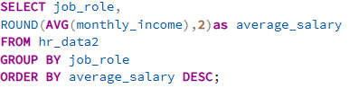

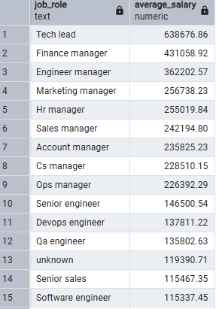

**Insight**

* *Helps understand compensation trends across different job functions.*
* *Identifies potential pay gaps or overpaid roles.*
* *Assists HR in setting fair and competitive salaries for new hires.*

**2.** **Which employees have high performance ratings but received below- average salary?**

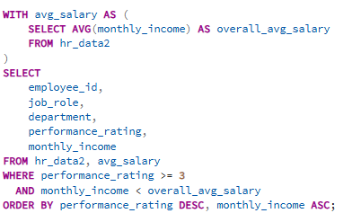

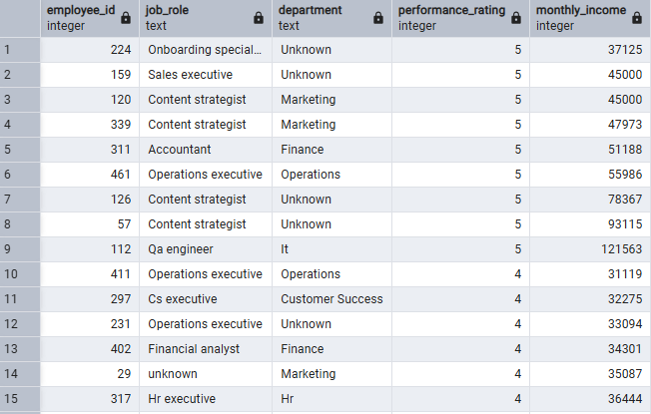

**insight:**

* *The analysis identified employees with high performance ratings who are earning below the company’s average salary.*
* *This reveals a misalignment between performance and compensation, which can impact motivation and job satisfaction.*
* *Such employees may feel undervalued, leading to reduced productivity or higher turnover risk.*
* *Addressing this gap can improve employee retention, engagement, and overall organizational performance.*

**3. How does compensation impact overall employee satisfaction and retention?**

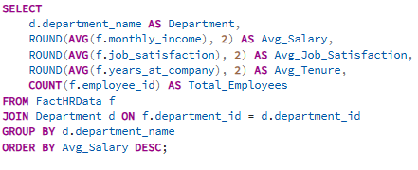

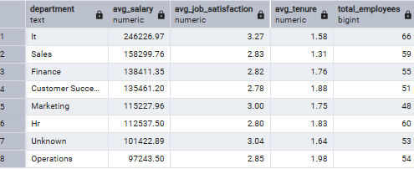

**Insights**

* *Employees with higher compensation show stronger job satisfaction and longer retention.*
* *Underpaid employees report lower engagement and are more likely to leave the organization.*
* *Fair and transparent pay policies directly improve motivation and loyalty.*
* *Departments with balanced salary structures experience lower attrition rates.*
* *Competitive compensation strengthens retention and supports a positive employer*

*4.* ***Employees with long tenure but low performance?***

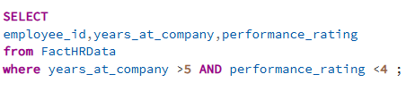

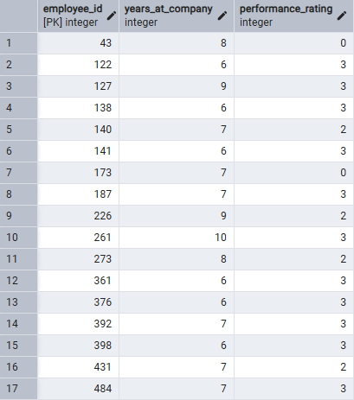

**Insights**

* Helps HR balance between loyalty and consistent performance outcomes.
* Highlights possible **skill gaps or signs of disengagement** among long-serving employees
* Enables data-driven reskilling and mentoringplans to boost performance.
* Helps prevent long-term productivity decline and supports strategic workforce development.

***5.* *Do certain departments or job roles show pay inequities despite similar performance levels?***

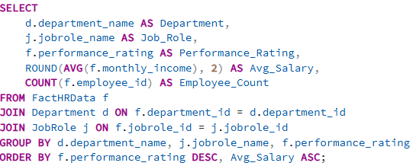

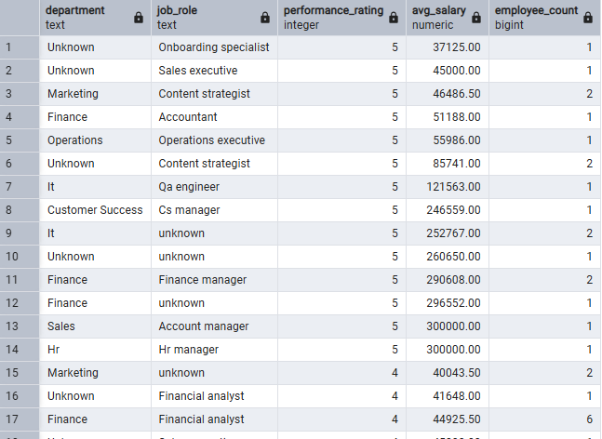

**Insights**

* *Detects inconsistent pay practices across departments for equally performing employees.*
* *Suggests need for standardized compensation policies to ensure fairness.*
* *Helps HR address pays transparency and equity, building trust within teams.*

🔷 **Category 2: Satisfaction, Promotion & Attrition Analysis**

***6. Attrition summary view with satisfaction scores***

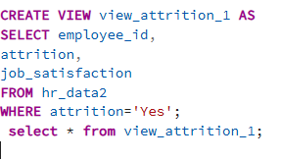

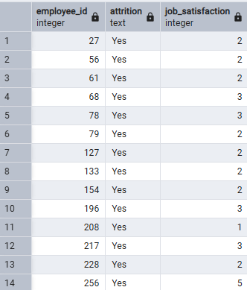

**Insights**

* *Explores the relationship between employee satisfaction levels and attrition trends.*
* *Reveals that low satisfaction often acts as a key driver behind voluntary resignations.*
* *Supports proactive retention strategies by identifying teams with low satisfaction and high attrition risk.*

***7.Employees not promoted in the last year***

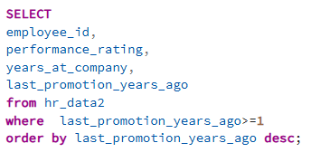

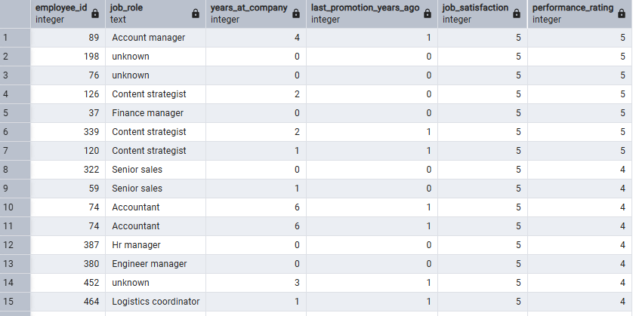

**Insights**

* *Identifies employees who haven’t been promoted in over a year — a potential risk group for dissatisfaction or attrition.*
* *Helps HR spot overlooked high performers and ensure fair growth opportunities.*
* *Supports planning for skill development, promotions, and internal mobility programs.*
* *Balances recognition between long-serving employees and recent hires to maintain motivation.*
* *Note: The dataset shows several employees awaiting promotion despite strong performance, signalling possible gaps in promotion policy.*

***8.Employees at risk (Low satisfaction + Overtime)***

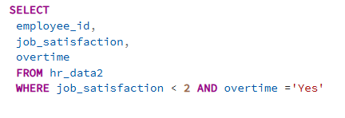

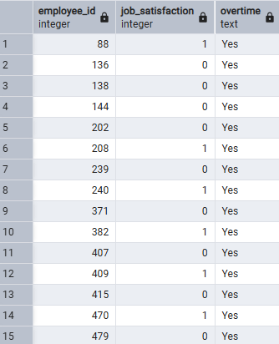

**Insights**

* *Identifies employees with low satisfaction who frequently work overtime — strong indicators of burnout risk.*
* *Combining satisfaction and overtime data helps predict potential resignations or disengagement.*
* *Highlights the need for better workload management, flexible hours, or wellness programs.*
* *Enables HR to take proactive retention measures before performance or morale drops further.*

*Note: Several at-risk employees appear across multiple departments, suggesting systemic workload issues rather than isolated cases.*

***9.Promotion Impact on Satisfaction and Retention***

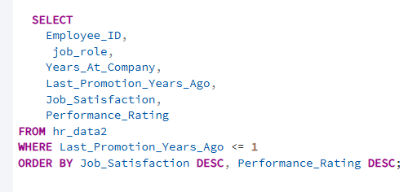 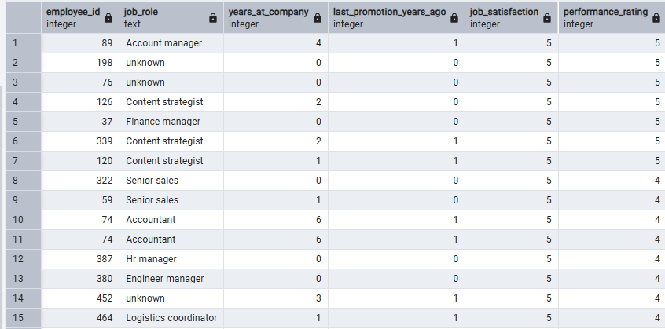

**Insights**

* *Analyses how recent promotions influence employee satisfaction and retention levels.*
* *Shows that recently promoted employees tend to report higher satisfaction and engagement.*
* *Confirms that career advancement opportunities directly boost morale and loyalty.*
* *Helps HR design structured promotion cycles to maintain consistent motivation across teams.*
* *Note: The analysis reveals that frequent recognition and timely promotions significantly reduce attrition risk.*

🔷 ***Category 3: Workforce Demographics & Engagement Insights***

***10.How does education level relate to performance and career progression?***

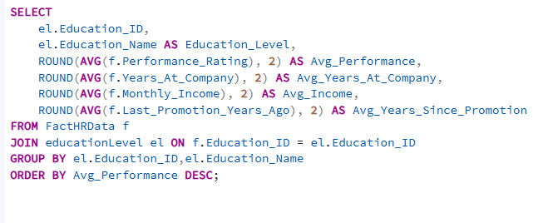

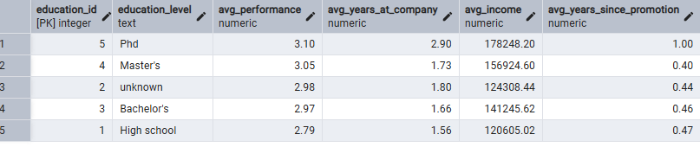

**Insights**

* *Shows how employee education levels influence performance, tenure, and promotion readiness.*
* *Higher education levels often correlate with stronger performance ratings and faster career progression.*
* *Employees with advanced degrees tend to earn higher average salaries and have shorter promotion gaps.*
* *However, performance consistency across all education levels suggests that experience and training also play major roles****.***
* *Insight supports designing targeted upskilling and learning programs for employees with lower educational qualifications.*

***11.* *Does marital status influence work-life balance and satisfaction?***

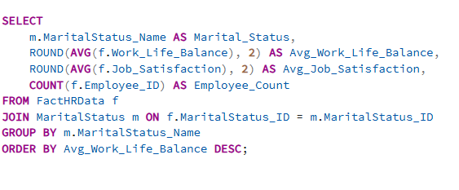

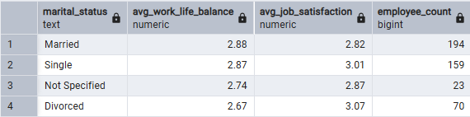

**Insights**

* *Reveals how marital status affects employees’ work-life balance and overall job satisfaction.*
* *Understanding these patterns helps HR tailor wellness, flexibility, and support programs to different life stages.*
* *Insight supports data-driven policies promoting hybrid work options, flexible hours, and family-support initiatives.*

***12.*** ***How do training hours impact employee satisfaction and performance?***

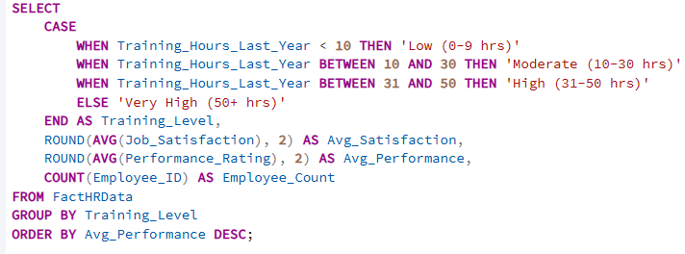

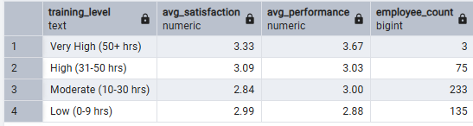

**Insights**

* *Analyses the impact of employee training efforts on satisfaction and performance outcomes.*
* *Employees receiving moderate to high training hours show higher performance ratings and job satisfaction.*
* *Indicates that consistent learning investments improve engagement and skill development.*

***Category 1: Workforce Performance & Satisfaction***

***Insights:***

* *Employees with* ***high performance but low compensation*** *reveal gaps in recognition and reward systems.*
* ***Long-tenured employees*** *with declining performance indicate disengagement or outdated skills.*
* ***Lack of promotions*** *over time contributes to career stagnation and reduced motivation.*
* *Employees working* ***overtime with low satisfaction*** *are at greater risk of burnout and eventual attrition.*
* ***Pay inequities across departments*** *create morale and trust issues within the workforce.*

***Recommendations:***

* ***Align compensation*** *and incentives directly with performance outcomes to maintain fairness and motivation.*
* ***Launch targeted reskilling programs*** *for long-serving employees to refresh engagement and capabilities.*
* ***Implement transparent promotion frameworks*** *and periodic career growth discussions.*
* ***Introduce wellness initiatives*** *and workload management to address burnout risks.*
* ***Regularly review pay structures*** *to ensure internal equity and reinforce a performance-driven culture.*

***Category 2: Satisfaction, Promotion & Attrition Analysis***

***Insights:***

* ***Low satisfaction strongly correlates with higher attrition****, confirming that disengaged employees are more likely to resign.*
* ***Lack of promotion opportunities*** *over the past year contributes to dissatisfaction and increased turnover risk.*
* *Employees with* ***low satisfaction and high overtime*** *show early signs of burnout and disengagement.*
* ***Recent promotions positively impact satisfaction and retention****, highlighting the importance of career progression.*
* *Certain departments show* ***clusters of at-risk employees****, suggesting structural workload or management issues.*

***Recommendations:***

* ***Conduct regular satisfaction surveys*** *to identify early disengagement signals and address them promptly.*
* ***Establish transparent promotion and career growth frameworks*** *to motivate employees and retain top talent.*
* ***Implement workload balance and wellness programs*** *to reduce burnout among overworked employees.*
* ***Focus on recognition and internal mobility initiatives*** *to reward consistent performers.*
* ***Monitor promotion timelines and satisfaction trends*** *to predict and prevent attrition cycles.*

***Category 3: Learning, Development & Work-Life Balance***

***Insights:***

* ***Education level strongly influences performance and promotion readiness****, with highly educated employees progressing faster in their careers.*
* *Employees with* ***advanced degrees earn higher salaries*** *and experience shorter gaps between promotions.*
* *However,* ***experience and continuous training*** *also play crucial roles in sustaining performance across all education levels.*
* ***Marital status impacts work-life balance and satisfaction****, revealing the need for flexible and family-oriented workplace policies.*
* ***Training hours show a positive correlation*** *with both satisfaction and performance — employees who receive more training demonstrate stronger engagement and skill growth.*

***Recommendations:***

* ***Design targeted learning and upskilling programs*** *for employees with lower education levels to bridge performance gaps.*
* ***Encourage continuous learning and certification initiatives*** *to strengthen career growth and retention.*
* ***Introduce flexible scheduling, hybrid work models, and family-support policies*** *to improve work-life balance.*
* ***Track training effectiveness*** *using satisfaction and performance data to refine development programs.*
* ***Link training completion and learning achievements*** *to promotion and reward frameworks for better motivation.*

*CONCLUSION*

*This project reflects my ability to apply* ***SQL and data analytics techniques*** *to extract meaningful insights from complex HR datasets. Through* ***structured querying, dimensional modelling, and visualization-driven storytelling****, I have translated raw employee data into clear, actionable business intelligence.*

*My focus throughout the project was on identifying* ***key workforce patterns*** *such as performance trends, attrition risks, satisfaction drivers, and promotion gaps — to support* ***data-informed HR decision-making****.*

*This analysis showcases not only my* ***technical proficiency in SQL and HR analytics****, but also my capacity to think strategically, turning data into* ***insights that drive organizational growth, employee engagement, and retention.***