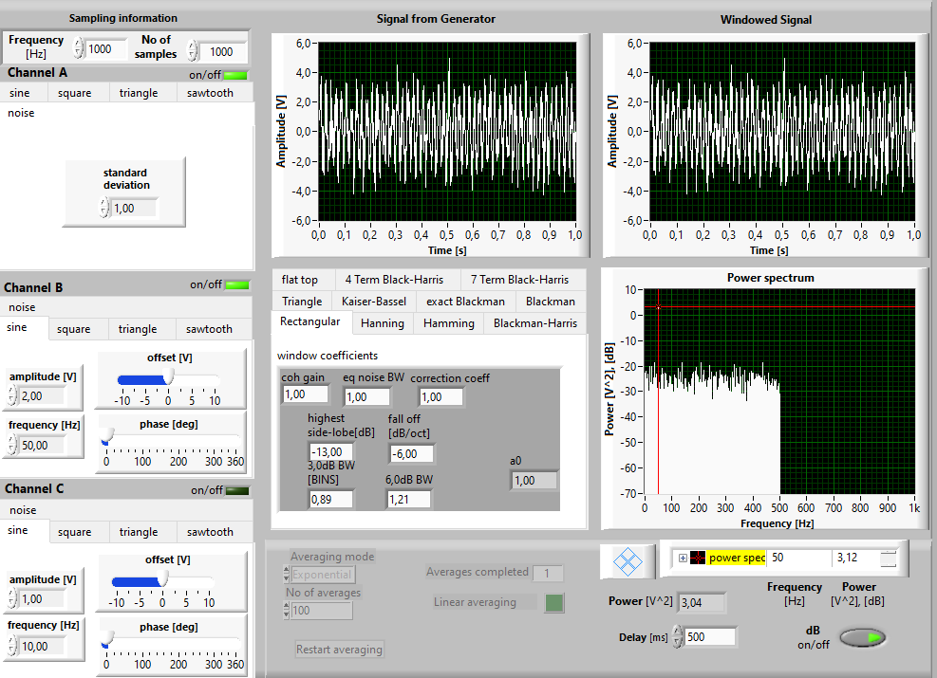

It doesn;t exceed 500 hunderders

Because the sampling frequcncy is 1000 and the spectrial resoltion is determind by

f=sampling frequcny/2

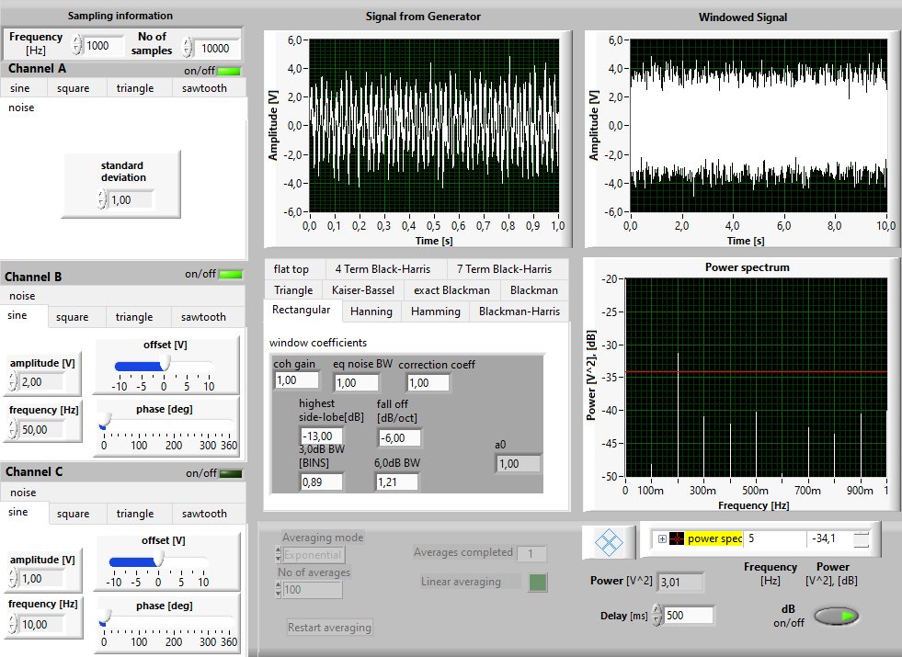
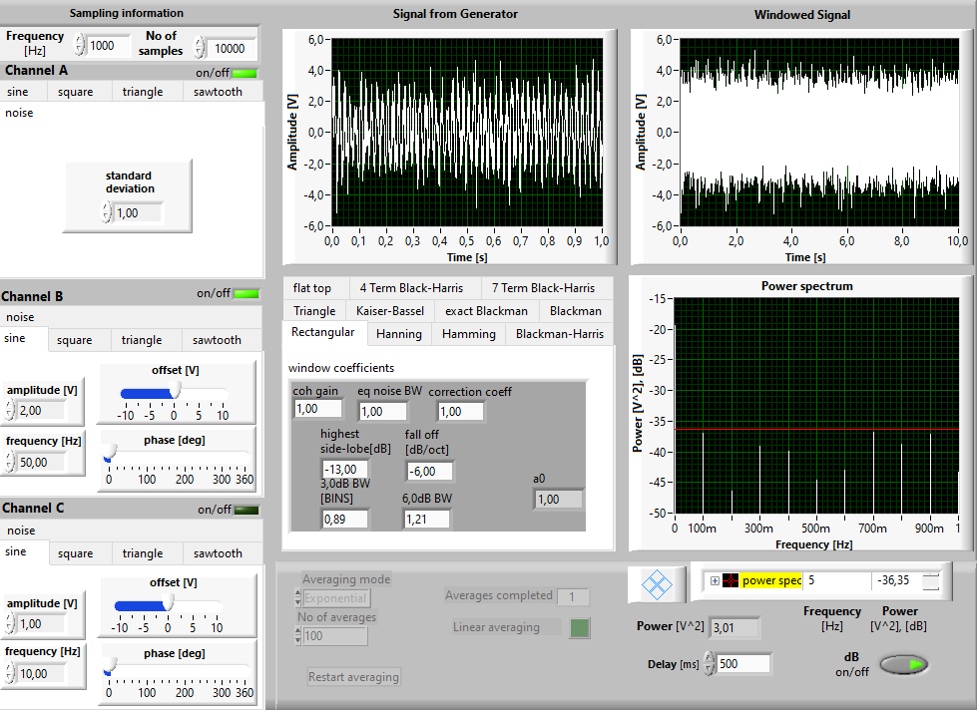

AS IT IS CLEAR IN THE PICTURE WHEN THE NO OF SAMPLES IS 10K THE RESULUTION IS 100mHz. But when I change the no of simples to 20k the resulution changes to 50m Hz

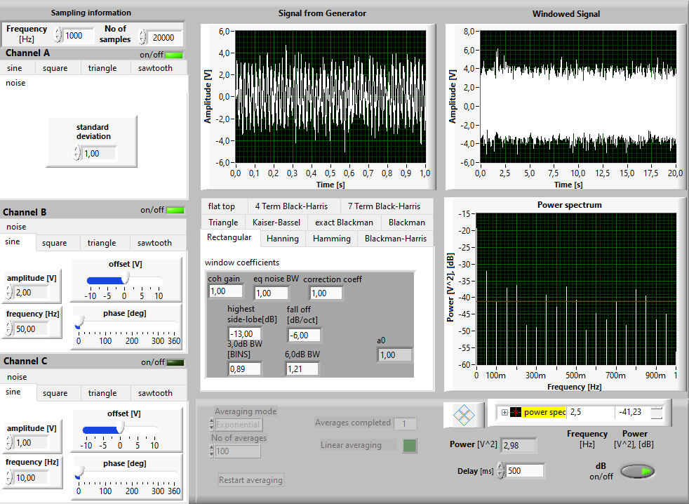
As well as if we change the frequency of the sampling the resulationi changes,

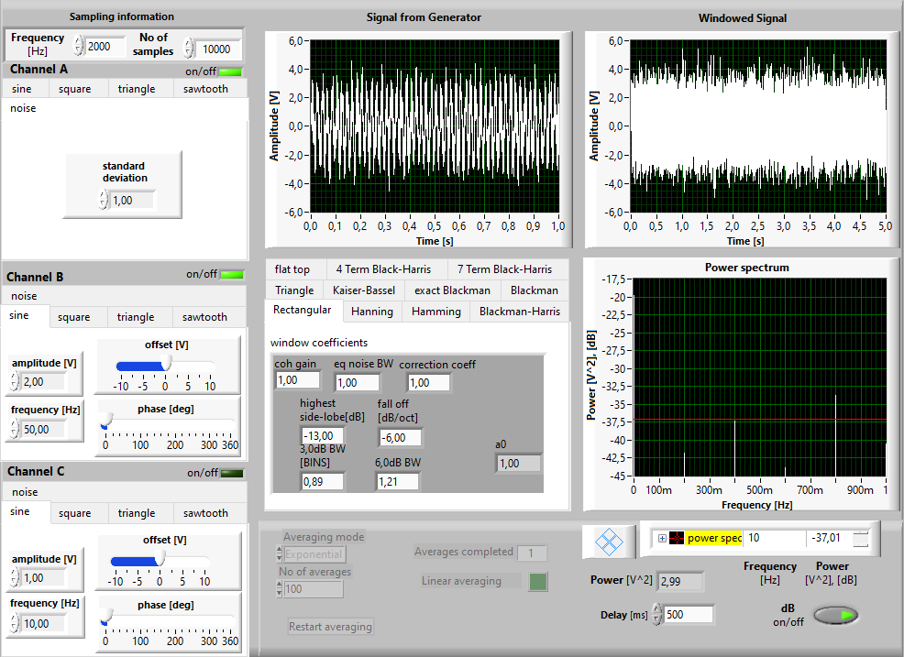

when the frequcny is 1k the resultion is 100mHz but when I increase the frequcy of the samples to 2k the resultions changes to 200mHz

in order to increase the resulotion:
increase the number of samples N (longer signal duration).
Decrease the sampling frequency fs​ (but this must be done carefully to avoid aliasing).

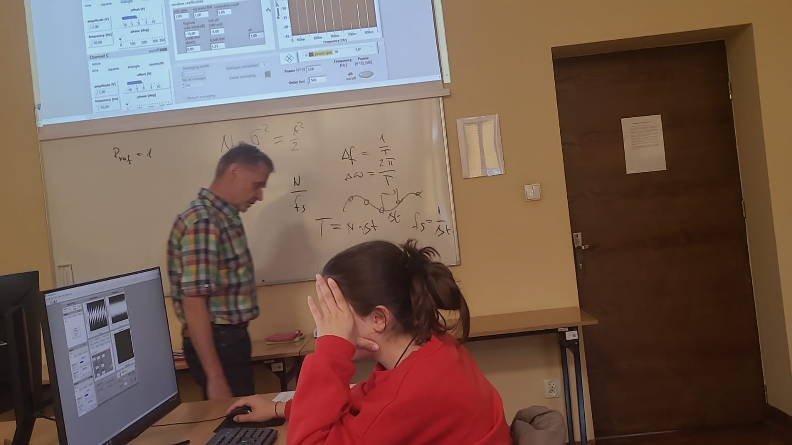

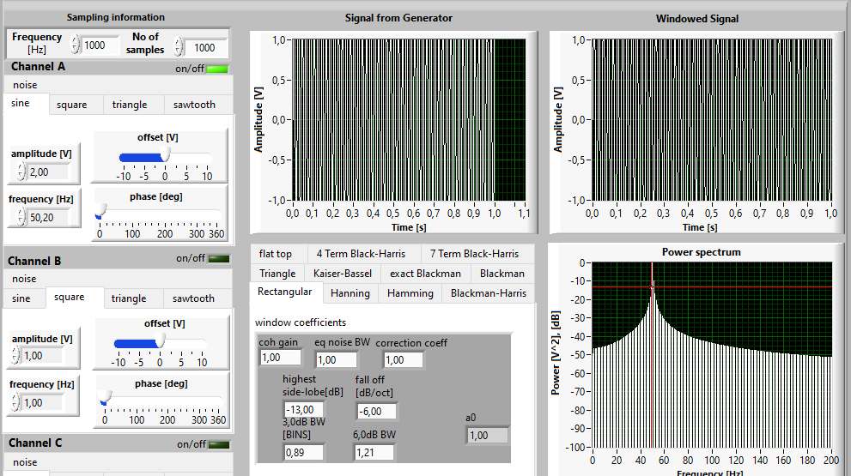

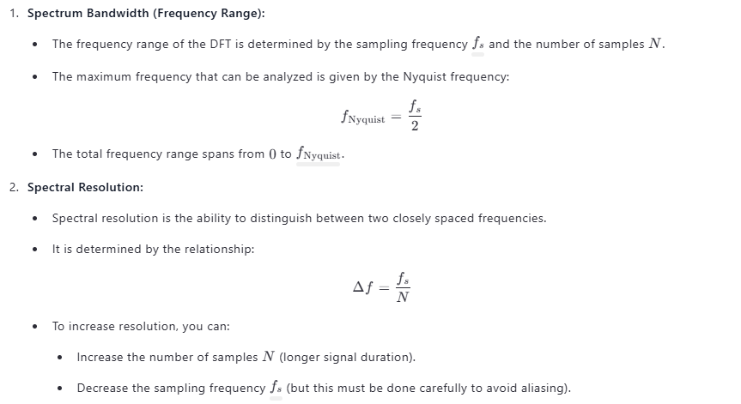

C)
we have to get an integer scyles to get a one peak

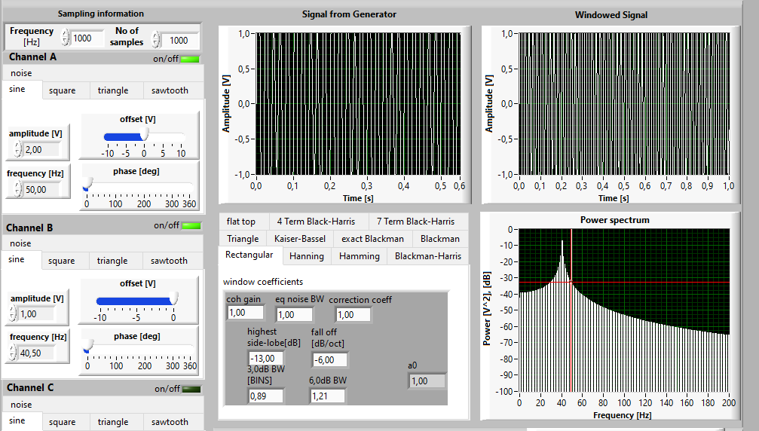

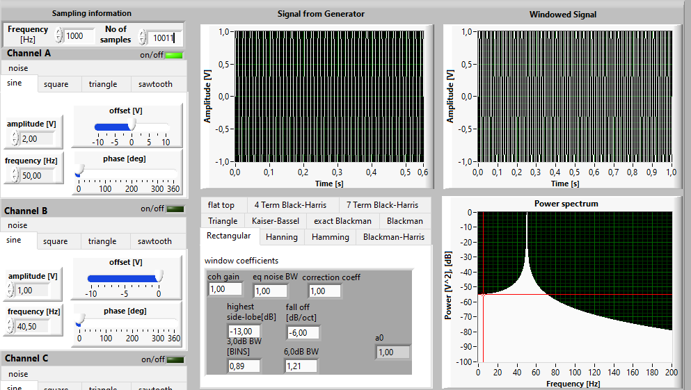
generate leakage first and then apply aonther window
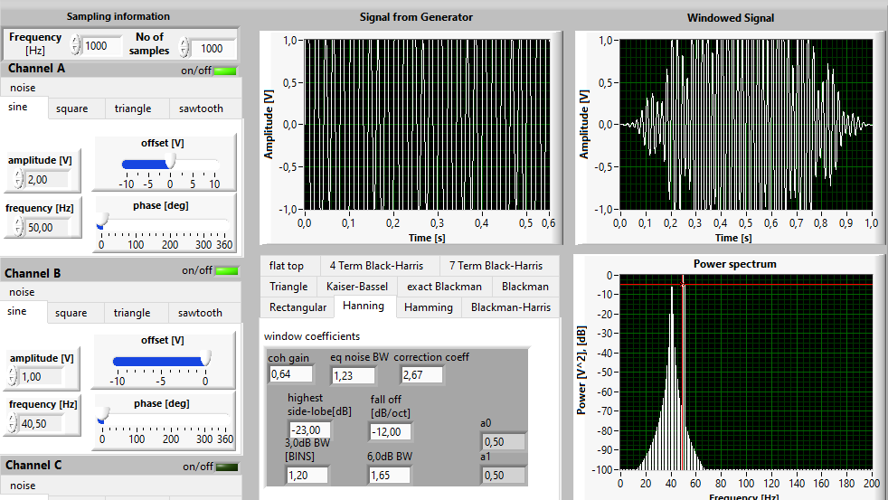
we can chagnge the number osd samples or the frequcny

