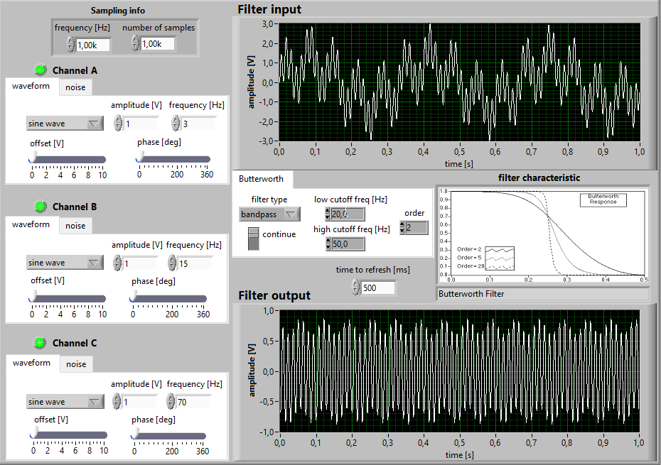
Exercise B:Analyse the the influence of filtering(its type and settings) on polyharmonic csignal composed of 3 sine waves
these are my setting for this
first the middle channel:
second: I want to keep the keep just the first channel and ignore the middle and the highest one so I will use the low pass
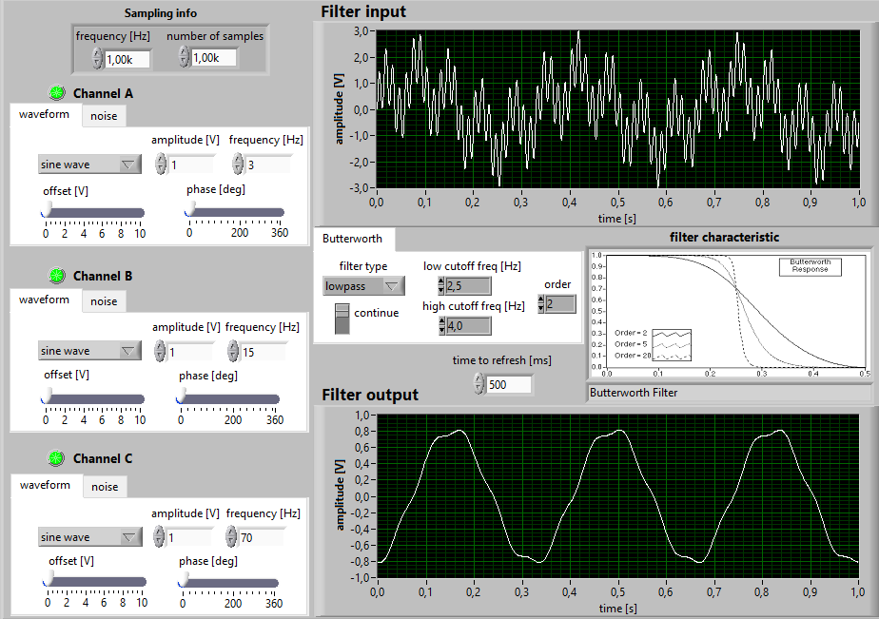

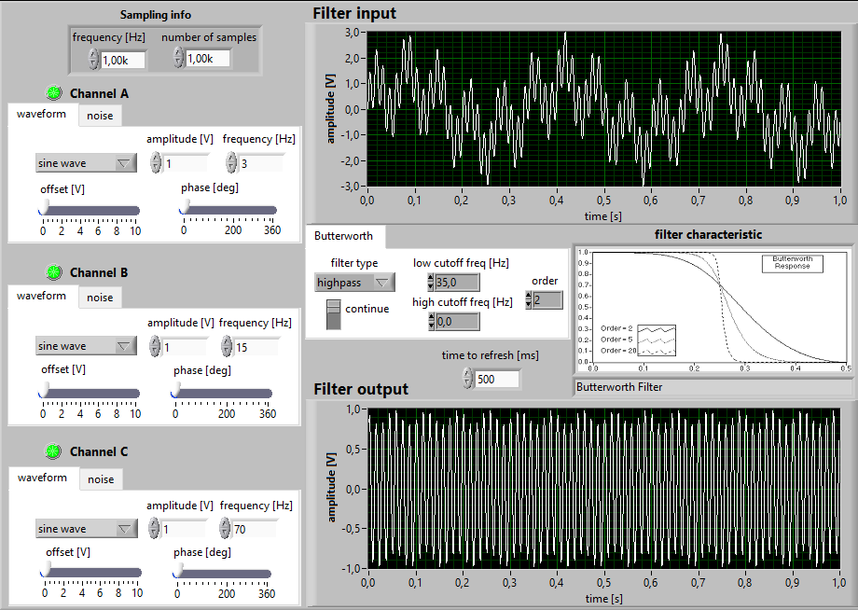
I want to keep thejust the highest one
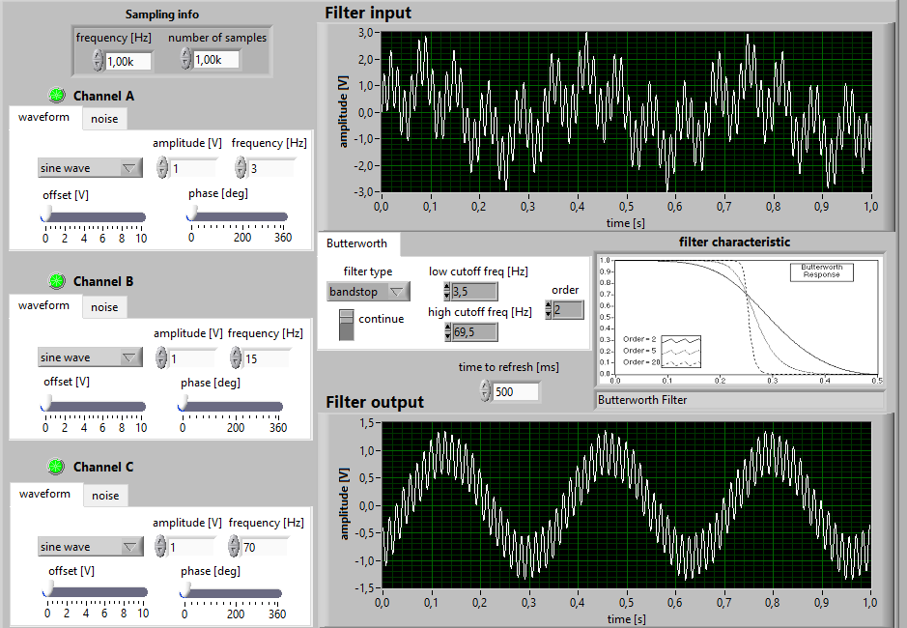
now I want to keep the lowest and the highest, so I need to performance the bandstop

now I want to keep just the middle channel so I need to use the bandpasss
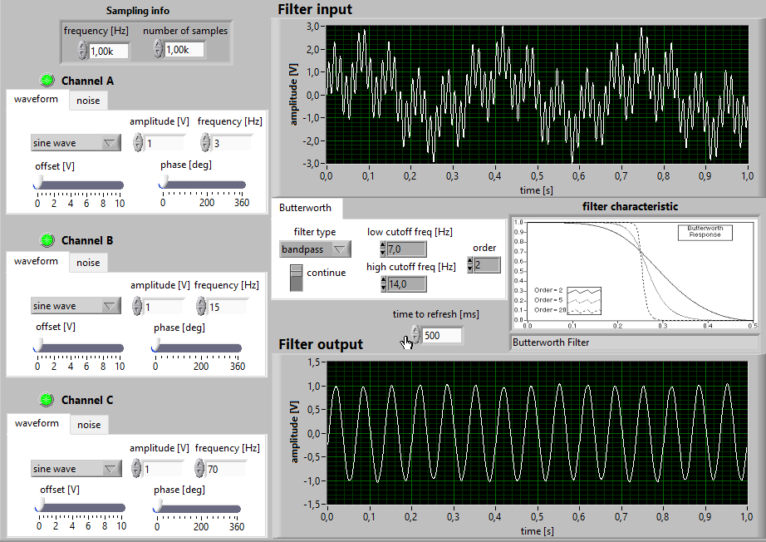

C) analyse the influence3 of the setting of a low pass filter on the square wave filtering

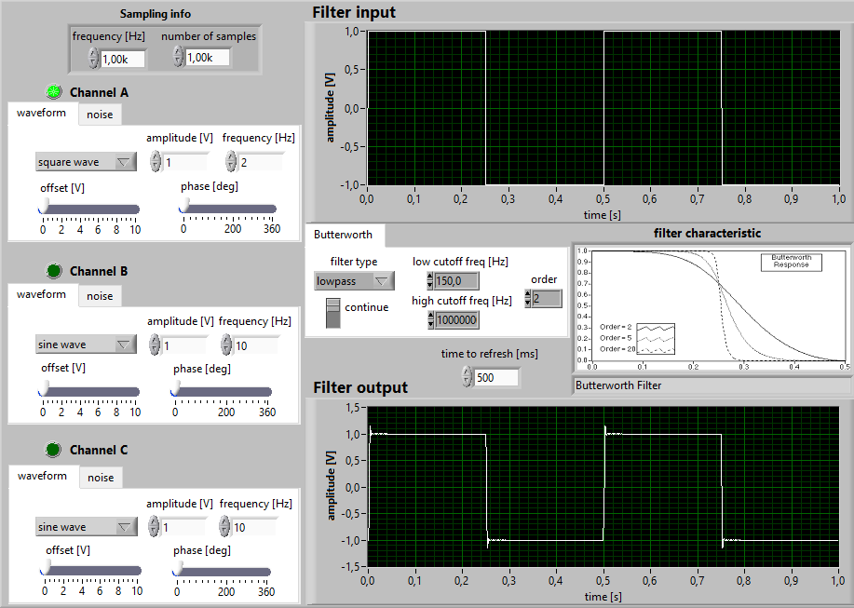

so when we reduce the low cutoff frequance we get a similar to the sine wave
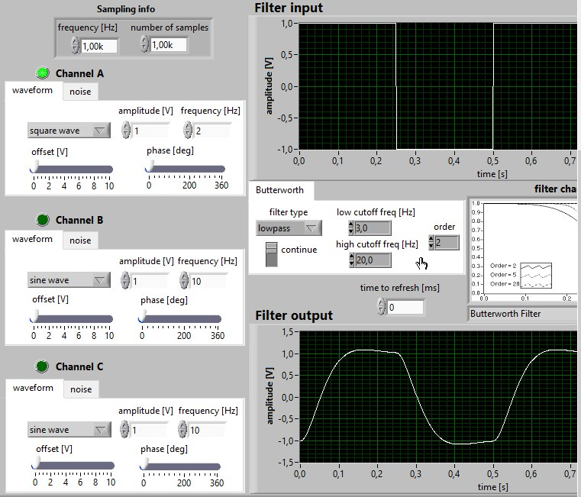

And when we reduce more low pass filetering to almost the zero we get the sine wave shape
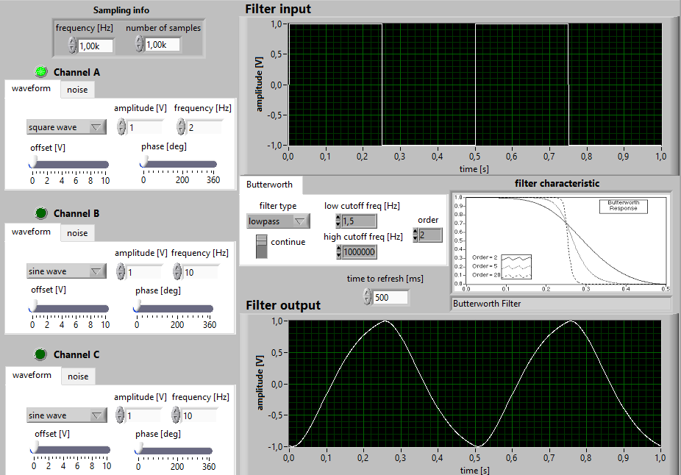

And as we can see the the square wave is orginaly sine wave…………..

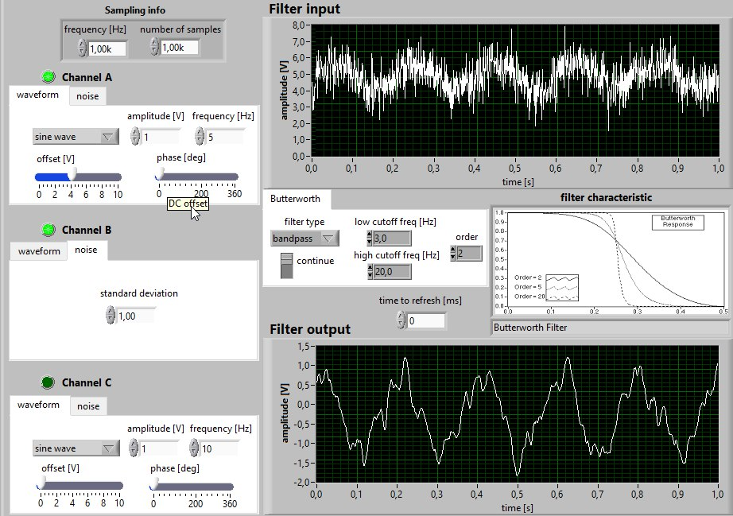
D)apply the band-pass filter to nose and mean removal.

when we reduce the high cutofffreq to 15 we get a better result
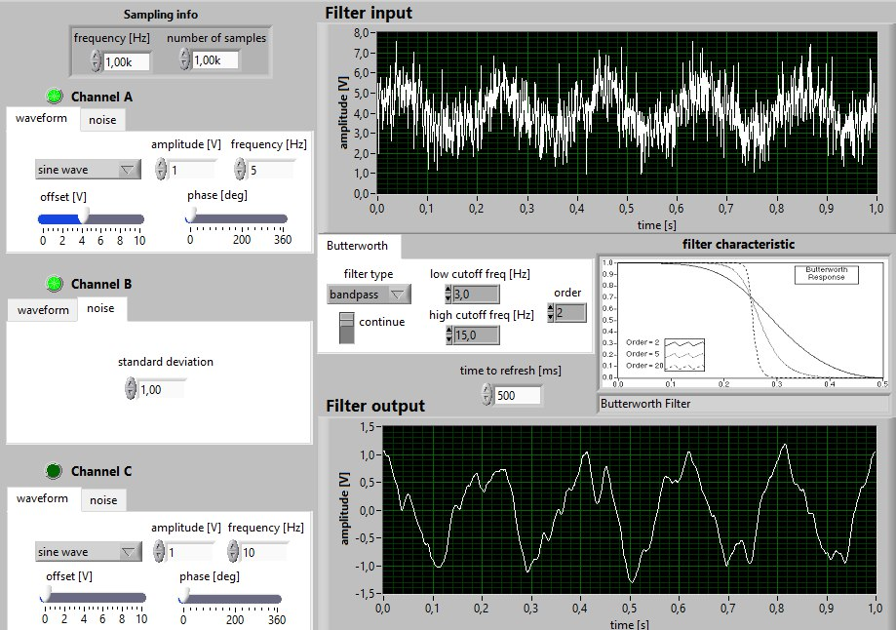

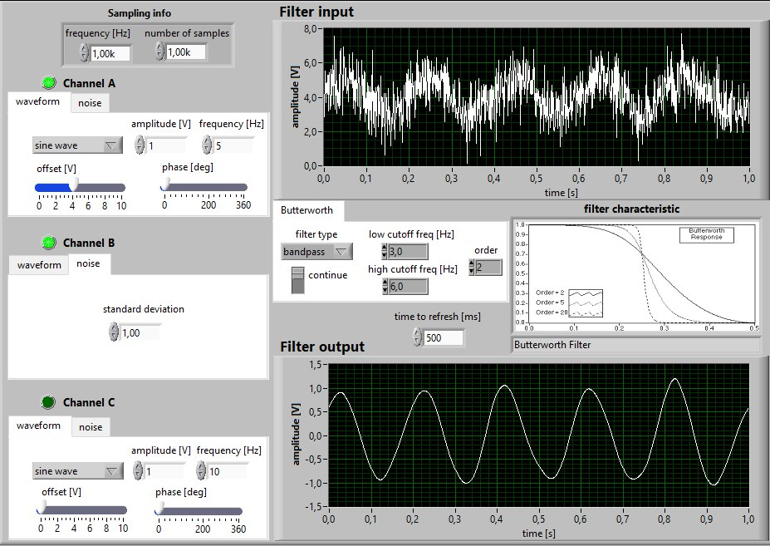

now it looks like the sinewave and the ampluite is 1 just like the first value
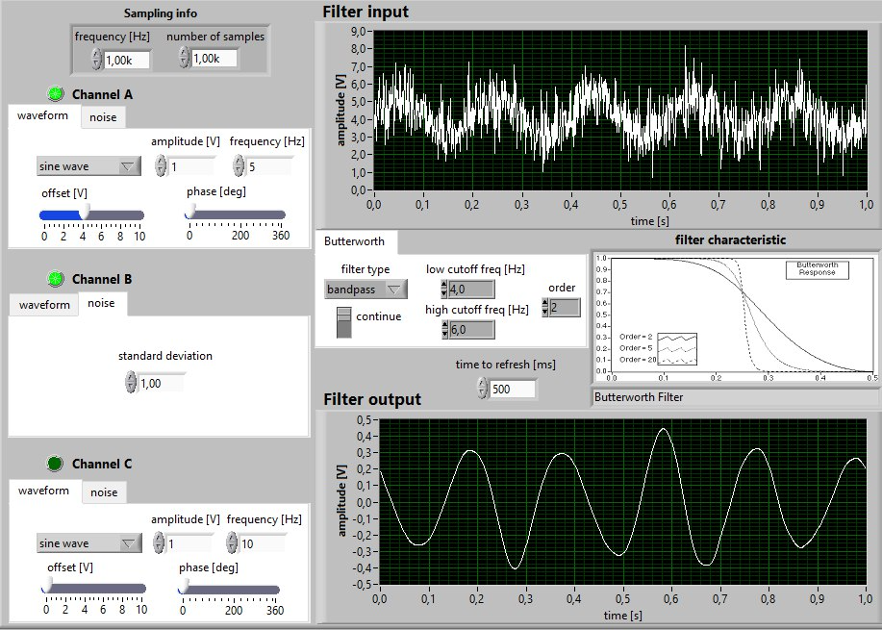

but when we reduce increase the value of the low cutoff to 4 the ampluite is not close to 1so the best value for the low cutoff is 3
and we can notice that the mean value became zero

