Exercise 6 Report: Aliasing and Frequency Folding
MOHAMMED ALMASHHOR SEMIH GUNDUZ

S

Task A: Influence of Signal Frequency on Resulting Waveform under Constant Sampling Rate
Objective:
In this task, we aim to analyze how changing the input sine wave frequency f1​ affects the observed output frequency f2​ when the sampling frequency fs is kept constant. This study helps illustrate the aliasing phenomenon, where higher frequencies appear as lower frequencies due to under-sampling.

Method:
- Sampling frequency fs = 1500 Hz
- Amplitude of all test signals A = 1
- Input frequencies f1 were varied from 0 Hz up to 3000 Hz (i.e., up to 2*f2​)
- The corresponding observed alias frequencies f2 were recorded
- The dimensionless ratios f1/fs​ and f2​/fs​ were also calculated
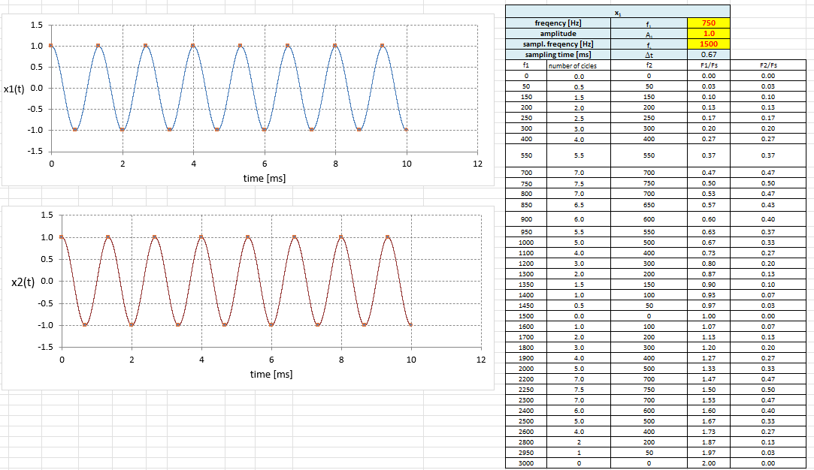
Data Used:

Plot: f1 vs f2 (Observed Aliased Frequencies)
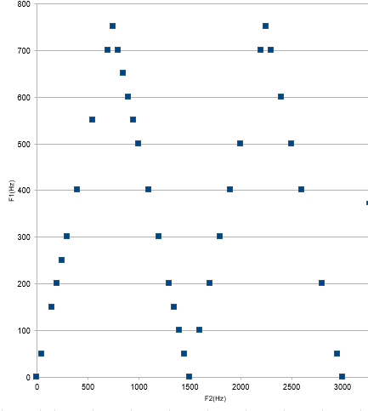

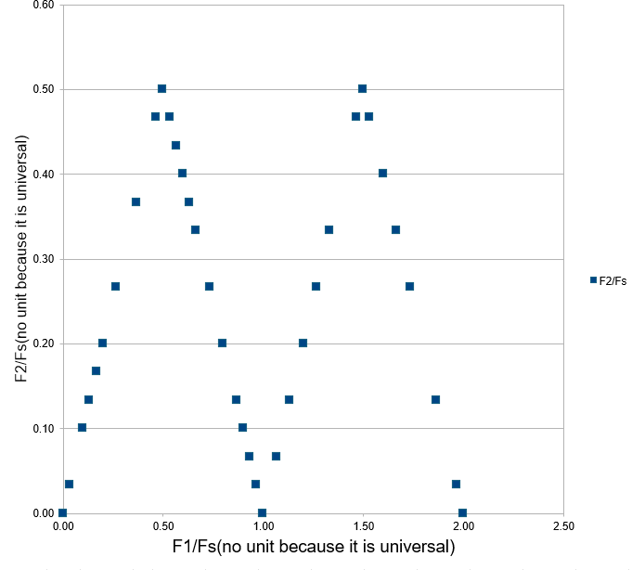
Plot: Dimensionless Plot (f1/fs vs f2/fs):

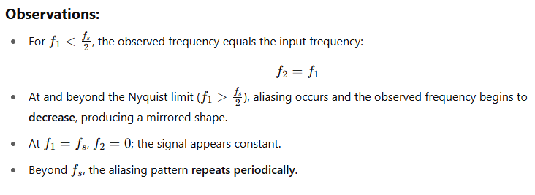
Conclusion:
Aliasing results in folding of frequencies about integer multiples of the sampling frequency. This highlights the importance of choosing a sufficiently high sampling frequency and using low-pass anti-aliasing filters before sampling.

Task B: Derivation of Universal Expression for Aliasing Behavior

Goal:
To derive a mathematical expression that relates the observed frequency f2f_2f2​ to the original signal frequency f1f_1f1​ and the sampling frequency fsf_sfs​, in both dimensional and normalized forms.
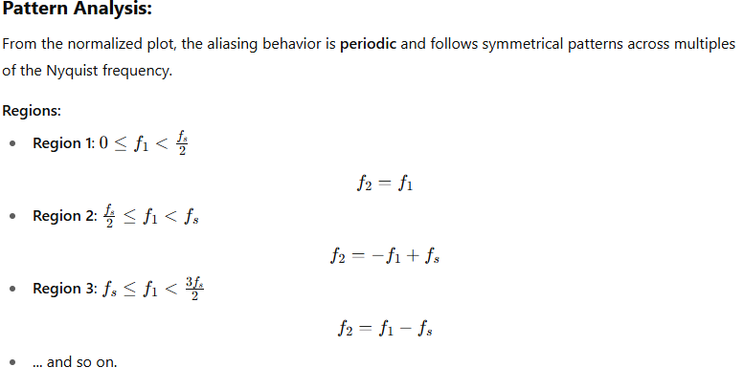

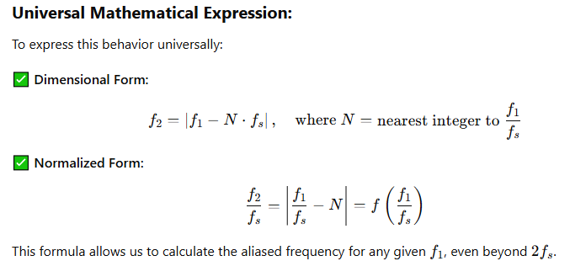Reference Plot (Normalized Aliasing Pattern):


Final Remarks:
- The aliasing effect is predictable and periodic.
- The universal formula enables generalization for any frequency range.
- This task demonstrates why band-limiting a signal before sampling is crucial for faithful digital signal acquisition.

