Introduction
The purpose of this lab exercise is to analyze signals using their Probability Density Functions (PDFs). The tasks involve performing stationarity tests, determining the optimal number of bins for smooth PDF distributions, analyzing deterministic signals, and studying the effects of noise on compound signals. These analyses are essential for understanding signal properties and extracting meaningful information.

Compulsory Tasks
Task A: Stationarity Test for Random or Compound Signal
- Objective : Perform a stationarity test to determine the signal length required for sufficient accuracy of the PDF distribution.
  - For compound signals, ensure the noise content is at least 50%.
- Methodology :
  - Generated a square wave with the following parameters:
    - Amplitude (A) = 1 V
    - Frequency (F) = 1 Hz
    - Phase = 6°
    - Noise added with standard deviation = 1 V
  - Sampling rate = 1 kHz, Number of samples = 1,000.
- Observations :
  - With 1,000 samples, the PDF graph was unclear and jagged.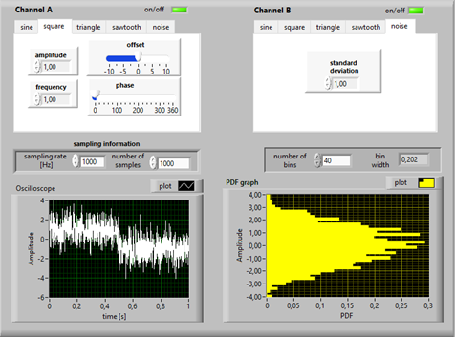
  - Increasing the number of samples to 50,000 resulted in a smooth PDF distribution and let us set the Parameters A =1,F=1 Hz,6 =1 ,samples =50000 , sample rate = 1000 Hz.
  - We can see in the graph below ,that the samples are sufficient to read the graph but the time has increased to 50 seconds: 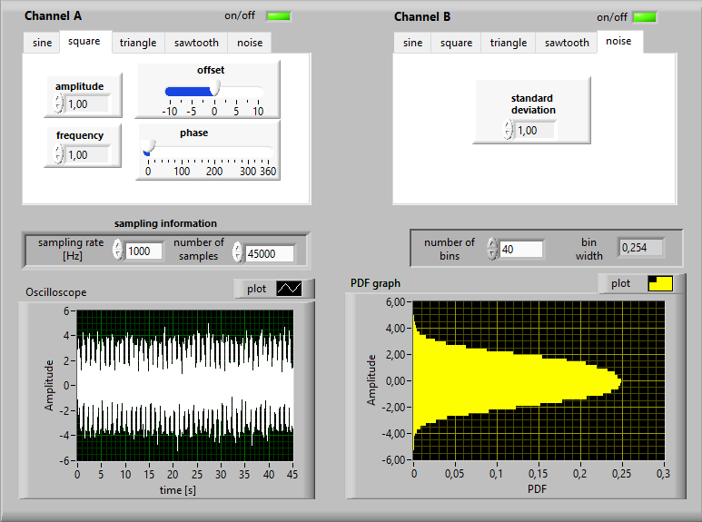
- Conclusion :
  - A signal length of approximately 50 seconds (50,000 samples at 1 kHz) ensured sufficient accuracy for the PDF distribution.
  - For compound signals, noise content was adjusted to 50% by setting the amplitude of the square wave equal to the standard deviation of the noise.
Task B: Optimal Number of Intervals (Bins)
- Objective : Determine the optimal number of bins ensuring a smooth PDF distribution for the same signal analyzed in Task A.
- Methodology :
  - Tested various bin numbers (e.g., 10, 40, 250) while keeping the signal parameters constant.
  - Used a sampling rate of 1 kHz and 50,000 samples.
- Observations :
  - With 10 bins, the PDF graph was blocky and unclear . 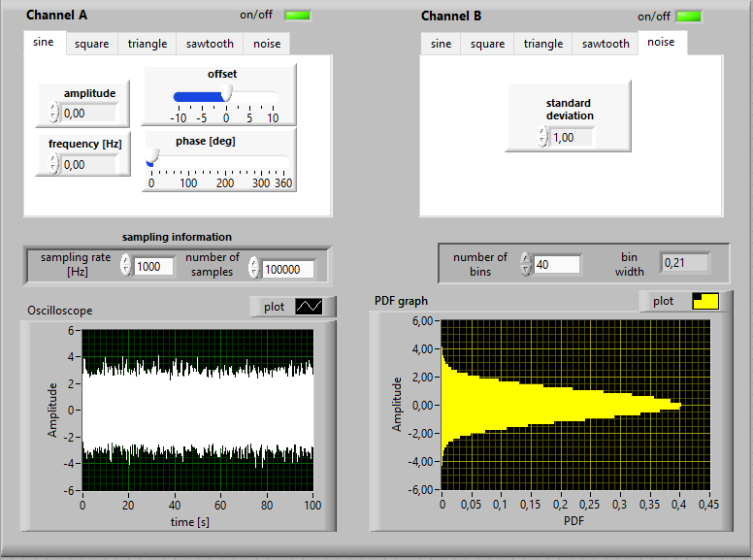
  - Increasing the number of bins to 40 resulted in a smooth and accurate PDF distribution.
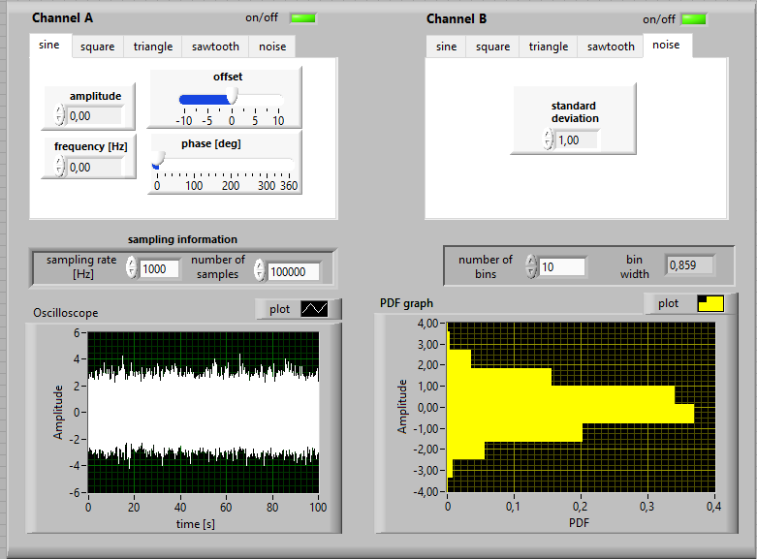
  - Excessive bins (e.g., 250) introduced irregularities in the PDF shape.
- Conclusion :
  - An optimal number of bins for smooth PDF distribution was found to be between 40 and 55.

Task C: PDF Distributions for Deterministic Signals
- Objective : Determine the PDF distributions for typical deterministic signals such as sine waves, square waves, triangle waves, and sawtooth waves.
- Methodology :
  - Generated each signal type with the following parameters:
    - Amplitude = 1 V
    - Frequency = 1 Hz
    - Phase = 0°
    - Offset = 0 V
  - Sampling rate = 1 kHz, Number of samples = 50,000.
- Observations :
Sine Wave: Smooth, bell-shaped PDF centered around zero. 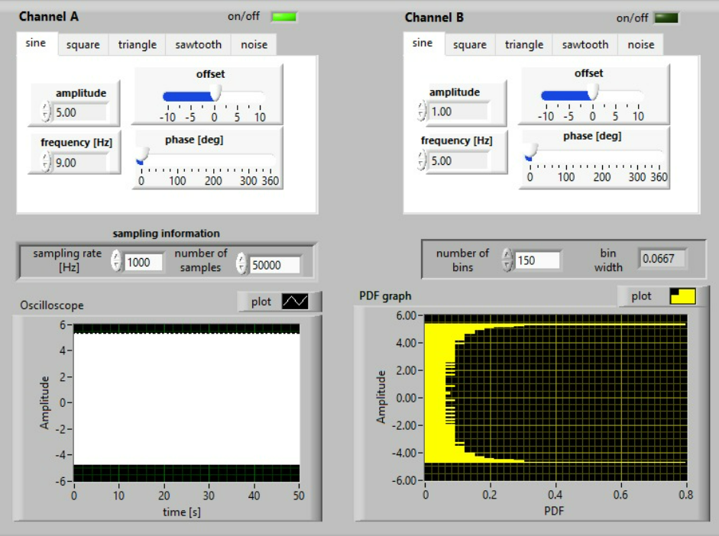
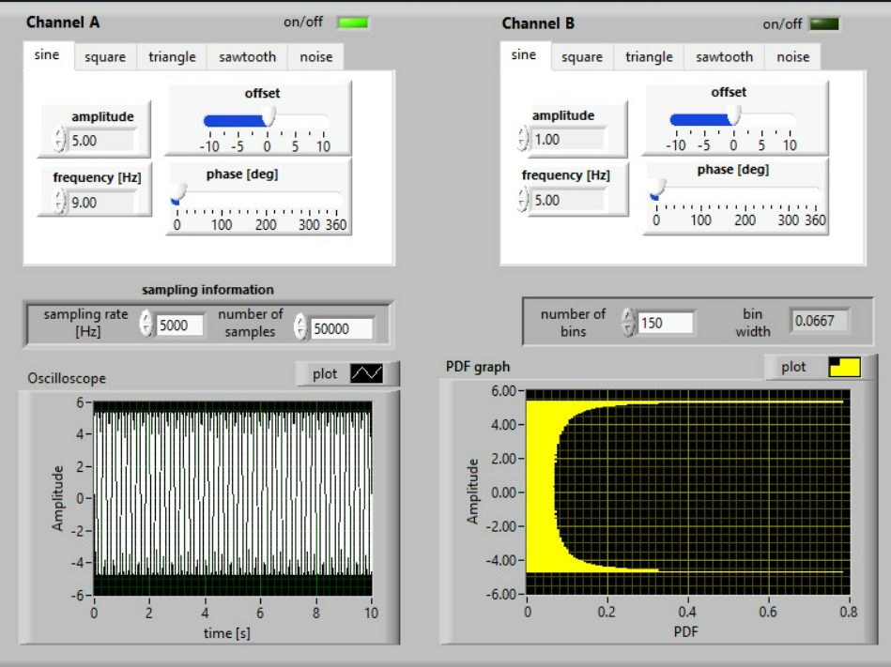
Sampling Rate=1000Hz, unclear graph

Sampling Rate=5000Hz, smooth graph

Square Wave: Two distinct peaks corresponding to the high and low levels of the signal. 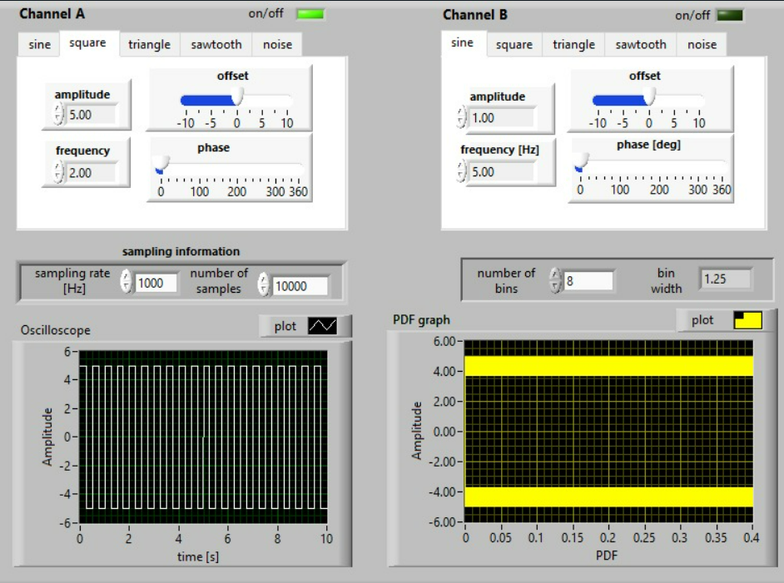
Triangle Wave: Uniform distribution across the amplitude range. 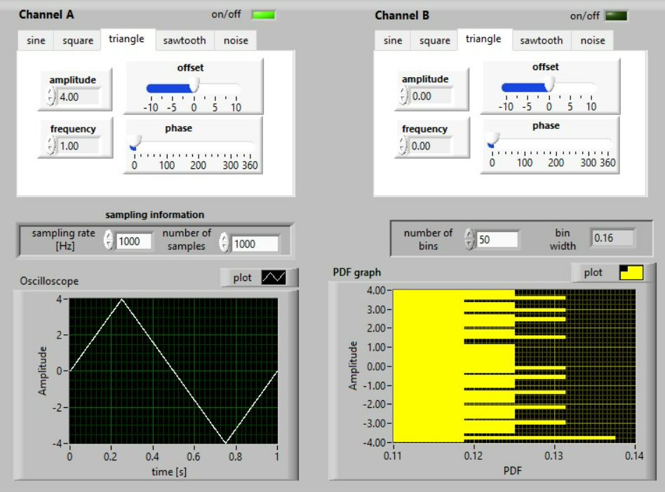Sawtooth Wave: Linearly increasing distribution. 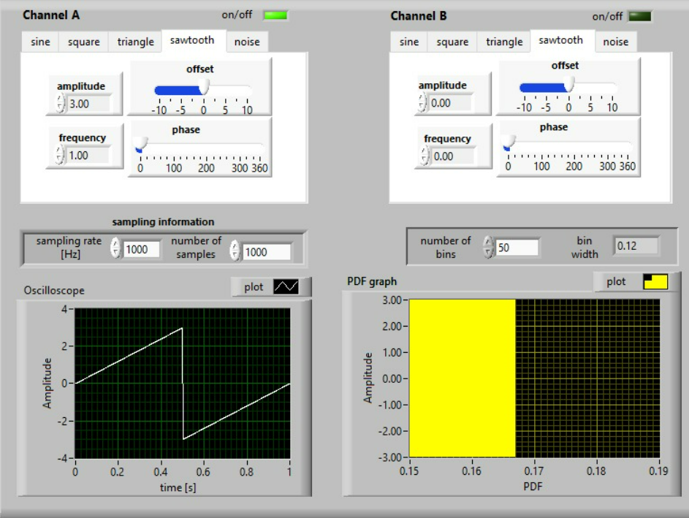
- Conclusion :
  - PDF shapes directly reflect the characteristics of the signal type, making them useful for signal identification.
Task D: Evolution of PDF Distribution for Compound Signals
- Objective : Analyze how the PDF distribution evolves for a selected compound signal when varying the noise content from 0% to 100%.
- Methodology :
  - Generated a compound signal consisting of a square wave and noise.
  - Parameters:
    - Square wave amplitude = 1 V
    - Noise standard deviation varied from 0 V to 1 V.
  - Calculated total power (N) using the formula:N=σsignal2​=σsquare2​+σnoise2​
  - Noise content (ϵ) calculated as:ϵ=Nσnoise2​​×100%
- Observations :
  - At 0% noise content, the PDF resembled the square wave's two-peak distribution.
  - As noise content increased, the PDF became broader and more uniform.
  - At 100% noise content, the PDF approached a Gaussian distribution.
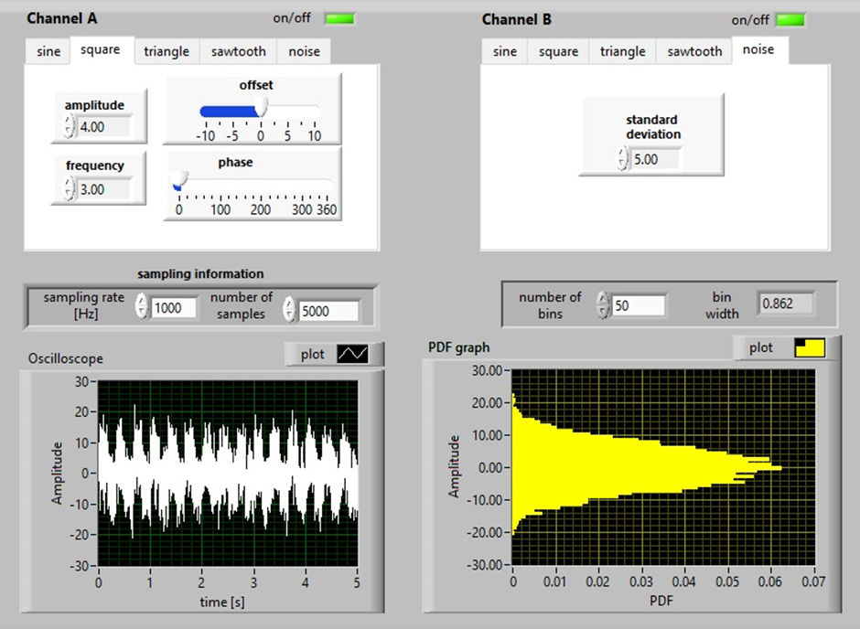
- Example Calculation :
  - For amplitude = 1 V and noise standard deviation = 1 V:N=12+12=2ϵ=21​×100%=50%
- Conclusion :
  - Increasing noise content causes the PDF to transition from deterministic to random characteristics.
  - Noise content significantly affects signal identification and analysis.

Optional Observations
- Sampling Rate Impact :
  - Higher sampling rates (e.g., 5 kHz vs. 1 kHz) improved PDF resolution and accuracy.
- Signal-to-Noise Ratio (SNR) :
  - Higher SNR (amplitude > noise) resulted in clearer PDF distributions.

Conclusion
- Stationarity Test :
  - A signal length of 50 seconds (50,000 samples) ensured sufficient accuracy for PDF distribution.
  - For compound signals, noise content should be at least 50%.
- Optimal Bin Number :
  - Approximately 40–55 bins were optimal for smooth PDF distributions.
- PDF Characteristics :
  - PDF shapes reflect signal type, enabling differentiation between deterministic signals.
- Noise Effects :
  - Increasing noise content broadens and flattens the PDF, transitioning it toward a Gaussian distribution.
These findings demonstrate the diagnostic value of PDF analysis in identifying signal types and understanding their properties under varying conditions.

