SQL & Excel Portfolio Project:

# Problem Statement:

## KIP’s Requirement:

We need to analyze key indicators for our pizza sales data to gain insight into our business performance. Specifically, we want to calculate the flowing metrics:

1. Total Revenue: The sum of the total price of all pizza orders.
2. Average Order Value: The average amount spent per order, calculated by dividing the total revenue by the total number of orders.
3. Total Pizzas Sold: The sum of the quantities of all pizza sold.
4. Total Orders: The total number of orders placed.
5. Average Pizzas Per Order: The average number of pizzas sold per order, calculated by dividing the total number of pizzas sold by the total number of orders.

## CHARTS Requirement:

We would like to visualize various aspects of our pizza sales data to gain insight and understand key trends. We have identified the flowing requirements for creating charts:

1. Daily Trend for Total Orders: Create a bar chart that displays the daily trend of total orders over a specific time period.
2. Hourly Trend for Total Orders: Create a line chart illustrates the hourly trend of total orders throughout the day.
3. Percentage Of Sales by Pizza Category: Create a pie chart that shows the distribution of sales across different pizza categories.
4. Percentage Of Sales by Pizza Size: Generate a pie chart that represents the percentage of sales attributed to different pizza sizes.
5. Total Pizzas Sold by Pizza Category: Create a funnel chart presents the total number of pizzas sold for each pizza category.
6. Top 5 Best Sellers by Total Pizzas Sold: Create a bar chart highlighting the top 5 best-selling pizzas based on the total number of pizzas sold.
7. Bottom 5 Worst Sellers by Total Pizzas Sold: Create a bar chart showing the bottom 5 worst-selling pizzas based on the total number of pizzas sold.

# Solving The Problem:

To solve the problem I used many technologies like:

1. MS SQL Server DB: To import data and make quires to solve the problem.
2. Excel: Data manipulation and make analysis using pivot tables and data visualization to end with the final dashboard.

## MS SQL Server:

I created a data base and imported the data and write quires:

### A. KPI’s

1. Total Revenue:

SELECT SUM(total_price) AS TOTAL_REVENUE FROM pizza_sales;

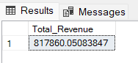

2. Average Order Value

SELECT CAST(SUM(total_price) / COUNT(DISTINCT order_id) AS DECIMAL(10,2)) AS AVG_ORDER_VALUE

FROM pizza_sales;

3. Total Pizzas Sold

SELECT SUM(quantity) AS Total_Quantity FROM pizza_sales;

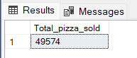

4. Total Orders

SELECT COUNT(DISTINCT order_id) AS Total_Orders FROM pizza_sales;

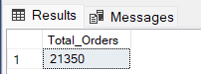

5. Average Pizzas Per Order

SELECT CAST (CAST(SUM(quantity) AS DECIMAL(10,2)) / CAST(COUNT(DISTINCT order_id) AS DECIMAL(10,2))

AS DECIMAL(10,2))AS Avg_Pizza_Per_Order

FROM pizza_sales;

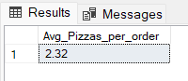

B. Daily Trend for Total Orders

--Daily Trend

SELECT DATENAME(DW,order_date) AS Order_Day, COUNT(DISTINCT order_id) AS Total_Orders

FROM pizza_sales

GROUP BY DATENAME(DW,order_date);

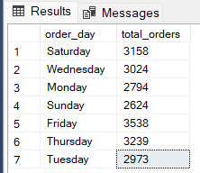

C. Hourly Trend for Orders

--Hourly Trend

SELECT DATEPART(HOUR, order_time) AS Order_Hours,

COUNT ( DISTINCT order_id) AS Total_Orders

FROM pizza_sales

GROUP BY DATEPART(HOUR,order_time)

ORDER BY DATEPART(HOUR,order_time);

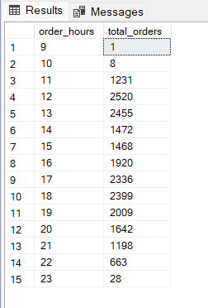

D. % of Sales by Pizza Category

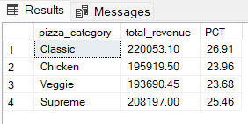

E. % of Sales by Pizza Size

--Percentage Of Sales By Pizza Size

SELECT pizza_size,CAST(SUM(total_price) AS DECIMAL(10,2)) AS Total_Sales,CAST(SUM(total_price)*100/

(SELECT SUM(total_price)FROM pizza_sales ) AS DECIMAL(10,2)) AS PCT

FROM pizza_sales

GROUP BY pizza_size

ORDER BY pizza_size;

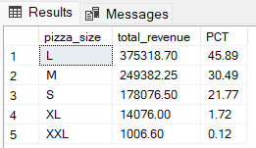

F. Total Pizzas Sold by Pizza Category

SELECT pizza_category, SUM(quantity) AS Pizza_Sold

FROM pizza_sales

GROUP BY pizza_category

ORDER BY Pizza_Sold DESC;

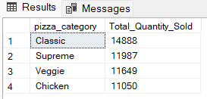

G. Top 5 Best Sellers by Total Pizzas Sold

SELECT TOP 5 pizza_name, SUM(quantity) AS Total_Pizza_Sold

FROM pizza_sales

GROUP BY pizza_name

ORDER BY Total_Pizza_Sold DESC;

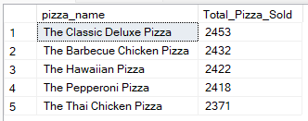

## H. Bottom 5 Best Sellers by Total Pizzas Sold

SELECT TOP 5 pizza_name, SUM(quantity) AS Total_Pizza_Sold

FROM pizza_sales

GROUP BY pizza_name

ORDER BY Total_Pizza_Sold;

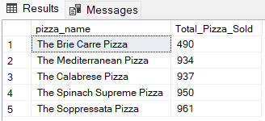

## Excel:

### A. KPI’s

1. Total Revenue:

2. Average Order Value

3. Total Pizzas Sold

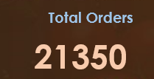4. Total Orders

5. Average Pizzas Per Order

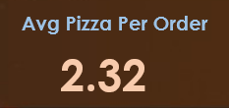

B. Daily Trend for Total Orders

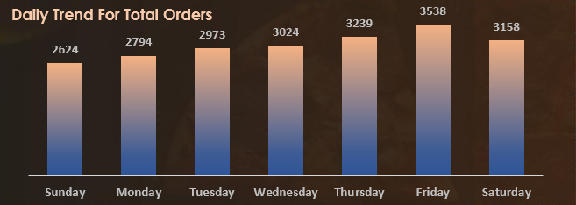

In the daily trend chart, we can see Friday has the highest orders of 3538 orders.

C. Hourly Trend for Orders

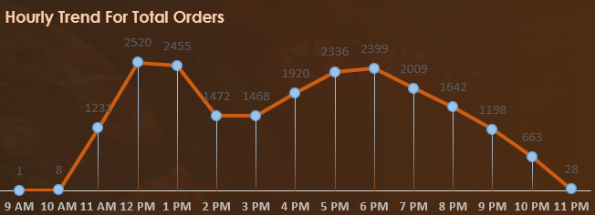

In hourly trend we can see that the shop opens at 9 am, and there are maximum orders from 12-01pm & after 5-8pm.

D. % of Sales by Pizza Category

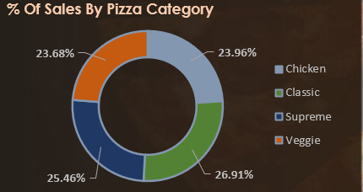The distribution of sales by pizza category we can see the highest sold pizza category is classic by 220053 total revenue which represents 26.91% and the lowest sold pizza category is Veggie by 193690.45 which represents 23.68%.

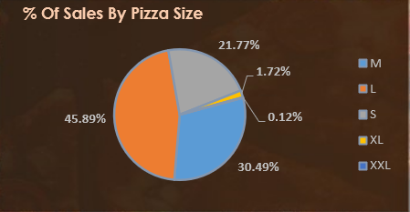E. % of Sales by Pizza Size

The distribution of sales by pizza size we can see the highest sold pizza size is Large by 45.89% and the lowest sold pizza size is XXL by 0.12%.

F. Total Pizzas Sold by Pizza Category

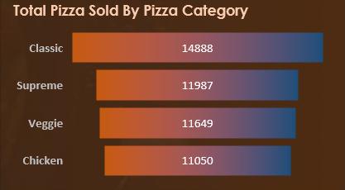

In the total pizza sold by category we can see that the classic category preferred by our customers.

G. Top 5 Best Sellers by Total Pizzas Sold

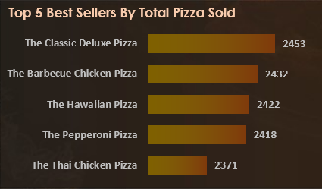

Here we can see the top 5 best sellers pizza sold.

H. Bottom 5 Best Sellers by Total Pizzas Sold

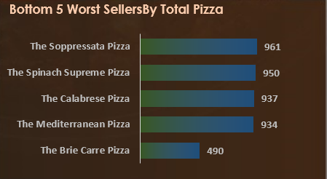

Here we can see the bottom 5 worst sellers pizza sold.