UDEMY COURSES ANALYTICS DASHBOARD

**Project Overview & Business Problem**

I work as a data analyst at Udemy, an educational technology company. My manager tasked me with analyzing course revenue data to identify ways to increase earnings and monitor course performance. Since Web Development courses are highly popular, she suggested considering a price increase and needs a report for the CEO in three weeks with ideas to boost next quarter's revenue.

**Tools Used**

I used Microsoft Excel, specifically the Power Query Editor, to clean the datasets effectively and create visual insights.

**Data Cleaning Process**

I cleaned the data using the following steps in Power Query Editor:

1. **Data Consolidation:** Combined data from multiple Excel files into a single table.

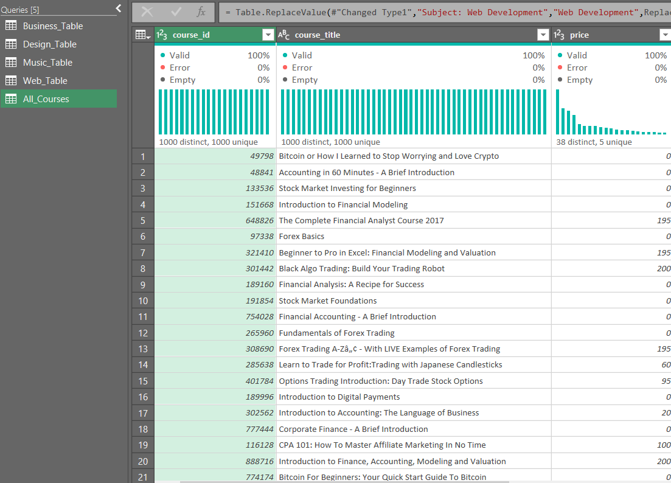

1. **Data Type Adjustment:** Corrected data types for all columns.

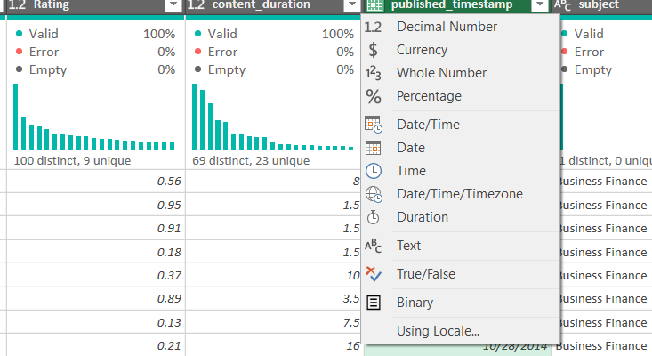

1. 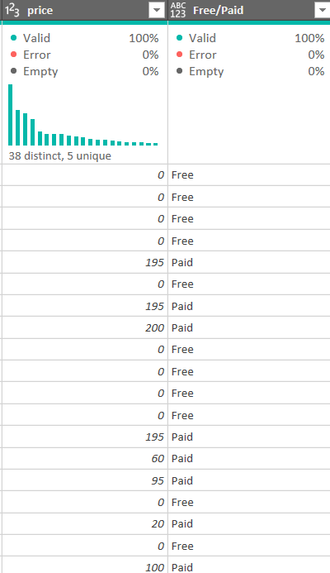**Conditional Column:** Added a column indicating if a course is "Free" or "Paid" based on the price column.

1. **Revenue Calculation:** Created a custom column labeled 'Revenue' calculated as Price * Number of Subscribers.

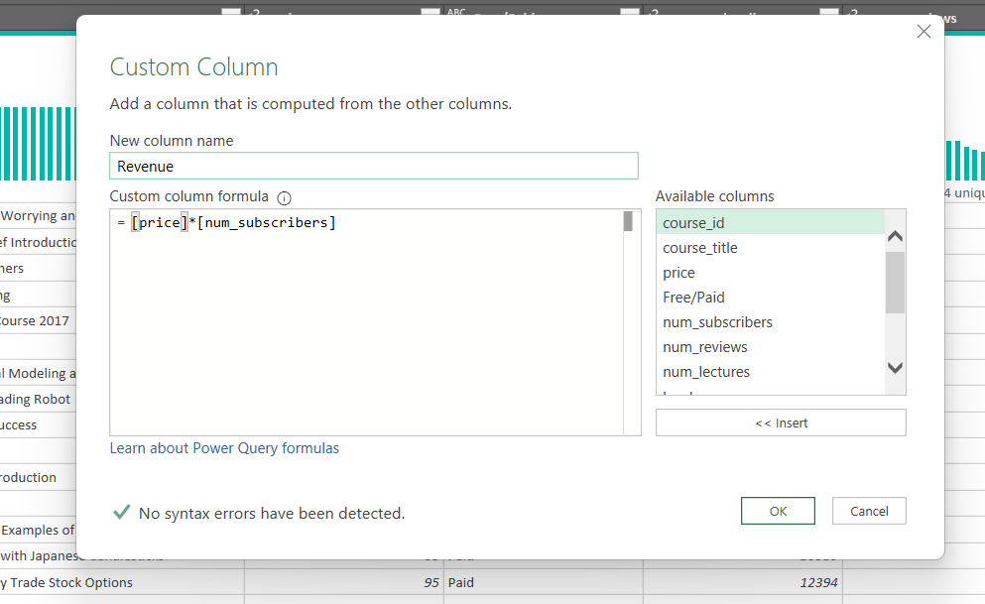

1. **Column Removal:** Deleted the URL column as it was irrelevant for analysis.
2. **Duplicate Removal:** Removed any duplicate rows.
3. **Blank Row Removal:** Deleted any blank rows.

# Data Analysis and Insights:

Using Pivot Tables, I summarized and analyzed the data, revealing the following insights:

* 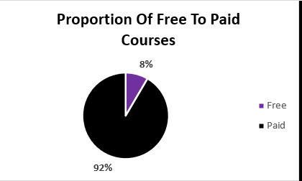**Course Distribution:** Out of 3,676 courses, 3,365 (92%) are paid, while 311 (8%) are free.

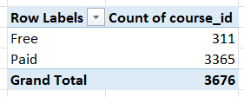

* **Subject Ratings:** Graphic Design has the highest average rating (0.73), followed by Business Finance (0.69). Musical Instruments has the lowest average rating (0.31).

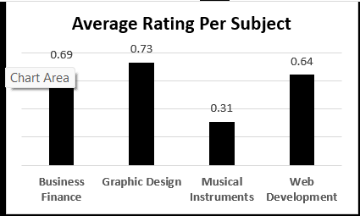

* **Content Duration:** Web Development courses have the highest average content duration (5.59 minutes), while Musical Instruments have the lowest (2.85 minutes).

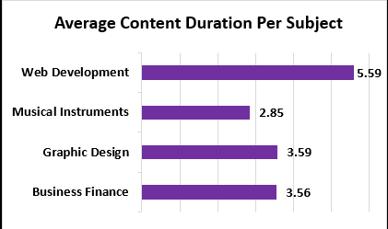

* **Revenue Generation:** Four of the top five revenue-generating courses belong to Web Development. Musical Instruments holds the third position among top earners.

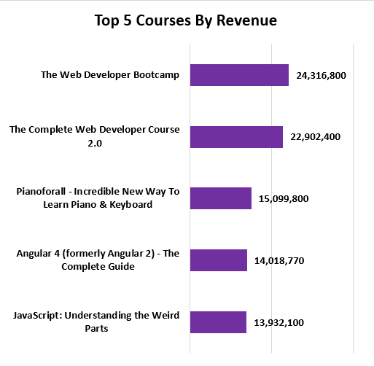

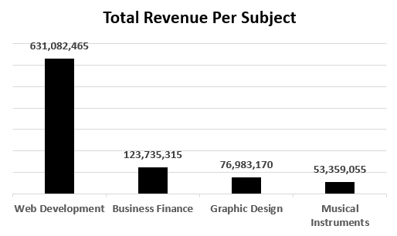

* **Total Revenue:** Web Development generated the highest total revenue of $631,082,465, while Musical Instruments generated the lowest at $53,359,055.

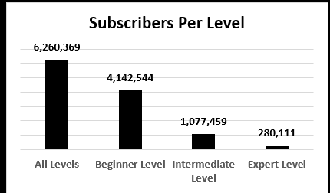

* **Subscriber Levels:** "All Levels" courses have the highest number of subscribers, followed by "Beginner" level courses. "Expert" level courses have the fewest subscribers.

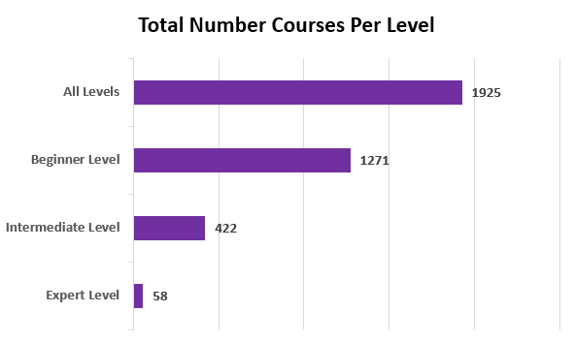

* **Course Levels:** Out of 3,676 courses, there are 1,925 "All Levels" courses, 1,271 "Beginner" courses, 422 "Intermediate" courses, and 58 "Expert" courses.
* 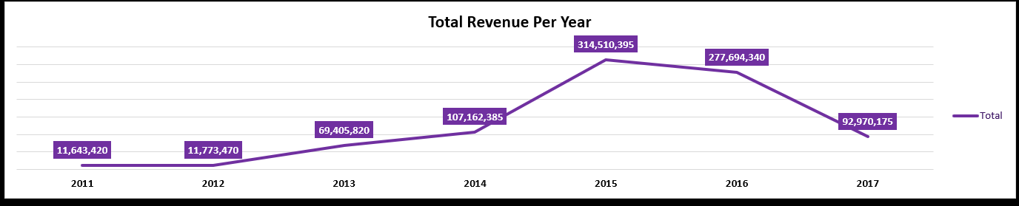Revenue steadily grew from $11,643,420 in 2011 to $314,510,395 in 2015. It then slightly declined to $277,694,340 in 2016, followed by a significant drop in 2017, with total revenue of $92,970,175.

# Visualization:

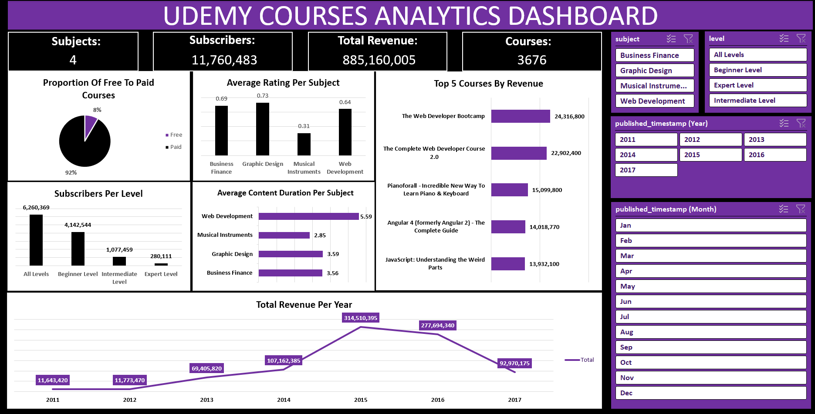Data visualizations were created using Excel charts and graphs to clearly present revenue trends, course distribution, and performance metrics.

1. Based on Average Rating Per Subject (Musical Instruments) the lowest rating at 0.31 we suggest reviewing the courses that under Musical Instruments category.
2. We suggest increasing the number of courses, as we currently have 3,676 courses: 1,925 for all levels, 1,271 for beginners, only 58 for experts, and 422 for intermediate learners. We recommend expanding the course offerings, especially for the expert and intermediate levels.
3. The courses under **Musical Instruments** had increasing profits, reaching their highest value in 2014 with $20,899,910. However, profits began to decline from 2015. We recommend reviewing these courses.
4. We suggest reviewing the **Business Finance** courses starting from 2016, as profits began to decrease in that year.
5. The profits of **Graphic** courses increased alongside the growth in the number of courses. We recommend increasing the number of courses to boost profits further.
6. In 2015, we had 3,475,324 subscribers and generated $314,510,395 in revenue. However, in 2016, we began losing subscribers, and by 2017, we were down to $92,970,175 in revenue,1,000,266 subscribers and in 2017, we had only 714 courses available. We recommend increasing the number of courses to help reverse this trend.