**IOT_PHASE1:** **PUBLIC TRANSPORT OPTIMIZATION**

**TEAM MEMBER:** MOHAMMED JASIR ALI S A(822721106305)

**Project Title:** Public Transport Optimization

**Project Description:** This project involves integrating IOT Sensors into public transportation vehicles to monitor ridership, track locations, and predict perfect arrival times. The goal is to provide real -time transit information to the public through a public platform, enhancing the efficiency and quality of public transportation services. This project includes defining Objectives, designing the IOT sensor system, developing the real-time transit information platform, and integrating them using IOT technology and python.

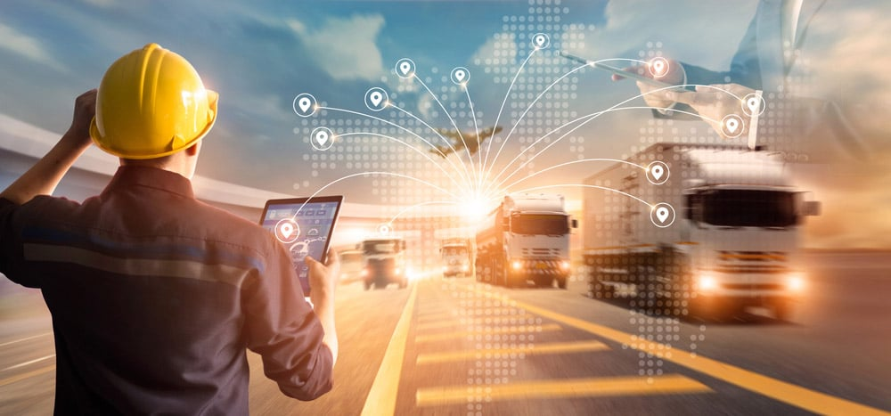

**Design Thinking:**

**Project Objectives:** This project includes defining Objectives, designing the IOT sensor system, developing the real-time transit information platform, and integrating them using IOT technology and python.

**1.Designing the IOT sensor system:**

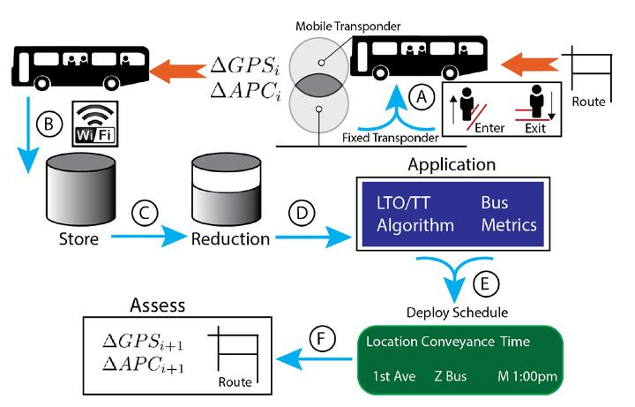

Common sensors for public transport optimization include GPS trackers, accelerometers, temperature sensors, cameras, passenger counters, fuel consumption sensors, and air quality monitors. Choose the appropriate hardware for your sensors. Consider factors such as durability, power efficiency, and communication capabilities. Ensure that the selected sensors are compatible with the public transport vehicles. Establish a reliable communication infrastructure for the IoT sensor system. This may involve using cellular networks, Wi-Fi, or dedicated communication protocols such as LoRaWAN or NB-IoT, depending on the range and data requirements of the sensors. Set up a data aggregation and processing system. IoT sensors generate vast amounts of data, so you'll need a way to collect, store, and process this information. Cloud-based platforms or edge computing solutions can be used for data processing

**2.Real-time transit information platform:**

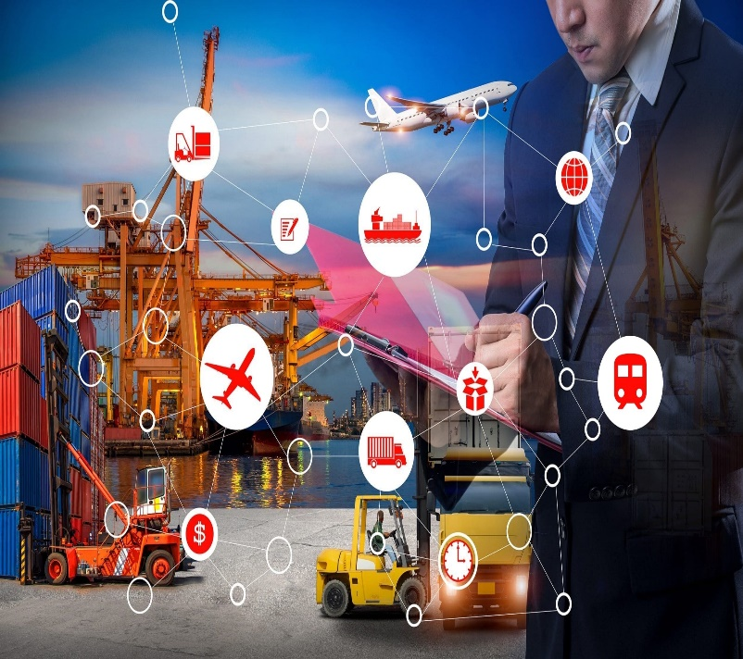Implement mechanisms to provide real-time updates on vehicle locations, estimated arrival times, and any delays or disruptions. Ensure that this information is easily accessible and reliable. Developing a real-time transit information platform is a complex task that requires collaboration between transportation authorities, technology providers, and software developers. It should be an ongoing effort to ensure that the platform remains effective in optimizing public transportation while enhancing the passenger experience. It will be user-friendly interfaces for both transportation operators and passengers.

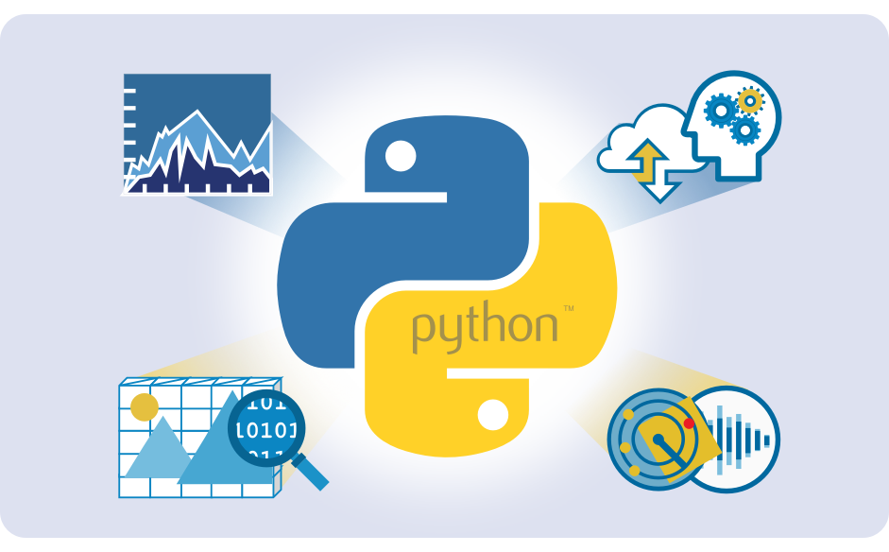**3.Integrating with IOT using Python:**

Integrating Python into public transportation optimization involves using Python programming and various libraries to analyze data, build models, and develop applications that enhance the efficiency and effectiveness of public transport systems.

**Data Collection and Preprocessing:** Gather relevant data sources, including vehicle GPS data, passenger counts, traffic information, and historical scheduling data. Python offers libraries like Pandas and NumPy for data manipulation and cleaning.

**Data Analysis:** Use Python's data analysis libraries, such as Pandas, Matplotlib, and Seaborn, to explore and visualize data trends, patterns, and anomalies. Identify areas where optimization is needed.

**Machine Learning and Predictive Modelling:** Employ machine learning techniques using libraries like Scikit-Learn or TensorFlow to build predictive models. For example, you can create models to predict demand patterns, estimate arrival times, or optimize routes based on historical and real-time data.

**Geospatial Analysis:** Leverage Python libraries like Geo-Pandas and Shapely to perform geospatial analysis. This can help in route planning, spatial clustering, and geofencing for public transportation optimization.

**Optimization Algorithms:** Implement optimization algorithms, such as linear programming or genetic algorithms, to find optimal solutions for scheduling, resource allocation, and route optimization. Libraries like PuLP or DEAP can be useful for this.

**Real-Time Data Integration:** Set up data pipelines to ingest real-time data from IoT sensors and other sources. Python can be used to develop real-time data processing modules that update route information, arrival times, and alerts in real-time.

**Development of Optimization Algorithms:** Develop custom optimization algorithms tailored to specific public transportation challenges. Python offers the flexibility to create custom algorithms using libraries like SciPy.

**Web and Mobile Applications:** Develop web or mobile applications for passengers and transportation operators using Python frameworks like Django, Flask, or Fast API. These applications can provide real-time information, trip planning, and feedback mechanisms.

**Integration with GIS:** Integrate with Geographic Information Systems (GIS) using Python libraries like ArcPy or PyQGIS to enhance spatial analysis and visualization of public transport routes and infrastructure.

**Cloud Services:** Host data analysis, modelling, and applications on cloud platforms like AWS, Azure, or Google Cloud to scale resources as needed and ensure high availability.

**APIs and Data Sharing:** Create APIs to share data with other systems, such as traffic management systems or third-party applications. Python's Flask or Fast API can be used to develop RESTful APIs.

**Security and Privacy:** Implement security measures to protect sensitive data and ensure data privacy. Python libraries and frameworks offer security features and encryption capabilities.

**Testing and Validation:** Thoroughly test the Python-based solutions to ensure they meet the defined optimization goals and are robust against different scenarios.

**Documentation and Training:** Document the codebase and provide training to transportation operators and staff on how to use the Python-based tools effectively.

**Maintenance and Updates:** Establish a maintenance plan to keep Python-based systems up-to-date and address any issues that arise.

**Monitoring and Optimization:** Continuously monitor the performance of the Python-based optimization solutions and make improvements based on data-driven insights.