AI PANIC DETECTOR SYSTEM USING NLP

TABLE OF CONTENTS

S.No | Topic
1 | Abstract
2 | Introduction
3 | Background and Literature Review
4 | System Requirements
5 | System Architecture and Modules
6 | . Output and Execution Flow
7 | System Features and Advantages
8 | Limitations and Future Scope
9 | Conclusion

1.Abstract

With the increasing need for personal safety in modern society, intelligent systems capable of detecting emergencies in real time have become highly important. This project presents the design and development of an AI-based Panic Detector System, which continuously monitors audio input and detects panic situations using speech recognition and Natural Language Processing (NLP).
The system converts real-time speech into text using a speech recognition model and analyzes it through a multi-layered detection mechanism. This mechanism includes keyword identification, phrase matching, and emotion classification using a pre-trained NLP model. Based on this analysis, a panic score is computed to determine the severity of the situation.
If the computed score exceeds a predefined threshold, the system automatically triggers an emergency alert and sends SMS notifications to registered contacts using the Twilio API. Additionally, the system retrieves the user’s approximate location and shares it through a Google Maps link. The application is implemented with a graphical user interface using Tkinter and uses SQLite for storing contact information and alert logs.

2.Introduction

In recent years, ensuring personal safety has become a critical concern due to the increasing number of emergency situations such as accidents, assaults, and medical crises. Traditional emergency systems rely heavily on manual interaction, such as pressing a panic button or making a phone call, which may not always be feasible during high-stress situations.
To address this limitation, this project introduces an automated system that continuously monitors the user’s speech and detects panic situations without requiring any manual input. The core idea is to enable machines to interpret human speech and identify distress signals using Artificial Intelligence techniques.
The system leverages speech recognition to convert audio into text and applies Natural Language Processing to understand the meaning and emotional context of the speech. By combining rule-based detection with machine learning models, the system achieves a balance between speed and accuracy.

3. Background and Literature Review

Existing emergency systems primarily fall into two categories: manual alert systems and sensor-based detection systems. Manual systems require user intervention, while sensor-based systems rely on physical parameters such as motion or heart rate. Both approaches have limitations in detecting verbal distress signals.
Recent advancements in Natural Language Processing have enabled machines to understand human language more effectively. Techniques such as keyword extraction, phrase detection, and emotion classification have been widely used in applications like chatbots and sentiment analysis.
This project builds upon these concepts by integrating speech recognition with NLP-based panic detection. Unlike simple keyword-based systems, this approach incorporates a multi-level scoring mechanism and emotion analysis to improve detection accuracy and reduce false positives.

4. System Requirements

4.1 Hardware Requirements

The system requires a standard computing device with a microphone for capturing audio input. A processor equivalent to Intel i5 or higher and a minimum of 8 GB RAM are recommended for smooth execution of real-time processing tasks.

4.2 Software Requirements

The application is developed using Python as the primary programming language. It utilizes libraries such as Tkinter for the graphical interface, Vosk for speech recognition, and Transformers for NLP-based emotion detection. SQLite is used for database management, while external APIs such as Twilio and Geocoder are used for sending alerts and retrieving location data.

5. System Architecture and Modules

The system is designed as a modular architecture consisting of multiple interconnected components that work together to achieve real-time panic detection.
The first module is the Audio Processing Module, which captures real-time audio input from the microphone and converts it into text using the speech recognition engine.
The second module is the Text Processing and Normalization Module, which cleans and standardizes the recognized text by removing noise and irrelevant characters.
The core component of the system is the Panic Detection Engine, which analyzes the processed text using a multi-level scoring mechanism. This includes detection of critical keywords, panic phrases, and supporting words, along with emotion analysis using an NLP model.
The Alert Module is responsible for triggering emergency notifications when the panic score exceeds a threshold. It sends SMS alerts using the Twilio API and includes the user’s location obtained through a geolocation service.
The system also includes a Database Module, which stores contact details and maintains a history of alerts. Finally, the User Interface Module provides a graphical interface for real-time monitoring, displaying audio activity, panic scores, and system status.

6. Output and Execution Flow

The execution of the system begins with the activation of the microphone, which continuously captures audio input. The captured audio is processed by the speech recognition engine to generate text output.
The generated text is then normalized and passed to the panic detection engine, where it is analyzed using predefined rules and NLP-based techniques. A panic score is calculated based on the presence of critical words, phrases, and emotional indicators.
If the calculated score exceeds the predefined threshold, the system triggers an alert. The alert module sends SMS notifications to registered contacts and includes a link to the user’s location. Simultaneously, the system logs the alert in the database and displays a notification on the user interface.

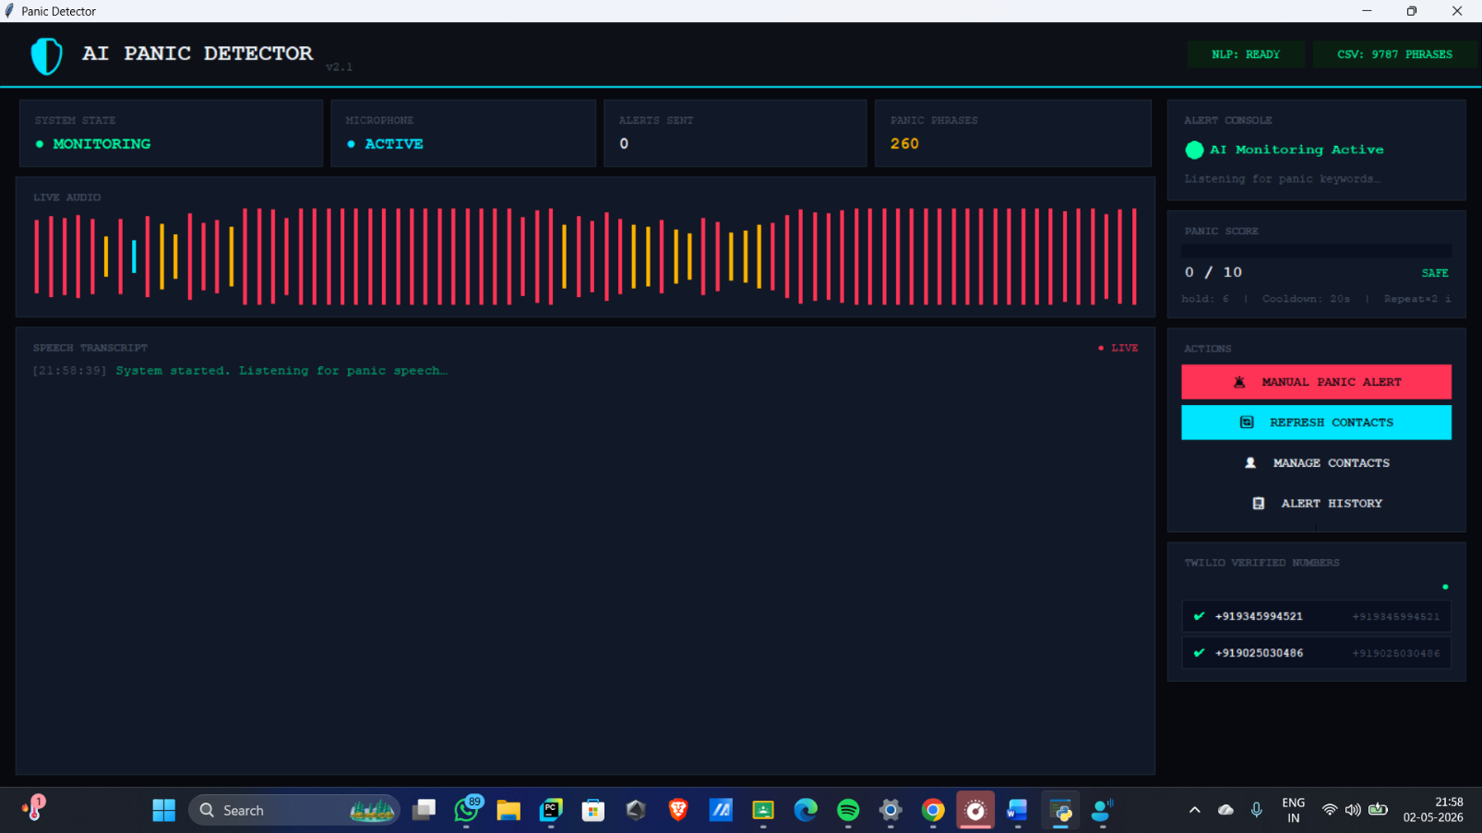
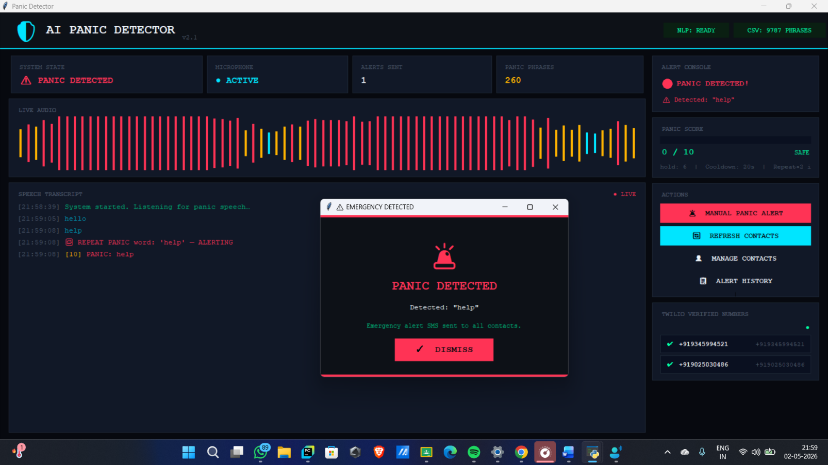

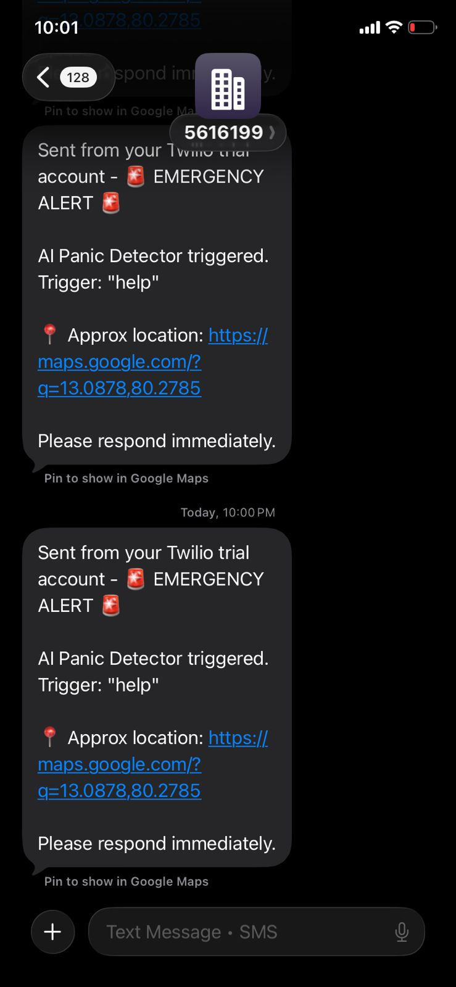
\

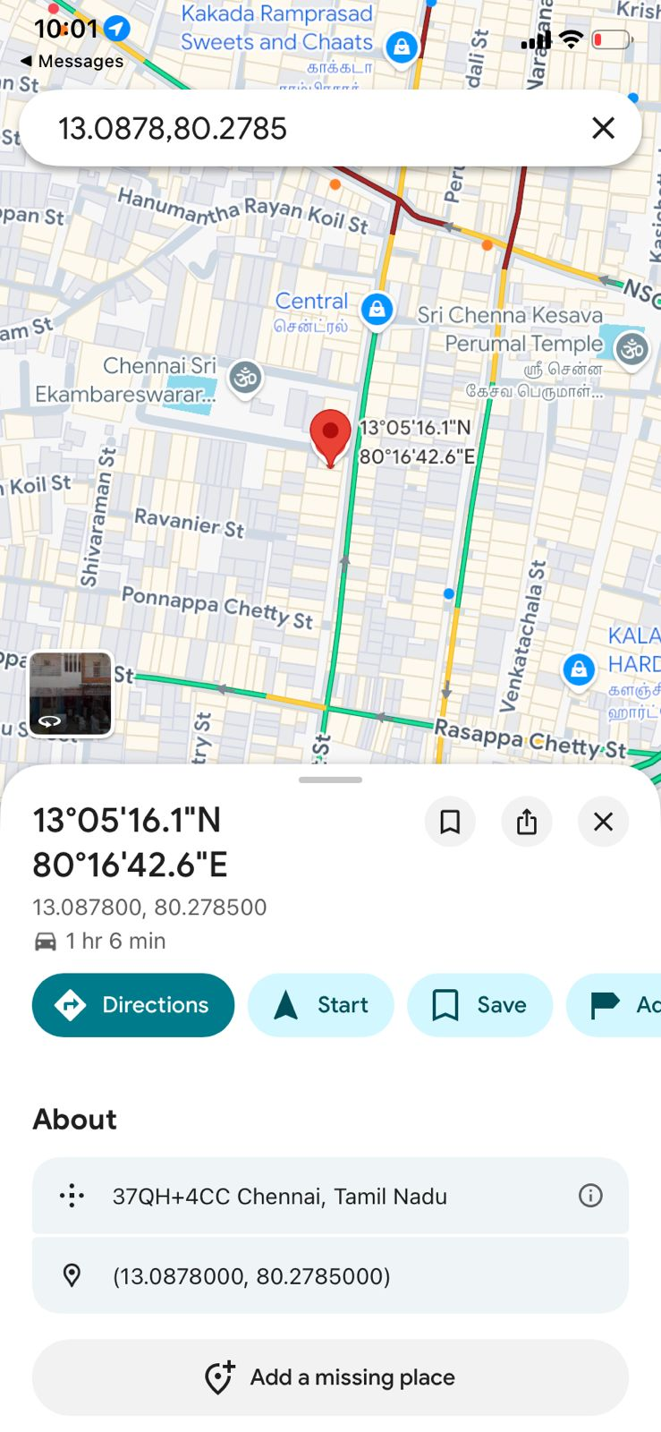

7. System Features and Advantages

7.1 Key Features

The system offers several advanced features, including real-time speech monitoring, multi-level panic detection, and emotion analysis using NLP. It supports multilingual inputs and provides automatic alert generation without requiring user interaction. The graphical interface enhances usability by providing real-time feedback and control options.

7.2 Advantages

The primary advantage of this system is its ability to operate automatically, reducing dependency on manual actions. It provides faster response times and improves safety by detecting emergencies in real time. The hybrid approach combining rule-based logic and NLP ensures better accuracy and reliability.

8. Limitations and Future Scope

Despite its effectiveness, the system has certain limitations. Its performance may be affected by background noise and variations in speech clarity. Additionally, it relies on internet connectivity for sending alerts via external APIs.
Future enhancements may include the development of a mobile application, integration with wearable devices, and the use of advanced deep learning models for improved accuracy. The system can also be extended to connect directly with emergency services for faster response.

9. Conclusion

The AI Panic Detector System demonstrates the practical application of Artificial Intelligence and Natural Language Processing in enhancing personal safety. By integrating speech recognition, intelligent analysis, and automated alert mechanisms, the system provides a reliable solution for detecting emergencies in real time.
The project highlights the potential of AI-driven systems in addressing real-world challenges and offers a scalable framework for future safety applications.

