Objective Questions
- What is the total no. of tables present in the data?
Answer
There is only one table is present in the given data.
- What is the total no. of attributes present in the data?
Answer
There are 55 attributes are present in the data
- The data consists of some inconsistent and missing values so ensure that the data used for further analysis is cleaned.
Answer
The data has been cleaned and updated column is in new column for all inconsistent column.

- What is the change in daily call volume day by day and also find the average daily call volume?
Answer
Reference Objective Sheet for Pivot Table
- To find the daily call volume, Created Pivot table with date and callSid to get call on daily basis.
- Then to get daily call changes subtracted Next date with current date.
- To get average daily call volume, used average functionAverage Function = 246.03

- Which months experienced the highest and lowest call volumes?
Answer
Reference Objective Sheet for Pivot and chart of Q.5
- To get the highest and lowest call volume, I used pivot table where selected new Created Month column and callSid column.
- We have only two months in our data as we got the output by pivot and chart which is showing December month has highest call volume and January has lowest call volume

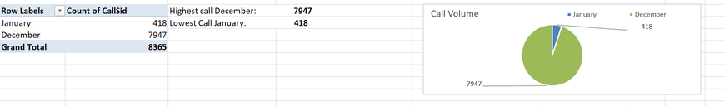

- What is the total operational cost for that month?
Answer
Reference Objective Sheet for Pivot and chart of Q.6
- To get to know the operational cost for each category and for each month Pivot table is created.
- where data for each category and for every month is reflecting as total and chart is also for better analyze.

- What is the average number of calls handled per agent per day?
Answer
Reference Objective Sheet for Pivot of Q.7
- We have consultation type column where we have different types of consultation as per our requirement is average call so to get average call.
- we have to filter call from consultation types and then agent, days and callsid with Pivot Table.
- Getting average call per day -and average calls per day is divided by total gurus.
Count of days |  | 34
Sum of total Calls |  | 8363
Sum of total guru |  | 8508
Average call per day |  | 245.97
Total Number of Gurus |  | 131
Average calls per day per agent |  | 1.88

- How many repeat callers are there, and what percentage of total calls do they represent?
Answer
Reference Objective Sheet for Pivot of Q.8 cell reference BQ TO CG
- Created a Pivot Table with UID in Rows and CallSid in Values (Count of CallSid).
- Counted total calls for each user.
- Applied a Value Filter: Count of CallSid > 1 to identify repeat callers.
- Counted the remaining rows to determine the number of repeat callers.
- Repeat Callers = 1276
- Summed total calls of repeat users.
- Total Calls by Repeat Users = 6012
- Subtracted 1 call for each repeat user (since the first call is not repetitive).
- Total Repetitive Calls = 6012-1276 = 4736
- Retrieved total calls from entire dataset (without filter).
- Total Calls (Overall) = 8363
- Percentage Calculation: 4736 / 8365 × 100 = 56.63%

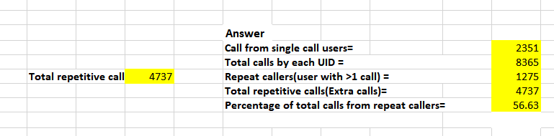

- What are the total sales generated by the call center for each product category?
Answer
Reference Objective Sheet for Pivot of Q.9
- Created pivot table with consultant type in row and sum of net amount in values to get the total sales generated by each product category.
- Table shows that total sales by “call” consultant type much greater than Others so there need to improvement in other part.

- Table shows that total sales by “call” consultant type much greater than Others so there need to improvement in other part.
Answer
Reference Objective Sheet for Pivot of Q.10
- To check calls for Guru ID and User ID
- Created 2 Pivot Table, one for Guru ID and another for User ID
- Used Filter to select call to get calls details of User ID and Guru ID
Total Call of Guru ID: 8363
Total Call of User ID: 8363

- What is the correlation between call duration and customer satisfaction?
Answer
Reference Objective Sheet for Pivot of Q.11
To check the correlation between call duration and customer satisfaction, taking the data sheet and applying correl function to get the correlation.
- Which guru has the highest and lowest customer satisfaction scores?
Answer
Reference Objective Sheet for Pivot of Q.12
- Created Pivot Table for guru to get the highest average and lowest rating on which basis we can define the satisfaction rate of guru.
- Rating converted into average and user min and max function for highest and lowest rating.
Highest Rating | 7.50
Lowest Rating | 0.00
Average Rating | 2.93
Lowest Guru Name:Tarot Rittika
Highest Guru Name: Astro Pujaa Rai & Tarot Mystical
- What is the average customer satisfaction score by month?
Answer
Reference Objective Sheet for Pivot and chart of Q.13
- Creating pivot table with month in rows and average of rating in values the average customer satisfaction score per month.
- We can see clearly that nothing as much difference in average rating in different month

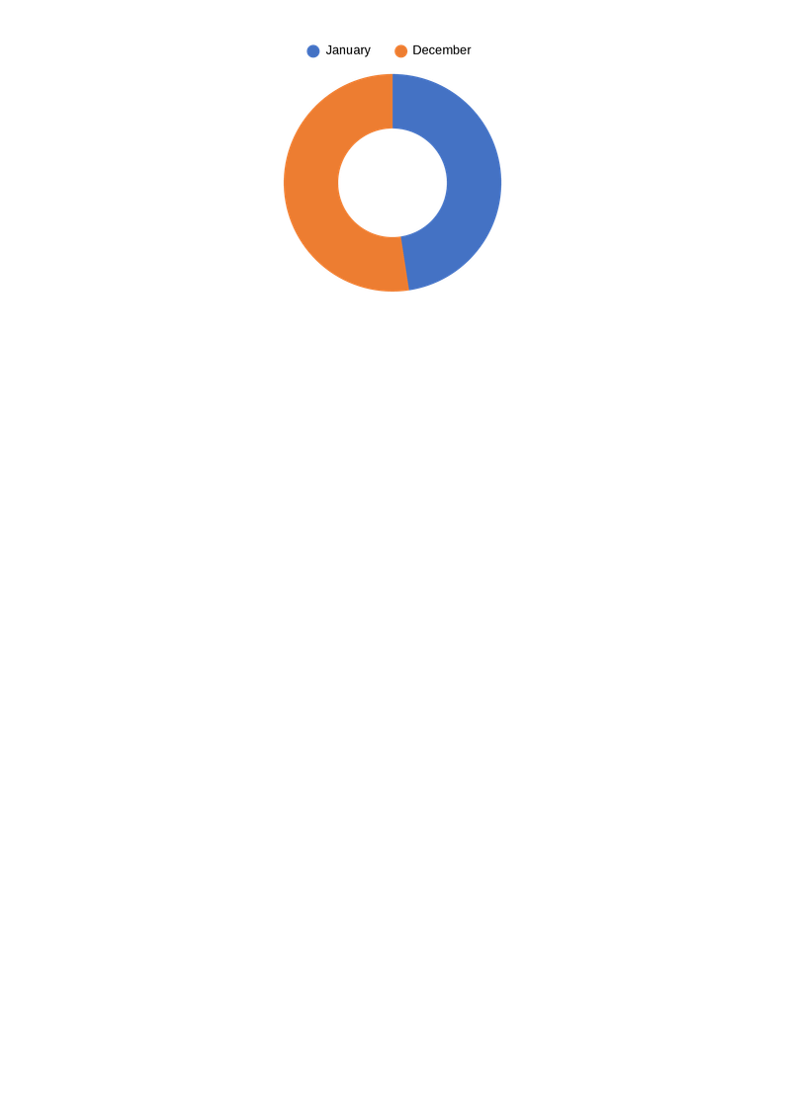

- How many categorical columns are there in the data? [Search about categorical and continuous data, and try to answer this question]?
Answer
Out of these 55 columns, there are 33 categorical columns are typically those with data type object or bool, as they represent qualitative data such as statuses, names, or Boolean flags.
Column Names:
_id, user. chatStatus, guru, guruName, gid, uid, consultationType, website, refundStatus, isWhiteListUser, freeCall, freeChat, statementEntryId, callChannel, callIvrType, callStatus, CallSid, astrologerCallStatus, region, userCallStatus, rating, Updated_ChatStatus, Updated_callStatus, Updated_astrologerCallStatus, Updated_region, Updated_userCallStatus, Updated_rating, CreatedAT_Date, CreatedAT_Year, CreatedAT_Month, CreatedAT_Day, Hour

Subjective Questions
- Should the investment be used to hire more agents, improve training programs, or upgrade call center technology?
Answer
Reference Subjective Sheet for Pivot and chart of Q.1
Approach for Hiring More Agents
- Created a pivot table with Rows: guruID (gid) and Values: Average of Rating
- Visualized average ratings guru-wise
Observations
A large number of ratings are 0, or 1 indicates that users are not happy with service.
Most non-zero ratings lie between 2 and 3, which reflects average customer satisfaction and Very few Guru received 4-5 or more than that rating.
Low-to-average ratings across many gurus suggest agent performance inconsistency

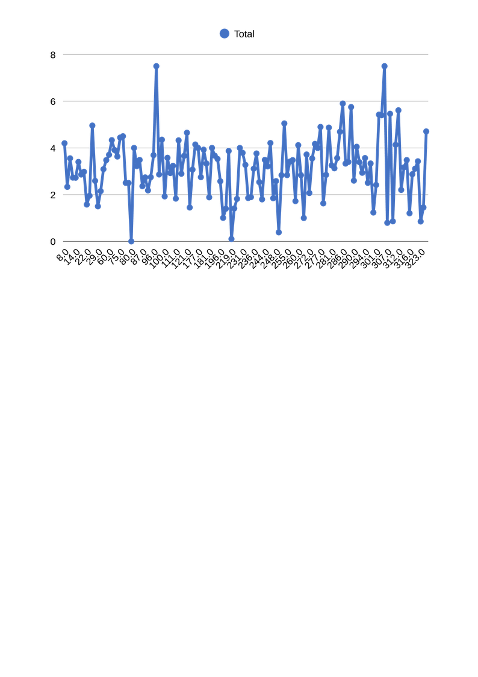

Approach for Improving Training Programs
Created a pivot table with Rows: guruID (GID) Values Average Call Duration and Average Rating

Observations
Several gurus have Long call durations, but still receive low or average rating
This indicates that longer calls are not translating into better customer satisfaction.
There might be gaps between customer and gurus as per their expectation for their problems, Communications, Consultations.

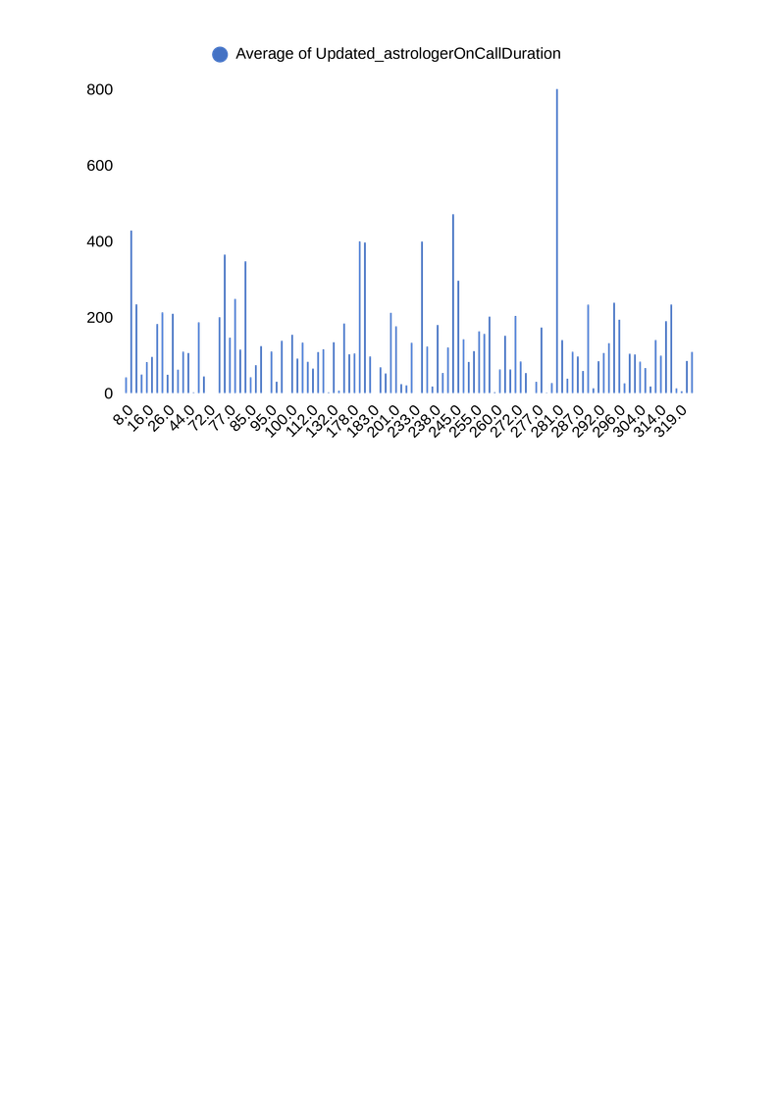
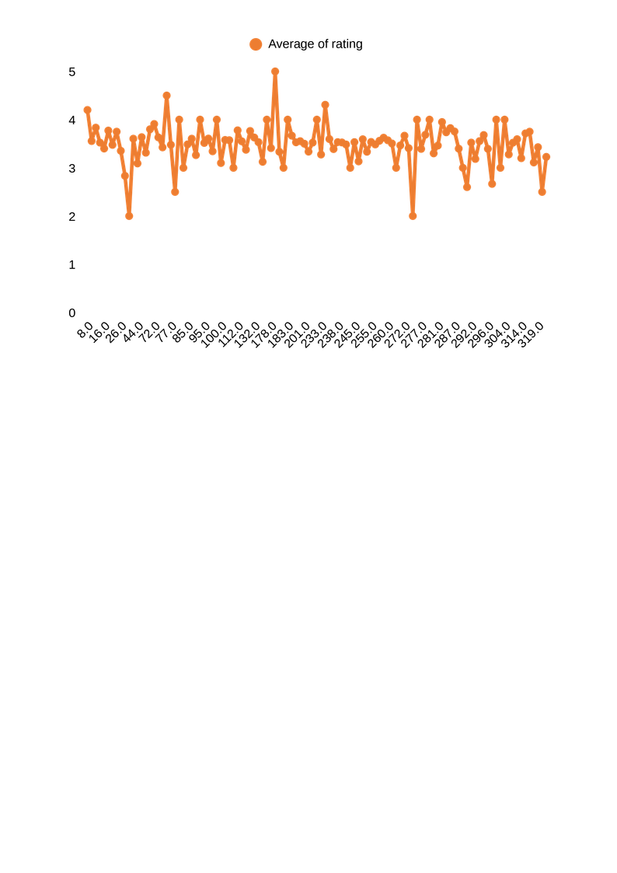

Approach for Upgrade Call Center Technology
Created pie charts for call Distribution to analyze the completed, busy, incomplete, no answer calls
Observation:
For Calls, A noticeable portion are busy, failed, or no-answer from the chart and pivot.
Recommendation:
Investment should first focus on improving training programs, followed by upgrading call center technology. Hiring more agents should be considered only after these improvements.

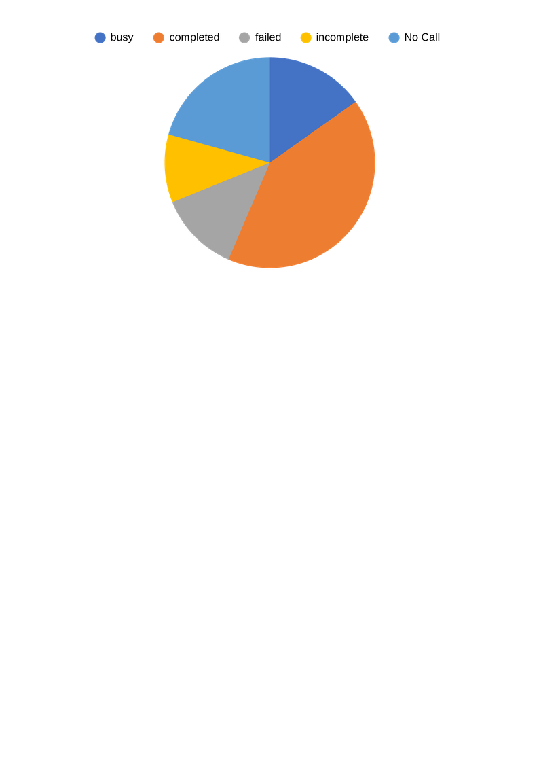

- What are the potential risks of each investment option (hiring, training, technology upgrades), and how can they be mitigated?
Answer
Reference Subjective Sheet for Pivot and chart of Q.2
Approach 1 for Hiring (Call Volume & Capacity Analysis)
- Creating Pivot table with Created ATDate in row and CallSid in Value to analyze the call Pattern whether more hiring is required or not.
- Creating Column Chart to see the date wise peak call status count.
Mitigation
- Hire based on trend and peak demand, not one-day spikes Because Over-hiring during temporary spikes increases but.
- Use contract or shift-based staffing during high-volume periods Under-hiring leads to missed calls and poor customer experience.

Approach 2: Training (Quality & Repeat Call Analysis)

- Creating Pivot table with GID in row and Count of Rating in Value to identify quality gaps. Low ratings and high repeat calls indicate the need for better training.
- As We have data of Total calls and repeated calls from objective's Answer we have here total calls and repeated calls.
- Create Pie chart for better clarity.
Mitigation
- Provide targeted training to Poor-rated gurus as we have more gurus with poor ratings.
- Focus training on common issues causing repeat calls.

Approach 3: Technology Upgrades

- Creating Pivot table with CallStatus and ID to get the busy, failed, Incomplete, no-answered called to identify the requirements.
- Created Pie chart call status ID wise.

Mitigation
- Upgrade systems in phases
- Track KPIs like call completion rate post-upgrade
- Provide basic training alongside tech rollout
Observation
The data shows high call volume on certain days, average user ratings, many repeat calls, and a significant number of failed or incomplete calls and chats. This indicates that while demand is strong, service quality and system efficiency need improvement.

Recommendation
- Hire carefully, based on peak call demand, to avoid extra cost and missed calls.
- Focus training on low-performing gurus, as better guidance will reduce repeat calls and improve ratings.
- Upgrade technology gradually, especially to reduce failed and incomplete calls and chats.
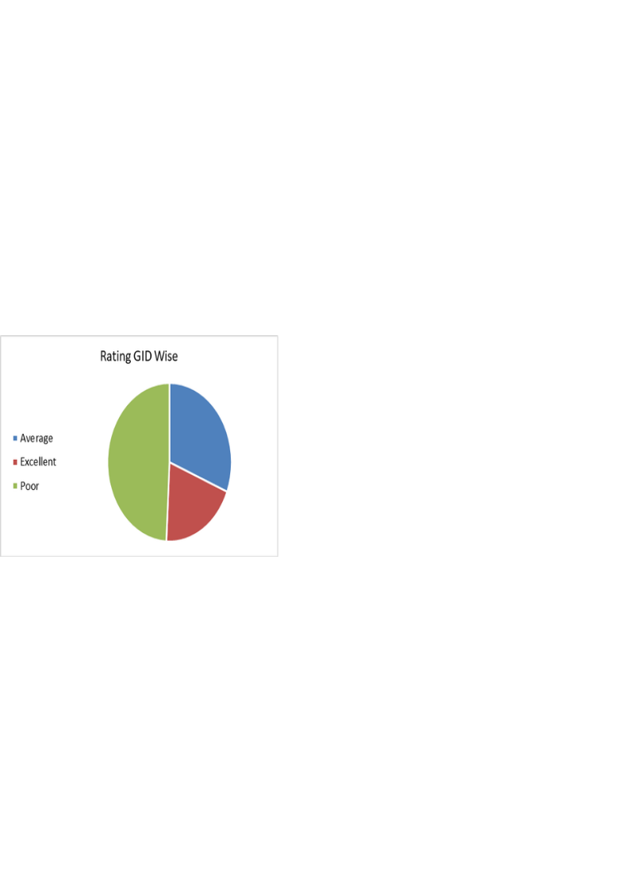

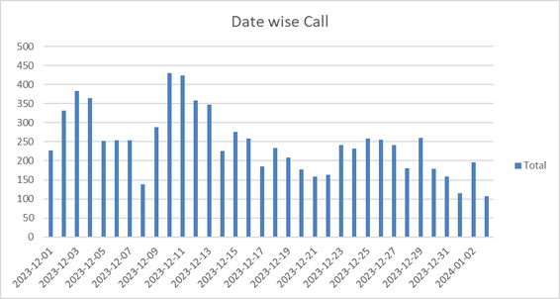

- How does AstroSage's call center performance compare to AstroGuru's average call volume, customer satisfaction, and agent performance. Will you use any aggregation function or a visualization here to solve the problem?
Answer
Reference Subjective Sheet of Q.3
There is no data provided for the AstroSage"s call center performance
AstroSage: Known for its strong online presence and free services, AstroSage likely handles a high call volume, especially for paid consultations.
AstroGuru: Positioned as a premium service with celebrity astrologers, AstroGuru may have a lower call volume but potentially higher-value calls.
Comparison
AstroSage might have a higher call volume due to broader accessibility, while AstroGuru could focus on quality over quantity.
AstroGuru may lead in customer satisfaction due to stricter quality control, whereas AstroSage’s satisfaction may vary based on free vs. paid services.

- How can the call center improve its handling of peak call periods to ensure high customer satisfaction? Mention the functionality you will use for giving the suggestions, will it be any aggregated function or a visualization?
Answer
Reference Subjective Sheet for Pivot and chart of Q.4
Approach
- Creating a pivot table hour range in row and “call” type consultant in value and consultant type in filter to filter out “chat”.
- Now creating column chart to visualize the peak hour in which most of call are made.
By This below Insight we get the Peak hours, low call hours and Count of ID

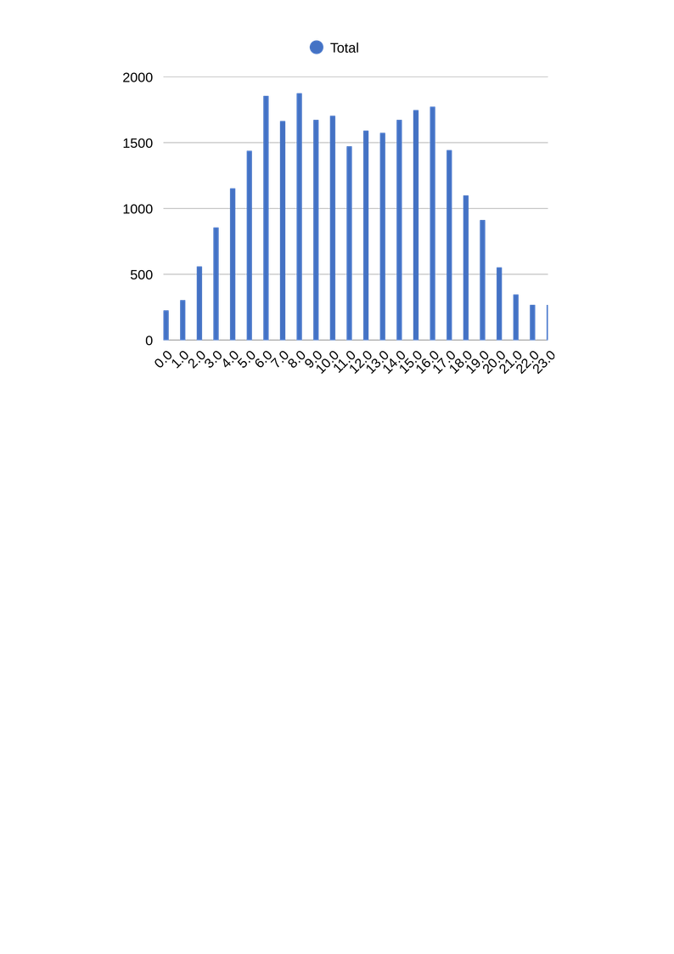

Insights
- The column chart shows that call volume increases steadily from early morning hours (03:00 onwards).
- Peak call volume is observed between 08:00 and 18:00, with the highest number of calls occurring during mid-day hours.
- Call volume drops significantly after 18:00, indicating low demand during late evening and night hours.
- Early morning and late-night hours have the lowest call traffic, suggesting underutilized capacity.
Recommendation
- Increase staff during peak hours (08:00-18:00) to handle the high call volume and reduce wait times.
- Implement automated systems or chatbots for common queries during peak hours to reduce the load on human agents.
- If the data includes different consultation types, analyze each type separately to identify specific patterns.

- Based on historical data, what strategic initiatives should be prioritized to improve efficiency and customer satisfaction?
Answer
Reference Subjective Sheet for Pivot and chart of Q.5
Approach 1
- Based on historic data we can check the ratings of websites, to get the idea where needs to prioritized to improve efficiency for customer satisfaction.
- Creating Pivot Table Website in row and rating in value to get the average rating of each individuals.
Observation
- Dashboard has the highest average rating (4.50), showing strong user satisfaction and good performance.
- Gurucool has the lowest average rating (2.72), indicating user dissatisfaction and a need for immediate improvement.
- The overall average rating is low (2.93), which shows that customer satisfaction across platforms is below expectations.

Approach 2
- Based on historic data we can check the ratings of websites, to get the idea where needs to prioritized to improve efficiency for customer satisfaction.
- Creating Pivot Table using Consultation type in row and average of rating in values to get the idea about consultations review.
Observation
- Complementary consultations have the highest rating (4.50), suggesting users are very satisfied with this service.
- Chat consultations have the lowest rating (2.69), indicating poor user experience and quality issues.
- Call and public live calls have average ratings (around 3–3.5), showing acceptable but improvable performance.
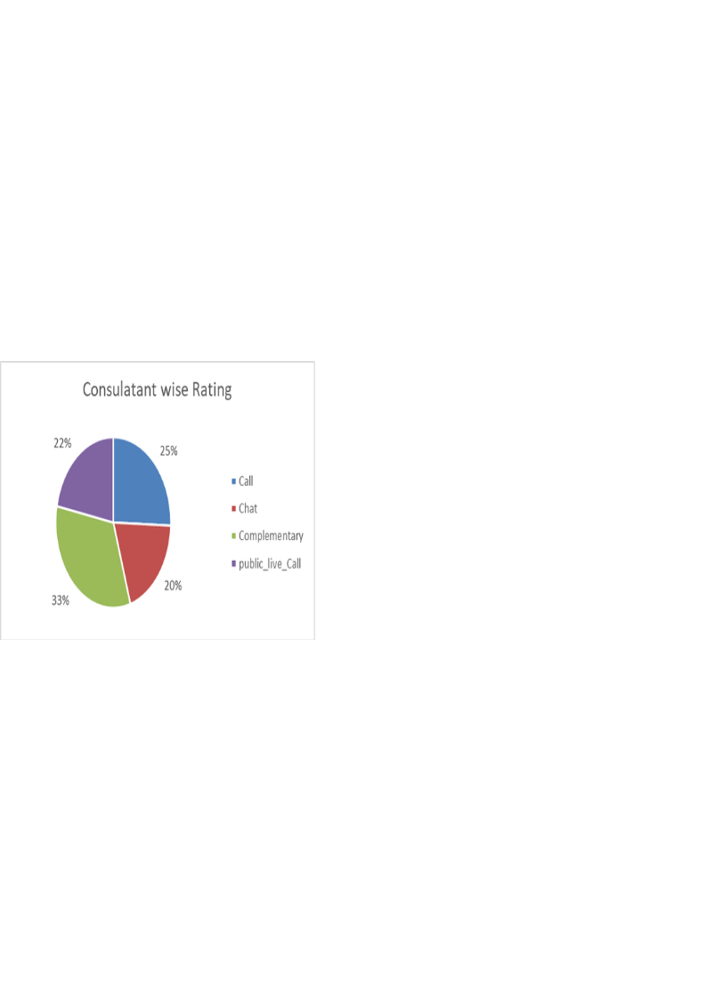

Recommendation
Focusing on improving low-rated websites and chat consultations will have the biggest impact on overall customer satisfaction.
- What can be the key factors contributing to high customer satisfaction scores, and how can these be leveraged to improve overall performance? What is the basis for the suggestions? And mention how you decided if the satisfaction score affects the ratings.
Answer
Reference Subjective Sheet for Pivot and chart of Q.6
Approach 1
- Grouped chat interactions by chat status (completed, failed, incomplete, etc.) using a pivot table.
- Calculated the count of ratings for each chat status to understand volume distribution.
- Analyzed which chat outcomes contribute most to overall customer experience.

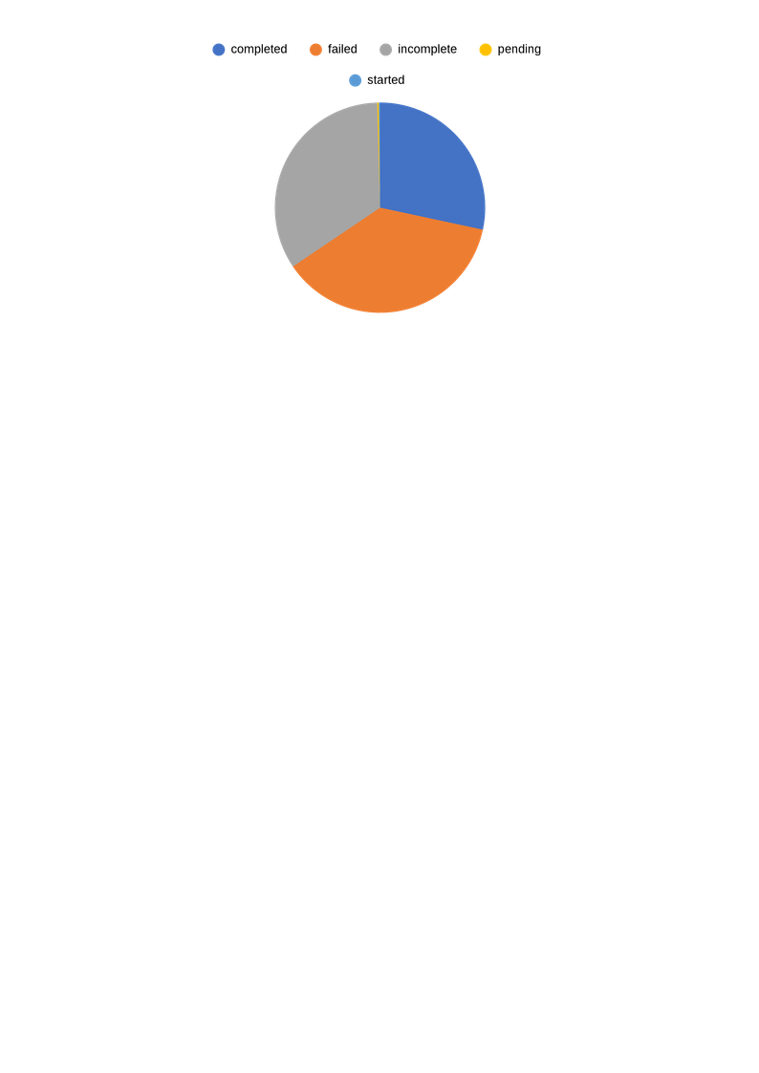

Observation
- Failed chats (7,256) and incomplete chats (6,641) form the largest share of chat interactions.
- Completed chats (5,535) are significantly lower compared to unsuccessful chat outcomes.
- Pending (48) and started (35) chats have negligible impact on overall performance.
Approach 2
- Segregated call interactions by call status such as completed, no-answer, busy, and failed.
- Used count of ratings to measure call handling effectiveness.
- Compared successful and unsuccessful call outcomes to assess service efficiency.

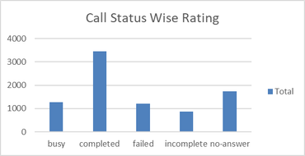

Observation
- Completed calls (3,453) have the highest count, indicating better resolution in call services.
- No-answer (1,729) and busy calls (1,270) together represent a significant portion of missed customer connections.
- Failed (1,214) and incomplete calls (875) highlight operational gaps in call handling.
Approach 3
- Grouped data by service type (Chat, Call, Complementary, Public_live_Call) and Calculated the average customer rating for Consultant
- Compared satisfaction levels across services to identify high and low performer

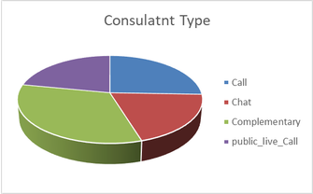

Observation
- Complementary service has the highest average rating (4.50), indicating strong customer satisfaction.
- Chat service has the lowest average rating (2.69), aligning with its high failure and incomplete rates.
Recommended
Astrosage should focus on completing more customer interactions, especially in the Chat service, because it has the most failed and incomplete chats and the lowest ratings. Improving system performance, ensuring enough agents are available, and following up on missed or unfinished chats and calls will help customers get their issues resolved. Reducing failures and responding on time across all services will lead to better customer satisfaction and higher overall ratings.
- How should the call center balance the workload among agents to ensure optimal performance and avoid burnout. Mention your approach and spreadsheet function for the answer.
Answer
Reference Subjective Sheet for Pivot and chart of Q.7
Approach 1
- Creating a pivot table with GID in rows and average rating in values.
- This help us to analyze how each guru is efficient and which guru is satisfied and which is less.
- Creating Chart to visualize the guru rating factors.

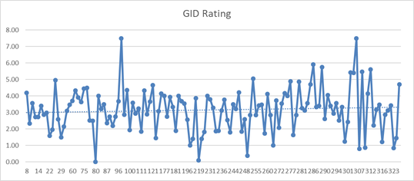

Observation
- The overall average rating is 2.93, showing that agent performance is below expectation.
- Ratings vary widely across GIDs, indicating uneven workload and performance levels.
- Low-rated agents may be overloaded or need support, while high-rated agents can handle more.
Approach 2
- Creating a pivot table with GID in rows, call volume and chat volume of respective guruID.
- This help us to analyze how each guru is efficient and which guru is overburdened and which is less.

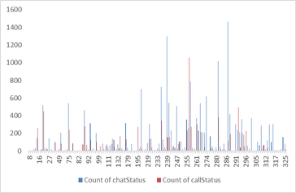

Observation
- Chat volume (19,515) is much higher than call volume (8,541), making chats the main workload for agents.
- Workload is uneven across GIDs, with some agents handling very high volumes while others handle very few.
- Agents with high chat and call loads are at higher risk of overload and burnout.
Recommendation
Work should be shared evenly among agents to avoid overload and burnout. Agents with high workload and low ratings need support or reduced load, while high-rated agents can handle complex cases with proper limits. Since chat volume is much higher than calls, more agents should be assigned to chats. Regular monitoring will help improve performance and customer satisfaction.
- What new technologies or tools could be implemented to enhance call center operations and customer service?
Answer
Reference Subjective Sheet
These technologies not only streamline operations but also elevate the overall customer experience.
1. AI-Powered Chatbots and Virtual Assistants
- Automate responses to common queries, reducing agent workload.
- Provide 24/7 support and seamless handoffs to human agents for complex issues.
2. Cloud-Based Contact Center Solutions
- Enable remote work for agents with secure, scalable, and cost-effective infrastructure.
- Offer flexibility and easy integration with other tools.
3. Workforce Management Software
- Optimize agent scheduling based on call volume predictions.
- Monitor performance and provide real-time feedback.
4. Real-Time Collaboration Tools
- Facilitate instant communication between agents and supervisors for quick problem-solving.
- Enhance teamwork and knowledge sharing.
5. Predictive Dialers and Call Routing
- Automate outbound calls and prioritize high-value leads.
- Use intelligent routing to connect customers with the most suitable agents.
6. Advanced Analytics and Reporting Tools
- Track key performance indicators (KPIs) and customer satisfaction metrics.
- Use data-driven insights to refine strategies and improve service quality.

- What metrics should be included in the final dashboard to comprehensively view call center performance and guide investment decisions?
Answer
This dashboard gives a complete view of our call center's health. By tracking efficiency, customer satisfaction, and costs, we can identify exactly where to invest money and resources to get the best results
In Dashboard which can be included for Call Center Performance.
1. Operational Performance Metrics
- Total Consultations
- Total User Calls
- Hourly Call Volume Distribution
- Daily Call Volume Trend
Insight & Investment Impact:
These metrics help identify peak and low call periods, enabling better workforce planning. High call volumes during specific hours indicate the need for additional staffing or automated support systems during peak times
2. Service Quality & Customer Satisfaction
- Average Rating: The overall score customers gives our service.
- Rating Distribution: A breakdown of how many users gave 1 to 5 stars.
- Call/Chat Completion: The percentage of sessions successfully finished versus those dropped.
Investment Insight & Impact:
By looking at ratings and completion rates together, we can see where service is failing. If many calls are dropped or ratings are low, it shows we need to invest in better agent training, smoother processes, or upgraded technology to handle calls more reliably.
3. Financial & Revenue Performance
- Total Revenue: Total money collected from customers.
- Total Net Amount: The final profit after all costs are deducted.
- Astrologer Earnings: The total payout made to service providers.
- Revenue by Service Type: A breakdown of earnings from different categories (e.g., Call, Chat).
Investment Insight & Impact:
These metrics show exactly where the money is coming from. By seeing which services are most profitable, management can decide where to increase marketing, adjust pricing, or improve low-earning channels to boost overall profit.
4. Platform & Channel Performance
- Website Comparison: Shows which websites are generating the most consultations.
- Call vs. Chat Revenue: Compares which method (Call or Chat) brings in more money.
- Completion Rates: Compares how many Calls vs. Chats are actually finished successfully.
Investment Insight & Impact:
This data shows which platforms and tools are the most effective. It helps leadership decide where to upgrade technology, which websites to promote, and which communication channels (Call or Chat) deserve more budget and staffing.

- How would you allocate a 1 crore rupee investment to optimize operational efficiency, enhance customer satisfaction, and boost profitability, and what analysis-based recommendations would you offer to support this?

- Technology Enhancements.
- Invest in cutting-edge technology to streamline operations and deliver better customer experiences:
- Implement or improve customer relationship management software for efficient tracking of customer queries and resolutions.
- Workforce Development
- Skill Development Offer advanced training in customer handling, empathy, and product knowledge.
- Employee Wellness Initiatives programs aimed at reducing burnout (e.g., flexible schedules, counseling support).
- Customer-Centric Initiatives
- Establish robust systems (e.g., post-call surveys, sentiment analysis tools) to capture customer feedback.
- Create rewards for long-term customers to build stronger relationships.
- Operational Improvements
- Invest in predictive tools for managing high-call periods effectively.
- Streamline workflows using lean methodologies to eliminate inefficiencies.
- Analysis-Based Recommendations

- Leverage predictive analytics to assess ROI on investments.
- Regularly measure metrics like AVERAGE HANDLING TIME, CUSTOMER SATISFACTION SCORE, and employee satisfaction to track progress and adjust strategies
DASHBOARD LINK:AstroSage_Analysis(Mohammedsadiq).xlsx

