Name : G.MOHAN SAI
Exercise 1: Implementing the Singleton Pattern
class BankConfig {
private static BankConfig instance;
private String bankName;
private double interestRate;
private BankConfig() {
bankName = "ABC Bank";
interestRate = 7.5;
}
public static BankConfig getInstance() {
if (instance == null) {
instance = new BankConfig();
}
return instance;
}
public String getBankName() {
return bankName;
}
public double getInterestRate() {
return interestRate;
}
public void updateInterestRate(double rate) {
interestRate = rate;
}
}
public class Main {
public static void main(String[] args) {

BankConfig config1 = BankConfig.getInstance();
BankConfig config2 = BankConfig.getInstance();

System.out.println("Bank Name: " + config1.getBankName());
System.out.println("Interest Rate: " + config1.getInterestRate());

config1.updateInterestRate(8.0);

System.out.println("\nAfter Update:");

System.out.println("Config1 Rate: " +
config1.getInterestRate());

System.out.println("Config2 Rate: " +
config2.getInterestRate());

System.out.println("\nSame Object? " +
(config1 == config2));
}
}
OUTPUT:
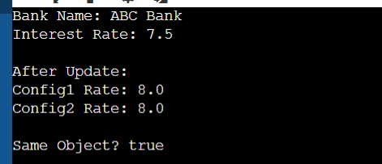

// Product Interface
interface Vehicle {
void start();
}

// Concrete Products
class Car implements Vehicle {
public void start() {
System.out.println("Car Started");
}
}

class Bike implements Vehicle {
public void start() {
System.out.println("Bike Started");
}
}

class Truck implements Vehicle {
public void start() {
System.out.println("Truck Started");
}
}

// Factory Class
class VehicleFactory {

public static Vehicle getVehicle(String type) {

if (type.equalsIgnoreCase("Car")) {
return new Car();
}
else if (type.equalsIgnoreCase("Bike")) {
return new Bike();
}
else if (type.equalsIgnoreCase("Truck")) {
return new Truck();
}

return null;
}
}

// Main Class
public class FactoryPatternDemo {

public static void main(String[] args) {

Vehicle v1 = VehicleFactory.getVehicle("Car");
v1.start();

Vehicle v2 = VehicleFactory.getVehicle("Bike");
v2.start();

Vehicle v3 = VehicleFactory.getVehicle("Truck");
v3.start();
}
}

OUTPUT:
