**Mohan BV**

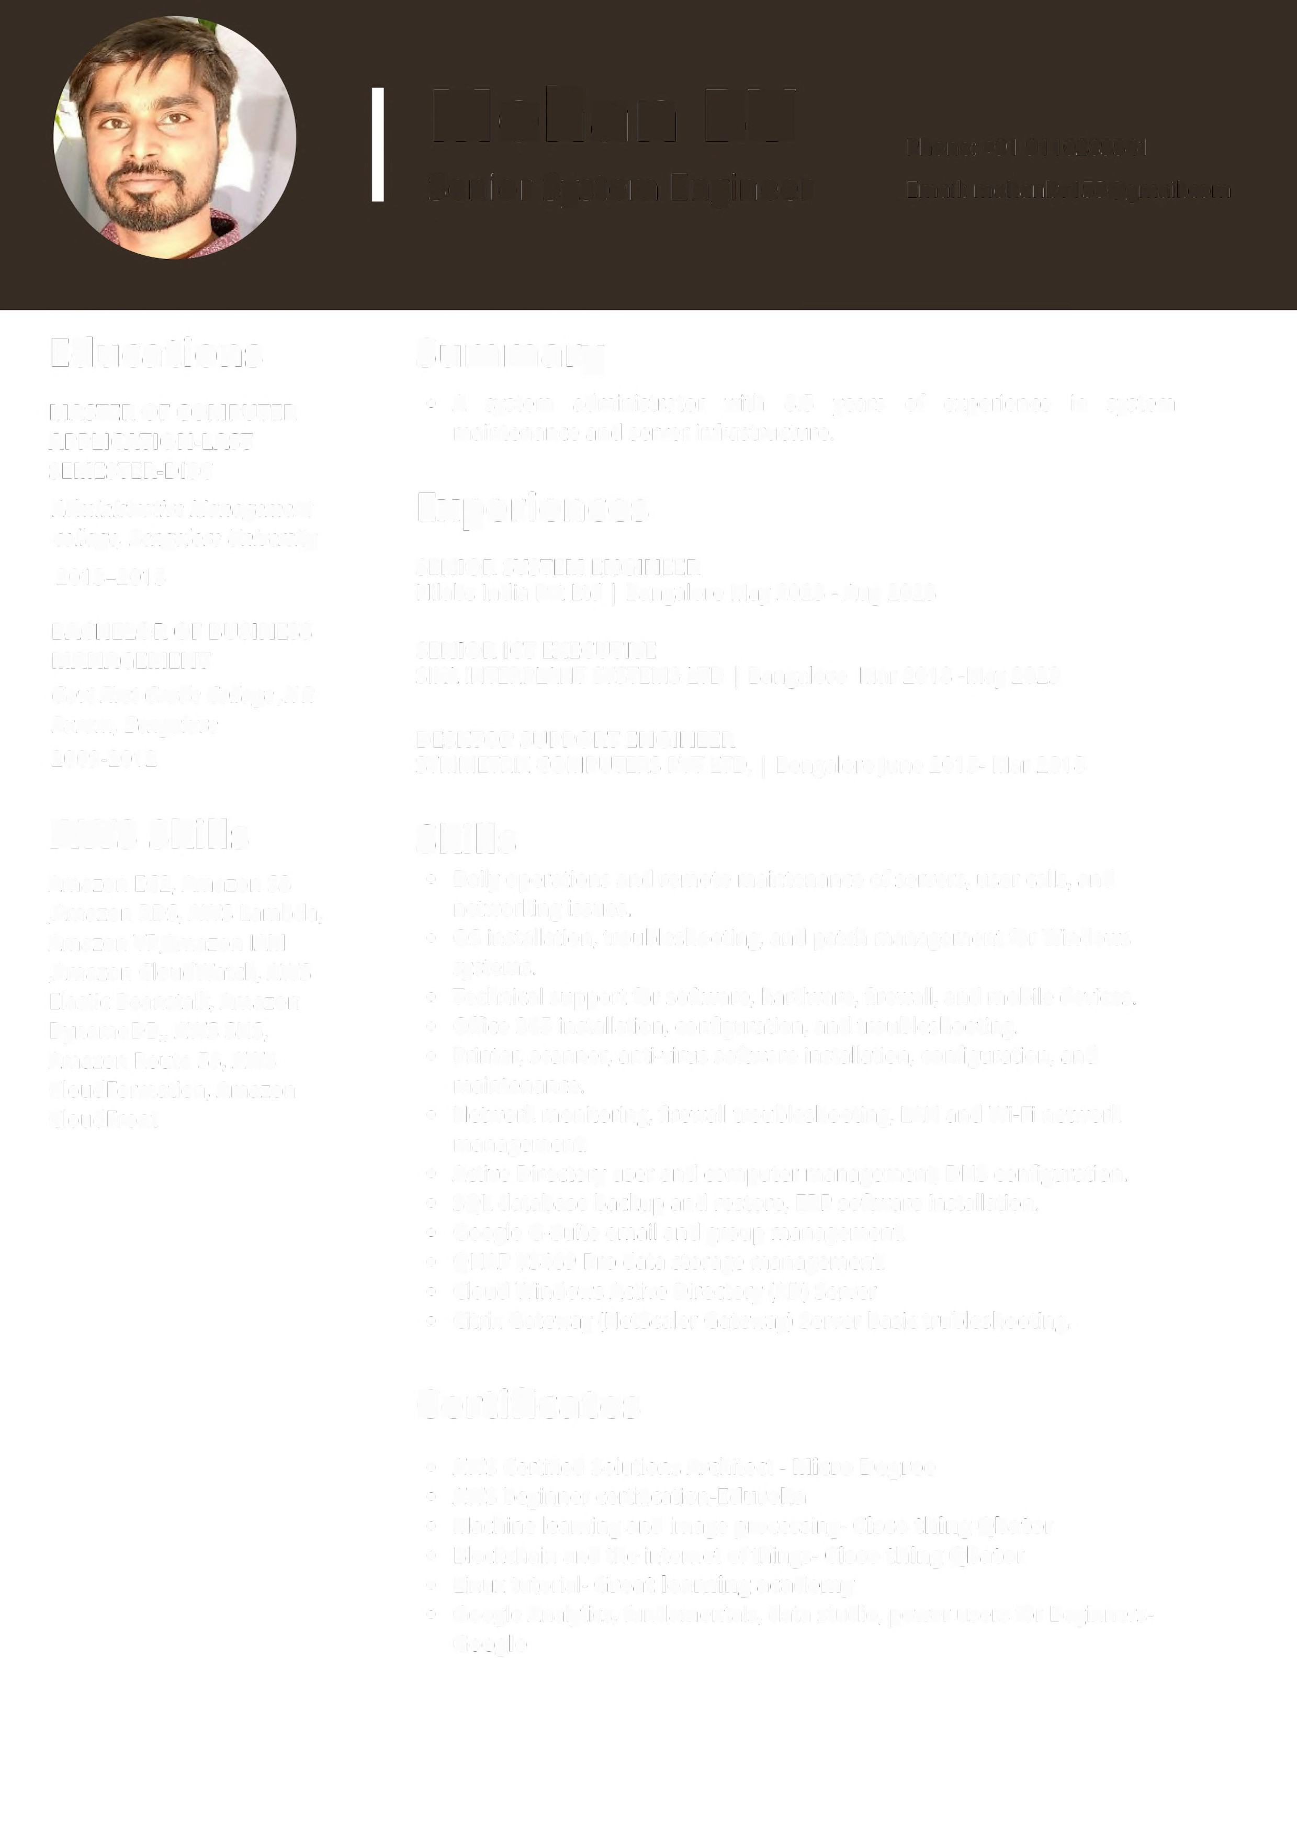

Senior DevOps Engineer

Phone:+91 9110285541

Email: [mohanbv153@gmail.com](mailto:mohanbv153@gmail.com)

**Professional Summary:**

* Having around **3+ years of experience** as a **Senior DevOps Engineer**, Support and Maintenance in environments like windows, RedHat Enterprise Linux, Centos and focus on DevOps tools and AWS Cloud Architecture.
* "Proficient in AWS and its services, including **IAM**, **VPC**, **EC2**, **EBS**, **S3**, **ELB**, **Auto Scaling**, **Route 53**, **CloudWatch**, **SNS**, and **Lambda**, I have extensive experience in designing customized VPCs, subnets, NAT configurations, and Security groups, ensuring a tailored and secure infrastructure environment."
* Utilizing multiple EC2 instances, Auto Scaling, Elastic Load Balancer, and AMIs, I meticulously crafted robust, cost-efficient, and fault-tolerant systems, ensuring high availability and reliability."
* Facilitating interconnectivity with AWS resources located in a different Virtual Private Cloud (VPC) within another geographical region through the implementation of AWS VPC Peering.
* Configured **S3 buckets** with various life cycle policies to archive the infrequently accessed data to Storage classes based on requirement.
* Creating alarms in **CloudWatch** service for monitoring the server performance, CPU Utilization, disk usage.
* Used Amazon **RDS** to create database snapshots and automate backups.
* I have experience with essential DevOps tools such as **Ansible**, **Docker**, **Kubernetes**, **Git**, **Jenkins**, and **Maven**, as well as AWS managed services including EC2, S3, Route 53, ELB, and EBS.
* I have extensive hands-on experience in creating Jenkins jobs, installing plugins, and configuring distributed builds using the master/slave architecture.
* Automated deployment of builds to different environments using Jenkins.
* Automate Deployment using configuration Management & automation tool like **Ansible** to Continuous Deployments.
* Experienced in in utilizing build automation scripting tools like **Maven** to build deployable artifacts (JAR, WAR) from source code.
* Worked experience in provisioning AWS instances using Infrastructure as Code (IaC) tools like **Terraform**.
* Experience in using **Tomcat** and Apache web servers for deployments.
* Experience in **Docker** like creating Docker images, containers, Dockerfile, tagging and publishing to Docker Hub.
* Setting up Kubernetes using EKS, KOPS and Kubeadm.
* Configuring Persistent volumes (PVs), PVCs for persistent database environments.
* Worked on demonsets, configMaps, Secretes, etc.

**Work Experience:**

Working as senior system engineer **Hilabs India Pvt Ltd** Bengaluru India, from May 2023 to Aug 2023

Working as Senior ICT Executive in **Sika Interplant Systems Ltd** Bengaluru India, from March 2018 to May 2023.

Desktop support engineer **Symmetrix Computers Pvt ltd**, Bengaluru India, from June 2015- Mar 2018

**Technical/ Functional Summary:**

|  |  |
| --- | --- |
| **Operating systems** | RHEL6.7, Centos 7, Amazon Linux 2 |
| **Version Control Tools** | GIT |
| **CI/CD tools** | Jenkins |
| **Provisioning tool/Infrastructure as Code** | Terraform |
| **Configuration Management Tools** | Ansible |
| **Containerization & Orchestration Tool** | Docker, Kubernetes, Docker Compose |
| **Scripting languages** | Bash Shell Scripting |
| **Application server** | Apache Tomcat, |
| **Build Tools** | Maven, Gradle, Ant |
| **Cloud Platform** | Amazon Web Services: Elastic Compute Cloud (EC2), Simple Storage Services (S3), Route 53, Cloud Front, Virtual Private Cloud (VPC), Elastic Load Balancer (ELB), Auto-Scaling, IAM Roles |

**Roles & Responsibilities:**

* Used **Git** Hub repository to run **Jenkins** job for Continuous Integration.
* Installing and Configuring Jenkins, installing plug-in, configuring security, creating a master and slaves for implementation of multiple parallel builds.
* Designed and documented CI/CD tools configuration management.
* Managing the working environments through configuration management tool **Ansible.**
* Working on **Ansible Playbooks** to bring the required infrastructure changes.
* Automated deployment of builds to different environments using **Jenkins**.
* Experience in **Docker** like creating Docker images, containers, Docker files, tagging and pushing to Docker Hub.
* Created and managed multiple containers using **Kubernetes**. And creating deployments using Yaml code.
* Performing regular tasks, such as cloning repositories, pulling updates, creating branches, and merging changes, is essential for maintaining an efficient and collaborative software development workflow.
* Responsible for creating Artifacts using **Maven** and deploying those artifacts into **Tomcat application Server**.
* Setting up **EC2 instances** and prerequisites on the instances for deploying the applications.
* Designing and deploying **AWS** solutions using EC2, S3, Elastic Load balancer (ELB), auto scaling groups.
* Provisioning of AWS instances using **Terraform** and creating modules to create infrastructure of aws.
* Experienced on writing JSON code for creating infrastructure.
* Experienced in creating multiple **VPCs**, both public and private subnets, as per project requirements, and successfully established connectivity to AWS resources in a different VPC located in another region through AWS **VPC Peering**.
* Used security groups, network **ACL**'s, internet gateways and route tables to ensure a secure zone for organization.
* Launching Amazon EC2 cloud instances using Amazon Web Services and configuring them to meet specific application requirements.
* Defined **AWS Security Groups** which acted as virtual firewalls that controlled the traffic allowed reaching one or more AWS EC2 instances.
* I have created **S3 buckets**, managed access policies for these buckets, and effectively utilized both S3 bucket and Glacier for storage and backup purposes on AWS.
* I have employed **CloudWatch** to establish alarms for notifications and automated actions, as well as to monitor logs, enhancing system understanding and operational efficiency.
* Strong working knowledge on **GIT**.
* Installed and configured **Nexus** artifact repository for sharing artifacts between internal teams.
* Used Maven dependency management system to deploy both SNAPSHOT and RELEASE artifacts to **Nexus**, enabling the sharing of artifacts across multiple projects.
* Configured and managed Git plugins in **Jenkins** **CI**/**CD** like GitHub, Maven Integration, Publish Over SSHVersion etc..
* Responsible for configuring the slave nodes in **Jenkins.**

**Educational Qualification:**

Master of computer application – backlogs |Administrative Management collage, Bengaluru University 2013-2015

Bachelor of business management | Govt First Grade Collage | KR Puram, Bengaluru 2009-2012