EX.NO:10 MINI PROJECT

25/APR/2020



**AIM:**

To write python program for automating web browser using selenium and simple chat bot that can feel using chatterbot module.

**DESCRIPTION:**

Anyone can control web browser and chat with FRIDAY (‘personel assistant similar to cortana’) with voice commands.

**LIBRARIES USED:**

1.)*timet*🡪To freeze the css selectors until webpage loads the content

*2.)selenium🡪*Selenium WebDriver is a web-based automation testing framework which can test web pages initiated on various web browsers and various operating systems.

*3.)* *pyttsx3🡪*  library *t*o read out texts

*4.)speech_recognition🡪*Library for performing speech recognition, with support for several engines and APIs, online and offline. Speech recognition engine/API  used here is Google Speech Recognition

**WORKING**:

1.Start.

2. Import the above libraries.

3.tell your name

4.And tell what you want to do like open whatsapp,google etc…

5.tell exit or bye to end

6.End

**CODE:**

import speech_recognition as sr

from selenium import webdriver

from selenium.webdriver.common.keys import Keys

from selenium.webdriver.common.by import By

import time

import pyttsx3

import subprocess

def assistant_speaks(output):

engine = pyttsx3.init()

if output!=None:

print("Jarvis:",output)

engine.say(output)

engine.runAndWait()

def get_audio():

r = sr.Recognizer()

try:

with sr.Microphone() as source:

r.adjust_for_ambient_noise(source, duration=0.2)

print('Speak...')

audio = r.listen(source,phrase_time_limit = 4)

print("Stop..")

MyText = r.recognize_google(audio)

MyText = MyText.lower()

if MyText!=0 or MyText!=None:

print('You:'+MyText)

return(MyText)

except sr.RequestError as e:

get_audio()

except sr.UnknownValueError:

get_audio()

def automation(name):

driver = webdriver.Chrome('D:/chromedriver.exe')

driver.get("https://web.whatsapp.com/")

assistant_speaks("Please scan the bar code once the whatsapp window opens")

driver.implicitly_wait(600)

assistant_speaks("To whom you want to message"+name)

print('\a')

target = str(get_audio())

print('\a')

driver.find_element_by_xpath('//span[contains(@title,"Wiki")]').click()

while(1):

msg_box=driver.find_element_by_class_name('_1Plpp')

assistant_speaks("Tell your message sir!")

print('\a')

message=str(get_audio())

print('\a')

msg_box.send_keys(message+Keys.ENTER)

print('\a')

assistant_speaks("1 to continue,0 to end")

if str(get_audio()) in ['1',1,'one','One','ONE']:

continue

else:

print("Thank you for speaking to me :)")

break

assistant_speaks("anyother request sir?")

q=str(get_audio)

if q=="no":

exit()

else:

comments(name)

def googlesearch():

driver = webdriver.Chrome('D:/chromedriver.exe')

driver.get("https://www.google.com/")

searchbox=driver.find_element_by_name("q")

assistant_speaks("What do you want to search sir!")

while True:

while(1):

search=str(get_audio())

if search==0:

continue

else:break

searchbox.send_keys(search+Keys.ENTER)

assistant_speaks("I cant travel with you from here sir!")

assistant_speaks("Need to come back?")

c=str(get_audio())

if c in["Yes",'s','S','YES']:

driver.navigate().back()

else:

assistant_speaks("You can say exit anytime to close the googlechrome window")

text=str(get_audio)

if "exit" in str(text) or "bye" in str(text) or "sleep" in str(text):

assistant_speaks("Sure sir")

driver.close()

break

assistant_speaks("anyother request sir?")

q=str(get_audio)

if q=="no":

exit()

else:

comments(name)

def youtube():

driver = webdriver.Chrome('D:/chromedriver.exe')

driver.get("https://www.youtube.com/")

searchbox=driver.find_element_by_id("search")

assistant_speaks("What do you want to search sir!")

while True:

search=str(get_audio())

searchbox.send_keys(search+Keys.ENTER)

assistant_speaks("I cant travel with you from here sir!")

assistant_speaks("Need to come back?")

c=str(get_audio())

if c in["Yes",'s','S','YES']:

driver.navigate().back()

else:

assistant_speaks("You can say exit anytime to close the youtube window")

text=str(get_audio)

if "exit" in str(text) or "bye" in str(text) or "sleep" in str(text):

assistant_speaks("Sure sir")

deiver.close()

break

assistant_speaks("anyother request sir?")

q=str(get_audio)

if q=="no":

exit()

else:

comments(name)

def email():

driver = webdriver.Chrome('D:/chromedriver.exe')

assistant_speaks('To whom you want to send sir!')

email=str(get_audio()).lower()

if ' ' in email:

email="".join(email.split())

assistant_speaks('subject sir?')

c=str(get_audio())

assistant_speaks('what is the Message')

s=str(get_audio())

try:

driver = webdriver.Chrome('D:/chromedriver.exe')

driver.get("https://mail.google.com/mail/u/0/#inbox")

driver.find_element_by_id('identifierId').send_keys("rvikasni@gmail.com")

driver.find_element_by_class_name('CwaK9').click()

driver.implicitly_wait(100)

driver.find_element_by_name('password').send_keys("VivoDell3593"+Keys.ENTER)

driver.implicitly_wait(70)

driver.find_element_by_class_name('z0').click()

driver.implicitly_wait(100)

to=driver.find_element_by_name('to')

to.send_keys(email+"@gmail.com"+Keys.ENTER)

if c in ['nothing','none']:

pass

else:

sub=driver.find_element_by_name('subjectbox').send_keys(c+Keys.ENTER)

if s in ['nothing','none']:

pass

else:

driver.find_element_by_css_selector("div[aria-label='Message Body']").send_keys(s+Keys.ENTER)

driver.find_element_by_xpath("//div[text()='Send']").click()

driver.implicitly_wait(20)

assistant_speaks("message sent successfully sir!")

assistant_speaks("Need to send anyother message sir?")

a=str(get_audio())

if a in ["no"]:

assistant_speaks("okay sir!")

driver.quit()

except:

driver.quit()

email()

assistant_speaks("anyother request sir?")

q=str(get_audio)

if q=="no":

exit()

else:

comments(name)

def music():

driver = webdriver.Chrome('D:/chromedriver.exe')

driver.get("https://www.google.com/")

searchbox=driver.find_element_by_name("q")

assistant_speaks("Which song do you want to play sir!")

search=str(get_audio())

searchbox.send_keys(search+Keys.ENTER)

driver.implicitly_wait(50)

try:

driver.find_element_by_class_name('j0joJb').click()

except:

assistant_speaks("couldnt find {}".format(search))

assistant_speaks("please try again!")

music()

assistant_speaks("Need to come back? and search any other song sir?")

c=str(get_audio())

if c in["Yes",'s','S','YES','yes']:

driver.quit()

music()

assistant_speaks("You can say exit anytime to close the googlechrome window")

text=str(get_audio())

if "exit" in str(text) or "enough" in str(text) or "pothum" or 'niruthuda' in str(text):

assistant_speaks("Sure sir")

driver.close()

assistant_speaks("anyother request sir?")

q=str(get_audio())

if q=="no":

exit()

else:

comments(name)

def comments(name):

assistant_speaks("What can i do for you?")

text = str(get_audio()).lower()

if "exit" in text or "bye" in text or "sleep" in text:

assistant_speaks("Ok bye, "+ name+'.')

exit()

elif "whatsapp" in text:

assistant_speaks("sure sir")

automation(name)

elif "google" in text:

assistant_speaks("sure sir")

googlesearch()

elif "youtube" in text:

assistant_speaks("sure sir")

youtube()

elif ('email' in text) or ('gmail' in text) or ('Gmail' in text) or ('Email' in text) or ('mail' in text):

assistant_speaks('sure sir!')

email()

elif 'song' in text or 'music' in text:

assistant_speaks('sure sire!')

music()

else:

assistant_speaks("sorry i cant do that!")

comments(name)

def exit():

assistant_speaks('see you soon sir!')

code=subprocess.call(["python.exe",'exit.py'])

print(code)

if __name__ == "__main__":

assistant_speaks("Hey im Jarvis!")

assistant_speaks("Hello,Mohan")

comments("Mohan")

**WORKING OF SPEECH RECOGNITION:**

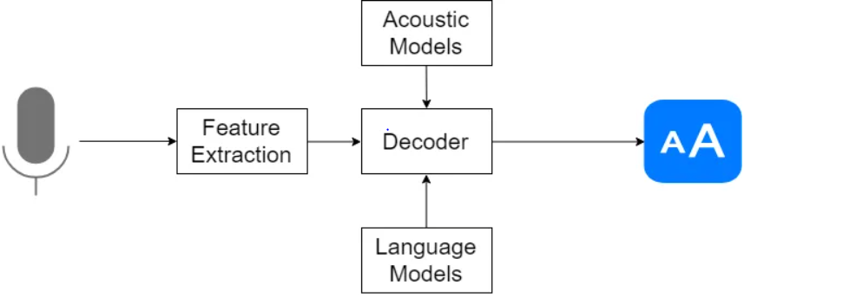

**SCREEN SHOT:**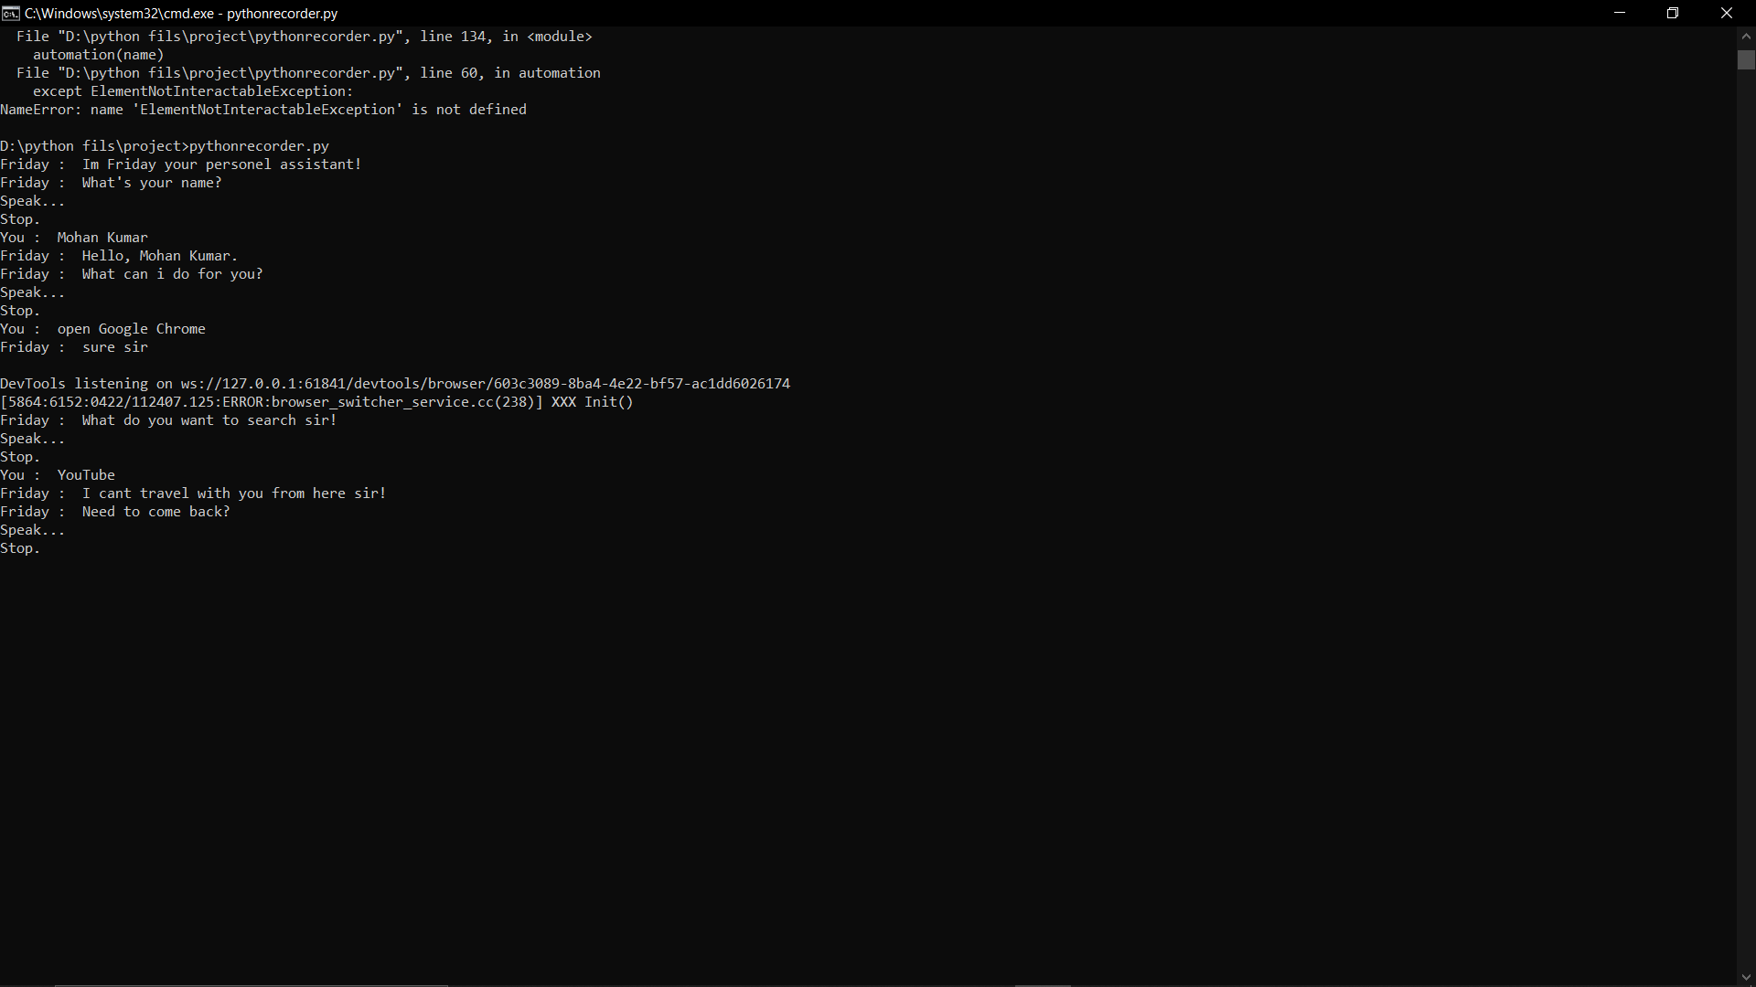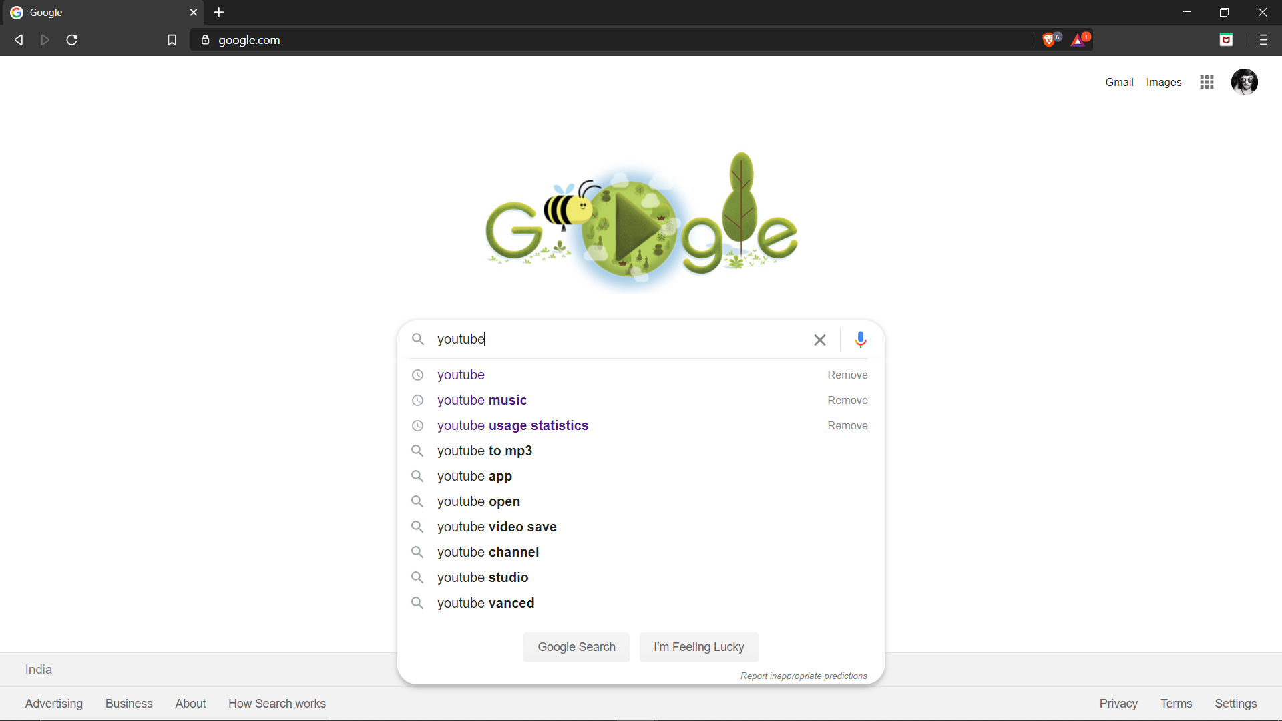 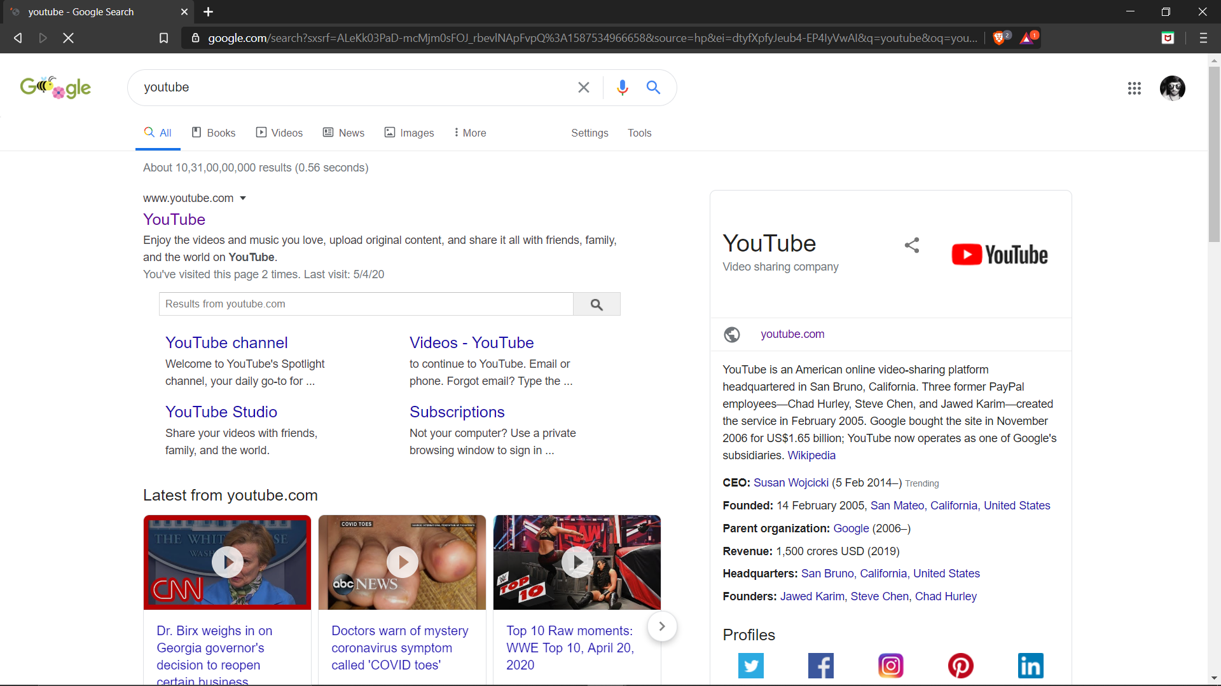

This just an example to show the working with voice command……

**CO-ATTAINMENT:**

*By this project I learned to automate web browswer and speech to text conversions*

**RESULT:**

*Thus the python program for personel assistant ‘****JARVIS****’ has worked and verified*

*…..*

Thank you..