TEAM 1

AI-Enabled Crop Disease Diagnosis and Remediation Support System with Native Language Assistance

Unit Testing Document

Back End: - (pytest)

- API TESTS
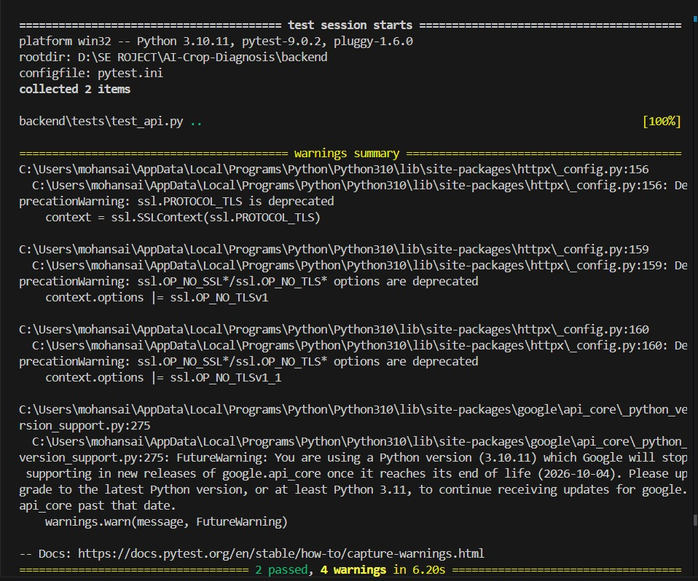

- Diagnosis Test
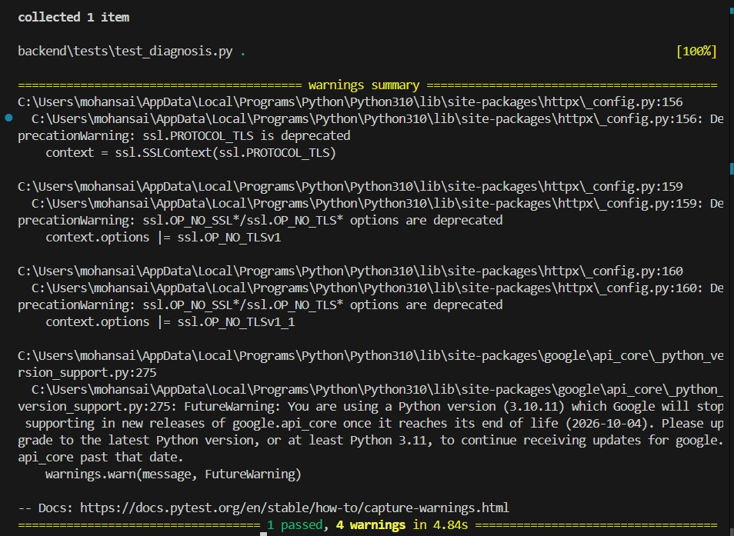

Front End:- (just)

UI Testing

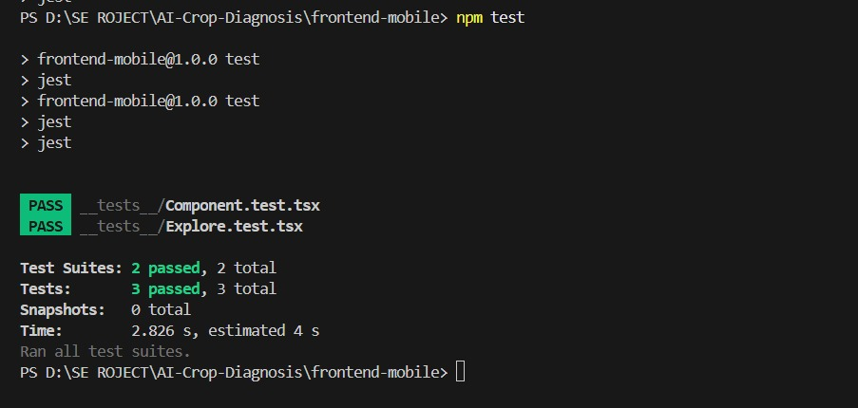
Integration Test:- (Post Man)

