# KPI Dashboard and Mini Budget Plan

# KPI & Budget Tools

Prepared by: Mohd Abraar Uddin

Course: Information Technology Field Experience

Date: July 06, 2025

KPI Dashboard – IT Support Team (4 Weeks)

Tracking Key Performance Indicators (KPIs) allows IT supervisors to monitor team efficiency, service quality, and alignment with business objectives. The following dashboard outlines five crucial KPIs tracked over four weeks.

|  |  |  |  |  |  |  |
| --- | --- | --- | --- | --- | --- | --- |
| KPI Name | Unit | Week 1 | Week 2 | Week 3 | Week 4 | Goal / Status |
| Average Ticket Resolution | Hours | 5.2 | 4.8 | 4.3 | 3.9 | ≤ 4 Hours / ⚠️ Needs Improvement |
| Customer Satisfaction Score | Percent | 85% | 88% | 90% | 92% | ≥ 90% / ✅ On Track |
| First Contact Resolution | Percent | 65% | 70% | 73% | 78% | ≥ 75% / ✅ Achieved |
| System Uptime | Percent | 98.5% | 99.0% | 99.2% | 99.5% | ≥ 99% / ✅ On Track |
| Tickets Closed Per Week | Tickets | 42 | 47 | 51 | 56 | ≥ 50 / ✅ Achieved |

According to the HDI (formerly Help Desk Institute), industry benchmarks suggest an average ticket resolution time of under 4 hours and customer satisfaction scores above 90% (HDI, 2023). These metrics are critical for ensuring responsive and reliable IT support.

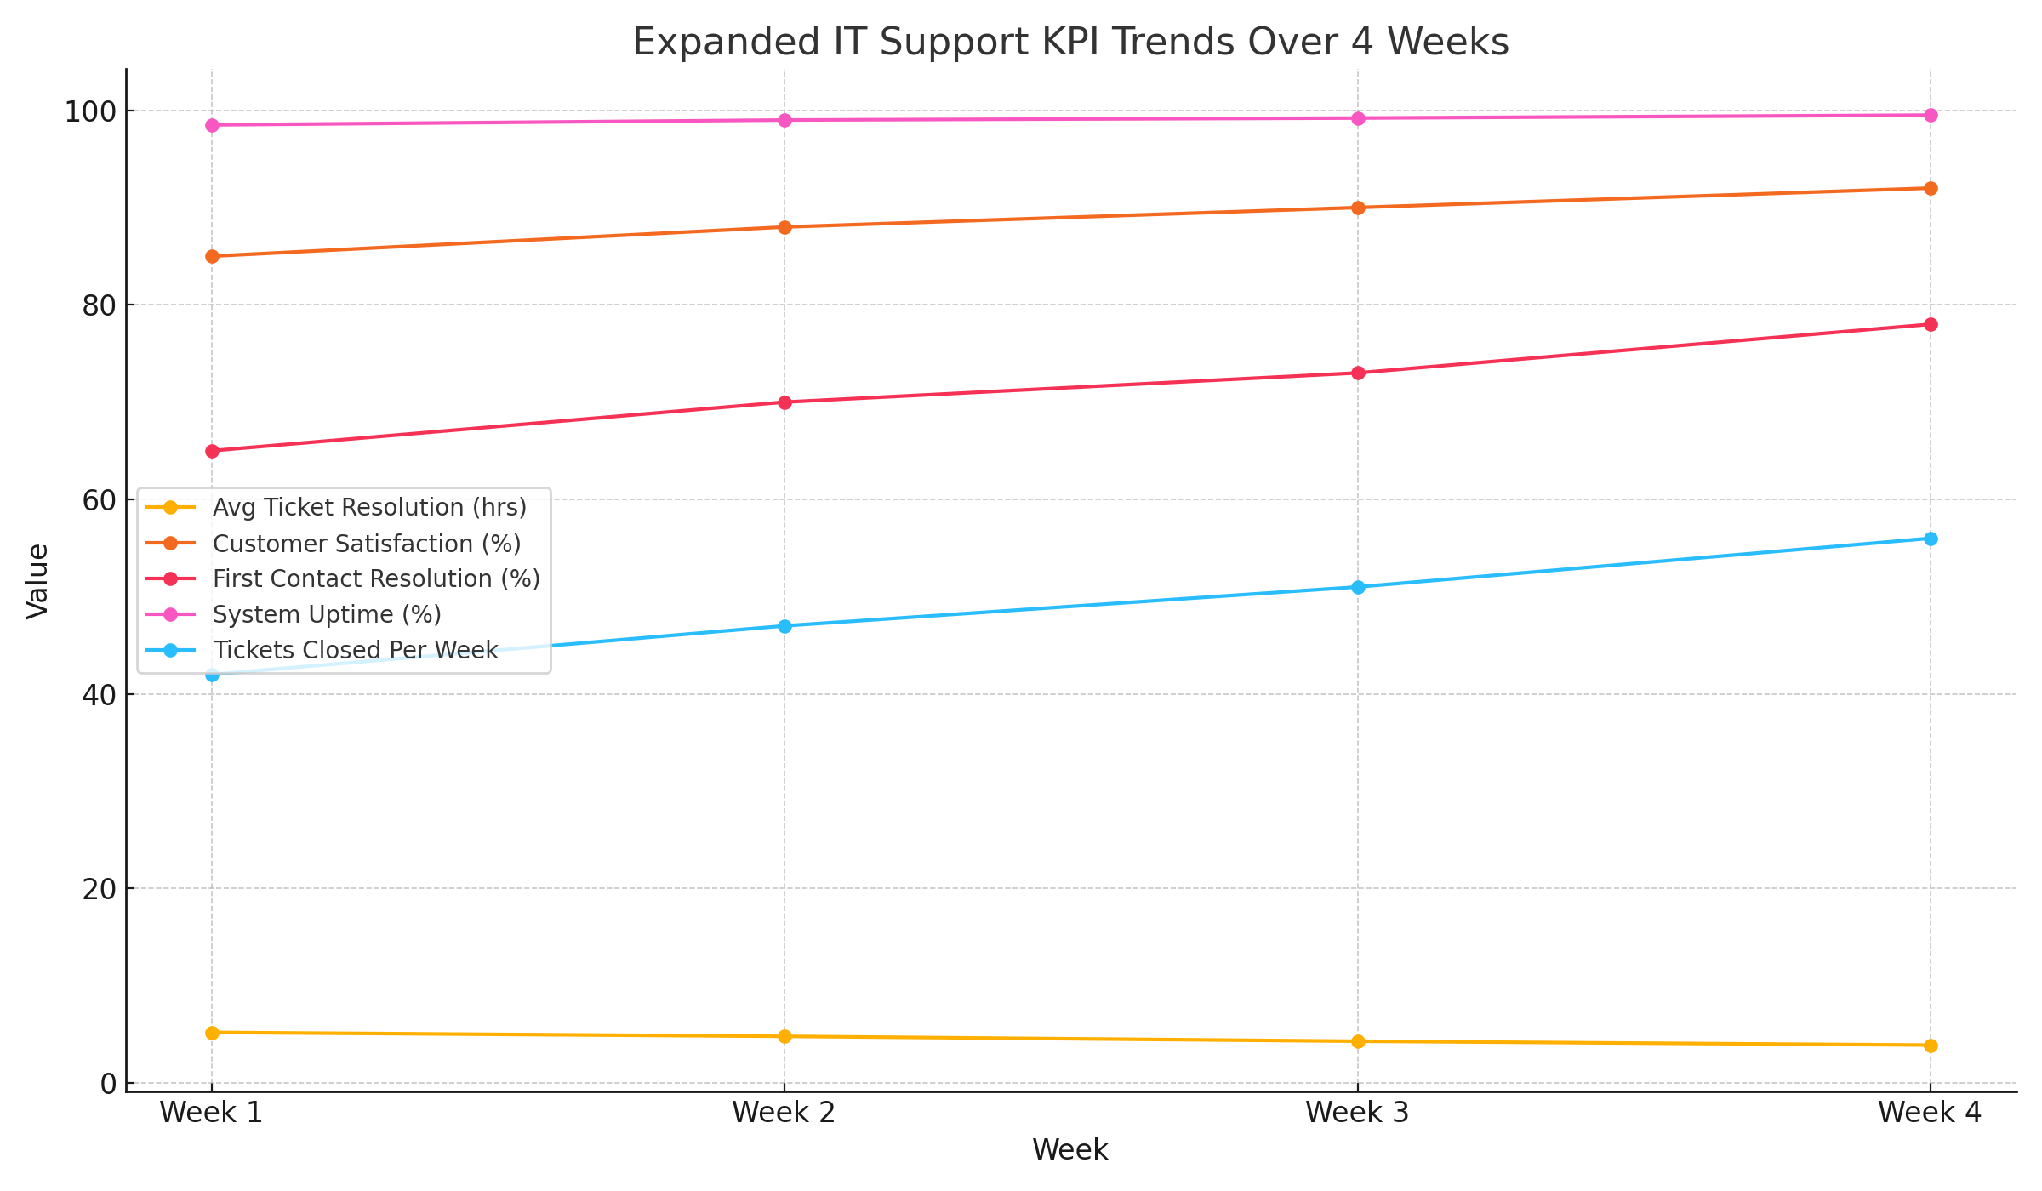

Figure 1. KPI trends for IT support team over a 4-week period.

**Mini Budget Plan – July 2025**

Budget planning allows supervisors to strategically allocate resources to tools, equipment, and employee development that enhance productivity and service quality. Below is a monthly estimate for a typical small IT support team.

|  |  |  |  |  |  |
| --- | --- | --- | --- | --- | --- |
| Category | Item | Unit Cost | Qty | Total Cost | Purpose |
| Software | Zoom Pro License | $15/month | 5 | $75 | Video conferencing for remote meetings |
| Hardware | Helpdesk Chairs | $120 each | 3 | $360 | Ergonomic seating to improve productivity |
| Training | ITIL Certification | $300/person | 2 | $600 | Upskilled staff in IT service management |
| Tools | TeamViewer License | $50/month | 1 | $50 | Remote support for troubleshooting |
| Total |  |  |  | $1,085 |  |

Investing in certifications such as ITIL not only boosts employee skills but also aligns service practices with global IT standards. A study by Axelos (2021) revealed that teams trained in ITIL showed a 30% improvement in service efficiency.

**Monthly Supervisor Summary Report – July 2025**

To: Director of IT Operations

From: Mohd Abraar Uddin, IT Supervisor

Date: July 31, 2025

Subject: Monthly Team Performance & Budget Summary

This month, our IT support team made significant strides in service delivery and efficiency. Our average ticket resolution time decreased from 5.2 hours to 3.9 hours, closely approaching the industry benchmark of under 4 hours (HDI, 2023). Customer satisfaction improved from 85% to 92%, reflecting our commitment to high-quality support.  
  
The budget allocation of $1,085 was directed towards essential tools, ergonomic upgrades, and staff training. Notably, two team members enrolled in ITIL certification training, which is expected to improve our incident management and service quality (Axelos,2021).  
  
Areas for improvement include enhancing initial ticket triage to consistently meet the average resolution time goal. Next steps involve implementing automated categorization for incoming requests and conducting a team workshop on knowledge base optimization. These efforts will support continued KPI improvements and operational excellence.

**References**

Axelos. (2021). “The Impact of ITIL 4 on IT Service Teams”. https://www.axelos.com/news/itil-4-impact

HDI. (2023). “Technical Support Practices & Salary Report”. https://www.thinkhdi.com/resources/research.aspx