CPEC/KKH Landslide Susceptibility Modelling
Current 2018 V3 model structure, results, domain transferability, and next steps
Item | Summary
Study focus | Landslide susceptibility for the CPEC region with special attention to KKH/CPEC infrastructure.
Main baseline year | 2018, because AlphaEarth annual embeddings are available from 2017 onward and 2018 is the validated baseline comparison year.
Main model | Spatial-CV Stacked Ensemble evaluated against Logistic Regression, Random Forest, Extra Trees, XGBoost, LightGBM, and CatBoost.
Main feature sets | Conventional; AlphaEarth Embeddings; Conventional + AlphaEarth Embeddings.
Current status | Core 2018 workflow is complete. Temporal 2017-2024 extension remains planned and partly staged.
Prepared | 2026-05-11

1. Executive Summary
- The project has produced a complete 2018 V3 landslide susceptibility framework for the official CPEC study area.
- The strongest result is not only high accuracy; it is a transferability-aware, explainable, reliability-aware model structure.
- The fused feature set, Conventional + AlphaEarth Embeddings, gives the best overall balance of discrimination, calibration, and spatial transferability.
- The domain analysis shows where the model generalizes well, where uncertainty is higher, and which controlling mechanisms dominate each subdomain.

2. Current Model Structure
The modelling design uses one validated CPEC-wide framework rather than separate regional models. This is important because it allows fair comparison among subdomains and directly tests spatial generalization.
Component | What was done | Why it matters
Official boundary | All samples and maps are clipped to the official CPEC study boundary. | Keeps the analysis spatially consistent.
Corrected factor database | Terrain, hydro-climate, vegetation, land cover, geology, soil, seismicity, road distance, river distance, and fault distance were included. | Covers physical, environmental, and infrastructure controls.
VIF gate | All final conventional factors passed global VIF screening; maximum final VIF = 3.88. | Reduces unstable or redundant predictors before modelling.
Model family | Seven model types were evaluated with spatial CV. | Shows that the chosen model is not an arbitrary single-model result.
Stacking | Base learners are combined through a Spatial-CV Stacked Ensemble. | Uses complementary model strengths while reducing reliance on any one learner.
Domain tests | Leave-one-domain-out tests were run for five CPEC subdomains. | Tests spatial transferability to withheld regions.
AOA | Area of Applicability and transfer confidence were generated. | Separates reliable predictions from extrapolated predictions.
Explainability | SHAP and TreeSHAP summaries were created globally and by domain. | Provides process interpretation, not just accuracy numbers.

3. Model Performance
The fused feature set produced the best overall performance. XGBoost and CatBoost gave the highest raw AUC values, while the Spatial-CV Stacked Ensemble gave the strongest balanced classification and lowest Brier score among fused models.
Feature set | Model | ROC-AUC | PR-AUC | Bal. acc. | F1 | Brier
Conventional + AlphaEarth Embeddings | XGBoost | 0.973 | 0.960 | 0.906 | 0.890 | 0.062
Conventional + AlphaEarth Embeddings | CatBoost | 0.972 | 0.959 | 0.900 | 0.880 | 0.062
Conventional + AlphaEarth Embeddings | Spatial-CV Stacked Ensemble | 0.972 | 0.957 | 0.914 | 0.897 | 0.060
Conventional | Spatial-CV Stacked Ensemble | 0.961 | 0.945 | 0.895 | 0.878 | 0.075
AlphaEarth Embeddings | Spatial-CV Stacked Ensemble | 0.951 | 0.922 | 0.879 | 0.860 | 0.082

Interpretation: the fused model improves over the conventional-only and embedding-only structures, showing that AlphaEarth provides complementary information rather than duplicating conventional factors.

4. Domain Transferability
Leave-one-domain-out means the model is trained on all other CPEC domains and tested only on the withheld domain. The values below therefore measure spatial generalization rather than ordinary random-split accuracy.
Held-out domain | Fused AUC | Fused PR-AUC | F1 | Brier | AOA | Uncertain high
Balochistan | 0.913 | 0.919 | 0.835 | 0.121 | 98.9% | 28.5%
Gilgit-Baltistan | 0.979 | 0.984 | 0.956 | 0.042 | 97.8% | 21.5%
KP-AJK | 0.976 | 0.973 | 0.929 | 0.057 | 90.7% | 30.8%
Kashgar (Xinjiang, China) | 0.965 | 0.957 | 0.880 | 0.065 | 98.9% | 10.5%
Punjab-Sindh lowland corridor | 0.990 | 0.954 | 0.878 | 0.033 | 98.2% | 5.2%

The fused model transferred strongly to all domains. Balochistan has the lowest AUC, which indicates that it is the most difficult transfer domain and likely has more distinct geomorphic or environmental controls. Punjab-Sindh has the highest AUC, but this should be interpreted with its simpler lowland contrast and smaller landslide-prone footprint in mind.
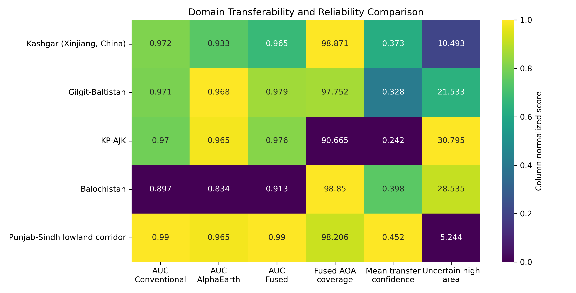
Figure 1. Domain transferability, Area of Applicability, and uncertainty comparison.

5. Area of Applicability and Reliability
ROC-AUC and PR-AUC evaluate ranking skill at sample points. Area of Applicability evaluates whether each mapped pixel is similar enough to the training data for the prediction to be trusted. This is why AOA is essential for a large corridor such as CPEC: a model can predict everywhere, but some locations are extrapolations.
- High probability inside AOA: stronger candidate for susceptibility interpretation and planning.
- High probability outside AOA: possible hotspot, but should be treated as uncertain and prioritized for field verification.
- Reliability-weighted probability is probability multiplied by transfer confidence; it is a secondary confidence-adjusted product, not the raw susceptibility probability map.
- Conventional reliability-weighted maps can look near zero where transfer confidence is low; this is expected and documented separately.

6. Domain Mechanisms From TreeSHAP
The domain-wise TreeSHAP analysis explains the XGBoost base learner within each feature set. It is used to identify dominant conditioning mechanisms while the Spatial-CV Stacked Ensemble remains the main predictive model.
Domain | Dominant fused-model mechanism groups
Balochistan | AlphaEarth embeddings (57.8%); Topography/morphometry (18.4%)
Gilgit-Baltistan | AlphaEarth embeddings (55.5%); Proximity controls (19.6%)
KP-AJK | AlphaEarth embeddings (57.3%); Proximity controls (16.9%)
Kashgar (Xinjiang, China) | AlphaEarth embeddings (53.8%); Proximity controls (20.7%)
Punjab-Sindh lowland corridor | AlphaEarth embeddings (60.6%); Topography/morphometry (21.7%)

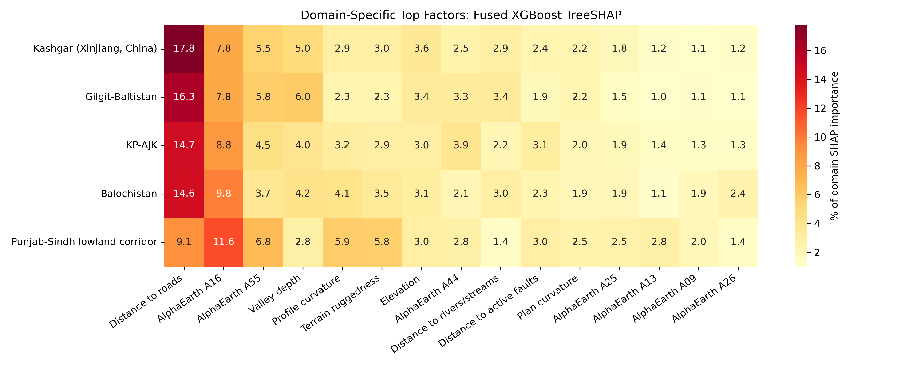
Figure 2. Domain-specific top TreeSHAP factors for the fused model.
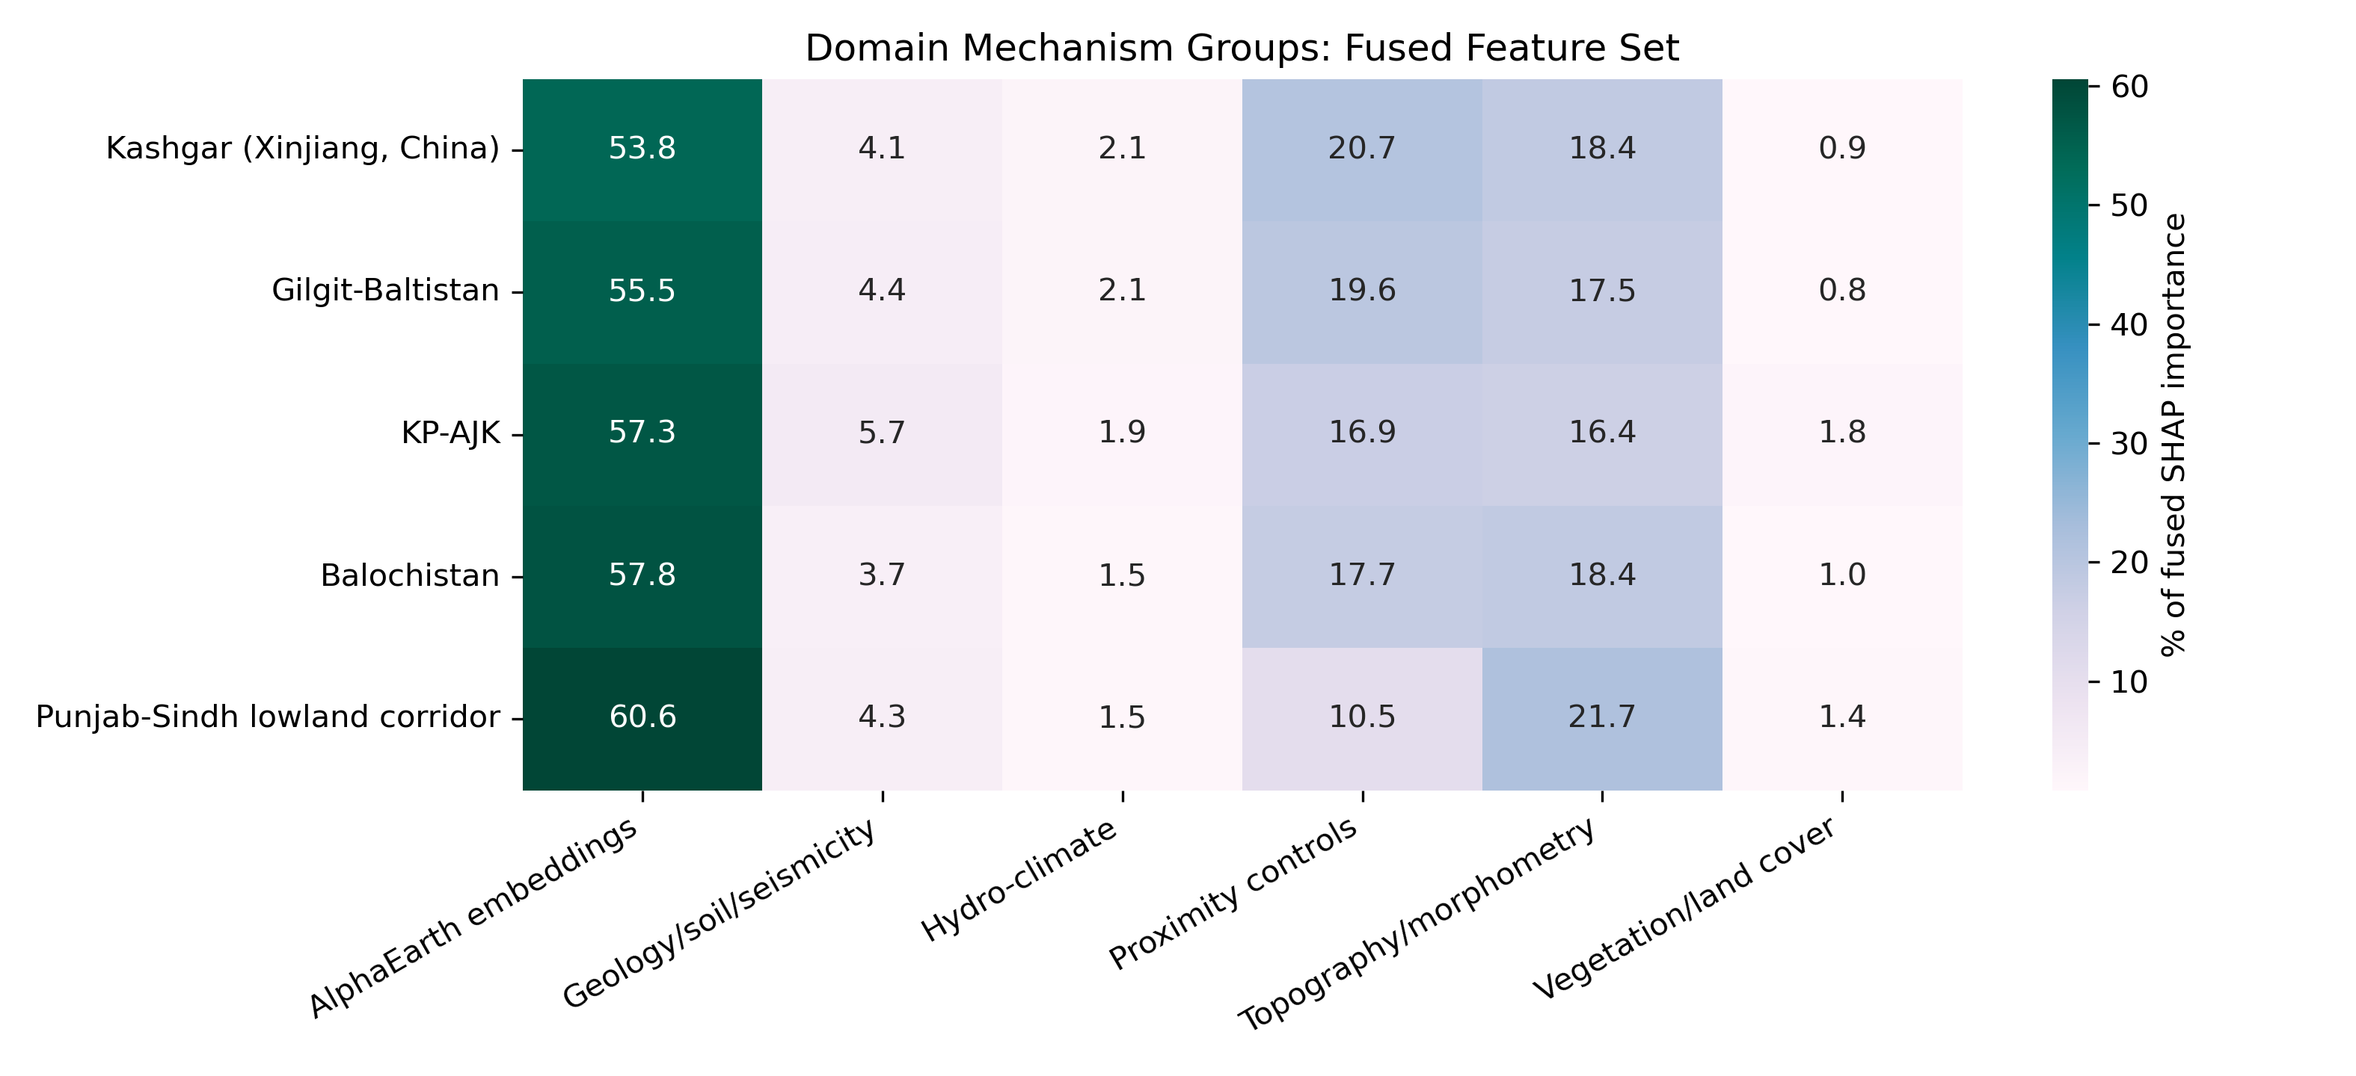
Figure 3. Domain mechanism groups from fused-model TreeSHAP importance.

7. Scientific Meaning of the Current Results
- The framework shows that AlphaEarth embeddings add useful surface-condition information to conventional landslide factors.
- The fused model is not only accurate; it is spatially tested through leave-one-domain-out validation.
- AOA and transfer-confidence maps show where predictions are reliable versus extrapolated.
- Domain-wise SHAP shows that the same CPEC-wide model can have different controlling mechanisms in different regions.
- Road exposure outputs turn susceptibility modelling into an infrastructure-relevant CPEC/KKH product.

8. Main Innovation
Proposed contribution: a transferability-aware, explainable, AlphaEarth-enhanced landslide susceptibility framework for the CPEC/KKH corridor.
This is stronger than a standard model-comparison paper because the workflow evaluates accuracy, spatial generalization, model applicability, factor mechanisms, reliability, and infrastructure exposure together.

9. Remaining Work
Task | Status | Recommended action
2018 core results | Mostly complete | Use this as the main paper foundation.
Figure selection | Needs final polish | Select the few strongest figures for main text and move the rest to supplementary material.
Temporal extension | Planned and partly staged | Use fixed 2018 model for compact 2017-2024 temporal stress-testing, not eight separate papers.
2020-2024 annual inputs | Pending | Export/download yearly GEE predictor stacks one year at a time.
Manuscript writing | Not yet complete | Convert this summary into Methods, Results, and Discussion sections.

10. Files to Open First
- README_START_HERE.md in the clean 2018 V3 results package.
- Domain comparison summary: domainwise_mechanism_and_transferability_interpretation_report.md.
- Temporal strategy: better_temporal_evaluation_strategy_2026-05-10.md.

11. Short Reference Basis
- Spatial/grouped CV reduces overoptimistic random-split accuracy.
- AOA links prediction reliability to similarity with the training space.
- TreeSHAP supports global and local interpretation for tree learners.
- AlphaEarth annual embeddings justify the 2017-onward temporal extension.

