Apparent emergent constraints on hyperarid extreme rainfall arise from predictand construction, sampling variability and post-processing
Mohib Ullah¹, Adam Fenech^{1,3,}*, Dan Scott², Xander Wang³, and Ross Gordon⁴
¹ Research and Excellence, Canadian University Dubai, City Walk, Al Wasl Road, Dubai, United Arab Emirates.
² Waterloo Climate Institute, University of Waterloo, 200 University Avenue West, Waterloo, ON N2L 3G1, Canada.
³ School of Climate Change and Adaptation, University of Prince Edward Island, 550 University Avenue, Charlottetown, Prince Edward Island C1A 4P3, Canada.
⁴ UTS Business School, University of Technology Sydney, 15 Broadway, Ultimo, NSW, Australia.
*Corresponding author: Adam Fenech; adam.fenech@cud.ac.ae

Abstract
Emergent constraints use present-climate observations to narrow projection spread, but their behaviour for a single arid country and statistically downscaled impact-assessment ensembles is untested. We evaluated eleven pre-specified observable predictors of projected change in wet-season extreme rainfall over the United Arab Emirates, spanning atmospheric process fidelity, present-day extreme-rainfall state, and present-day variability and historical change. Across 23 NEX-GDDP-CMIP6 models from 13 genealogical families, two domains and four emission scenarios, we ran 176 tests with one false-discovery correction and leave-one-family-out cross-validation. Eleven tests met every criterion, but all used predictors mathematically embedded in the projected-change metric (the predictand), all relationships were negative, and nine occurred under the weakest-forcing scenario, consistent with shared sampling error. No predictor independent of the predictand met the criteria, and 29 of 44 relationships reversed sign between scenarios. Three measurable properties explain this: finite-period sampling supplies a quarter to a half of inter-model spread; percentile indices calibrated on the same historical period can generate artificial anticorrelation between subperiods, confounding conventional split-sample tests; and bias-corrected downscaling removes 85–89% of between-model variance in present-day extremes. Robust constraint analysis requires predictors external to the predictand, out-of-sample index calibration and testing across forcing pathways.

Introduction
Extreme rainfall in hyperarid climates is concentrated in a few storms, so a single event can dominate annual totals, groundwater recharge and flood impacts. The United Arab Emirates (UAE) exemplifies this regime: mean annual rainfall at its longest gauge record is about 81 mm, yet the 15–16 April 2024 cut-off-low storm delivered about 144 mm at Dubai International Airport and a national daily maximum near 259.5 mm [1]. CMIP6 simulations project stronger precipitation extremes over the Arabian Peninsula [2], and downscaled multi-model projections for the UAE report intensification across emission pathways [3], but with a spread wide enough that the sign of change differs between models. Whether any observable property of present-day models can narrow that spread is therefore a practical question for adaptation planning.
Emergent constraints address this question by relating an observable present-day predictor to a projected quantity (the predictand) across a model ensemble and evaluating the relationship at the observed value [4,5]. For precipitation extremes, they have succeeded at large scales. Present-day precipitation variability reduced projection spread by 20–40% in extratropical applications [6], and observed changes in the frequency of extremes constrain projected changes globally [7]. Other approaches combine temperature- and precipitation-based predictors hierarchically [8], aggregate spatial information to reduce local error variance [9], or use observed Hadley-circulation trends to constrain subtropical precipitation [10]. However, constraints may not reproduce between model generations [11–13], can be confidently wrong when the predictor–predictand relationship is misspecified [14], and require out-of-sample validation to be credible [15]. Historical model performance improves regional projections only when the performance metric is tied to the future response [16].
Three conditions relevant to hyperarid regions have not been examined together. The first is spatial scale: published constraints rest on global or continental aggregates, where averaging suppresses the internal variability that dominates a single arid country. The second is the processing chain: constraint studies use raw model output, whereas impact assessment uses statistically downscaled products in which bias adjustment has already reshaped the inter-model distribution of present-day extremes [17,18]. The third is predictand construction: where projected change is measured relative to a present-day baseline, the historical value enters both predictor and predictand, and shared sampling error can generate a correlation with no physical content. That effect grows as the forced signal falls relative to interannual variability, which is the hyperarid condition.
Here we ask why plausible observable predictors fail to constrain projected extreme rainfall at the scale of a hyperarid country, and what the answer implies for constraint analysis elsewhere. We first establish the observed rainfall gradient and its moisture-transport context and score CMIP6 models on a precipitation-independent measure of circulation and moisture-transport fidelity. We then test eleven pre-specified predictors against projected change in two extreme-rainfall indices under four emission scenarios, and identify the measurable properties of the data that determine the outcome.

Results

Observed rainfall gradient and its moisture pathway
Three independent gauge sources resolve a west–east gradient in UAE rainfall (Fig. 1). National Center of Meteorology (NCM) annual means rise from 33.1 mm yr⁻¹ at Zayed International Airport to 113.1 mm yr⁻¹ at Masafi, and Global Summary of the Day (GSOD) airport records give east/west ratios of 1.67 for annual rainfall and 2.06 for mean annual Rx1day. Across the 15-station NCM network, annual means correlate with longitude (r = 0.64) and elevation (r = 0.53), and every Hajar Mountains station is wetter than every western-desert station. Station-corrected CHIRPS preserves the eastward increase across six indices (Supplementary Fig. S1; Supplementary Table S1), but gauge-derived correction factors do not transfer between stations: leave-one-station-out error was 63% for the corrected field against 50% for raw CHIRPS, and factors ranged from 0.27 to 1.96 (Supplementary Fig. S2; Supplementary Tables S2 and S3). The corrected field is therefore used only for climatological spatial completion, and the gradient rests on the gauges.
The ERA5 composite of the 62 wettest of 186 wet-season months defines a UAE Rainfall Circulation Signature (URCS): a 500-hPa trough north-west of the country with anomalous integrated vapour transport (IVT) from the Arabian Sea and Gulf of Oman toward the eastern and northern emirates, where it meets the Hajar Mountains (Fig. 2). Independent total-column water-vapour diagnostics reproduce the same pathway (Supplementary Fig. S3). No wet-season index shows a 1982–2024 trend that survives false-discovery control (minimum q = 0.72), and nominal results depend on the 2024 endpoint (Supplementary Fig. S4; Supplementary Table S4).

Process fidelity of CMIP6 models
Scored against the URCS without using simulated precipitation, 21 CMIP6 models span a Process Fidelity Score (PFS) of 0.51–0.99 (median 0.88), with most of the spread arising from IVT amplitude rather than spatial pattern (Fig. 3; Supplementary Table S5). CESM2-family models and MIROC6 rank highest and CanESM5 lowest, and the ranking is robust to weighting: across four schemes and 10,000 random perturbations of the weights, rank correlations remain 0.88–1.00. MERRA-2 and JRA-55 score 0.98 and 0.92, so the reference pattern is not specific to one reanalysis (Supplementary Table S6).

Projected change across four emission scenarios
On the 23 models available under all four scenarios, projected change in wet-season extremes for 2076–2100 relative to 1990–2014 is large in the ensemble mean, widely spread and not ordered by forcing (Table 1). National Rx1day increases by 21.4% under SSP1-2.6, 13.7% under SSP2-4.5, 30.0% under SSP3-7.0 and 14.5% under SSP5-8.5, with inter-model standard deviations of 26–76 percentage points. Between 13 and 15 of the 23 models project an increase in each scenario. National R95p increases by 57.7–174.5%, with standard deviations of 83–464 percentage points. Baselines are 13.44 mm for national Rx1day and 12.54 mm for national R95p. Because the model set is identical across scenarios, the non-monotonic ordering cannot arise from ensemble composition: the forced response is smaller than the spread in which it is embedded, and this ensemble does not resolve the ordering of scenarios at this scale. Resampling the 25 seasons of each period shows that finite-period sampling alone accounts for a quarter to a half of inter-model spread in absolute change (Supplementary Table S7; Supplementary Figs. S5 and S6).

Constraint tests across eleven predictors and four scenarios
Of 176 pre-specified tests on absolute change, 11 met every criterion (Table 2; Fig. 4), and their pattern identifies them. All 11 used a predictor drawn from the present-day level of an index, a quantity that also enters the predictand; none of the 112 tests using a predictor independent of the predictand construction met the criteria. All 11 correlations were negative, with mean magnitude 0.760, and nine fell in SSP1-2.6, the scenario with the smallest forced change; the other two fell in SSP3-7.0. Results for every test are given in Supplementary Data 1.
Each of these features is predicted by shared-error coupling. When the predictand is the difference between future and historical means and the predictor is the historical mean, their covariance contains a term equal to minus the variance of the historical level. Where the across-model covariance of historical and future levels is small, as here, that term dominates and the correlation is negative by construction, and its magnitude grows as the forced change shrinks relative to the historical level. Because the coupling is present in every model, it transfers between training and validation subsets and is invisible to cross-validation, bootstrap resampling and family jackknifing.
Repeating the grid with change expressed as a fraction of the baseline gives the same picture: nine tests met the criteria, all from level predictors, all negative, with mean magnitude 0.842. Expressing change in absolute units therefore does not remove the coupling; it weakens each correlation while admitting more tests. The strongest relationship from a predictor independent of the predictand, between interannual Rx1day variability and eastern R95p change under SSP1-2.6 (r = −0.711), had an adjusted probability of 0.108 and leave-one-family-out skill of −0.216. Process fidelity is unrelated to projected change in any index, domain or scenario (Fig. 4; Supplementary Fig. S7; Supplementary Table S8), and the observed historical warming trend, the predictor class on which the leading published constraints rest, likewise gives no out-of-sample skill under SSP5-8.5 (leave-one-family-out skill −0.066 to +0.053; minimum q = 0.144).
Relationships are not stable across forcing pathways. On the fixed 23-model set, the correlation between historical and future national R95p is −0.63 under SSP1-2.6, +0.16 under SSP2-4.5, −0.52 under SSP3-7.0 and +0.08 under SSP5-8.5. The corresponding eastern values are −0.73, +0.23, −0.49 and +0.19 (Fig. 5b), and leave-one-family-out skill for these level-to-level relationships is negative in 22 of 24 cases. Across the battery, 29 of 44 predictor–index–domain combinations change sign between scenarios (22 of 44 for fractional change). A physically grounded constraint may change slope between pathways as the response scales, but a relationship that reverses direction between pathways on identical models is not stable enough to support a predictive interpretation.

Index construction and the split-sample remedy
A standard remedy for shared-error coupling is a split-sample test, in which predictor and baseline are computed from disjoint subperiods. For percentile-threshold indices this remedy is itself confounded. Two disjoint halves of a model's historical record should be independent estimates of the same quantity and should correlate positively across models. For Rx1day they do, at +0.41 nationally and +0.34 in the east (Fig. 5a). For R95p computed with a threshold estimated over the whole historical period they correlate negatively, at −0.37 and −0.46, and the half-record standard deviation is 1.7 times the full-record value, which is not possible for independent halves. Because the 95th percentile is estimated from the same 25 seasons over which R95p is accumulated, total exceedance over the record is nearly fixed and seasons compete for it. Estimating the threshold from the odd-numbered seasons alone reduces the correlation between halves to −0.18 and −0.11 and brings the half-record standard deviation to within 11% of the full-record value.
The consequence is visible in the SSP5-8.5 ensemble. A split-sample estimate relating odd-season R95p to projected absolute change against an even-season baseline gives an apparent positive relationship (r = +0.43 nationally, +0.50 in the east; Supplementary Fig. S8; Supplementary Table S9). The result depends on which seasons are assigned to each half. Across 500 random disjoint splits, the national correlation has a median of +0.14 (95% range −0.24 to +0.44) and the eastern correlation a median of +0.21 (−0.13 to +0.48). These values match the medians of permutation nulls that retain the coupling but remove any historical–future link (+0.14 and +0.21). The odd–even estimates are therefore upper-tail outcomes of an arbitrary split rather than evidence of a relationship, consistent with the absence of any correlation between historical and future R95p levels in the same ensemble (r = +0.02 and +0.08).

Loss of between-model information in bias-corrected downscaling
For the 27 models available both as raw CMIP6 output and as NEX-GDDP-CMIP6, the coefficient of variation of present-day wet-season Rx1day across models falls from 0.463 to 0.178 after bias-corrected downscaling, retaining 14.8% of the normalised variance. For R95p, it falls from 0.576 to 0.194, retaining 11.4% (Fig. 6; Supplementary Table S10). The correspondence between a model's raw and downscaled present-day level is weak for Rx1day (r = +0.26) and absent for R95p (r = −0.03). Projection magnitude also depends on the downscaling workflow: for five parent models common to NEX-GDDP-CMIP6 and ISIMIP3b, NEX-GDDP changes are 12–110 percentage points smaller in all ten parent–index comparisons, and four comparisons differ in sign (Supplementary Fig. S9).

Thermodynamic and dynamic contributions
Partitioning projected change under SSP5-8.5 into Clausius–Clapeyron scaling of each model's own regional warming (7% per kelvin) and a residual shows that the residual accounts for 86.6–99.0% of the summed component variances (Supplementary Table S11; Supplementary Fig. S10). Projected change nevertheless scales with projected regional warming at 11.1–56.4% per kelvin, well above the Clausius–Clapeyron rate, and all four index–domain relationships survive false-discovery control (Supplementary Fig. S11). Regional warming is a model output rather than an observable, so this relationship characterises inter-model behaviour rather than constraining it. It shows that most component variance lies outside the simple Clausius–Clapeyron thermodynamic contribution.

Discussion
Three measurable properties of the data, rather than deficiencies of individual predictors, account for the absence of a usable constraint. The first is the sampling floor. With one realisation per model and 25 seasons per period, finite-period sampling supplies a quarter to a half of inter-model spread in absolute change, and where change is expressed as a fraction of a small baseline the within-model sampling variance can equal or exceed the spread across models. With 23 models, a correlation of about 0.56 is needed for 80% power at the two-sided 5% level, and about 0.71 if the 13 families are treated as the effective sample; weaker relationships cannot be resolved by this ensemble whatever their physical reality.
The second is predictand construction. Every one of the 20 apparent successes across the two predictand forms used a predictor algebraically embedded in the predictand, and their sign, their concentration in the weakest-forcing pathway and their passage through every conventional robustness test all follow from that embedding. It is natural to respond to small, noisy baselines by testing constraints on absolute rather than fractional change; our results show that this is insufficient, because absolute change retains the historical value as a subtrahend and admitted more spurious relationships than fractional change. The requirement is that the predictor not enter the predictand at all. Where that is impossible, a coupling diagnostic is needed, and for percentile-threshold indices the diagnostic must be referred to a permutation null, because the index is internally constrained over its calibration period and disjoint subperiods are not independent.
The third is the post-processing chain. Bias-corrected downscaling is designed to bring each model's present-day distribution toward observations, and the between-model spread in that distribution is precisely what it removes. A constraint built on a present-day predictor requires that models differ systematically in the predictor and that those differences carry information about the model; after bias correction neither condition holds. Maraun et al. [17] showed that bias correction can alter a model's change signal in ways that present-day cross-validation cannot detect; the result here is the complementary statement in the cross-model dimension. Because constraint studies work with raw output and impact studies with downscaled products [18], this interaction has not previously been quantified. Part of the variance reduction may reflect the difference in resolution between native and downscaled grids as well as bias adjustment; degrading the downscaled field to each parent grid would separate the two.
These results do not contradict constraints established at larger scales; they locate the conditions under which the approach stops being informative. The constraints of Thackeray et al. [7], Shiogama et al. [8] and Chemke and Yuval [10] are established on global or continental aggregates using raw model output. Li et al. [9] obtain a cross-validated local constraint by aggregating neighbouring grid cells and ensemble members to suppress internal variability, which is the step a single hyperarid country with one realisation per model cannot take. Li et al. [16] similarly find that model performance improves regional projections only where the performance metric is tied to the future response and separable from internal variability. The precipitation-independent PFS illustrates the latter point: it ranks models robustly on the circulation that produces UAE rainfall, yet an unsigned distance from a present-day reference has no prescribed relationship with forced change. In the thermodynamic partition, the residual accounts for 87–99% of the summed component variances after simple Clausius–Clapeyron scaling is removed. Relative to earlier demonstrations that constraints can fail across model generations or through structural misspecification [11–14], the present analysis adds a failure mode that is arithmetic, arising from predictand and index construction, and one introduced by the post-processing on which impact assessment relies.
The observational analysis supports a firmer statement about the present than about the future. Agreement among three gauge networks shows that the west–east gradient is not an artefact of one network or gridded product. The URCS places this gradient in a physical context: moisture carried from the Arabian Sea and Gulf of Oman meets the Hajar Mountains in the eastern and northern emirates, consistent with analyses of the April 2024 storm [1] and projected changes in regional moisture transport [2]. Gauge-anchored correction of satellite–gauge rainfall improved agreement at the calibration sites but did not transfer between them. Local calibration accuracy should therefore not be interpreted as spatial skill in heterogeneous hyperarid terrain; this extends earlier UAE evaluations of satellite products [19] by separating the two properties. The absence of a robust 1982–2024 trend, with nominal results appearing or disappearing with the 2024 endpoint, is expected in an event-dominated climate and does not contradict projected intensification.
Four practices follow for constraint analysis generally: predictors external to the predictand; out-of-sample calibration of percentile-based indices; evaluation across more than one forcing pathway on a fixed model set, since sign reversal is inexpensive to test and highly diagnostic; and, for downscaled ensembles, confirmation that the between-model information a predictor requires has survived post-processing. For the UAE, the gauge gradient and its Arabian Sea–Gulf of Oman moisture pathway justify greater attention to the eastern and northern emirates in spatial hazard assessment, whereas future change should be represented by the full, product-dependent ensemble range rather than narrowed by model selection, with model interdependence accounted for and physical storylines used to explore plausible outcomes [20,21]. The modest ensemble-mean change does not imply modest risk, because impacts are concentrated in the upper tail.
The analysis has limits. The PFS is computed from monthly fields with IVT approximated on four pressure levels, so it does not resolve storm occurrence, persistence or precipitation efficiency, and it rests on 15 models, making it the least well-powered element. Only one realisation per model was available, so resampling gives a lower bound on internal variability. The eastern domain contains 22 land cells and cannot resolve individual Hajar Mountains catchments. Gauge undercatch and siting affect absolute observed amounts, and the influence of operational cloud seeding could not be assessed. The null result excludes relationships strong enough to be resolved by this ensemble; it does not exclude weaker relationships, or constraints based on event-conditioned diagnostics such as extreme vapour transport, convective environments or sea-surface temperature, which require sub-daily multi-model fields and initial-condition ensembles and are the clear next step.
In a hyperarid extreme-rainfall setting, apparent emergent constraints arose from predictand construction, index calibration and sampling variability rather than from physical predictability, and bias-corrected downscaling removed the between-model information that a present-day predictor would need. Narrowing projections of hyperarid extreme rainfall will depend on lowering the sampling floor, on event-conditioned diagnostics and on attention to the post-processing chain, rather than on selecting models by present-day skill.

Methods

Study area and analytical framework
The UAE occupies the south-eastern Arabian Peninsula (22.6–26.1°N, 51.5–56.5°E; Fig. 1), between the Arabian Gulf and the Gulf of Oman. Sand deserts dominate the west and south, whereas the Hajar Mountains along the eastern border reach approximately 1,900 m at Jebel Jais. Annual rainfall is generally below 120 mm yr−1, occurs predominantly from November to April, and is concentrated in a small number of synoptically driven events.
The analysis separates evidence by spatial support and function (Supplementary Fig. S12). Gauge records establish the observed climatology and west–east gradient. Gauge-anchored CHIRPS provides climatological spatial completion, conditional on transferability between stations. ERA5 circulation and moisture fields define a precipitation-independent process reference for model evaluation, whereas downscaled CMIP6 products provide the future-change predictands. Cross-validation, false-discovery control, and construction-sensitivity tests determine which inferences are supported.

Observations, gridded products, and climate simulations
Gauge evidence came from three sources representing 19 distinct sites (Fig. 1). The NCM daily record at Dubai International Airport (1990–2020; mean 80.6 mm yr−1) served as the daily reference, and the NCM monthly network provided 15 stations across the western desert, interior, and Hajar Mountains for 2005–2014. Seven GSOD airport records from the Integrated Surface Database [22] supplied independent daily series for 1991–2020. Precipitation values below the missing-data code were retained, converted to millimetres, and shifted one day earlier to align with the local observing day; at Dubai, this adjustment increased the daily correlation with NCM from 0.17 to 0.54. GSOD underestimates the NCM reference by approximately 20% at Dubai (46.9 versus 61.1 mm yr−1), and the Sharjah and Bateen records have additional siting and completeness limitations. These records were therefore used to confirm the gradient and evaluate gridded products, but not as correction anchors.
The Climate Hazards InfraRed Precipitation with Station data (CHIRPS) v2 daily product (0.05°, 1981–2024) [23] provided the gridded rainfall field. Among ten products evaluated against the Dubai record (Supplementary Fig. S13), CHIRPS was selected for its spatial resolution and suitability for station anchoring, not for superior raw daily skill, consistent with the limited daily skill of satellite–gauge products over the UAE [19]. ERA5 monthly fields (0.25°, 1990–2020) [24] comprised geopotential, wind, and specific humidity at 250, 500, 700, and 850 hPa, mean-sea-level pressure, total-column water vapour, and 10-m wind. MERRA-2 [25], JRA-55 [26], and one Coordinated Regional Climate Downscaling Experiment (CORDEX) WAS-22 simulation were used for reference sensitivity and regional-model comparison.
Historical monthly fields were obtained from 22 Coupled Model Intercomparison Project Phase 6 (CMIP6) models on their native grids for 1990–2014 [27]. Twenty-one models were scored after ACCESS-CM2 was excluded because of a time-coordinate fault (Supplementary Data 2). Projection predictands came from daily NEX-GDDP-CMIP6 precipitation (0.25°) [28]. ISIMIP3b daily precipitation (0.5°) [29] was analysed for five common parent models. One ensemble member was retained per model (r1i1p1f1 where available; the member used for every model is listed in Supplementary Data 2), and native-grid cells were assigned to GADM v4.1 regions by point-in-polygon.
The projection ensemble was expanded beyond the models carrying Process Fidelity Scores. The NEX-GDDP-CMIP6 archive yielded 31 distinct models with complete historical precipitation after removing three models without historical files (CNRM-CM6-1, CNRM-ESM2-1 and MRI-ESM2-0) and two alternative-grid duplicates (GFDL-CM4_gr2 and GFDL-ESM41). Cross-scenario analyses use the fixed 23-model subset available under all four SSPs, preventing scenario differences from reflecting ensemble composition. This subset spans 13 genealogical families. Models were grouped by genealogy rather than institution: NorESM2 and TaiESM1 were grouped with CESM, NESM3 with MPI, and KACE-1-0-G and UKESM1-0-LL with HadGEM because they share atmospheric components. Process-fidelity analyses use the 15 models with the required upper-air fields. The raw-versus-downscaled comparison uses 30 raw CMIP6 models with complete 1990–2014 data, of which 27 have NEX-GDDP-CMIP6 counterparts. SSP5-8.5-only analyses—the sampling partition, shared-error controls, split-sample tests, thermodynamic partition and warming scaling—use 33 models: the 31-model set plus CNRM-CM6-1 and CNRM-ESM2-1, which were available in the earlier SSP5-8.5 extraction but not in the multi-scenario recomputation. The valid-cell averaging described below multiplies R95p by a domain-specific constant. It therefore changes absolute R95p magnitudes but not the reported correlations, fractional changes or variance ratios.
Supplementary Table S12 summarises the datasets, variables, spatial support, analysis periods and evidential role of each source, and Supplementary Data 2 documents model availability, ensemble members and exclusions.
Daily precipitation was taken from NEX-GDDP-CMIP6 for the historical experiment and for SSP1-2.6, SSP2-4.5, SSP3-7.0 and SSP5-8.5. Wet seasons run from November to April and are labelled by the January year; the historical period comprises the 25 seasons 1990–2014 and the future period the 25 seasons 2076–2100. Indices were computed on the model's own calendar, read from the time axis of each file rather than inferred from array length, because several models are archived with 364-day years. The 23-model common set is used for every cross-scenario comparison, so that scenario differences cannot arise from changes in ensemble composition.
Two domains are used: a national domain spanning 22.2–26.5 degrees N and 51.2–57.6 degrees E, and an eastern domain spanning 24.6–26.5 degrees N and 55.7–56.6 degrees E that isolates the Hajar Mountains and their forelands. NEX-GDDP-CMIP6 is defined over land only, so the national box contains 295 valid cells of 425 and the eastern box 22 of 24. Domain means are taken over valid cells; cells without data are excluded rather than treated as zero.

Rainfall indices, station-anchored correction, and correction validation
Extreme-rainfall indices followed Expert Team on Climate Change Detection and Indices (ETCCDI) definitions [30] using a 1 mm wet-day threshold: Rx1day, Rx5day, R95p, PRCPTOT, SDII, and R10mm. Gridded climatological indices were calculated annually at each cell for 1991–2020 and then averaged; R95p thresholds were estimated from each cell’s 1991–2020 wet-day distribution. At least 95% of each index occurs during November–April, so trend analyses used explicit wet-season series.
Station anchoring used a multiplicative gauge-to-CHIRPS factor at each anchor:
$$f_{s}={\overset{‾}{P}}_{s}^{NCM}/{\overset{‾}{P}}_{s}^{CHIRPS}, (1)$$
where ${\overset{‾}{P}}_{s}^{NCM}$ and ${\overset{‾}{P}}_{s}^{CHIRPS}$ are the 2005–2014 annual means at anchor station $s$ from the gauge and from the nearest 0.05° cell, giving Masafi 1.35, Jabal Jais 0.70, Dubai 0.61, Al Ain 1.28 and Zayed 0.52. The factor field is interpolated by inverse-distance weighting,
F(x)=s​ds-2(x) fss​ds-2(x), (2)
with $d_{s}$ the great-circle-equivalent distance in degrees. An elevation-based correction is not supported by the anchors (factor–elevation correlation −0.01). Daily extremes at Dubai are additionally corrected by empirical quantile mapping of wet-day amounts,
$$\tilde{x}={\hat{F}}_{obs}^{-1}​\left({\hat{F}}_{CHIRPS}(x)\right), (3)$$
where $\hat{F}$ denotes the empirical cumulative distribution of wet-day amounts over 1990–2020.
Spatial transferability was tested by leave-one-station-out validation. Each anchor was withheld, its factor was interpolated from the remaining stations, and the predicted factor was compared with the observed gauge-to-grid ratio. The test was applied to both the five-anchor configuration and the full 15-station NCM network. Mean absolute error and station-rank correlation were compared with raw CHIRPS. Where transferability was unsupported, the corrected field was treated only as climatological spatial completion.
Rx1day is the wet-season maximum one-day accumulation and Rx5day the maximum five-day accumulation, each computed per cell and then averaged over the domain. PRCPTOT is the wet-season accumulation on wet days, defined as days of at least 1 mm, and wet-day frequency is the count of such days. R95p and R99p are the accumulations on days exceeding, respectively, the 95th and 99th percentile of historical wet-day precipitation, with the threshold estimated per cell over 1990–2014 and held fixed for the future period so that changes reflect the distribution rather than a moving threshold.
A threshold estimated over the same seasons from which the index is then computed constrains that index: the total exceedance over the calibration record is close to fixed, so disjoint subperiods of the record must trade off against one another. To quantify this, R95p was computed a second time with the threshold estimated from the 13 odd-numbered historical seasons alone, leaving the remaining seasons and the entire future period out of sample.

Trend estimation and sensitivity analysis
Wet-season (November–April) regional-mean index series for 1982–2024 (43 seasons) were analysed using the Mann–Kendall trend test [31,32], the Theil–Sen slope estimator [33,34], and the Hamed–Rao variance correction for serial correlation [35]; full definitions are provided in Supplementary Methods S1 (Eqs. S1–S5). Slopes are reported per decade as a percentage of the series mean, with Mann–Kendall-based 95% confidence intervals. Rank-autocorrelation lags significant at the 5% level were included in the variance adjustment. Benjamini–Hochberg control was applied across the 12 index–region tests at a 5% false-discovery rate [36]. Sensitivity was assessed by excluding 2024, and robustness by repeating the analysis with raw CHIRPS and the Dubai gauge record. The April 2024 storm was retained only as context for the magnitude of present-day variability.

Rainfall circulation signature and process-fidelity scoring
The UAE Rainfall Circulation Signature (URCS) was defined from ERA5 as composite anomalies of 500-hPa geopotential height, integrated vapour transport (IVT), mean-sea-level pressure, and 850-hPa wind during the wettest tercile of wet-season months (62 of 186 months, 1990–2020). The leading wet-season 500-hPa geopotential-height empirical orthogonal function (EOF; 63.4% of variance) provided a common basis for model evaluation. IVT was estimated by mass-weighted integration across four pressure levels (850–250 hPa),
$${IVT}_{u}=\frac{1}{g}\int_{250 hPa}^{850 hPa}{q} u dp, IVT=\sqrt{{IVT}_{u}^{2}+{IVT}_{v}^{2}}, (4)$$
The IVT calculation was applied identically to ERA5 and each model, preserving comparability despite uncertainty in absolute magnitude. Complementary ERA5 diagnostics related standardised Dubai wet-season rainfall to total-column water vapour and 10-m wind and compared wet- and dry-season composites.
Model fidelity was evaluated for 1990–2014 after bilinear regridding to the ERA5 grid. This period matches the CMIP6 historical experiment and is distinct from the 1991–2020 observational climatology. Spatial pattern fidelity was measured with the Taylor [37] skill score
$$S_{T}=\frac{4 (1+R)}{{\left(\hat{σ}+1/\hat{σ}\right)}^{2}(1+R_{0})}, R_{0}=1, (5)$$
with $R$ the spatial correlation and $\hat{σ}$ the normalised spatial standard deviation; IVT amplitude fidelity is
$$A_{IVT}=1-\left|\text{ln}{\hat{σ}}_{IVT}\right|; (6)$$
IVT direction fidelity is the transport-weighted mean cosine between model and ERA5 vapour-flux vectors, rescaled to [0, 1],
DIVT=1+c2, c=i​wicosθii​wi, wi=IVTiERA5; (7)
and $C$ is the uncentered congruence between the simulated wet-season Z500 anomaly pattern and the observed EOF1. The composite Process Fidelity Score is
$$PFS=0.35 S_{IVT}+0.25 A_{IVT}+0.20 D_{IVT}+0.10 S_{Z500}+0.05 S_{MSL}+0.05 C. (8)$$
Component weights were fixed before examining projected changes and assigned 80% of the total weight to the IVT terms. Sensitivity to weighting was assessed using equal and alternative weights, 10,000 Dirichlet perturbations, and correlations among components. The PFS characterises the climatological circulation and moisture background and its leading variability, not event-conditioned anomalies.

Constraint-testing protocol
The fractional change in wet-season Rx1day and R95p is defined as
$$ΔX=100 \frac{{\overset{‾}{X}}_{2076\text{–}2100}-{\overset{‾}{X}}_{1990\text{–}2014}}{{\overset{‾}{X}}_{1990\text{–}2014}}, (9)$$
Changes were calculated for the national and eastern domains under all four scenarios, both as percentages of the historical baseline and as absolute differences. R95p thresholds were fixed from the historical period.
Predictors were regressed against projected change with model-family down-weighting to account for shared development lineages [20,38],
wm=1/nF(m)m'​1/nF(m'), (10)
where $n_{F(m)}$ is the number of ensemble members sharing model $m$’s development lineage (nine effective families among the 15 models carrying process scores and 13 among the 23-model common set). Out-of-sample performance uses the cross-validated skill
skill=1-i​yi-y-i2i​yi-y-i2, (11)
Leave-one-family-out cross-validation, which withholds complete model lineages, was the primary out-of-sample test. Because PFS is an unsigned distance from the reference state with no prescribed relationship to forced change, it was treated as a performance-weighting metric rather than a formal emergent constraint [4]. Finite-period sampling uncertainty was estimated by resampling the 25 seasons in each period; this captures sampling variability, not full initial-condition variability. The downscaling comparison used identical masks, periods and index definitions for five parent models common to NEX-GDDP-CMIP6 and ISIMIP3b.
Four further analyses were performed. To estimate the contribution of finite-period sampling, the 25 seasons of each model and period were resampled with replacement 5,000 times and projected change was recomputed. The mean squared within-model sampling standard deviation was then compared with the variance of projected change across models. This partition was computed for both absolute and fractional change because the two behave differently where the baseline is small.
Because the present-day-level predictor also appears in the denominator of fractional change, two controls for shared sampling error were applied. First, the correlation expected from this sharing alone was estimated by resampling seasons within each model and period and recomputing both the predictor and projected change from the same resample, repeated 2,000 times. Second, a split-sample estimate used the odd-numbered historical seasons for the predictor and the even-numbered seasons for the projected-change baseline, so that no observation was shared. This estimate was evaluated for both fractional and absolute change using the same cross-validation, permutation, bootstrap and jackknife procedures as the primary tests (Supplementary Table S9). Permutation nulls were generated by relabelling future values across models 5,000 times while retaining each model's historical halves. Sensitivity to the split was assessed with 500 random disjoint partitions of the 25 historical seasons because disjoint halves of a percentile-threshold index are not independent.
To assess how much inter-model information in present-day extreme rainfall survives bias-corrected downscaling, both indices were computed for 1990–2014 from raw CMIP6 output on each model’s native grid and from the NEX-GDDP-CMIP6 equivalent using identical domain, season and index definitions. Spread was compared as the coefficient of variation across models, which is dimensionless and therefore insensitive to the difference in mean level between grids, and correspondence between versions was measured by the across-model correlation of present-day level. Native grids contain between 2 and 64 cells within the domain against 295 valid land cells for the downscaled product, so only normalised spread and correspondence were compared.
Finally, projected change was partitioned into a thermodynamic term, defined as Clausius–Clapeyron scaling at 7% per kelvin applied to each model’s projected regional warming, and a residual. Component variance shares were normalised by the sum of the thermodynamic and residual variances; covariance between the components was not allocated. Projected regional warming, defined as the difference in domain-mean annual near-surface air temperature between 2076–2100 and 1990–2014, was also related to projected change. Because warming is a model output rather than an observable, the relationship is reported as a scaling and not as a constraint. The observed historical warming trend over 1980–2014, computed by ordinary least squares on each model’s domain-mean annual temperature, was tested as a predictor under SSP5-8.5 because this predictor class underpins published constraints on extreme precipitation. Temperature data were unavailable for CMCC-CM2-SR5, so warming-based analyses use 32 models. All random procedures used seed 20260918.
Eleven predictors were specified before any constraint test was run, in three families. Family A is atmospheric process fidelity, represented by the Process Fidelity Score. Family B describes the present-day extreme-rainfall state: Rx1day climatology, R95p climatology, R99p climatology, the tail concentration R95p/PRCPTOT, the event-duration ratio Rx5day/Rx1day, and wet-day frequency. Wet-day frequency is retained as an interpretive contrast rather than a candidate, since a constraint operating through wet-day counts rather than event intensity would carry a different physical meaning. Family C describes present-day variability and historical change: the interannual standard deviation of Rx1day and of R95p, and the Theil-Sen trend in each index over the 25 historical seasons.
Each predictor was tested against projected change in Rx1day and in R95p, for both domains and all four scenarios, giving 176 tests. The full grid was evaluated twice, once with change expressed as an absolute difference and once as a fraction of the historical baseline. For every test we report the Pearson correlation, a permutation probability from 5,000 relabellings, leave-one-family-out cross-validated skill, and bootstrap sign stability from 1,000 resamples. Benjamini-Hochberg control was applied once across the whole grid rather than within scenarios or families. A test was considered to satisfy the pre-specified criteria only if its false-discovery-adjusted probability was below 0.05, its leave-one-family-out skill was positive, and its sign stability exceeded 0.9. Predictors were additionally classified by whether the quantity used as predictor also enters the construction of the predictand. The correlation detectable with 80% power at the two-sided 5% level was obtained from the Fisher transformation, using both the number of models and the number of families as the sample size.

Data availability
All gridded and reanalysis datasets used in this study are publicly available from their respective providers: CHIRPS from the Climate Hazards Center (https://www.chc.ucsb.edu/data/chirps), ERA5 from the Copernicus Climate Change Service Climate Data Store (https://cds.climate.copernicus.eu), MERRA-2 from the NASA Goddard Earth Sciences Data and Information Services Center (https://disc.gsfc.nasa.gov), JRA-55 from the NCAR Research Data Archive (https://rda.ucar.edu), GSOD from the NOAA National Centers for Environmental Information (https://www.ncei.noaa.gov), NEX-GDDP-CMIP6 from the NASA Center for Climate Simulation (https://www.nccs.nasa.gov/services/data-collections/land-based-products/nex-gddp-cmip6), ISIMIP3b from the ISIMIP data repository (https://data.isimip.org), raw CMIP6 output from the Earth System Grid Federation (https://esgf.llnl.gov), and administrative boundaries from GADM (https://gadm.org).
The daily station records for the United Arab Emirates were supplied by the UAE National Center of Meteorology and are subject to the provider’s access conditions; they cannot be redistributed by the authors, and requests should be directed to the National Center of Meteorology. The derived seasonal index series, the model manifest listing every simulation, ensemble member, Process Fidelity Score and documented exclusion, and all tabulated statistics reported in the paper are provided with the analysis code. The results of every constraint test and the model inventory are provided as Supplementary Data 1 and 2.

Code availability
The analyses were carried out in Python 3 using NumPy, pandas, netCDF4 and Matplotlib. The complete analysis code, the derived seasonal index series for every model and scenario, and the scripts that generate every figure and table are available at https://github.com/MOHIBULLAH141300/Hyperarid_Rainfall_Emergent_Constraints. All resampling, permutation, bootstrap and cross-validation procedures use the fixed random seed 20260918, so the reported statistics are exactly reproducible.

References
1. Francis, D. et al. From cause to consequence: Examining the historic April 2024 rainstorm in the United Arab Emirates through the lens of climate change. npj Clim. Atmos. Sci. 8, 183 (2025). https://doi.org/10.1038/s41612-025-01073-1
2. Pathak, R. et al. Dynamics of intensification of extreme precipitation events over the Arabian Peninsula derived from CMIP6 simulations. npj Clim. Atmos. Sci. 8, 126 (2025). https://doi.org/10.1038/s41612-025-01016-w
3. Rao, K. K. et al. Future changes in the precipitation regime over the Arabian Peninsula with special emphasis on UAE: insights from NEX-GDDP CMIP6 model simulations. Sci. Rep. 14, 151 (2024). https://doi.org/10.1038/s41598-023-49910-8
4. Hall, A., Cox, P., Huntingford, C. & Klein, S. Progressing emergent constraints on future climate change. Nat. Clim. Change 9, 269–278 (2019). https://doi.org/10.1038/s41558-019-0436-6
5. Brient, F. Reducing uncertainties in climate projections with emergent constraints: Concepts, examples and prospects. Adv. Atmos. Sci. 37, 1–15 (2020). https://doi.org/10.1007/s00376-019-9140-8
6. Zhang, W., Furtado, K., Zhou, T., Wu, P. & Chen, X. Constraining extreme precipitation projections using past precipitation variability. Nat. Commun. 13, 6319 (2022). https://doi.org/10.1038/s41467-022-34006-0
7. Thackeray, C. W., Hall, A., Norris, J. & Chen, D. Constraining the increased frequency of global precipitation extremes under warming. Nat. Clim. Change 12, 441–448 (2022). https://doi.org/10.1038/s41558-022-01329-1
8. Shiogama, H. et al. Combined emergent constraints on future extreme precipitation changes. Nat. Commun. 16, 5293 (2025). https://doi.org/10.1038/s41467-025-60385-1
9. Li, C., Liu, J., Du, F., Zwiers, F. W. & Feng, G. Increasing certainty in projected local extreme precipitation change. Nat. Commun. 16, 850 (2025). https://doi.org/10.1038/s41467-025-56235-9
10. Chemke, R. & Yuval, J. Atmospheric circulation to constrain subtropical precipitation projections. Nat. Clim. Change 15, 287–292 (2025). https://doi.org/10.1038/s41558-025-02266-5
11. Schlund, M., Lauer, A., Gentine, P., Sherwood, S. C. & Eyring, V. Emergent constraints on equilibrium climate sensitivity in CMIP5: do they hold for CMIP6? Earth Syst. Dyn. 11, 1233–1258 (2020). https://doi.org/10.5194/esd-11-1233-2020
12. Simpson, I. R. et al. Emergent constraints on the large-scale atmospheric circulation and regional hydroclimate: Do they still work in CMIP6 and how much can they actually constrain the future? J. Clim. 34, 6355–6377 (2021). https://doi.org/10.1175/JCLI-D-21-0055.1
13. Ferguglia, O., von Hardenberg, J. & Palazzi, E. Robustness of precipitation emergent constraints in CMIP6 models. Clim. Dyn. 61, 1439–1450 (2023). https://doi.org/10.1007/s00382-022-06634-1
14. Sanderson, B. M. et al. The potential for structural errors in emergent constraints. Earth Syst. Dyn. 12, 899–918 (2021). https://doi.org/10.5194/esd-12-899-2021
15. Nowack, P. & Watson-Parris, D. Opinion: Why all emergent constraints are wrong but some are useful – a machine learning perspective. Atmos. Chem. Phys. 25, 2365–2384 (2025). https://doi.org/10.5194/acp-25-2365-2025
16. Li, T., Zhang, X. & Jiang, Z. What aspect of model performance is the most relevant to skillful future projection on a regional scale? J. Clim. 37, 1553–1568 (2024). https://doi.org/10.1175/JCLI-D-23-0312.1
17. Maraun, D. et al. Towards process-informed bias correction of climate change simulations. Nat. Clim. Change 7, 764–773 (2017). https://doi.org/10.1038/nclimate3418
18. Lafferty, D. C. & Sriver, R. L. Downscaling and bias-correction contribute considerable uncertainty to local climate projections in CMIP6. npj Clim. Atmos. Sci. 6, 158 (2023). https://doi.org/10.1038/s41612-023-00486-0
19. Baig, F., Abrar, M., Chen, H. & Sherif, M. Rainfall consistency, variability, and concentration over the UAE: Satellite precipitation products versus rain-gauge observations. Remote Sens. 14, 5827 (2022). https://doi.org/10.3390/rs14225827
20. Knutti, R. et al. A climate model projection weighting scheme accounting for performance and interdependence. Geophys. Res. Lett. 44, 1909–1918 (2017). https://doi.org/10.1002/2016GL072012
21. Shepherd, T. G. et al. Storylines: an alternative approach to representing uncertainty in the physical aspects of climate change. Clim. Change 151, 555–571 (2018). https://doi.org/10.1007/s10584-018-2317-9
22. Smith, A., Lott, N. & Vose, R. The Integrated Surface Database: recent developments and partnerships. Bull. Am. Meteorol. Soc. 92, 704–708 (2011). https://doi.org/10.1175/2011BAMS3015.1
23. Funk, C. et al. The climate hazards infrared precipitation with stations — a new environmental record for monitoring extremes. Sci. Data 2, 150066 (2015). https://doi.org/10.1038/sdata.2015.66
24. Hersbach, H. et al. The ERA5 global reanalysis. Q. J. R. Meteorol. Soc. 146, 1999–2049 (2020). https://doi.org/10.1002/qj.3803
25. Gelaro, R. et al. The Modern-Era Retrospective Analysis for Research and Applications, Version 2 (MERRA-2). J. Clim. 30, 5419–5454 (2017). https://doi.org/10.1175/JCLI-D-16-0758.1
26. Kobayashi, S. et al. The JRA-55 reanalysis: general specifications and basic characteristics. J. Meteorol. Soc. Jpn. 93, 5–48 (2015). https://doi.org/10.2151/jmsj.2015-001
27. Eyring, V. et al. Overview of the Coupled Model Intercomparison Project Phase 6 (CMIP6) experimental design and organization. Geosci. Model Dev. 9, 1937–1958 (2016). https://doi.org/10.5194/gmd-9-1937-2016
28. Thrasher, B. et al. NASA global daily downscaled projections, CMIP6. Sci. Data 9, 262 (2022). https://doi.org/10.1038/s41597-022-01393-4
29. Lange, S. Trend-preserving bias adjustment and statistical downscaling with ISIMIP3BASD (v1.0). Geosci. Model Dev. 12, 3055–3070 (2019). https://doi.org/10.5194/gmd-12-3055-2019
30. Zhang, X. et al. Indices for monitoring changes in extremes based on daily temperature and precipitation data. WIREs Clim. Change 2, 851–870 (2011). https://doi.org/10.1002/wcc.147
31. Mann, H. B. Nonparametric tests against trend. Econometrica 13, 245–259 (1945).
32. Kendall, M. G. Rank Correlation Methods. 4th edn (Charles Griffin, London, 1975).
33. Theil, H. A rank-invariant method of linear and polynomial regression analysis. Proc. K. Ned. Akad. Wet. 53, 386–392 (1950).
34. Sen, P. K. Estimates of the regression coefficient based on Kendall’s tau. J. Am. Stat. Assoc. 63, 1379–1389 (1968).
35. Hamed, K. H. & Rao, A. R. A modified Mann–Kendall trend test for autocorrelated data. J. Hydrol. 204, 182–196 (1998). https://doi.org/10.1016/S0022-1694(97)00125-X
36. Benjamini, Y. & Hochberg, Y. Controlling the false discovery rate: a practical and powerful approach to multiple testing. J. R. Stat. Soc. B 57, 289–300 (1995).
37. Taylor, K. E. Summarizing multiple aspects of model performance in a single diagram. J. Geophys. Res. 106, 7183–7192 (2001). https://doi.org/10.1029/2000JD900719
38. Brunner, L. et al. Reduced global warming from CMIP6 projections when weighting models by performance and independence. Earth Syst. Dyn. 11, 995–1012 (2020). https://doi.org/10.5194/esd-11-995-2020

Acknowledgements
This research was supported by the Dubai Future Foundation through its Research, Development and Innovation (RDI) Grant Program, awarded to Canadian University Dubai under Project Reference No. 2025/DRDI0746 (Principal Investigator: A.F.). The authors thank the UAE National Center of Meteorology for providing station data.

Author contributions
M.U. and A.F. conceived the study. M.U. developed the methodology and analysis software, curated the observational, reanalysis and model archives, carried out the formal analysis, produced the figures and tables, and wrote the original draft. A.F. supervised the work. D.S. contributed to the methodology and validated the statistical procedures. R.G. validated the observational data handling and contributed to the writing. A.F., X.W. and R.G. reviewed and edited the manuscript. All authors reviewed and approved the submitted version.

Competing interests
The authors declare no competing interests.

Additional information
Supplementary Information accompanies this paper. Correspondence and requests for materials should be addressed to A.F.

Figures
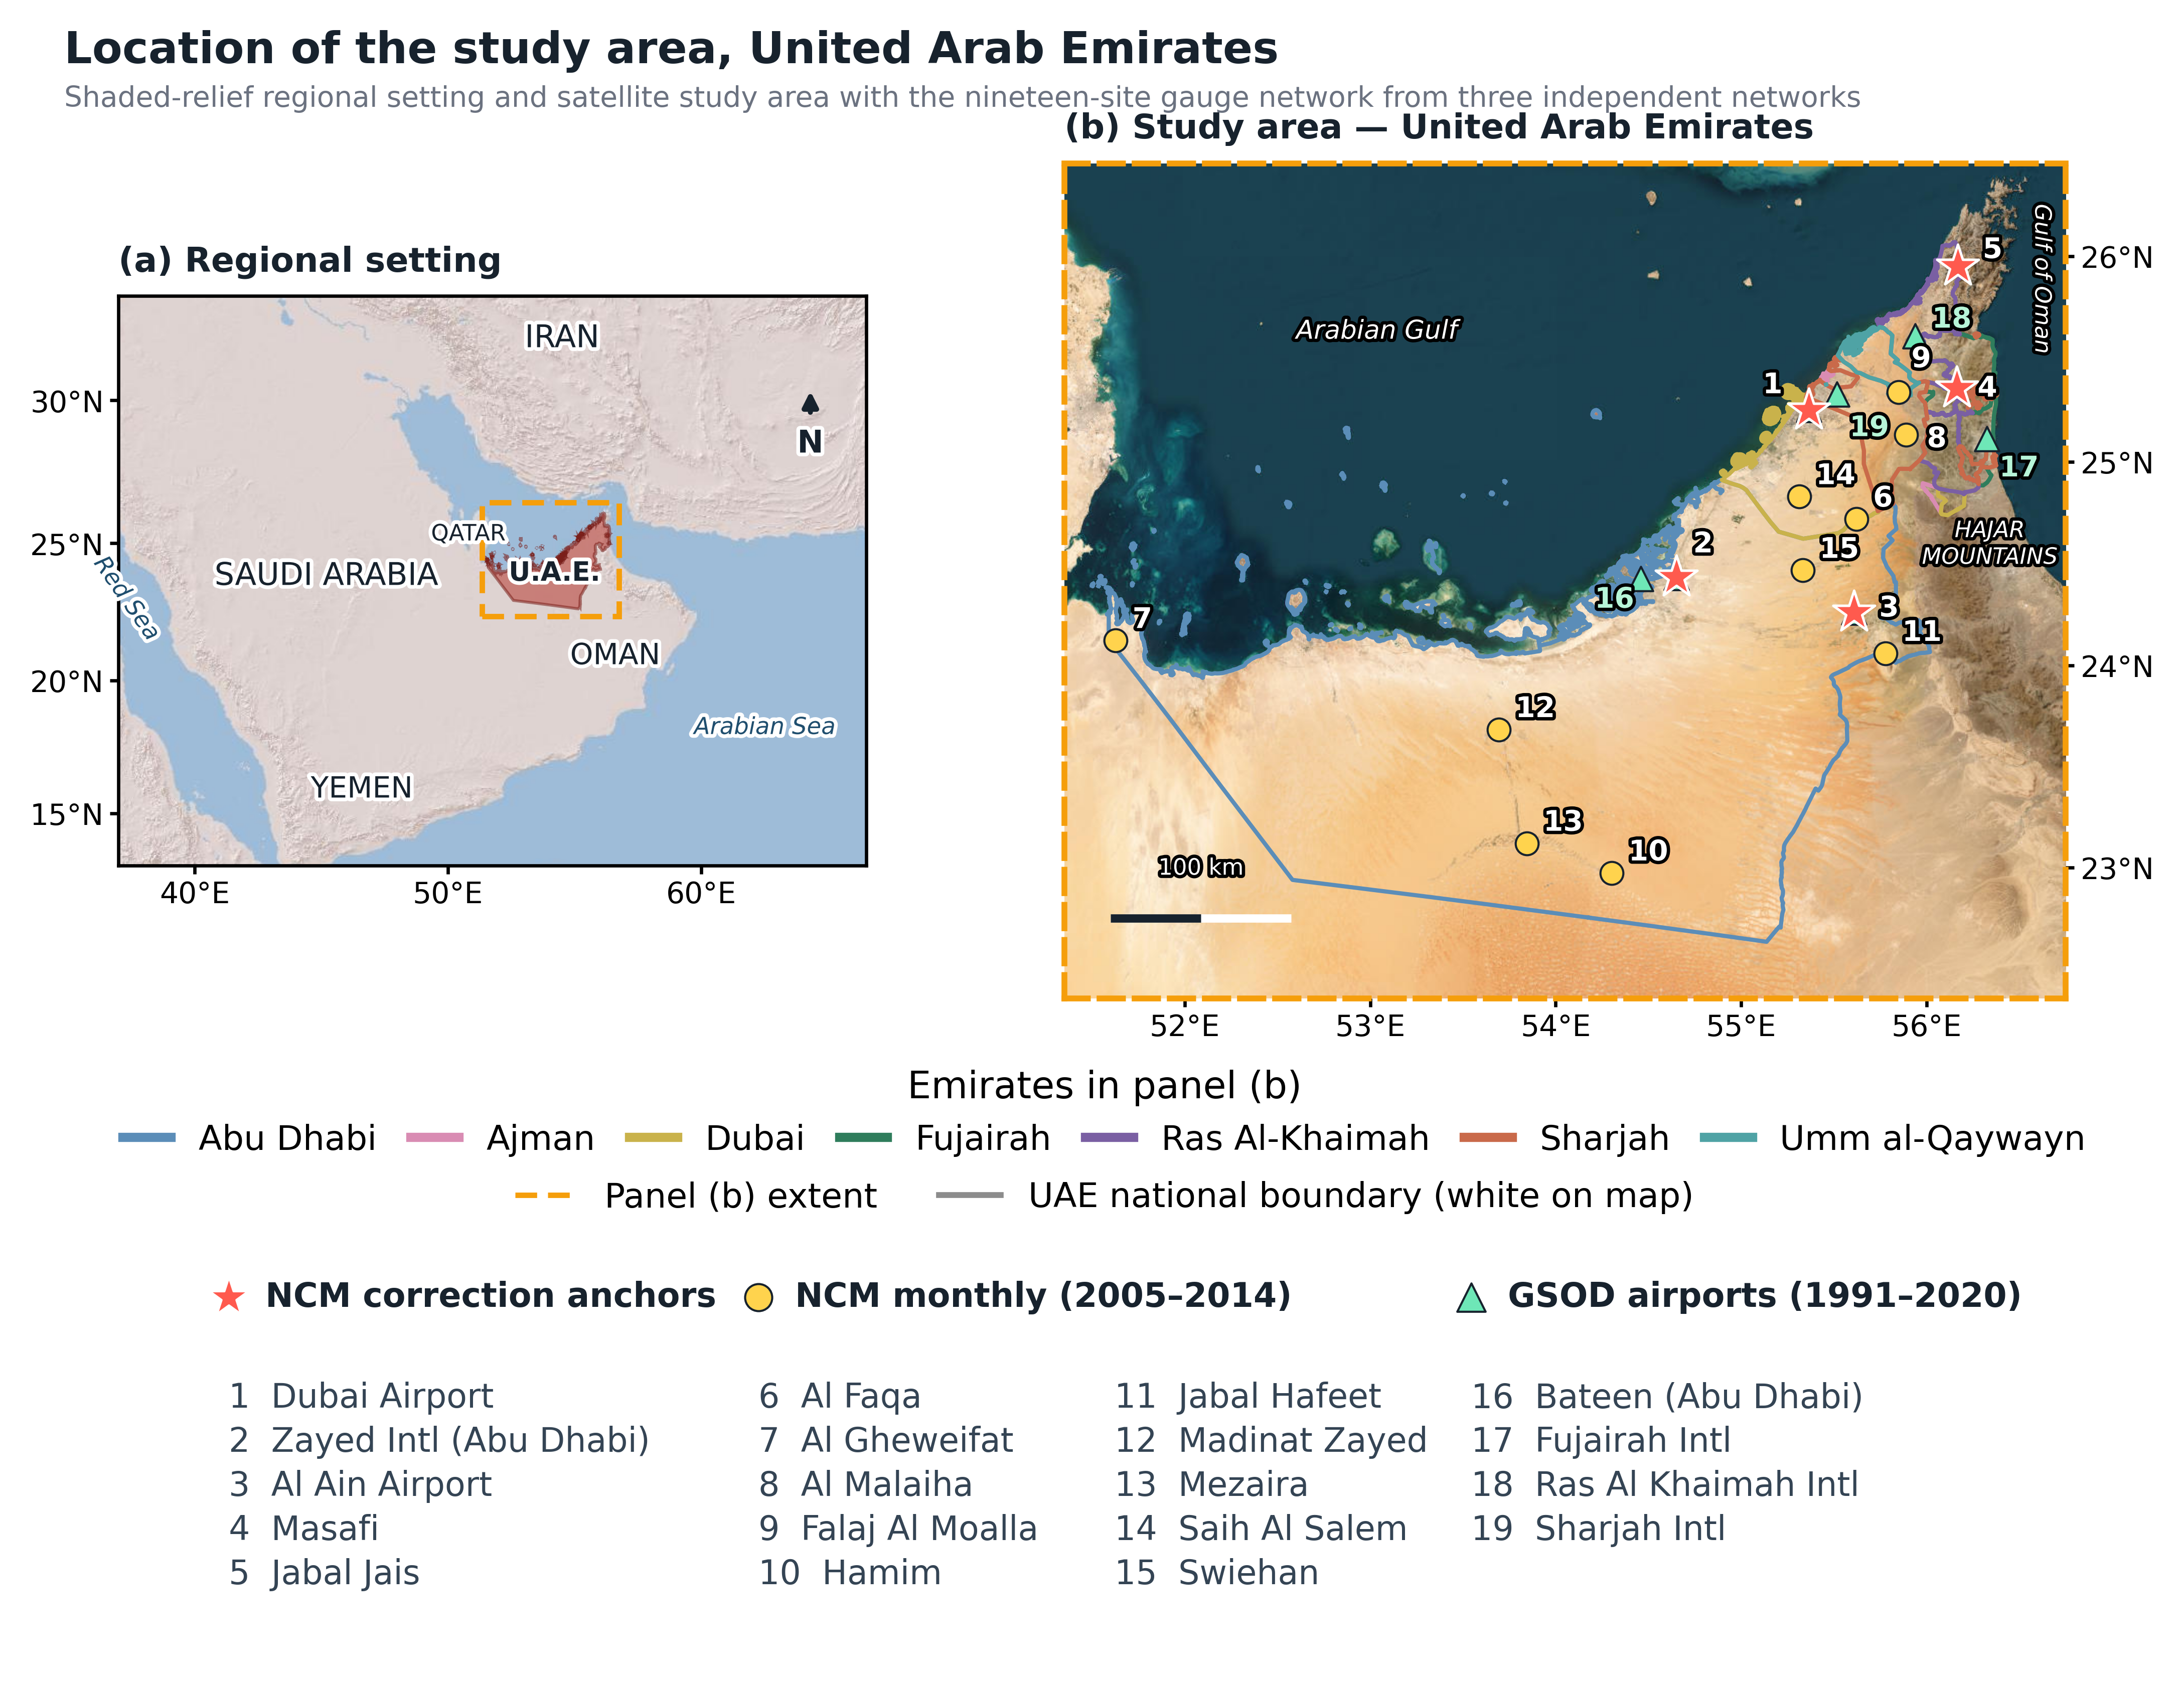
Figure 1. Study area and gauge network. The map shows GADM v4.1 emirate boundaries, the Hajar Mountains, 15 National Center of Meteorology (NCM) monthly stations (2005–2014; five correction anchors marked by stars), the NCM Dubai daily reference station, and seven Global Summary of the Day (GSOD) airport stations (1991–2020).
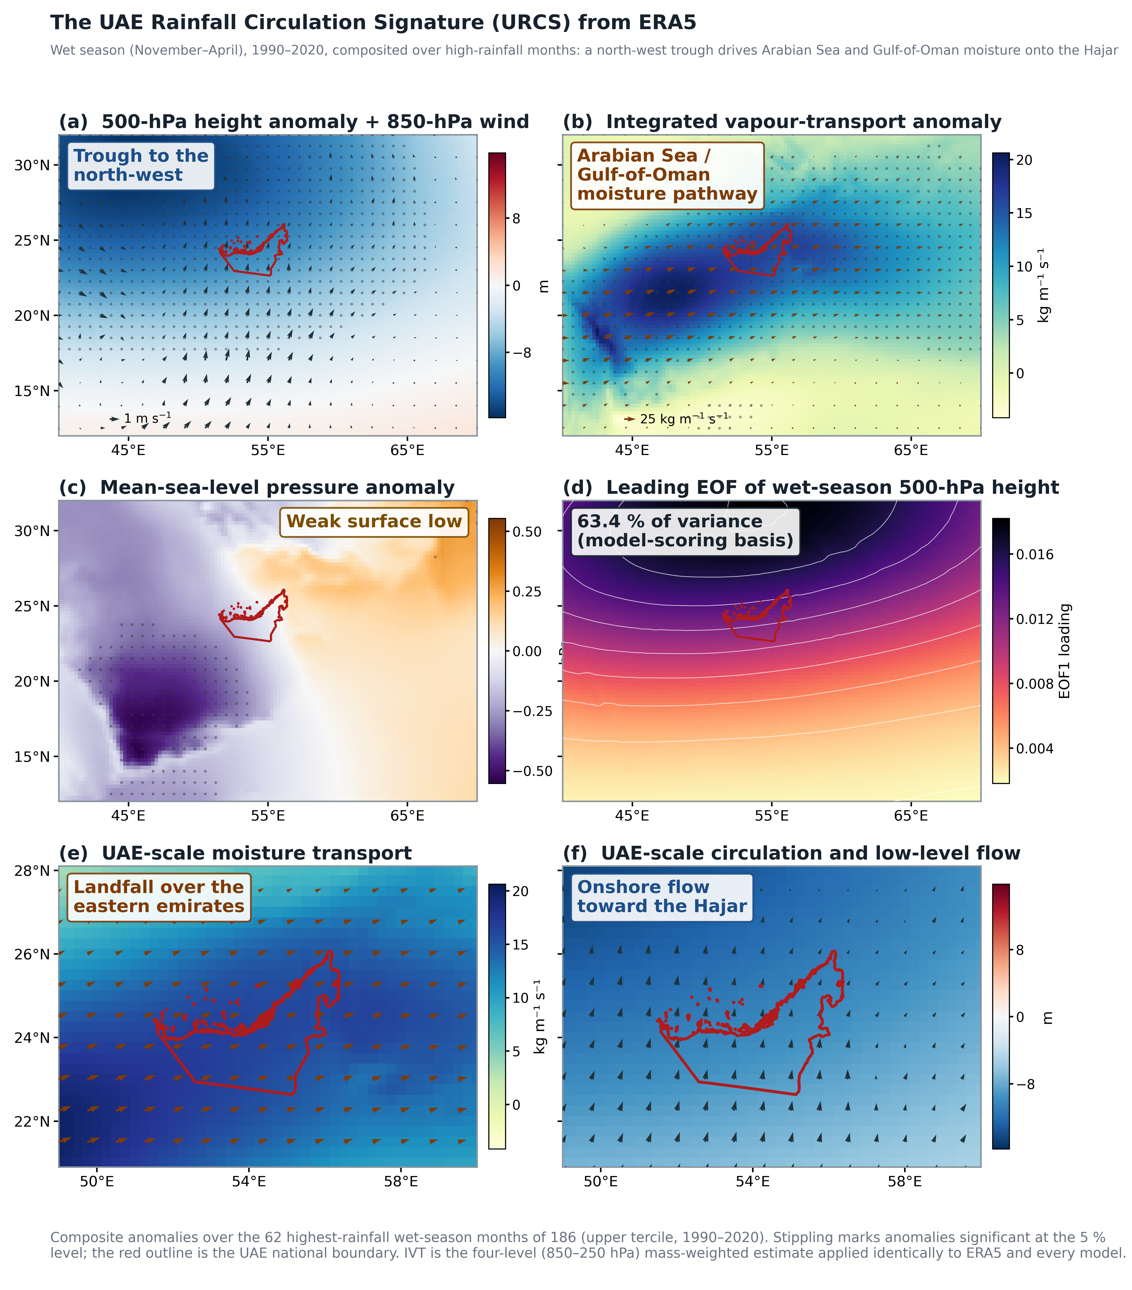
Figure 2. ERA5 UAE Rainfall Circulation Signature, November–April 1990–2020, composited for the 62 wettest months. (a) 500-hPa height anomaly and 850-hPa wind; (b) IVT anomaly; (c) mean-sea-level-pressure anomaly; (d) leading 500-hPa height EOF (63.4% of variance); and (e,f) UAE-scale moisture-transport and low-level-flow fields. Stippling denotes p < 0.05; the red outline denotes the UAE boundary.
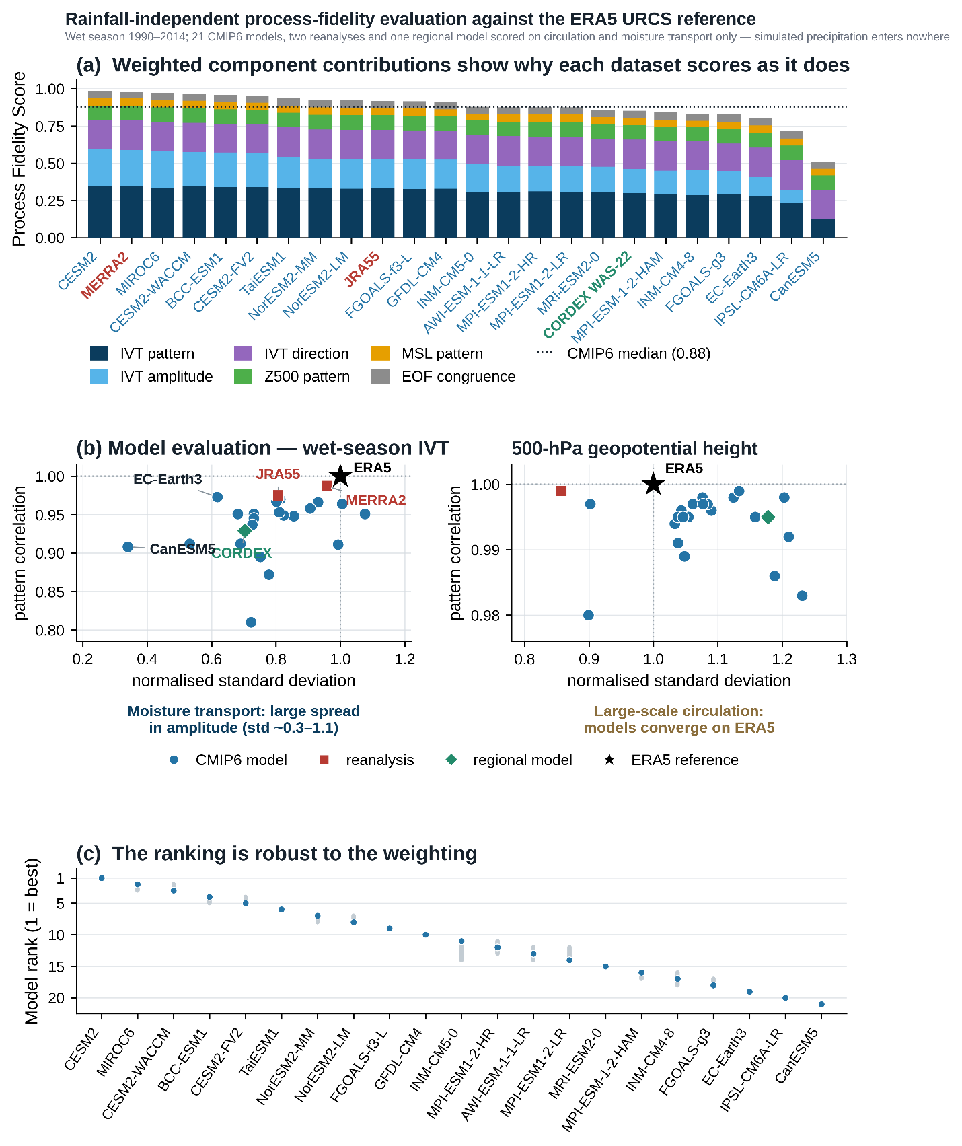
Figure 3. Precipitation-independent process evaluation for 1990–2014. (a) PFS and weighted components for 21 CMIP6 models, MERRA-2, JRA-55, and CORDEX WAS-22; (b) normalised standard deviation and spatial correlation for IVT and 500-hPa height; and (c) model-rank intervals from 10,000 Dirichlet weight perturbations.
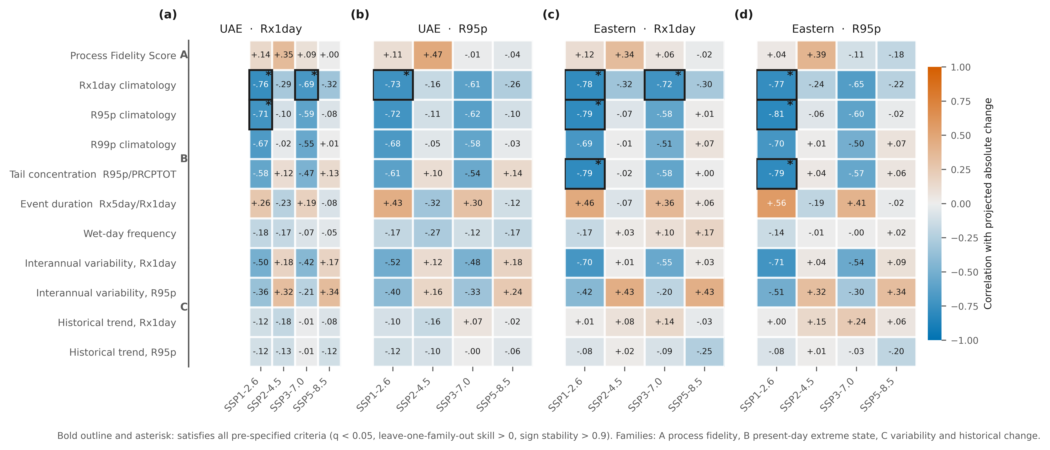
Figure 4. Pre-specified constraint battery: correlation between each observable predictor and projected absolute change, for (a) national Rx1day, (b) national R95p, (c) eastern Rx1day and (d) eastern R95p, under four emission scenarios on an identical 23-model set. Colour is diverging about zero with a neutral midpoint. Cells with a bold outline and asterisk satisfy all pre-specified criteria; every such cell uses a predictor that also enters the predictand. Predictor families: A atmospheric process fidelity, B present-day extreme-rainfall state, C present-day variability and historical change.
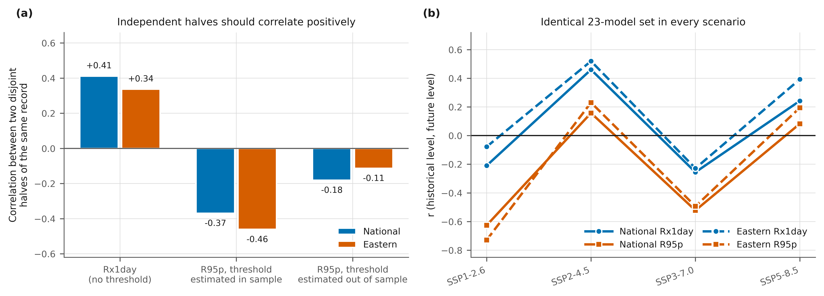
Figure 5. Two diagnostics for apparent constraints. (a) Correlation across models between two disjoint halves of the same model's historical record. Independent halves correlate positively, as Rx1day does; R95p computed with a threshold estimated over the same seasons correlates negatively, and estimating the threshold out of sample removes most of the effect. (b) Correlation between historical and future index level in each of the four scenarios, evaluated on an identical 23-model set.
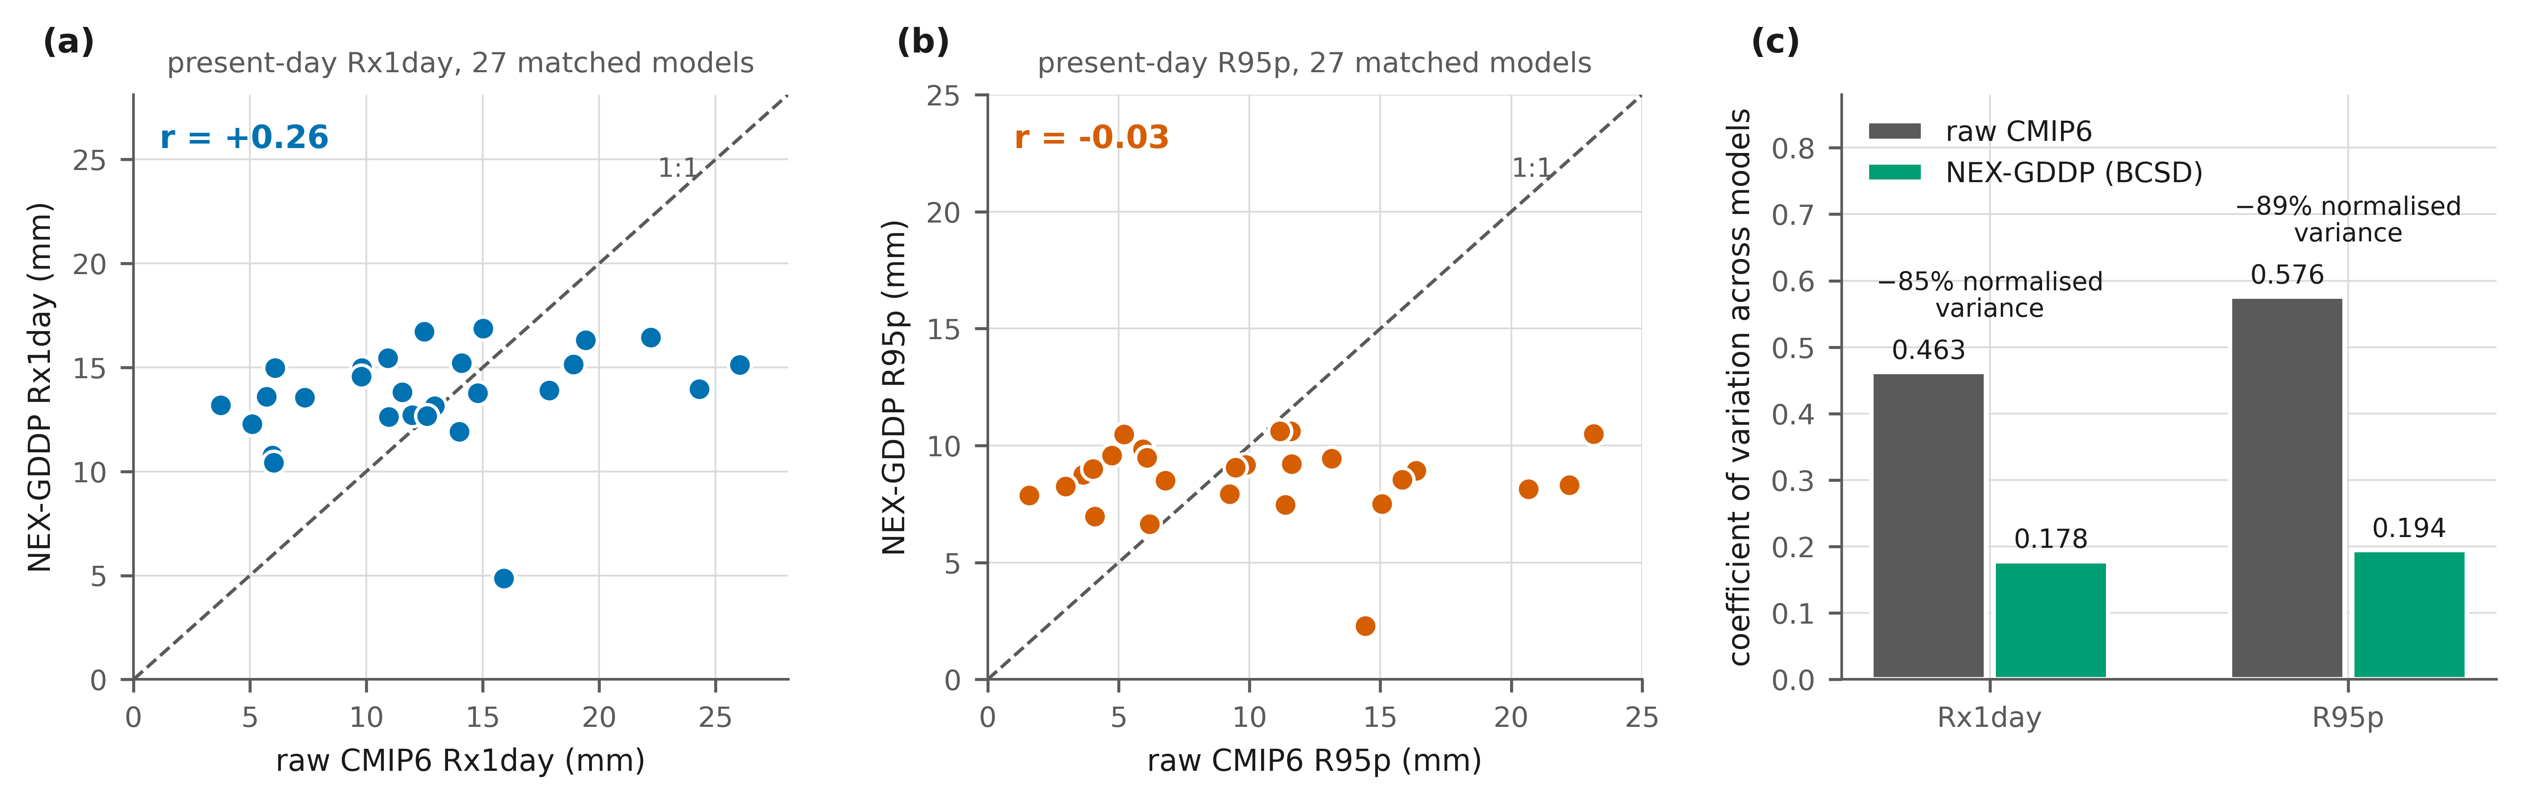
Figure 6. Effect of bias-corrected downscaling on inter-model spread. (a,b) Present-day Rx1day and R95p in raw CMIP6 output against the NEX-GDDP equivalent for 27 matched models. (c) Coefficient of variation across models in each version.

Tables
Table 1. Projected change in wet-season extreme rainfall for 2076–2100 relative to 1990–2014, for the 23 NEX-GDDP-CMIP6 models available under all four scenarios. Cells give the multi-model mean percentage change, the inter-model standard deviation in percentage points, and the number of models projecting an increase. Baselines are wet-season means over 1990–2014 computed over valid land cells.
Index | Domain | Baseline (mm) | SSP1-2.6 | SSP2-4.5 | SSP3-7.0 | SSP5-8.5
Rx1day | National | 13.44 | +21.4% (65); 14/23 | +13.7% (26); 15/23 | +30.0% (76); 15/23 | +14.5% (34); 13/23
Rx1day | Eastern | 20.44 | +14.8% (69); 12/23 | +6.3% (22); 12/23 | +26.3% (85); 14/23 | +6.7% (28); 11/23
R95p | National | 12.54 | +132.0% (404); 16/23 | +57.7% (83); 17/23 | +174.5% (464); 17/23 | +75.3% (112); 14/23
R95p | Eastern | 22.25 | +110.6% (398); 14/23 | +35.6% (69); 15/23 | +152.7% (463); 14/23 | +50.7% (94); 14/23
Table 2. Outcome of the pre-specified constraint battery. Eleven predictors were tested against projected change in two indices over two domains under four scenarios, giving 176 tests for each predictand form, with Benjamini-Hochberg control applied once across the whole grid. A test satisfies the criteria if its adjusted probability is below 0.05, its leave-one-family-out skill is positive, and its bootstrap sign stability exceeds 0.9.
Predictand | Predictor class | Tests | Satisfying all criteria | Mean |r| of those | Scenarios in which they occur
Absolute change | Predictor also enters the predictand | 64 | 11 | 0.760 | SSP1-2.6 (9), SSP3-7.0 (2)
Absolute change | Predictor independent of the predictand | 112 | 0 | – | –
Fractional change | Predictor also enters the predictand | 64 | 9 | 0.842 | SSP1-2.6 (6), SSP3-7.0 (3)
Fractional change | Predictor independent of the predictand | 112 | 0 | – | –

