***NAME : MOHIL MANDAPE***

***MIS NO. : 112316028***

***Q.1.***

***class Animal {***

***String name = "Animal";***

***void eat() {***

***System.out.println("Eating...");***

***}***

***}***

***class Dog extends Animal {***

***void display() {***

***System.out.println("This is a Dog.");***

***}***

***}***

***public class Main {***

***public static void main(String[] args) {***

***Dog labrador = new Dog();***

***System.out.println(labrador.name);***

***labrador.eat();***

***labrador.display();***

***}***

***}***

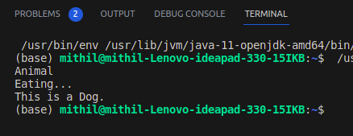

***Q.2.***

***class Parent {***

***void show() {***

***System.out.println("Parent method");***

***}***

***}***

***class Child extends Parent {***

***@Override***

***void show() {***

***System.out.println("Overridden Child method");***

***}***

***}***

***public class Main {***

***public static void main(String[] args) {***

***Child obj = new Child();***

***obj.show();***

***}***

***}***

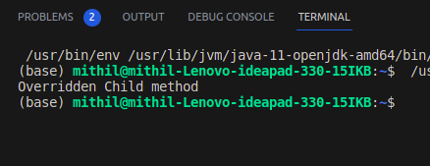

***Q.3***

***class Person {***

***String name = "John";***

***}***

***class Student extends Person {***

***int id = 101;***

***}***

***public class Main {***

***public static void main(String[] args) {***

***Student s = new Student();***

***System.out.println("Name: " + s.name);***

***System.out.println("ID: " + s.id);***

***}***

***}***

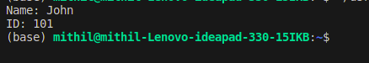

***Q.4.***

***class Parent {***

***void message() {***

***System.out.println("Parent Message");***

***}***

***}***

***class Child extends Parent {***

***void message() {***

***super.message();***

***System.out.println("Child Message");***

***}***

***}***

***public class Main {***

***public static void main(String[] args) {***

***Child obj = new Child();***

***obj.message();***

***}***

***}***

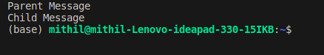

***Q.5.***

***interface A {***

***void showA();***

***}***

***interface B {***

***void showB();***

***}***

***class C implements A, B {***

***public void showA() {***

***System.out.println("Interface A method");***

***}***

***public void showB() {***

***System.out.println("Interface B method");***

***}***

***}***

***public class Main {***

***public static void main(String[] args) {***

***C obj = new C();***

***obj.showA();***

***obj.showB();***

***}***

***}***

