HandsMen Threads - Salesforce CRM Implementation

# Abstract

HandsMen Threads is a tailored Salesforce CRM project designed to streamline operations for a textile and garment company. The platform enables efficient customer management, inventory tracking, order processing, marketing campaigns, and loyalty tracking using Salesforce's automation and customization features. The system supports real-time decision-making through triggers, flows, validation rules, and role-based access control.

# Objective

To build a scalable, automated CRM system using Salesforce that efficiently manages customer orders, stock levels, marketing strategies, and user roles while offering customized workflows and business logic.

# Technical Description

The project makes use of several core Salesforce features:

- **Salesforce Platform**: A leading cloud-based CRM that offers declarative tools and programmatic customization.

- **Custom Objects**:

- HandsMen Customer__c: Stores customer details.

- HandsMen Product__c: Stores product catalog.

- HandsMen Order__c: Manages individual orders.

- Inventory__c: Tracks stock levels.

- Marketing_Campaign__c: Organizes promotional activities.

- **Tabs**: Custom tabs were created for easy access and navigation to each custom object.

- **Custom Apps**: A dedicated “HandsMen Threads” Lightning app groups all relevant objects, reports, and dashboards.

- **Profiles and Roles**: Defined for Sales Rep, Inventory Manager, and Marketing Lead to ensure secure and role-specific access.

- **Validation Rules**:

- Inventory Object - Stock Quantity: Prevents negative stock values.

- Customer Object - Email: Ensures valid Gmail addresses.

- Order Object - Total Amount: Prevents invalid order amounts.

- Email Alerts & Templates: Configured for order confirmation and stock threshold alerts.

**- Flows:**

- Order Confirmation Flow: Sends auto-confirmation emails.

- Stock Alert Flow: Alerts when stock falls below a threshold.

- Loyalty Checker Flow: Scheduled flow updating loyalty status (Gold, Silver, Bronze) based on order history.

- **Apex Triggers:**

- Calculates Order Total.

- Deducts inventory after each order.

- Updates Loyalty Status automatically.

# Detailed Execution of Project Phases

**Developer Org Setup**: Salesforce Developer Edition was created and verified.

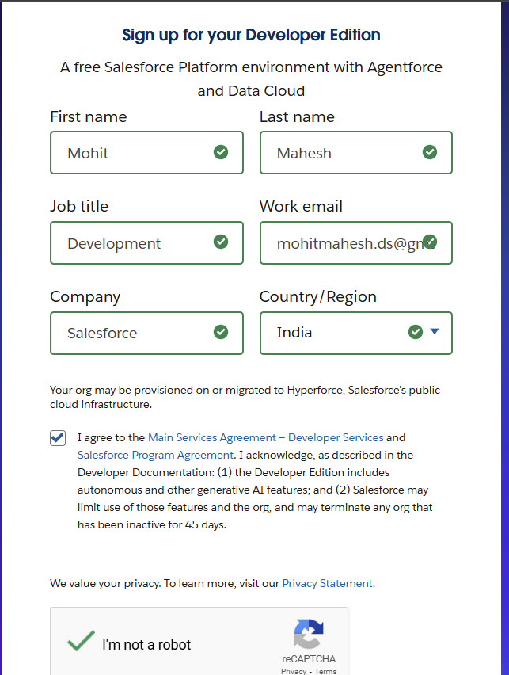

**Custom Object Creation**: Designed and linked five core objects using Lookup and Master-Detail relationships.

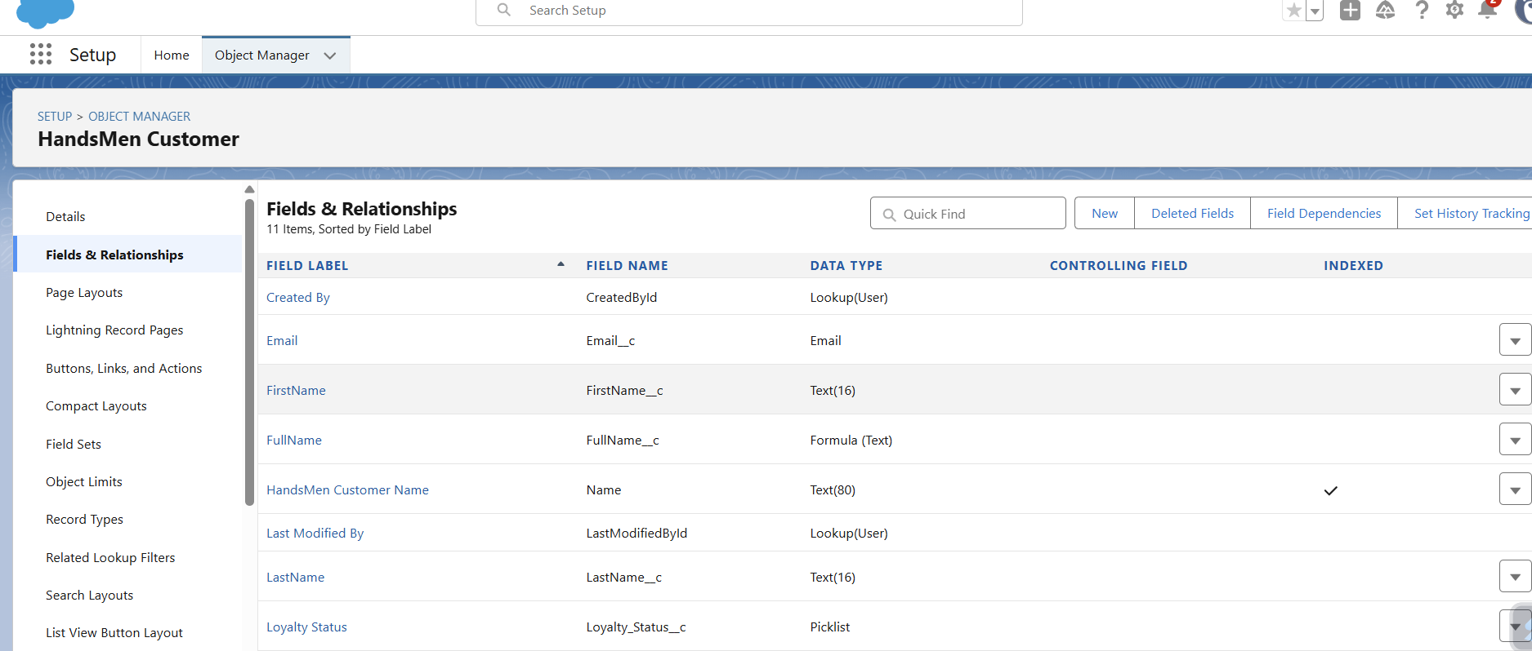

**Lightning App Creation**: A unified Lightning app was created to centralize all modules.

**Validation Rules**: Implemented to prevent bad data entry across Inventory, Customer, and Order objects.

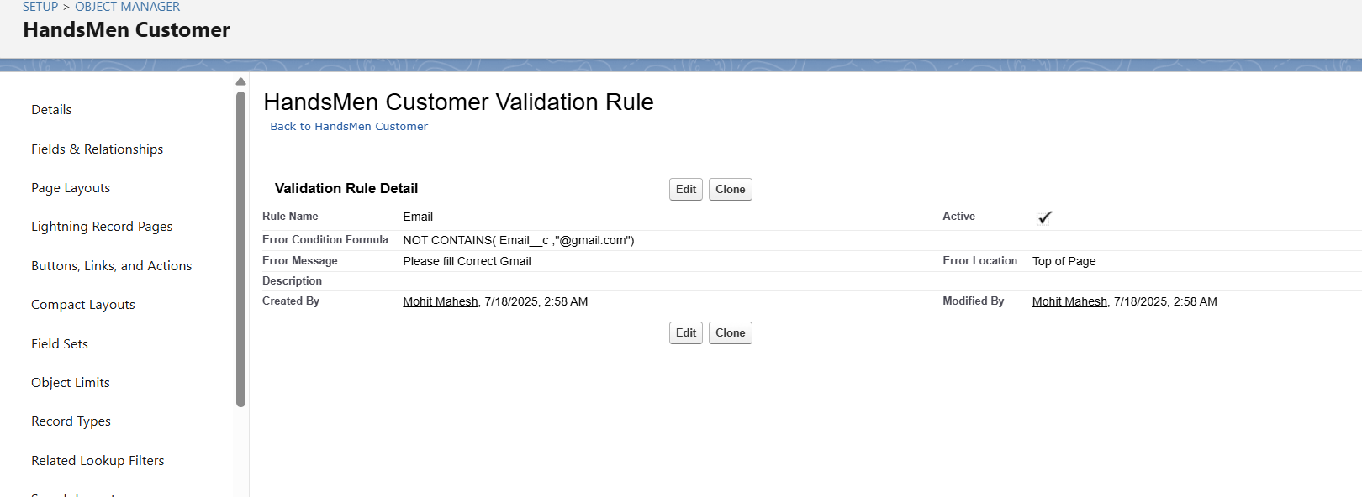

**User Role and Profile Setup**: Role hierarchy established. Profiles configured to control field and object-level permissions.

**User Creation**: Users assigned roles such as Sales Rep, Inventory Manager, and Marketing Lead.

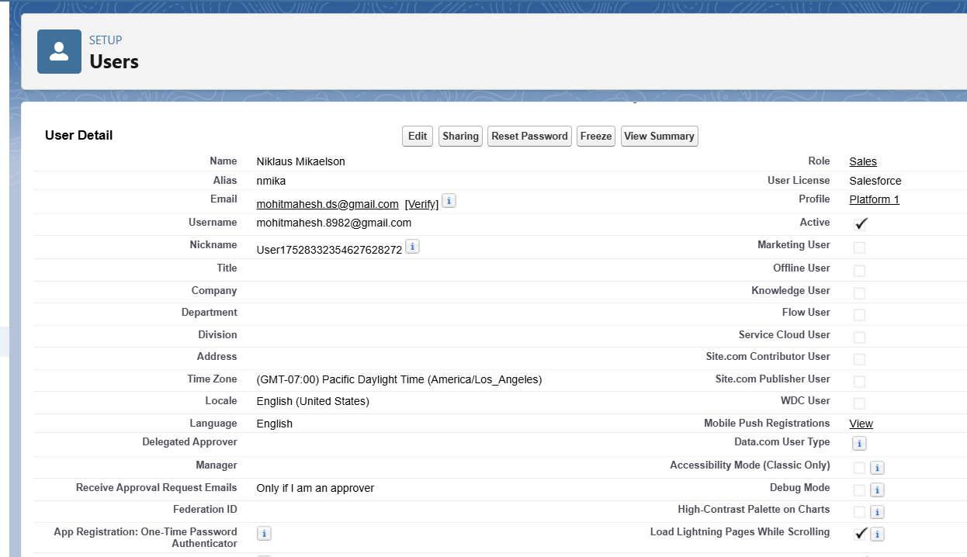

**Email Templates and Alerts**: Created HTML templates for order confirmation and triggered alerts based on record criteria.

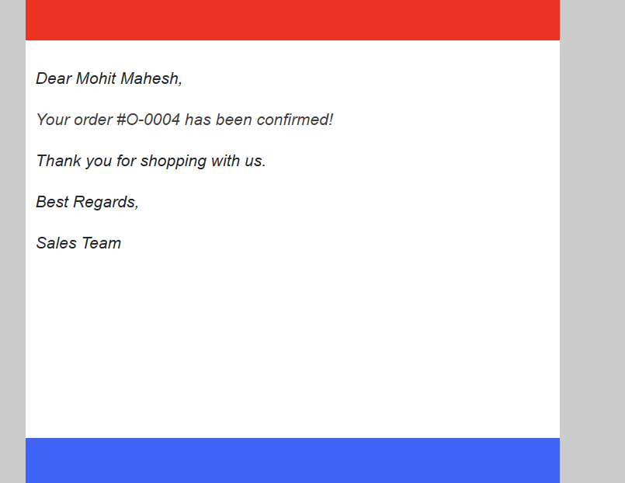

**Flows:**

- Order Confirmation Flow: Sends confirmation mail.

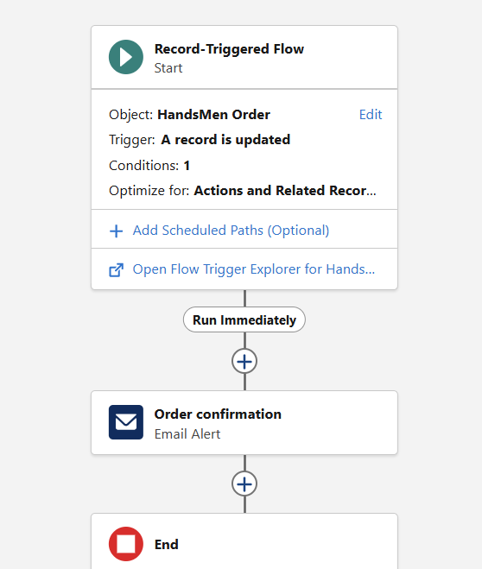

- Stock Alert Flow: Auto-alerts the inventory manager.

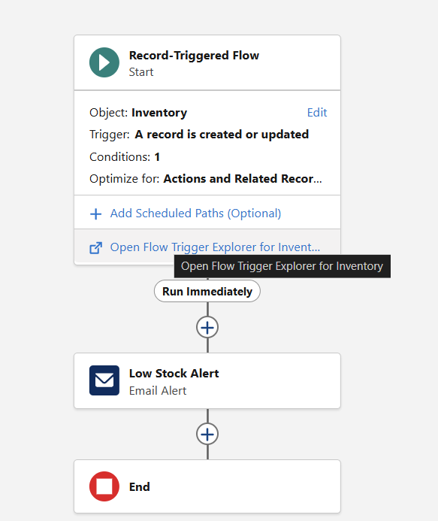

- Loyalty Flow: Updates loyalty tier on schedule.

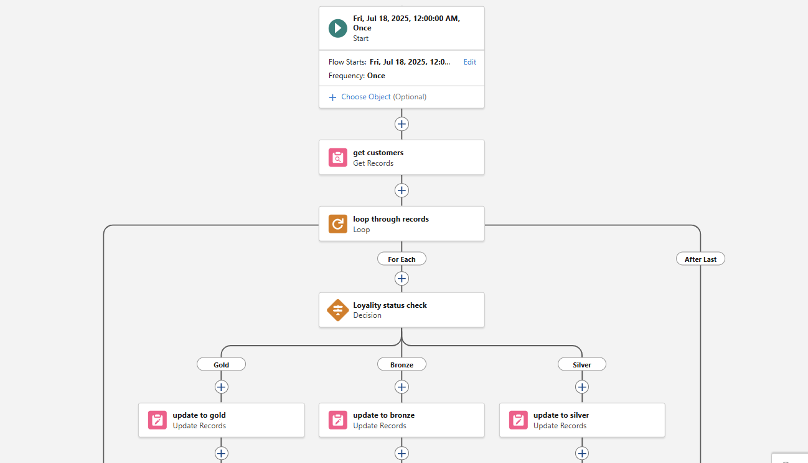

**Apex Triggers:**

- Order Total Trigger: Calculates total cost.

- Stock Deduction Trigger: Reduces stock per order.

- Loyalty Trigger: Classifies customers into Gold/Silver/Bronze tiers.

# Real-World Example

Scenario: Retail Garment Store Chain (HandsMen Threads)

1. Customer Registration: A new customer signs up on the platform, providing contact and email details.

2. Product Setup: The product catalog is updated with new shirts using the HandsMen Product__c object.

3. Order Placement: The customer places an order for five premium shirts.

4. Order Total Calculation: Upon saving the order, the Order Total is automatically calculated using an Apex Trigger.

5. Inventory Update: The stock count for shirts is reduced in real-time through a Stock Deduction Trigger.

6. Stock Threshold Alert: If stock goes below threshold, a Stock Alert Flow triggers an email to the Inventory Manager.

7. Loyalty Evaluation: A scheduled flow evaluates total order history and updates the customer’s loyalty status (e.g., Gold tier if orders > ₹10,000).

8. Order Confirmation: A confirmation email is sent to the customer using an Email Alert.

9. Marketing Campaign: The Marketing Team launches seasonal promotions using Marketing_Campaign__c object and targets loyal customers.

# Conclusion

This Salesforce CRM implementation for HandsMen Threads has centralized critical business operations and provided a robust automation layer. It ensures data consistency, real-time decision-making, and better customer engagement.

# Future Scope

- Integrate external payment gateways and shipping APIs.

- Implement Einstein Analytics for deeper insights.

- Expand loyalty program with coupons and referral rewards.

- Deploy a customer-facing portal for order tracking.

- Enable SMS alerts and WhatsApp integration for high engagement.