Placement Readiness and Career Intelligence Portal
Faculty problem cluster: student placement preparation, skill visibility, company fit, and structured upskilling.

Stakeholders: Students, Placement Cell
Problems heard: Students lack a single view of placement readiness; skill gaps against target roles are not visible until interviews; company-fit is guessed rather than data-driven; coding practice and mock-interview feedback are scattered and not tied to a learning plan.

Prompt command for faculty to retry later:
/apnileap-aura design-agentic-workflow --workflow "Placement Readiness and Career Intelligence Portal" --problem "resume parsing, skill gap visibility, coding analytics, company matching, and interview readiness" --student-groups "resume, skill-gap, coding-analytics, job-matching, interview" --outputs "placement score, skill gaps, company matching, learning roadmap" --constraints "human approval, privacy, audit log, source citations"

AI solution direction: Build a Placement Readiness and Career Intelligence Portal. It should start by parsing the student's resume and coding-platform activity, benchmark skills against target-role requirements, score placement readiness, rank company and role matches, and generate a personalized learning roadmap with mock-interview practice. The key is to turn scattered student data into one auditable, faculty-reviewed readiness picture.

Recommended workflow
- Student uploads a resume and links coding-platform and academic-record accounts, with explicit consent for each source.
- The agent extracts skills, projects, and experience, and retrieves target-role benchmarks and prior placement records.
- AI generates a skill gap report and coding analytics summary before any score is shown to the student.
- A job matching agent computes the placement score and ranks company/role matches with visible confidence and reasoning.
- Placement Cell convener reviews exceptions and low-confidence matches, approves the readiness score, and releases the learning roadmap and mock-interview plan to the student.

Agentic execution node graph
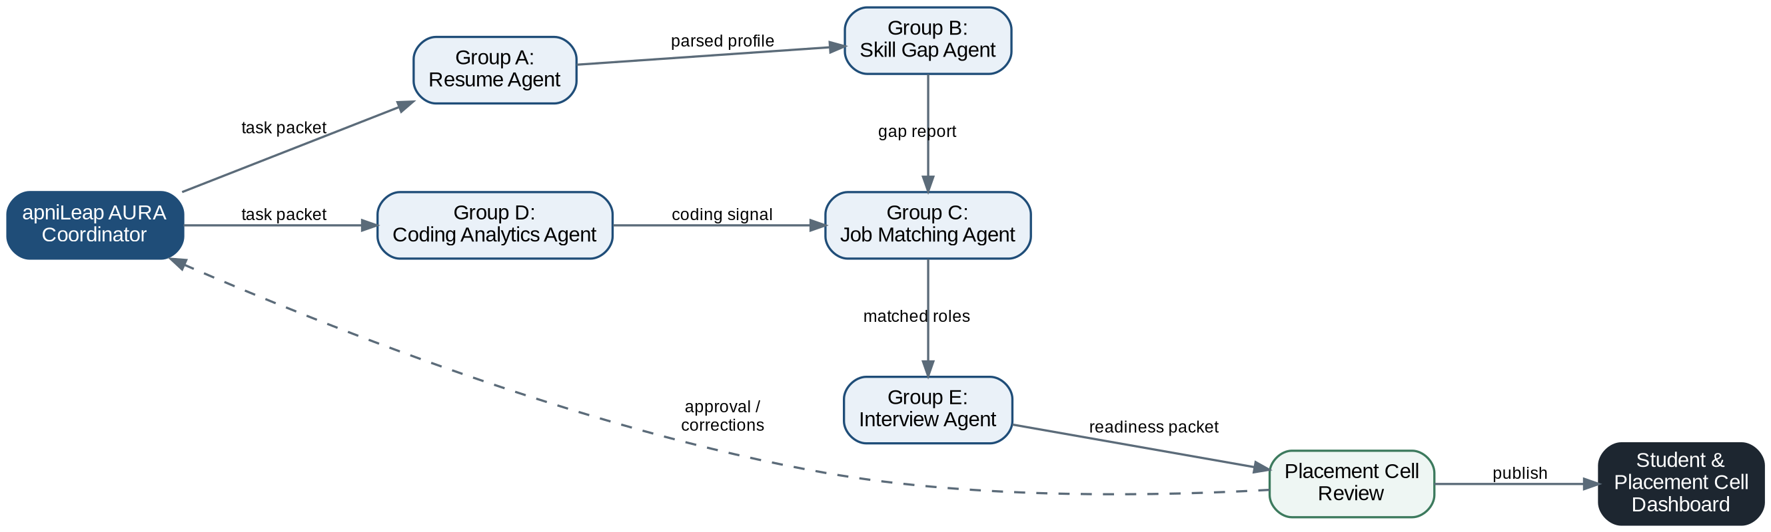
Execution blueprint: divide the workflow into smaller agents so student groups can build, test, and demo each node.

Agent explanations, communication order, and guardrails
In each project, apniLeap AURA acts as the workflow coordinator: it starts the run, passes scoped task packets to student-group agents, collects their outputs, routes exceptions to the Placement Cell convener, and publishes only approved artifacts to the dashboard. The detailed orchestrator mechanics are explained after the problem-specific examples.

Order | Agent | Role and communication | Guardrails
0 | apniLeap AURA Coordinator | Receives the faculty prompt command, checks permissions, creates the run plan, initializes agents with scoped instructions, and monitors state. | Never bypass human approval; enforce data scope, audit logging, source citation, and exception routing.
1 | Group A: Resume Agent | Parses the student's resume, extracts skills, projects, and experience, and normalizes them into structured profile fields. Receives the first task packet from apniLeap AURA and returns structured profile data. | Validate consent before parsing personal data, never expose resumes beyond role permissions, flag incomplete or inconsistent entries.
2 | Group B: Skill Gap Agent | Compares the parsed profile against target-role skill benchmarks and placement records. Receives prior-agent output from apniLeap AURA, performs its specialized task, and returns structured results plus exceptions. | Use approved skill benchmarks, cite the source of each benchmark, do not label a student unfit without human review.
3 | Group C: Coding Analytics Agent | Aggregates coding-platform activity, contest performance, and problem-solving trends. Receives prior-agent output from apniLeap AURA, performs its specialized task, and returns structured results plus exceptions. | Pull only from authorized coding-platform integrations, keep raw submission data private, surface trends rather than raw scores.
4 | Group D: Job Matching Agent | Creates the placement score and ranks company/role matches using the skill gap and coding analytics outputs. Receives prior-agent output from apniLeap AURA, performs its specialized task, and returns structured results plus exceptions. | Show match confidence and reasoning, do not overstate fit, route low-confidence matches to a human reviewer.
5 | Group E: Interview Agent | Runs mock interview and communication practice sessions, and compiles a learning roadmap. Receives approved/validated outputs and publishes dashboard-ready artifacts back through apniLeap AURA. | Mark AI-generated feedback clearly, keep session recordings and transcripts private, require faculty sign-off before final readiness certification.
6 | Placement Cell convener Review | Reviews exceptions, approves the placement score and learning roadmap, requests corrections, or changes scope. apniLeap AURA then resumes the relevant agent. | Placement Cell decision is the final authority for student-facing readiness scores and company matching outputs.

Hybrid execution methodology
The apniLeap AURA Coordinator should not force every agent to run one after another. It should use a hybrid model: run independent agents in parallel to save time, but keep sequential gates wherever output quality, data dependency, privacy, or approval matters.

Stage | Execution mode | How apniLeap AURA Coordinator manages it
Gate 1: profile intake | Sequential | Start only after the Resume Agent has a validated, parsed student profile with consent confirmed.
Parallel build | Parallel | Skill Gap Agent benchmarks the profile while Coding Analytics Agent aggregates platform activity at the same time.
Join and scoring | Sequential | Job Matching Agent runs only after both the skill gap report and coding analytics are available.
Interview and roadmap | Sequential | Interview Agent builds the learning roadmap using the matched roles once ranking is confirmed.
Placement Cell approval | Sequential | Placement Cell approves the readiness score and roadmap; apniLeap AURA sends corrections back to the relevant agent if needed.
Dashboard update | Parallel after approval | Dashboard Agent publishes the placement score, skill gaps, company matching, and roadmap together once approved.

Dummy dashboard template
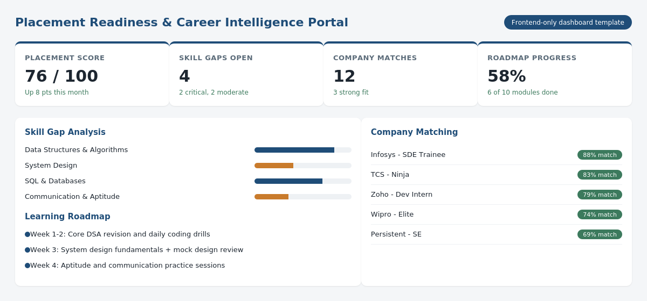
Frontend-only dashboard template for this problem statement. HTML file: placement_readiness_dashboard_template.html

Pilot artifacts: A resume/profile intake form, a skill-gap benchmark library for 5-8 target roles, a coding-analytics connector, and a placement score dashboard with an exportable learning roadmap.
Guardrails: Do not release a placement score or company match to a student without Placement Convenor review. Keep skill benchmarks and company requirements current, and never expose one student's data to another.

