**California State University, Fresno – Fall 2013**

**Computer Science 166, Principles of AI (3 units)**

**Assignment #1**

**Due:** 9/20

**Value:** 20 points

**Part 1: MySQL 5.6 - Installation**

Part 1 of this assignment requires that you install MySQL 5.6 on a machine that you intend to do future homework assignments.

The link for MySQL is:

<http://www.mysql.com/>

In-class, I will assume that we are working under Windows, but I will generally accept assignments under any platform as long as the results are functionally equivalent.

Assuming a windows environment, you will download the 5.6 software from here:

<http://dev.mysql.com/downloads/installer/5.6.html>

The installation is straightforward. You may want to create an Admin user when installing rather that simply using ‘root’.

Once the software is installed open up the MySQL Workbench: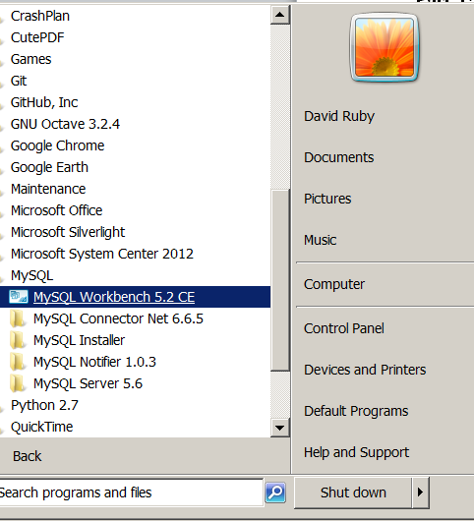

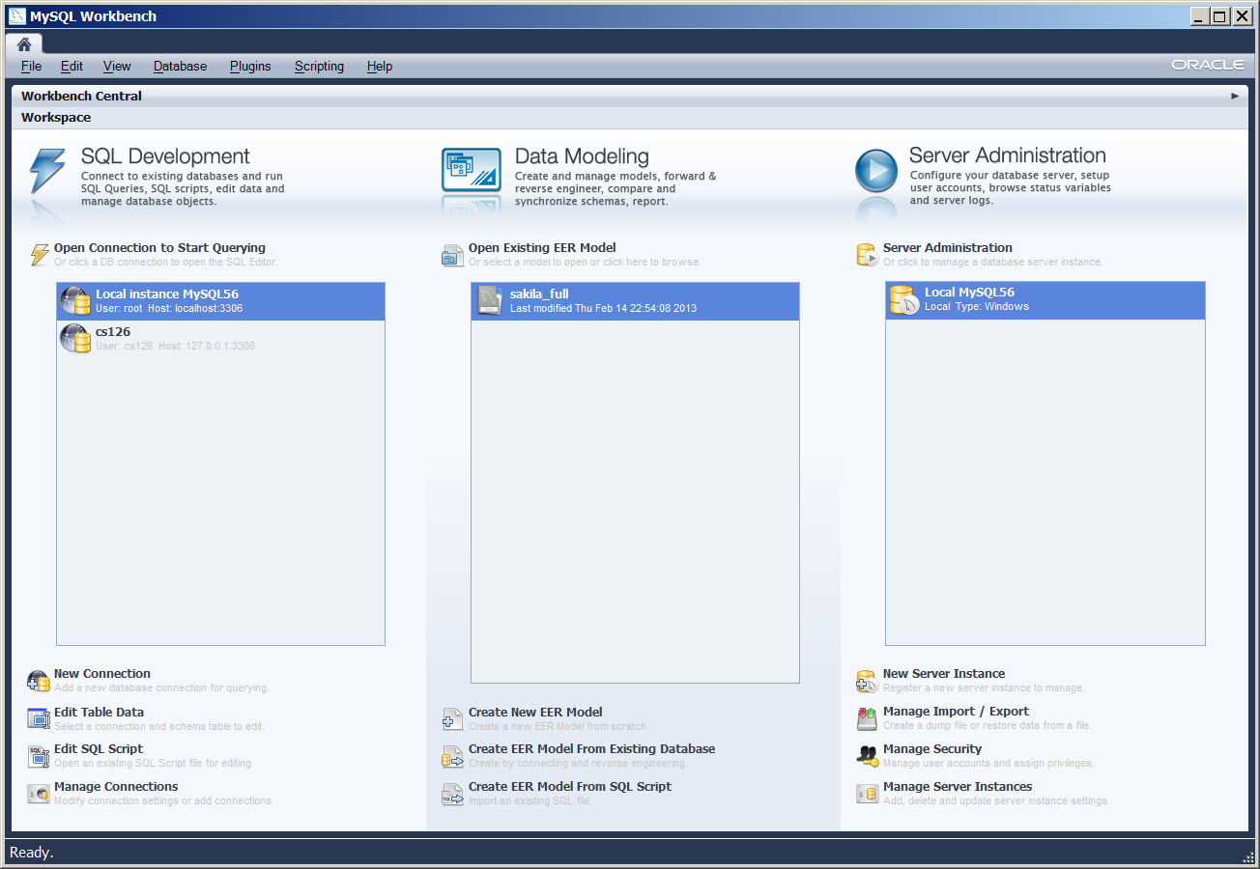

Take a screen capture of this to satisfy this section of assignment.

**Part 2: Getting GIT**

Git will be used to retrieve code for the class, and also post code for sharing with my and the class.

Start by requesting a student account at:

<https://github.com/edu>

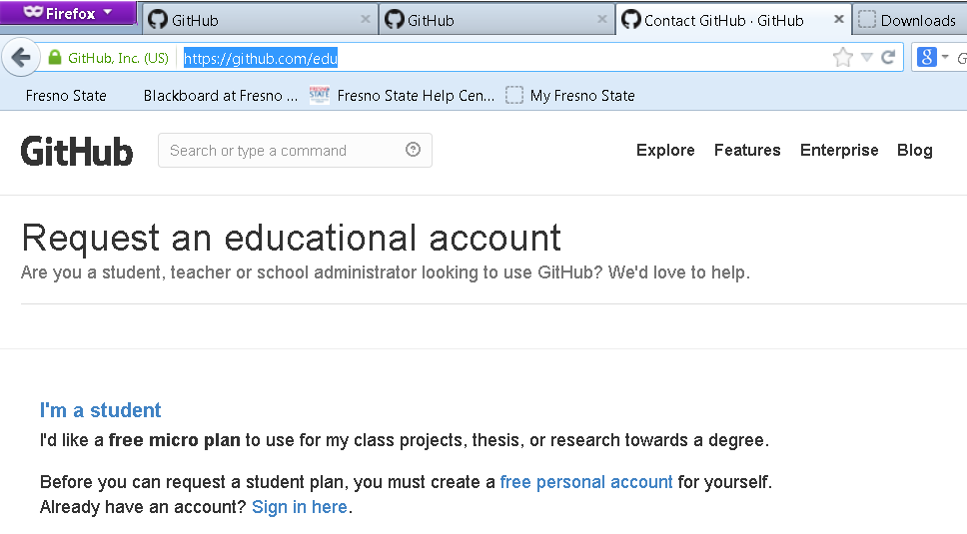

Install the native application for working with GIT on your system:

<https://help.github.com/articles/set-up-git>

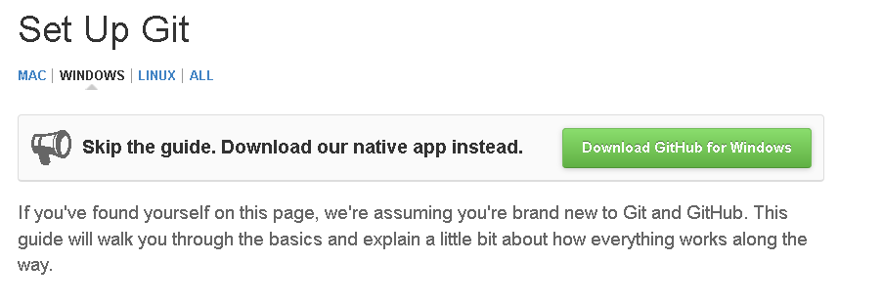

Once the windows app is installed, you can pull down the code for the class. You should do this at least before each assignment to get the latest version of the software.

My github page is: <https://github.com/everestso>

The github project for this course is: <https://github.com/everestso/CSci166.Fall13>

Select ‘Clone In’ as shown below, to get code:

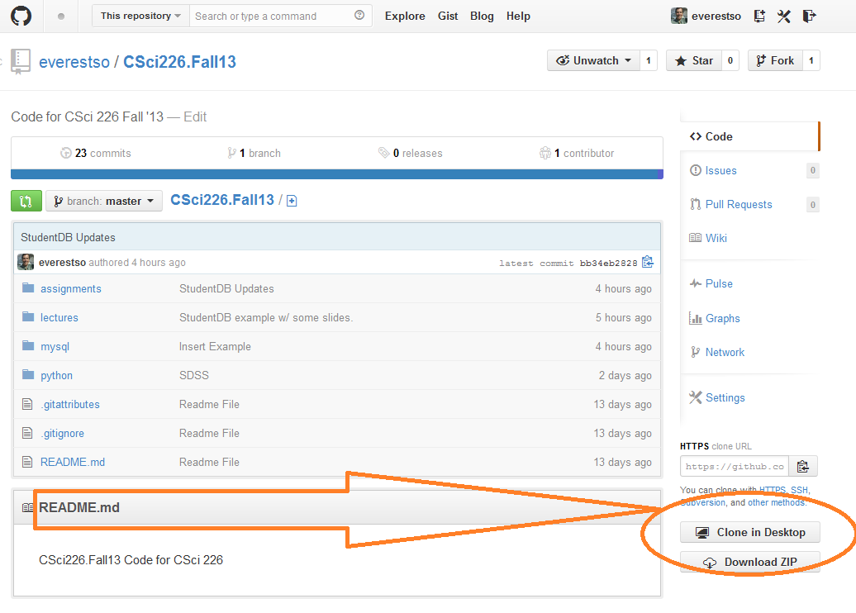

You should then be able to see the respository in your local Windows app:

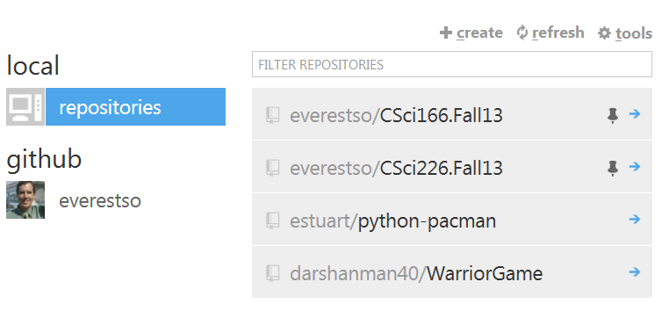

Take a screen capture of this, to complete this section.

**Part 3: Python**

For this part you will need to install Python. Start by downloading & installing Python 2.7.5

[http://www.python.org/download/releases/2.7.5](http://www.python.org/download/releases/2.7.5/)

Since we will be using MySQL with python from the start install MySQLDB next:

<http://sourceforge.net/projects/mysql-python/>

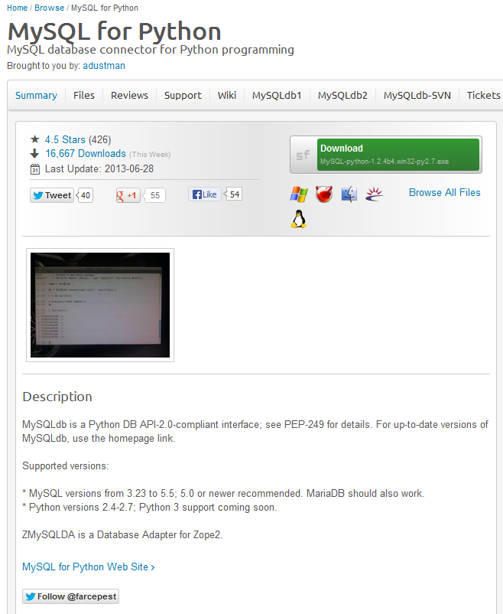

Once installed open IDLE (python gui):

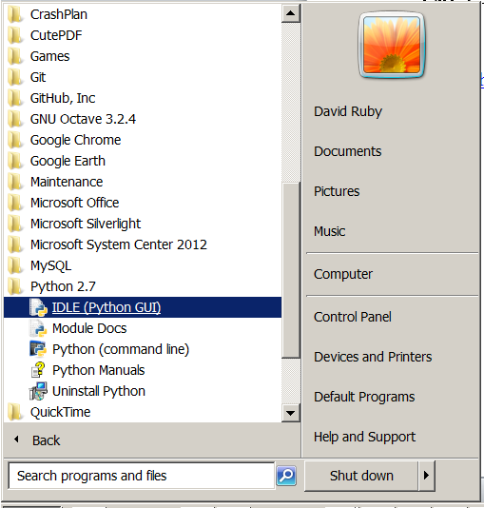

Then open a file from the GitHub project:

**GitHub\CSci166.Fall13\python\mysql.py**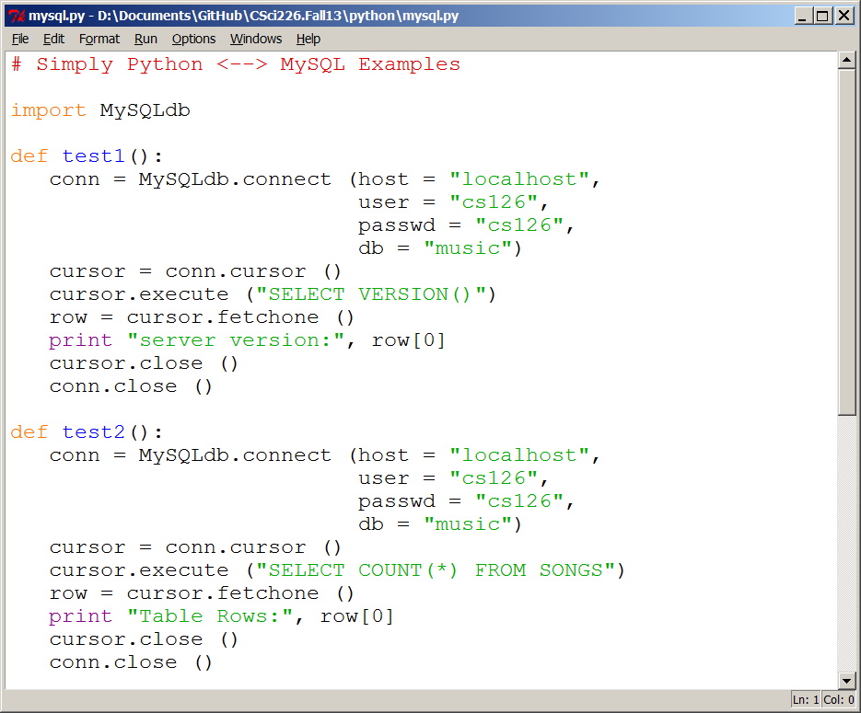

From the command line you will need to test1():

1. Select menu: Run/Run Module (F5)
2. In the Shell Window, enter: test1() <cr>
3. Screen capture the output, it should look like below:

