A
Industrial Training Report
on
Full stack
Web Development
submitted
in partial fulfilment
for the award of the degree of
Bachelor of Technology
in department of Computer Science

Submitted To: Submitted By:
Mr. Atul Gaur Mohit Kumar
LIET-Alwar Roll no: 23ELDCS030

Department of Computer Science & Engineering
Laxmi Devi Institute of Engineering & Technology, Alwar
Bikaner Technical University [2025-26]
ACKNOWLEDGEMENT
We would like to first express our thanks to Dr. Rajesh Bhardwaj, Group Director of LIET, for providing us such a great infrastructure and environment for our overall development.
We express sincere thanks to Principal Dr. Amit Malik, for his kind cooperation and extensible support toward the completion of our seminar.
Words are inadequate in offering our thanks to Dr. Pratap Singh Patwal, HOD of CSE Department, for consistent encouragement and support for shaping our seminar in the presentable form. Also, for his support in providing technical requirement and fulfilling our various other requirement for making our seminar success.
We would like to thank our project co-ordinator Mr. Atul Gaur, Asst. Prof. CSE Department for their support and guiding us to make seminar successful. Without their support and measurement, we would not be able to accomplish our goal.
We also like to express our thanks to all supporting CSE faculty members who have been a constant source of encouragement for successful competition of the project.
Also, our warm thanks to Laxmi Devi Institute of Engineering and Technology, who provide us this opportunity to carry out this prestigious seminar and enhance our learning in various technical fields.
CANDIDATE’S DECLARATION

I hereby declare that the Industrial/Field Project, which is being intern in the field, entitled “Full Stack Web Development” in partial fulfilment for the award of Degree of “Bachelor of Technology” in Department of Computer Science & Engineering with Specialization in Computer Science Engineering , and submitted to the Department of Computer Science & Engineering, Laxmi Devi Institute of Engineering & Technology, Alwar, Bikaner Technical University is a record of my own Learning and internship carried under the Guidance of Mr. Atul Gaur, Project Report co-ordinator(CSE) : Laxmi Devi institute of Engineering & Technology, Alwar.
I have not submitted the matter presented in this field work report anywhere for the award of any other Degree.

Student Name: MOHIT KUMAR
Branch: Computer Science
Roll no: 23ELDCS030
Laxmi Devi Institute of Engineering & Technology, Alwar

Counter Signed by
Guide Name: Mr. Atul Gaur
Department: Computer Science & Engineering Department
Laxmi Devi Institute of Engineering & Technology, Alwar



TABLE OF CONTENTS
1. INTRODUCTION 1
2. THE RISE OF FULL-STACK JAVASCRIPT 2
2.1 Historical Context and the Pre-Node.js Era 2
2.2 The Node.js Revolution 2
2.3 The Economic and Developmental Advantages 3
3. DECONSTRUCTING MERN STACK 4
3.1 What is a Technology Stack? 4
3.2 MERN Stack 5
4. MongoDB - The NoSQL Database 7
4.1 Introduction to NoSQL Databases 7
4.2 Why MongoDB for MERN? 7
4.3 Core Concepts: Databases, Collections, Documents 8
4.4 BSON Format: Beyond JSON 9
4.5 MongoDB Query Language (MQL) Deep Dive 9
4.6 Data Modeling and Schema Design 10
5. EXPRESS.JS - THE WEB APPLICATION FRAMEWORK 12
5.1 The Role of a Backend Framework 12
5.2 Introduction to Express.js 12
5.3 Core Concepts: Middleware, The Request-Response Cycle 13
5.4 Routing: Defining API Endpoints 14
5.5 Middleware Deep Dive: Built-in, Third-party, Custom 15
5.6 Request and Response Object Manipulation 16
5.7 Template Engine EJS - A Brief Overview 16
5.8 Error Handling Middleware 17
5.9 Structuring an Express Application 18
6. REACT - THE FRONTEND LIBRARY 20
6.1 Why React? The Virtual DOM Concept 20
6.2 The Evolution of Frontend Development 21
6.3 JSX Syntax: JavaScript + XML 21
6.4 Core Concepts: Components, Props, and State 22
6.5 Functional Components vs. Class Components 23
6.6 The React Hooks Revolution (useState, useEffect, etc.) 24
6.7 Handling Events and Forms 25
7. NODE.JS - THE JAVASCRIPT RUNTIME 26
7.1 From Browser to Server: The Birth of Node.js 26
7.2 The Event-Driven, Non-Blocking I/O Model 26
7.3 Node Package Manager (NPM) and Package Management 27
7.4 Understanding the Event Loop 28
7.5 Managing Asynchronous Operations: Callbacks, Promises, Async/Await 28
FUTURE OF THE MERN STACK AND JAVASCRIPT ECOSYSTEM 30
CONCLUSION 32
REFERENCES 33

TABLE OF FIGURES
Figure 1: SQL vs NONSQL database 10
Figure 2: Basic Operations and Operators 11
Figure 3: MongoDB Compass Interface 12
Figure 4: Creating schema for the database 13
Figure 5: Creating a server 16
Figure 6: Defining APIs routes 17
Figure 7: Custom Middleware 18
Figure 8: Creating an EJS Template 19
Figure 9: Error Handling middleware 20
Figure 10: React's JSX file 25
Figure 11: React's function component 26
Figure 12: React's Class Component 27
Figure 13: A counter component using useState 27
Figure 14: Creating a like button using event Handler 28

INTRODUCTION

The evolution of web development has been marked by a constant pursuit of efficiency, performance, and developer ergonomics. In the early days of the web, development was siloed: backend developers worked in languages like Java, PHP, or Python, while frontend developers focused on HTML, CSS, and JavaScript. This separation often led to integration challenges, communication gaps, and a steep learning curve for full-stack developers who needed proficiency in multiple, disparate technologies.
The introduction of Node.js in 2009 was a watershed moment. For the first time, JavaScript could be executed outside the browser, on the server. This breakthrough gave rise to the concept of "full-stack JavaScript," where a single language could power every layer of an application. The MERN stack is a direct and highly successful product of this evolution.
This stack is not merely a random collection of tools; it is a carefully curated set of technologies that complement each other perfectly. MongoDB's document model uses a JSON-like format, which aligns naturally with JavaScript objects. Express.js provides a simple, unopinionated layer on top of Node.js to create robust APIs. React offers a declarative and efficient way to build complex UIs that consume these APIs. Together, they form a powerful, cohesive, and modern foundation for developing web applications that are expected to handle real-time data, provide a rich user experience, and scale to accommodate millions of users.
This report is structured to guide the reader from foundational concepts to advanced implementation details, providing a 360-degree view of what it means to be a MERN stack developer in today's competitive technology environment.

THE RISE OF FULL-STACK JAVASCRIPT

The paradigm of full-stack JavaScript has fundamentally reshaped the web development industry. Its ascendancy can be attributed to several key factors that address both technical and business needs.

Historical Context and the Pre-Node.js Era
Before Node.js, the web development world was largely bifurcated. The backend, or server-side, was responsible for business logic, database interactions, and server configuration. It was dominated by languages like PHP (powering platforms like WordPress and Facebook initially), Java (with its robust enterprise frameworks), Ruby (with the Rails framework), and Python (with Django and Flask). The frontend, or client-side, was primarily concerned with presentation and user interaction, using a combination of HTML for structure, CSS for styling, and JavaScript for basic interactivity. Developers who could work on both ends were rare and had to maintain expertise in two very different technological domains.

The Node.js Revolution
Node.js, created by Ryan Dahl, solved a critical problem: I/O bottlenecks. Traditional server-side languages were synchronous and blocking. When a server needed to read a file or query a database, it would halt (block) all other operations until that task was complete. This model was inefficient for I/O-heavy applications like web servers.
Node.js introduced a non-blocking, event-driven architecture. It uses a single-threaded event loop to handle numerous concurrent connections. Instead of waiting for a task to finish, Node.js registers a callback and moves on to the next task. When the initial task is complete, the callback is executed. This model makes Node.js exceptionally fast and efficient for data-intensive, real-time applications that run across distributed devices.

The Economic and Developmental Advantages
The unification of the stack under JavaScript offers compelling advantages:
- Developer Efficiency: A team can have developers who are proficient across the entire stack, increasing flexibility and reducing the need for specialized roles. Context switching between different syntaxes and paradigms is minimized.
- Code Reuse and Isomorphism: The ability to share code between the server and the client (e.g., validation logic, helper functions) becomes feasible, reducing redundancy and potential errors.
- Vibrant Ecosystem: By leveraging JavaScript across the stack, developers tap into the massive npm (Node Package Manager) registry, the largest ecosystem of open-source libraries in the world. This provides pre-built solutions for almost any conceivable functionality.
- Recruitment and Learning Curve: It is often easier to find developers skilled in JavaScript than in multiple, more niche languages. Furthermore, new developers have a single, core language to master before they can contribute to the entire application.

DECONSTRUCTING MERN STACK

What is a Technology Stack?
A technology stack (or tech stack) is a combination of software tools, programming languages, frameworks, and technologies that developers use to build a web or mobile application.
A simple analogy is building a house:
- The Foundation & Structure (Backend): This is the part you don't see—the concrete, the wooden frames, the electrical wiring, and the plumbing. It provides support and functionality.
- The Interior & Exterior (Frontend): This is the part you interact with—the paint, the furniture, the light switches, and the faucets. It's all about the user experience.
In web development, a tech stack is traditionally divided into two main parts:
- Frontend (Client-Side): Everything that runs in the user's browser.
- Purpose: The user interface and user experience. It's what you see and interact with.
- Common: Technologies: HTML, CSS, JavaScript, and frontend frameworks like React, Vue.js, or Angular.
- Backend (Server-Side): Everything that runs on the server, "behind the scenes."
Purpose: Handles business logic, database interactions, user authentication, and server configuration. It's the brain of the operation.
Common Components:
- Server: A computer that listens for requests (e.g., Node.js, Apache).
- Application Logic: The program that runs on the server (e.g., an Express.js application).
- Database: Where the application's data is stored (e.g., MongoDB, MySQL).
A "stack" is born when you choose a specific set of these technologies that work well together. The MERN Stack is one of the most popular and cohesive examples.

MERN Stack
MERN is an acronym for four key technologies: MongoDB, Express.js, React, and Node.js. The beauty of MERN is that every component uses JavaScript or JSON, making development incredibly smooth and consistent.
Let's break down each layer, following the flow of a typical user request:
- M - MongoDB (The Database)
Role: The persistent data storage. It holds your application's data (e.g., user profiles, product details, blog posts).
What it is: A NoSQL database. Instead of storing data in tables with rows and columns (like SQL), it stores data in flexible, JSON-like documents.
Key Feature: This JSON-like structure (called BSON) integrates perfectly with the JavaScript used everywhere else in the stack. You can pass data between the frontend and backend without complex translation.
- E - Express.js (The Web Framework)
Role: The backend application framework that runs on top of Node.js. It's the "plumbing" of your server.
What it is: A minimal and flexible web application framework for Node.js. It provides a robust set of features to build web servers and APIs.
What it does: Defines the routes (URLs) of your application (e.g., what happens when a user visits /API /users).
Handles HTTP requests (GET, POST, PUT, DELETE) and formulates responses. Connects to the MongoDB database to Create, Read, Update, and Delete (CRUD) data. Can handle user authentication and authorization.
- R - React (The Frontend Library)
Role: The user interface layer. It's what the user sees and interacts with in their browser.
What it is: A powerful JavaScript library for building dynamic and highly interactive user interfaces, developed by Facebook.
Key Feature: It uses a component-based architecture. You build your UI from small, reusable pieces (components), like a search bar, a product list, or a navigation menu. This makes the code modular, maintainable, and efficient.
- N - Node.js (The Runtime Environment)
Role: The engine that runs the server-side JavaScript code.
What it is: A JavaScript runtime environment that allows you to execute JavaScript code outside of a browser. It's the foundation that allows Express.js to run.
Key Feature: It uses an event-driven, non-blocking I/O model, which makes it very efficient and lightweight, perfect for data-intensive real-time applications.
Advantages of the MERN Stack:
- Single Language: Uses JavaScript throughout, which reduces context-switching for developers and allows for code reuse.
- Full-Stack: It's a complete package for building modern web applications from the ground up.
- High Performance: Node.js is known for its speed and ability to handle many concurrent connections.
- Large Community & Ecosystem: Each technology is immensely popular, meaning extensive documentation, tutorials, and community support.
- Modular & Scalable: The component-based structure of React and the modular nature of Node.js/Express make applications easy to scale and maintain.

4. MongoDB - The NoSQL Database

Introduction to NoSQL Databases
Relational Database Management Systems (RDBMS) like MySQL and PostgreSQL have been the industry standard for decades. They structure data into tables, rows, and columns, enforcing a rigid, predefined schema and using SQL for queries. While powerful for complex queries and transactions, they can struggle with scalability and flexibility when data structures are highly variable or unstructured.
NoSQL databases emerged to address these challenges. "NoSQL" stands for "Not Only SQL," indicating a shift away from the rigid table-based structure. They are designed for scalability, flexibility, and high performance with large volumes of data. Types of NoSQL databases include Document stores (MongoDB), Key-Value stores (Redis), Column-family stores (Cassandra), and Graph databases (Neo4j).

Why MongoDB for MERN?
MongoDB's alignment with the JavaScript ecosystem makes it the ideal database choice for the MERN stack.
- JSON-like Documents: MongoDB stores data in BSON (Binary JSON) documents. This format is native to JavaScript, making data transfer between the backend (Node.js/Express) and the database seamless. There is no need for complex Object-Relational Mapping (ORM) to translate between incompatible type systems.
- Flexible Schema: The document model does not require a fixed schema. Fields can vary from document to document within the same collection. This provides immense flexibility during development, as the data structure can evolve with the application's requirements without costly and complex migration scripts in the early stages.
- Scalability: MongoDB is designed to scale out horizontally using sharding. This involves distributing data across multiple machines, which is a more cost-effective and robust approach to handling massive data growth compared to the vertical scaling (upgrading a single server) often required by traditional RDBMS.
- Aggregation Pipeline: MongoDB provides a powerful aggregation framework for performing complex data transformations and analytics directly within the database, like piping in Unix commands.

Core Concepts: Databases, Collections, Documents
It is crucial to understand the terminology, which differs from relational databases.
- Database: A container for collections. A single MongoDB server can host multiple databases (e.g., myapp_production, myapp_development).
- Collection: The equivalent of an RDBMS table. It is a grouping of MongoDB documents. However, unlike a table, a collection does not enforce a schema. A collection could contain documents with entirely different structures (though in practice, documents in a collection have a similar structure for organization).
- Document: The equivalent of a row or record in an RDBMS table. A document is a set of key-value pairs. Documents are stored in BSON format, which allows for rich data types including strings, numbers, dates, arrays, and even nested documents (objects).
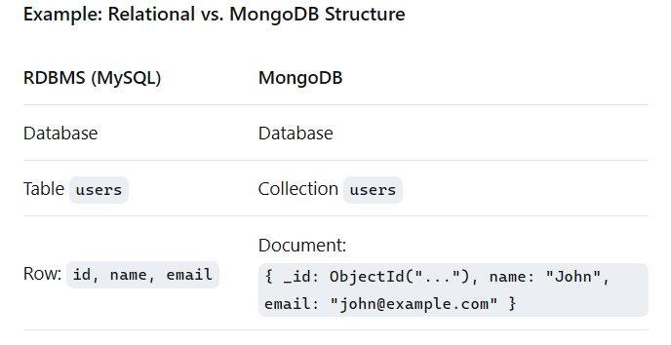
Figure 1: SQL vs NONSQL database
Analogy:
- SQL: Database > Tables > Rows > Columns
- MongoDB: Database > Collections > Documents > Fields

BSON Format: Beyond JSON
BSON (Binary JSON) is the binary-encoded serialization of JSON-like documents. While JSON is human-readable and easy to work with, it is inefficient for computational purposes due to its text-based nature and lack of type specificity. BSON extends JSON by providing additional data types such as Date and Binary Data and is designed to be efficient in both storage and traversal. The _id field in a MongoDB document is typically a special BSON type called ObjectId, which is a 12-byte identifier that provides a high probability of uniqueness without a central authority.

MongoDB Query Language (MQL) Deep Dive
MQL is used to interact with the database. Its syntax is method-based and can feel intuitive to JavaScript developers.
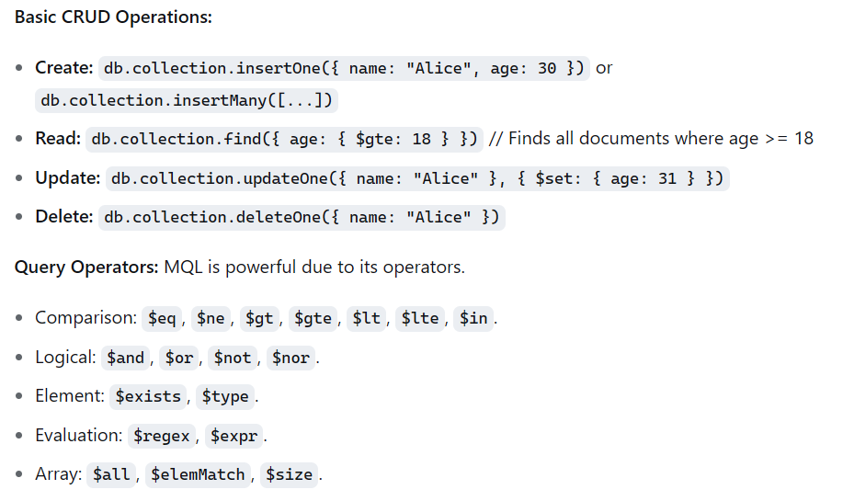
Figure 2: Basic Operations and Operators
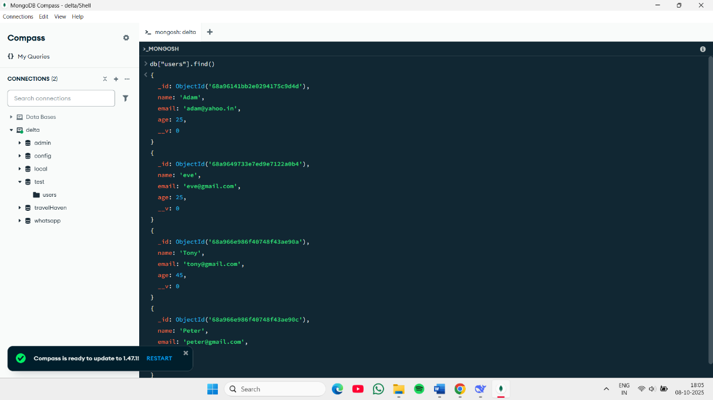
Figure 3: MongoDB Compass Interface

Data Modeling and Schema Design
While MongoDB is schema-less, careful data modeling is critical for performance and scalability. Key considerations include:
Embedding vs. Referencing:
- Embedding: Placing related data in a single document (e.g., putting an array of addresses inside a user document). Best for "contains" relationships and small, frequently accessed sub-documents.
- Referencing: Storing related data in separate collections and linking them using an ObjectId (e.g., having a separate posts collection where each post has a user_id). Best for "references" relationships and large, independent sub-documents.
- Patterns: Common patterns like the Polymorphic Pattern (for different document types in one collection) and the Bucket Pattern (for time-series data) are used to optimize for specific query patterns.

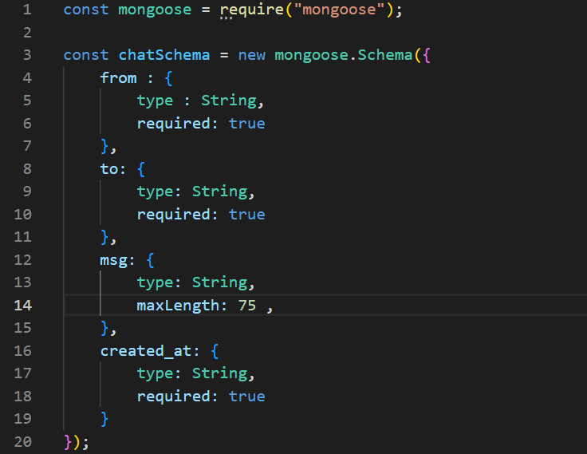
Figure 4: Creating schema for the database

EXPRESS.JS - THE WEB APPLICATION FRAMEWORK
Express.js is a fast, unopinionated, and minimalist web framework for Node.js. It simplifies the process of building server-side logic by providing a thin layer of fundamental web application features, without obscuring Node.js' core functionality. It is the de facto standard for building web servers with Node.js due to its performance, simplicity, and extensive middleware ecosystem.

The Role of a Backend Framework
A backend framework provides a structured foundation for building server-side applications. Its primary roles include:
- Routing: Mapping incoming HTTP requests (URLs and methods like GET, POST) to specific code handlers.
- Middleware Processing: Providing a way to execute functions that have access to the request and response objects, used for tasks like parsing, authentication, and logging.
- Request Handling: Simplifying the extraction of data from requests (e.g., query parameters, form data, JSON payloads).
- Response Generation: Facilitating the sending of responses in various formats (HTML, JSON, XML, files).
- Abstracting Complexity: Handling low-level protocols and repetitive tasks, allowing developers to focus on business logic.

- Introduction to Express.js
Express.js, created by TJ Holowaychuk, is built on top of Node.js's http module. It provides a higher-level, more intuitive API for creating web servers and APIs. Its key characteristics are:
- Minimalist: It provides only the core features needed for web development, allowing developers to add other libraries as needed.
- Unopinionated: It does not enforce a specific project structure or architecture, offering maximum flexibility.
- High Performance: Due to its lightweight nature and non-blocking I/O model of Node.js.
A basic “Hello World” Server in Express is remarkably concise:
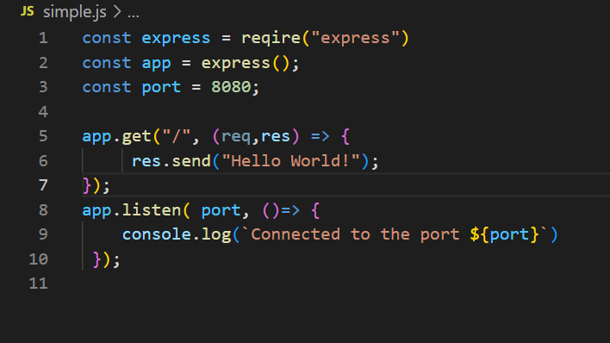
Figure 5: Creating a server
- Core Concepts: Middleware, The Request-Response Cycle
These two concepts are the heart of Express.js.
- The Request-Response Cycle: This is the fundamental flow of data in a web application.
- A client (e.g., a browser) sends an HTTP request to the server.
- The Express application receives this request.
- The request passes through a series of middleware functions.
- A route handler finally processes the request and sends an HTTP response back to the client.

- Middleware: These are functions that have access to the request object (req), the response object (res), and the next middleware function in the application’s request-response cycle (next). Middleware can:
  - Execute any code.
  - Make changes to the request and response objects.
  - End the request-response cycle (by sending a response).
  - Call the next middleware function in the stack.

- Routing: Defining API Endpoints
Routing refers to how an application’s endpoints (URIs) respond to client requests. Express provides methods that correspond to HTTP methods (app.get(), app.post(), app.put(), app.delete(), etc.).
- Route Paths: Can be strings, string patterns, or regular expressions.
- Route Parameters: Named URL segments used to capture values at specific positions in the URL (e.g., /users /:userId ).
- Route Handlers: The callback function(s) that execute when the route is matched.
Example:
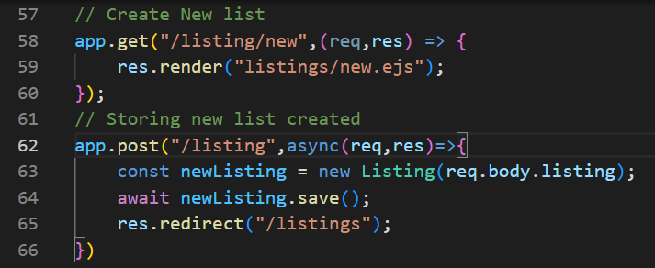
Figure 6: Defining APIs routes

- Middleware Deep Dive: Built-in, Third-party, Custom
Middleware functions are the building blocks of an Express application.
- Built-in Middleware: Express previously had middleware like body-parser bundled with it. Now, it includes key middleware directly.
  - express.json(): Parses incoming requests with JSON payloads.
  - express.urlencoded(): Parses incoming requests with URL-encoded payloads.
  - express.static(): Serves static files (e.g., images, CSS, JavaScript).
- Third-party Middleware: A vast ecosystem exists. Common examples include:
- morgan: HTTP request logger.
- helmet: Helps secure apps by setting various HTTP headers.
- cors: Enables Cross-Origin Resource Sharing.
- passport: Authentication middleware.
- Custom Middleware: Developers can write their own middleware for specific application needs, such as authentication or request logging.
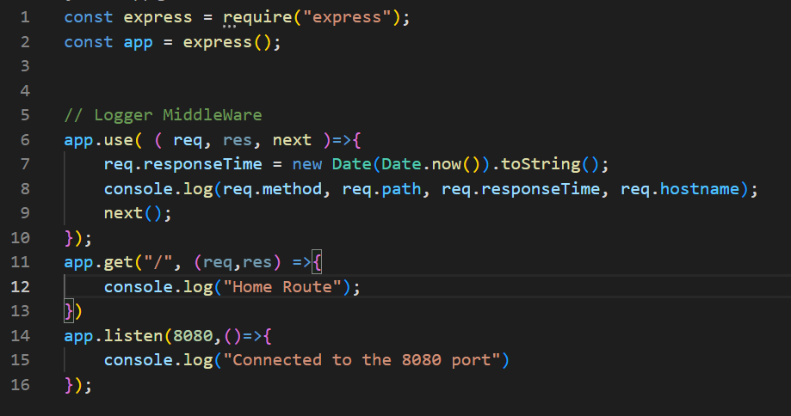
Figure 7: Custom Middleware
- Request and Response Object Manipulation
Middleware and route handlers spend most of their time interacting with the req and res objects.
- Request Object (req): Contains information about the incoming HTTP request.
  - req.params: Route parameters (from the URL path).
  - req.query: Query string parameters.
  - req.body: Data from the request body (requires a parser middleware like express.json()).
  - req.headers: The request headers.
- Response Object (res): Used to send a response back to the client.
  - res.send(): Sends a response of various types (Buffer, String, Object, Array).
  - res.json(): Sends a JSON response.
  - res.status(): Sets the HTTP status code for the response.
  - res.sendFile(): Sends a file as an octet stream.
  - res.redirect(): Redirects a request.

Template Engine EJS - A Brief Overview
While Express is often used to build APIs that return JSON, it can also render dynamic HTML on the server using template engines. They allow you to inject data into HTML templates.
EJS (Embedded JavaScript): A simple templating language that lets you generate HTML markup with plain JavaScript. Its syntax is closer to classic HTML.
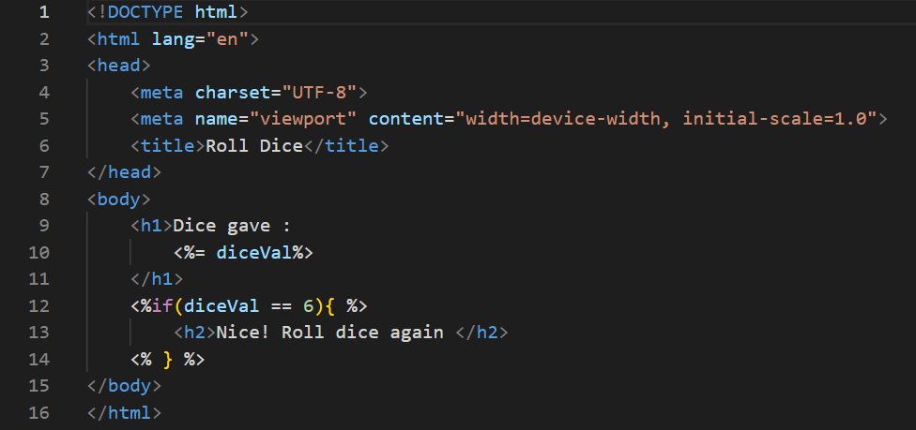
Figure 8: Creating an EJS Template
To use them, you must set the view engine and create a views directory.

Error Handling Middleware
Error handling middleware is a special type of middleware that is defined with four arguments instead of three: (err, req, res, next). It is used to catch and process errors that occur either in route handlers or in other middleware.
- It should be placed after all other app.use() calls and route definitions.
- Errors can be forwarded to this middleware by calling next(error) from any previous middleware or route.
Example:
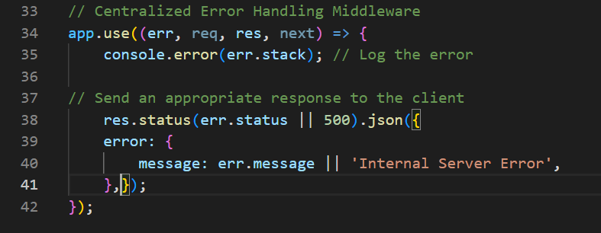
Figure 9: Error Handling middleware

Structuring an Express Application
As an application grows, a well-defined project structure is crucial for maintainability, scalability, and teamwork. A common and effective structure is MVC (Model-View-Controller) or a Modular Route-Handler structure.
Sample Project Structure:
project/
├── config/
│ └── db.js Database connection configuration
├── controllers/
│ └── userController.js Contains logic for user routes
├── models/
│ └── User.js Defines the User data schema (if using an ODM like Mongoose)
├── routes/
│ └── userRoutes.js Defines all routes for '/users'
├── middleware/
│ ├── auth.js Custom authentication middleware
│ └── errorHandler.js Centralized error handler
├── public/ Static files (CSS, JS, images)
├── views/ Template files (if using a view engine)
├── app.js Main application file (sets up middleware, routes)
└── server.js Server entry point (starts the app)
Key Benefits:
- Separation of Concerns: Logic is split into distinct, manageable parts (Routes, Controllers, Models).
- Reusability: Middleware and utility functions can be easily reused across the application.
- Testability: Isolated components are much easier to unit test.
- Team Collaboration: Different developers can work on different parts (e.g., routes, controllers) without conflict.
Conclusion:
Express.js is the backbone of the server-side MERN stack. Its power lies in its simplicity and the middleware-centric architecture that allows developers to build complex applications from small, modular components. From handling basic routing and requests to implementing sophisticated security, logging, and error handling through middleware, Express provides all the necessary tools for building robust and scalable web servers and APIs. Adopting a clean, modular project structure is the final step in leveraging Express.js to its full potential, ensuring that applications remain maintainable and efficient as they grow in complexity.

6. REACT - THE FRONTEND LIBRARY

React is an open-source JavaScript library developed and maintained by Meta (formerly Facebook). Its primary purpose is to facilitate the creation of interactive, stateful, and reusable UI components. Unlike a full-fledged framework, React focuses solely on the view layer, giving developers the freedom to choose other libraries for routing, state management, and building tools.

Why React? The Virtual DOM Concept
Manipulating the browser's actual DOM (Document Object Model) is a slow process. Complex UIs with frequent updates can become sluggish. React solves this by creating a Virtual DOM—a lightweight JavaScript object representation of the real DOM.
When a component's state changes, React creates a new Virtual DOM tree. It then compares this new tree with the previous one using a "diffing" algorithm. Once it identifies the exact changes, it updates the real DOM only with those specific changes, in the most efficient way possible. This reconciliation process provides a significant performance boost and a smooth user experience.
React's performance and developer experience are largely due to the Virtual DOM.
The Problem: Directly manipulating the real DOM (Document Object Model) is slow. Repainting and reflowing the entire UI for small changes is inefficient.
The Solution:
- Virtual DOM: React creates an in-memory JavaScript object representation of the real DOM.
- Re-render on Change: When a component's state changes, React creates a new Virtual DOM tree.
- Diffing Algorithm: React compares the new Virtual DOM with the previous one ("diffing").
- Efficient Update: It calculates the most efficient way to update the real DOM and applies only the necessary changes.
This process avoids costly full-page re-renders, leading to a highly performant user experience.

The Evolution of Frontend Development
To understand React's impact, it's essential to see the evolution:
- Static Websites (1990s-2000s): Server-rendered HTML pages with minimal JavaScript for basic interactivity.
- jQuery Era (2006-2010s): Simplified DOM manipulation and AJAX calls, enabling more dynamic experiences but leading to complex, hard-to-maintain "spaghetti code."
- MVC Frameworks (2010s): Frameworks like AngularJS introduced structure with Model-View-Controller patterns but often involved complex data-binding and performance challenges with large-scale applications.
- The Component Era (2013-Present): React introduced a paradigm shift by breaking down UIs into independent, composable components, managing a virtual representation of the DOM for performance, and using a unidirectional data flow.

JSX Syntax: JavaScript + XML
JSX is a syntax extension for JavaScript that looks like HTML. It allows developers to write UI structures directly within JavaScript code.
- What it is: A syntactic sugar for React.createElement() calls. It is not HTML, but it translates to JavaScript objects.
- Benefits:
  - Readability: Makes code more intuitive and easier to visualize.
  - Power: You can use the full power of JavaScript (e.g., mapping over arrays, using variables) inside your markup.
- Key Rules:
  - Must return a single parent element (or use a React Fragment <>...</>).
  - All tags must be closed (<br />).
  - Use className instead of class, htmlFor instead of for.
Example:
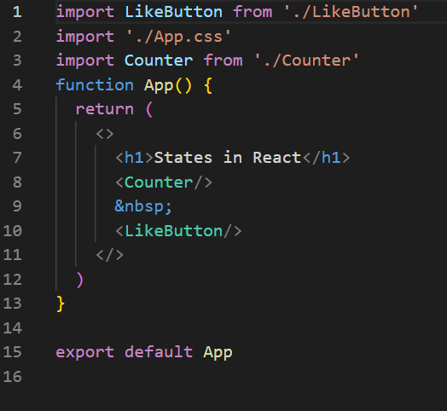
Figure 10: React's JSX file

Core Concepts: Components, Props, and State
These are the three pillars of any React application.
- Components: The building blocks of a React UI. They are self-contained, reusable pieces of code that return JSX. Think of them as JavaScript functions that return HTML.
- Props (Properties): How data flows down from parent to child components. Props are read-only; a component cannot change its own props. They are for passing data and event handlers.
- State: A component's internal memory. It is data that changes over time, usually in response to user interactions. When state updates, the component re-renders.
Analogy: A component is like a function. Props are its parameters, and State is its internal variables.

Functional Components vs. Class Components
React has two primary ways to define components, with functional components now being the modern standard.
- Functional Components:
  - Defined as JavaScript functions.
  - Simpler and cleaner syntax.
  - Use Hooks (since React 16.8) to manage state and lifecycle.
  - Modern Standard.
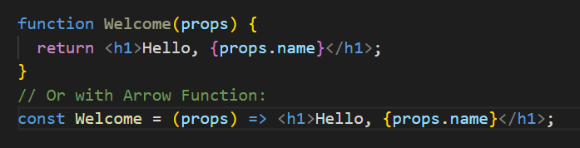
Figure 11: React's function component
- Class Components:
  - Defined as ES6 classes that extend React.Component.
  - Require a render() method that returns JSX.
  - Manage state and lifecycle using this.state and lifecycle methods (e.g., componentDidMount).
  - Legacy, but important for maintaining older codebases.

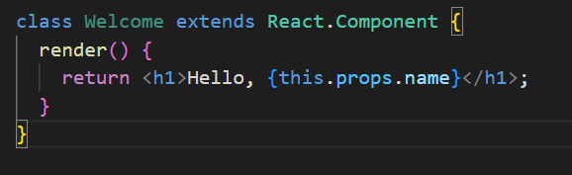
Figure 12: React's Class Component

- The React Hooks Revolution (useState, useEffect, etc.)
Hooks, introduced in React 16.8, allow functional components to use state and other React features without writing a class. This made code more reusable, composable, and easier to understand.
- useState Hook: Adds local state to a functional component.
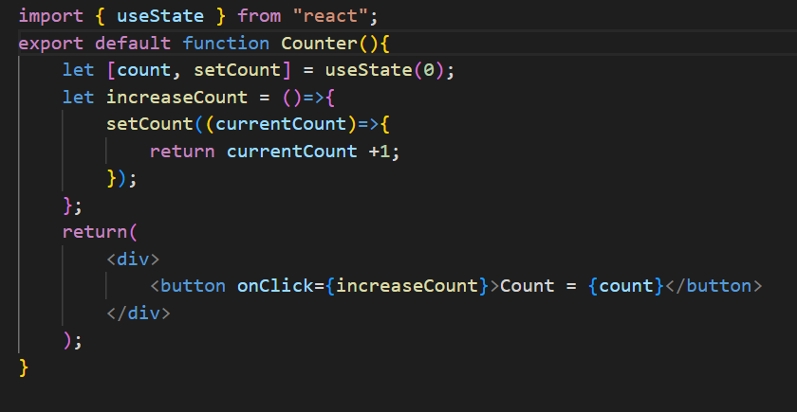
Figure 13: A counter component using useState
- useEffect Hook: Handles side effects in functional components (e.g., data fetching, subscriptions, manually changing the DOM). It serves the purpose of componentDidMount, componentDidUpdate, and componentWillUnmount combined.
- Other Essential Hooks: useContext, useReducer, useMemo, useCallback.

Handling Events and Forms
React handles events with synthetic events, which are wrappers around native browser events for cross-browser compatibility.
- Event Handling:
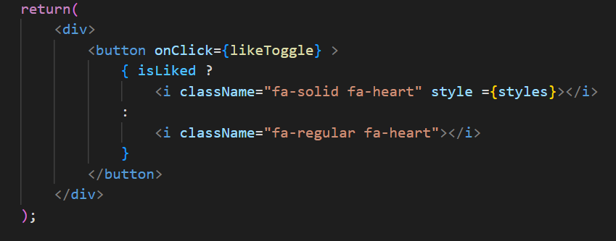
Figure 14: Creating a like button using event Handler
- Form Handling: React recommends using controlled components, where form data is handled by the component's state.
Conclusion:
React has fundamentally reshaped frontend development by championing a component-based, declarative paradigm. Its core concepts—JSX, components, props, and state—provide a powerful and intuitive model for building UIs. The introduction of Hooks has solidified functional components as the future, simplifying state and lifecycle management. When combined with complementary libraries like the Context API for simpler global state and React Router for SPA navigation, React provides a complete, efficient, and highly scalable solution for developing modern, interactive web applications. Its position as the leading frontend library is a direct result of this powerful, yet flexible, design.

7. NODE.JS - THE JAVASCRIPT RUNTIME

Node.js is an open-source, cross-platform JavaScript runtime environment built on Chrome's V8 JavaScript engine. It allows developers to execute JavaScript code outside of a web browser, enabling the use of JavaScript for server-side scripting and building scalable network applications. Its non-blocking, event-driven architecture makes it particularly suited for data-intensive real-time applications.

From Browser to Server: The Birth of Node.js
Node.js was created by Ryan Dahl in 2009 to solve a fundamental performance issue in web servers.
- The Problem: Traditional web servers (like those in Apache HTTP Server) use a multi-threaded, blocking I/O model. Each connection spawns a new thread, which consumes significant memory and CPU overhead. When a thread is blocked waiting for I/O (e.g., reading a file, querying a database), it remains idle, wasting resources.
- The Insight: Dahl realized that the browser's event-driven model and non-blocking I/O, used for handling user interactions and AJAX calls, could be applied to server-side programming.
- The Solution: He built Node.js by embedding Google's high-performance V8 JavaScript engine into a C++ program, adding an event loop and a non-blocking I/O library (libuv). This allowed a single-threaded process to handle thousands of concurrent connections efficiently.

The Event-Driven, Non-Blocking I/O Model
This model is the cornerstone of Node.js's performance and scalability.
- Non-Blocking I/O: When a Node.js application performs an I/O operation (like reading from a network socket or a database), it does not wait for the operation to complete. Instead, it continues executing other code. Once the operation finishes, a callback function is placed in a queue to be executed.
- Event-Driven: The runtime constantly monitors for completed operations (events) in the background. The Event Loop picks up the corresponding callbacks from the queue and executes them.
- Single-Threaded: JavaScript execution is single-threaded. This simplifies development by avoiding the complexity of multi-threading, such as race conditions and deadlocks. However, Node.js uses a thread pool in libuv for some file system and CPU-intensive tasks to prevent blocking the main thread.
Analogy: A single waiter (the main thread) in a restaurant can take orders from multiple tables (clients) without waiting for the kitchen to cook each order. The waiter keeps taking new orders, and when the kitchen (the operating system) signals that an order is ready, the waiter delivers it.

Node Package Manager (NPM) and Package Management
NPM is the world's largest software registry and the default package manager for Node.js. It consists of two main parts:
- The Registry: A vast public database of JavaScript software packages (over 2 million).
- The Command-Line Interface (CLI): A tool that developers use to interact with the registry—to install, manage, and publish packages.
Key Commands:
- npm init: Initializes a project and creates a package.json file.
- npm install <package-name>: Installs a package locally.
- npm install -g <package-name>: Installs a package globally.
- npm update: Updates packages.
package.json: The manifest file for a Node.js project. It lists metadata about the project, its dependencies (packages it needs to run), and development dependencies.

Understanding the Event Loop
The Event Loop is the mechanism that allows Node.js to perform non-blocking I/O operations despite being single-threaded. It is a continuous loop that checks the call stack and the callback queue.
Simplified Phases of the Event Loop:
- Timers: Executes callbacks scheduled by setTimeout() and setInterval().
- Pending Callbacks: Executes I/O callbacks deferred from the previous cycle.
- Idle, Prepare: Internal phases used by Node.js.
- Poll:
  - Retrieves new I/O events.
  - Executes I/O-related callbacks (almost all except close callbacks, timers, and setImmediate).
  - If the poll queue is empty, it will wait for callbacks to be added to the queue.
- Check: Executes setImmediate() callbacks.
- Close Callbacks: Executes close event callbacks (e.g., socket.on('close', ...)).
The loop continues until there are no more callbacks left to execute.

Managing Asynchronous Operations: Callbacks, Promises, Async/Await
Handling the results of non-blocking operations is central to Node.js development. The methodology has evolved significantly.
- Callbacks (The Original Pattern): A function passed as an argument to another function, to be executed later once an operation completes. This led to "Callback Hell" or "Pyramid of Doom," where nested callbacks made code hard to read and maintain.
- Promises (The Savior): An object representing the eventual completion (or failure) of an asynchronous operation. They allow chaining with .then() and .catch(), which flattens the code.
- Async/Await (The Modern Syntax): Syntactic sugar built on top of Promises. It allows writing asynchronous code that looks and behaves like synchronous code, making it the most readable and maintainable approach.
Conclusion:
Node.js is the engine that powers the server-side of the MERN stack. Its revolutionary event-driven, non-blocking architecture enables the development of highly scalable and efficient network applications. The rich ecosystem managed by NPM, combined with powerful built-in modules, provides developers with a comprehensive toolkit. Understanding the Event Loop is key to mastering Node.js performance, while the evolution from callbacks to promises to async/await has dramatically improved the developer experience for managing asynchronous operations. Node.js successfully unified web application development around a single programming language, JavaScript, from the frontend to the backend.

FUTURE OF THE MERN STACK AND JAVASCRIPT ECOSYSTEM

The MERN stack, while already a dominant force in full-stack development, exists within a rapidly evolving JavaScript ecosystem. Its future is not about stagnation but about adaptation and integration with new paradigms and technologies.
- The Rise of the Meta-Frameworks and Full-Stack Architectures:
- Next.js and Remix: React-based meta-frameworks like Next.js (from Vercel) and Remix are gaining immense popularity. They provide built-in solutions for critical features like Server-Side Rendering (SSR), Static Site Generation (SSG), and simplified data fetching, which are complex to implement manually in a standard MERN setup.
- Impact on MERN: The traditional MERN architecture (separate React frontend and Express/Node backend) is increasingly being complemented or replaced by these integrated frameworks for new projects, especially those where SEO and initial page load performance are critical. The "E" (Express) and "N" (Node) are still there but are often abstracted and configured by the framework.
- The GraphQL Paradigm Shift:
- While RESTful APIs (built with Express) remain hugely relevant, GraphQL is becoming a strong alternative for building APIs. It allows clients to request exactly the data they need, reducing over-fetching and under-fetching.
- Impact on MERN: Developers may choose to replace or co-locate a GraphQL server (using libraries like Apollo Server or Yoga) alongside their Express API, moving from a REST-centric MERN to a GERN (GraphQL, Express, React, Node) or MENR (MongoDB, Express, Node, React) with GraphQL.
- The TypeScript Supremacy:
- TypeScript, a statically typed superset of JavaScript, is being adopted at an accelerating rate. Its ability to catch errors at compile-time, improve code readability, and enhance developer experience through superior IDE support makes it a compelling choice for large-scale applications.
- Impact on MERN: The future MERN stack is likely to be a TMERN stack. All components—from React components and Express routes to Node.js scripts and Mongoose schemas—can be written in TypeScript, bringing end-to-end type safety to the entire application.
- Serverless and Edge Computing:
- The "serverless" model (e.g., AWS Lambda, Vercel Functions, Netlify Functions) abstracts server management entirely. Functions are executed in response to events.
- Impact on MERN: Instead of deploying a monolithic Express server, developers can break down their backend into smaller, single-purpose serverless functions. This can lead to more cost-effective and scalable architectures. Furthermore, Edge Computing allows running code closer to the user, reducing latency, which frameworks like Next.js are leveraging.
- Evolution of State Management and Data Fetching:
- On the frontend, state management continues to evolve. While the Context API and useReducer suffice for many applications, more complex state logic is being managed by libraries like Zustand and Jotai, which offer a simpler alternative to the once-dominant Redux.
- Data fetching libraries like TanStack Query (React Query) and SWR are becoming standard for managing server state, caching, and synchronization, handling complexities that useEffect alone cannot.

CONCLUSION
The MERN stack represents a powerful and cohesive full-stack JavaScript solution that has democratized web development. By unifying the development environment around a single language, it streamlines the entire process, from database design to UI implementation, fostering efficiency and team collaboration.
This report has illuminated the distinct and vital role of each component:
- MongoDB provides the flexible, scalable data layer with its document-oriented model.
- Express.js offers the minimalist, middleware-driven framework to build robust and structured server-side APIs.
- React delivers a component-based, reactive frontend that creates dynamic and high-performance user interfaces.
- Node.js serves as the unifying runtime, enabling JavaScript to power the server with its non-blocking, event-driven architecture.
Mastering the MERN stack is more than just learning four technologies; it is about understanding how they interconnect. It involves grasping the flow of data from a document in MongoDB, through an Express API endpoint, to a stateful React component that renders it for the user. It requires a mindset that embraces asynchronous operations, component reusability, and secure API design.
While new frameworks and paradigms will continue to emerge, the fundamental concepts embodied by the MERN stack—component-based UIs, API-driven backends, and JSON-based data exchange—are enduring principles of modern web development. Whether one builds with the classic MERN architecture or its modern evolutions, the knowledge gained provides a solid and transferable foundation for a career in software engineering. The MERN stack is not just a toolkit; it is a gateway to the vast and dynamic world of full-stack JavaScript development.

REFERENCES
https://www.geeksforgeeks.org/ - (For Topics and pictures)
https://www.npmjs.com/ - (Node packages details)
https://mui.com/material-ui/ - (React’s Components)
https://developer.mozilla.org/en-US/ - (HTML, CSS, JavaScript Documentations)
https://getbootstrap.com/ - (For pre-built css components)

