**AGRISEEKS**

**A MINI-PROJECT REPORT**

***Submitted by***

**MOHITH S – 2116220701170**

***in partial fulfilment of the award of the degree***

***of***

# BACHELOR OF ENGINEERING

**IN**

**COMPUTER SCIENCE AND ENGINEERING**



# RAJALAKSHMI ENGINEERING COLLEGE

**AUTONOMOUS, CHENNAI**

## NOV/DEC, 2024

### BONAFIDE CERTIFICATE

Certified that this mini project “**AGRISEEKS**” is the bonafide

work of “**MOHITH S (2116220701170)”** who carried out the project work under my supervision.

|  |
| --- |
| **SIGNATURE** |
| **Mrs. JANANEE V,** |
| Assistant Professor, |
| Computer Science & Engineering |
| Rajalakshmi Engineering College |
| Thandalam, Chennai -602105. |

Submitted for the End semester practical examination to be held on

**INTERNAL EXAMINER EXTERNAL EXAMINER**

### ACKNOWLEDGEMENT

I express my sincere thanks to my beloved and honourable chairman **MR.S.MEGANATHAN** and the chairperson **DR.M.THANGAM MEGANATHAN** for their timely support and encouragement.

I am greatly indebted to my respected and honourable principal **Dr.S.N.MURUGESAN** for his able support and guidance.

No words of gratitude will suffice for the unquestioning support extended to us by my head of the department **Dr.P. KUMAR,** and my Academic Head **Dr.R.SABITHA,** for being ever supporting force during my project work.

I also extend my sincere and hearty thanks to my internal guide **Mrs. JANANEE V** for her valuable guidance and motivation during the completion of this project.

My sincere thanks to my family members, friends and other staff members of Computer Science and Engineering.

Mohith S 2116220701170

## ABSTRACT

Agriculture remains a critical industry globally, yet it continues to face significant challenges, particularly in managing its labour force. The AGRISEEKS project is an innovative web-based platform designed to address these challenges by creating a centralized system where farmers can efficiently post job opportunities, and agricultural labourers can search, apply, and connect with these opportunities. The platform serves as a marketplace for agricultural employment, facilitating direct interaction between job providers (farmers) and job seekers (labourers).

The AGRISEEKS platform simplifies a traditionally complex process of finding and managing agricultural labour through the use of modern web technologies. It provides a dual-dashboard system: one for farmers to post job requirements, specify the number of workers needed, and include location and job details; and another for labourers to browse available jobs, apply, and manage their applications. Each user type has a streamlined experience tailored to their needs. The platform supports essential features such as registration, login, secure job postings, and real-time job updates, ensuring the system remains dynamic and responsive to user inputs.

By integrating database management, responsive design, and a seamless user interface, AGRISEEKS aims to provide a highly functional, easy-to-use solution that addresses a crucial gap in agricultural workforce management. The core idea of the project is to promote agricultural efficiency by reducing the friction and costs associated with hiring temporary or permanent workers. AGRISEEKS also allows farmers to reach a broader labour pool and for labourers to access jobs that match their skills and location, thus enhancing productivity and satisfaction for both parties.

Moreover, the project has been designed with scalability in mind, allowing for future expansions that could include additional features such as a rating system for workers, mobile app integration, and smart matching algorithms that recommend jobs based on a labourer’s past applications or proximity. The platform adheres to modern security protocols to ensure that user data, including personal and job-related information, remains secure.

Ultimately, AGRISEEKS strives to bring technological innovation to the agricultural sector by addressing labour shortages, reducing inefficiencies, and fostering better communication between farmers and workers. It is a step toward improving agricultural productivity, ensuring sustainable farming practices, and supporting rural economies through better workforce management.

## TABLE OF CONTENTS

## CHAPTER NO            TITLE       PAGE

## ABSTRACT 4

## 1 INTRODUCTION   6

## 1.1 INTRODUCTION 6

## 1.2 SCOPE OF THE WORK    6

## 1.3           AIM AND OBJECTIVES OF THE PROJECT  7

## 2. SYSTEM SPECIFICATIONS   8

## 2.1 HARDWARE SPECIFICATIONS  8

## 2.2 SOFTWARE SPECIFICATIONS    8

## 3 ARCHITECTURE DIAGRAM  9

## 4  MODULE DESCRIPTION 10

## 5 SYSTEM DESIGN 12

## 5.1 USE CASE DIAGRAM 12

## 5.2     ER DIAGRAM 13

## 5.3 DATA FLOW DIAGRAM 14

## 5.4 ACTIVITY DIAGRAM 15

## 6 SAMPLE CODING 16

## 7 SCREENSHOTS 20

## 8       CONCLUSION 30

## REFERENCES                                                       25

## CHAPTER 1

### INTRODUCTION

**1. INTRODUCTION**

AGRISEEKS is designed to solve challenges faced by both farmers and labourers. Farmers often struggle to find the right workforce for specific tasks during peak agricultural seasons, while labourers find it hard to secure jobs matching their skillsets. The platform bridges this gap by providing a digital marketplace for job postings and applications in the agricultural domain. Using modern web development technologies like PHP, MySQL, jQuery, and Bootstrap, AGRISEEKS ensures a responsive and user-friendly experience for rural communities.

**1.2 SCOPE OF THE WORK**

The scope of AGRISEEKS extends beyond simple job postings. It offers features such as smart matching algorithms, real-time notifications, a customizable dashboard for both farmers and labourers, secure user authentication, and personalized occupation-based interfaces. Farmers can manage farm details, track labour availability, and post jobs specific to their needs, while labourers can showcase their skills, view job opportunities, and apply with ease.

AGRISEEKS aims to be scalable to accommodate thousands of users and to potentially integrate AI for better labour-job matching. The platform is built with security in mind, providing robust protection for user data, especially sensitive information like Aadhaar numbers.

.

**1.3 AIM AND OBJECTIVES OF THE PROJECT**

The primary aim of the **AGRISEEKS** project is to bridge the gap between farmers seeking labour and labourers looking for agricultural jobs, through a streamlined and efficient online platform. This platform will allow farmers to post job listings and hire skilled labourers, while labourers can browse and apply for available jobs based on their skillsets and location. By creating a user-friendly interface for both parties, the platform aims to ease labour sourcing challenges and contribute to increased agricultural productivity.

The objectives include:

1. Developing a dynamic and responsive platform for farmers and labourers.
2. Enabling secure job postings and labourer applications.
3. Integrating an automated system for validating labourers' details against a user database.
4. Providing features like job status tracking, labourer availability management, and seamless communication between both parties.
5. Supporting future scalability for additional agricultural services, such as equipment rentals or expert consultations.

### CHAPTER 2

### SYSTEMSPECIFICATIONS

1. **HARDWARE SPECIFICATIONS**

• **Processor:** Intel i3 or equivalent

• **RAM:** 4 GB or higher

• **Storage:** 500 GB hard disk or SSD

• **Display:** 1024x768 resolution or higher

• **Network:** Active internet connection with minimum 2 Mbps speed

1. **SOFTWARE SPECIFICATIONS**

• **Operating System:** Windows 10 / Linux / macOS

• **Web Server:** Apache 2.4 or above

• **Database:** MySQL 5.7+ / MariaDB 10.2+

• **Scripting Language:** PHP 7.4 or higher

• **Front-End:** HTML5, CSS3, Bootstrap, JavaScript, JQuery

• **Browser:** Latest version of Chrome, Firefox, Edge

**CHAPTER 3**

**ARCHITECTURE DIAGRAM**

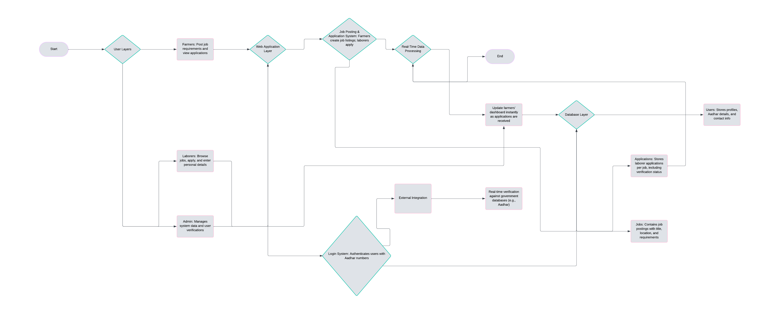

**CHAPTER 4**

**MODULE DESCRIPTION**

**1. Login Page**

The login page is the gateway for both farmers and labourers to access the AGRISEEKS platform. Users are required to input their Aadhaar number and password to authenticate their credentials. Successful login directs users to their respective dashboards.

**2. Farmer Dashboard**

After logging in, farmers land on the farmer dashboard. This page allows farmers to:

* **Post New Jobs**: Farmers can create job listings by providing job title, description, location, the number of workers needed, and contact details.
* **View Posted Jobs**: A table lists all jobs posted by the farmer, showing details such as job title, description, workers needed, location, and contact number.
* **Job Applications**: Farmers can also view the labourers who have applied for each job, along with their details.

**3. Labourer Dashboard**

The labourer dashboard is the main page for labourers after login, where they can:

* **View Available Jobs**: A list of jobs posted by farmers is displayed with job title, description, location, and number of workers required.
* **Apply for Jobs**: Labourers can select a job, input the number of labourers applying, and submit their Aadhaar details. The system verifies these details before submitting the application.

**4. Job Posting Page**

This page is part of the farmer’s dashboard where they can create new job posts. It includes a form where farmers enter information such as:

* Job title
* Job description
* Number of workers needed
* Location
* Phone number

# CHAPTER 5

**SYSTEM DESIGN**

**5.1 USE CASE DIAGRAM**

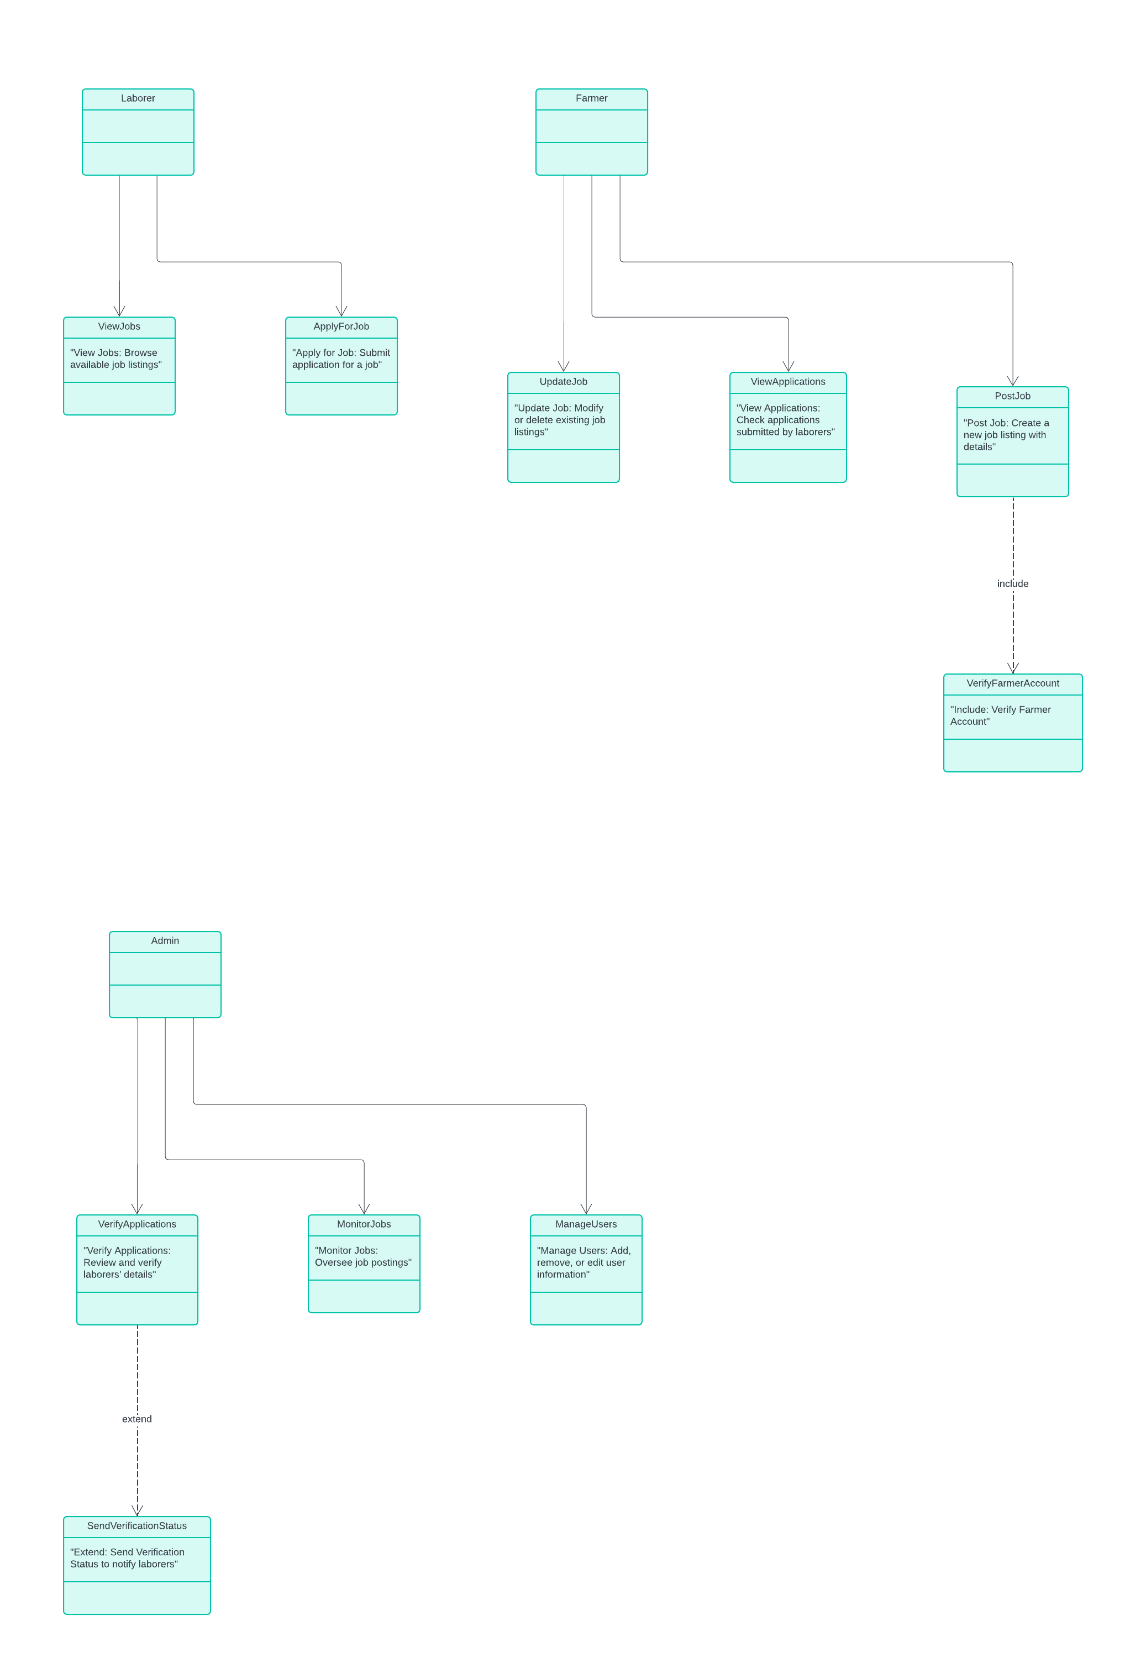

**5.2 ER DIAGRAM**

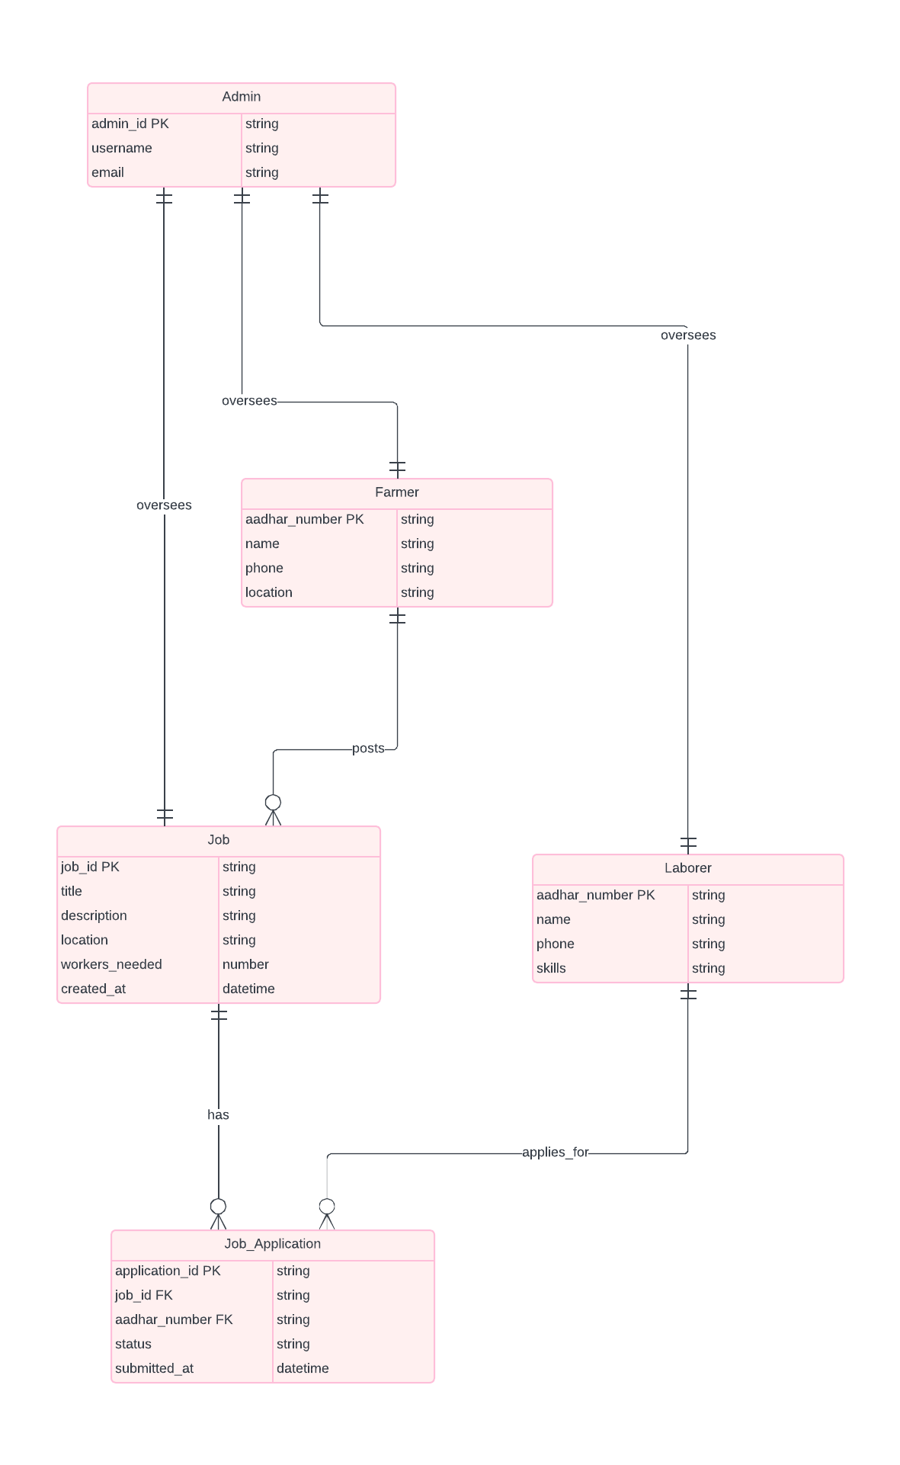

**5.3. DFD DIAGRAM**

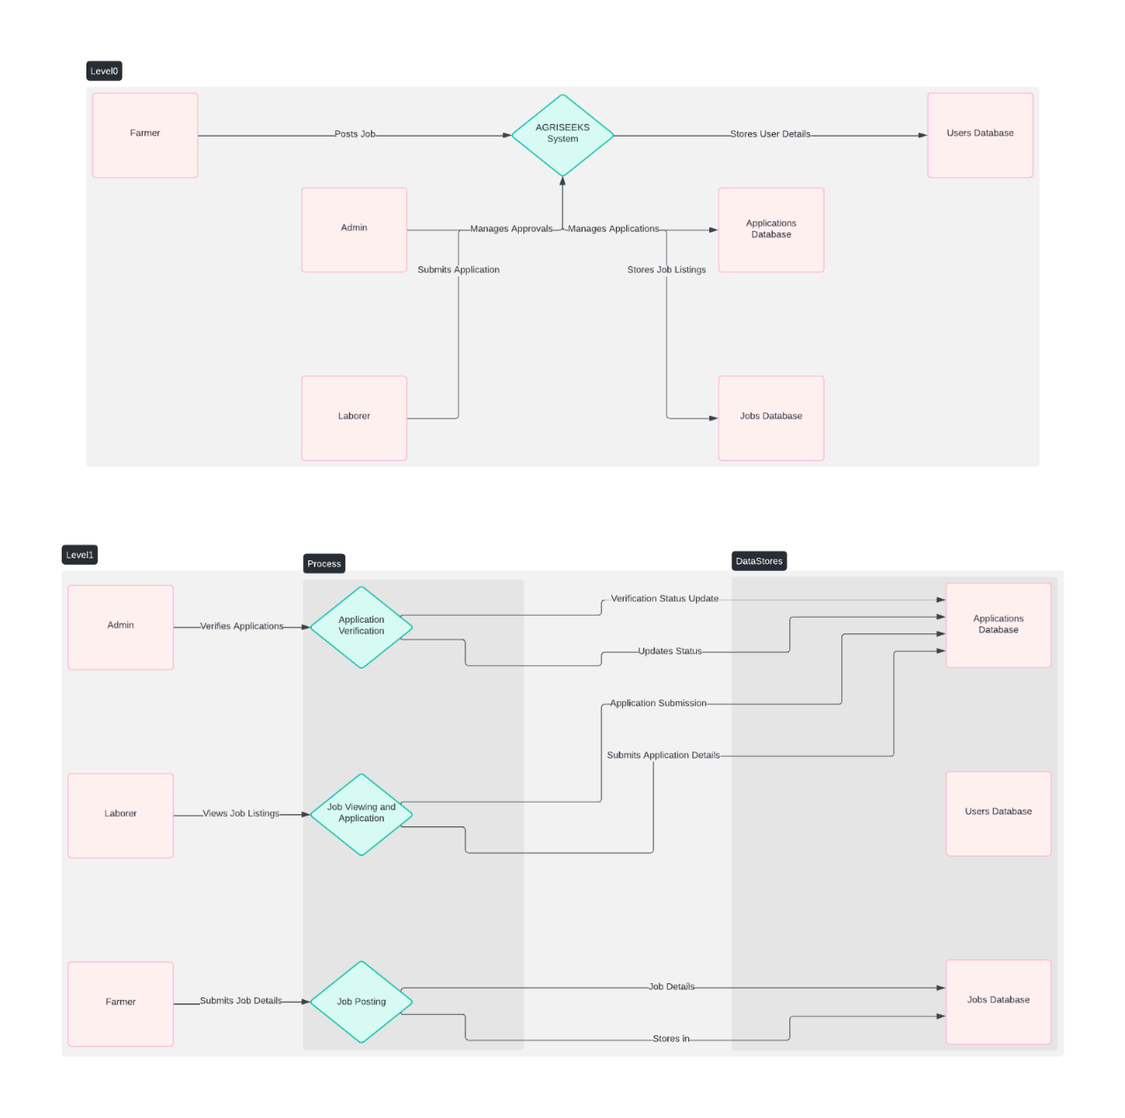

**5.4. ACTIVITY DIAGRAM**

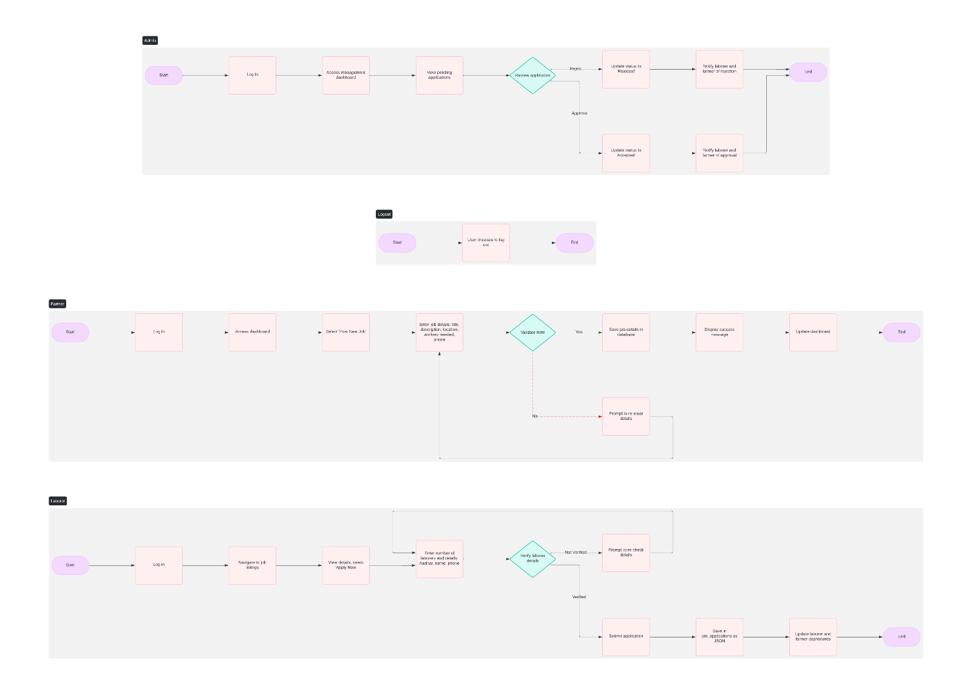

## CHAPTER 6

## SAMPLE CODING

LOGIN PAGE

<!DOCTYPE html>

<html lang="en">

<head>

    <meta charset="UTF-8">

    <meta name="viewport" content="width=device-width, initial-scale=1.0">

    <title>Login | AGRISEEKS</title>

    <!-- Bootstrap CSS -->

    <link href="https://cdn.jsdelivr.net/npm/bootstrap@5.3.0-alpha1/dist/css/bootstrap.min.css" rel="stylesheet">

    <!-- Custom CSS -->

    <link rel="stylesheet" href="styles2.css">

    <!-- jQuery -->

    <script src="https://code.jquery.com/jquery-3.6.0.min.js"></script>

    <!-- Bootstrap JS -->

    <script src="https://cdn.jsdelivr.net/npm/bootstrap@5.3.0-alpha1/dist/js/bootstrap.bundle.min.js"></script>

    <style>

        body {

            background-color: #f8f9fa;

        }

        .card {

            margin: 50px auto;

            max-width: 1200px;

        }

        .card img {

            height: 100%;

            object-fit: cover;

        }

        .form-container {

            padding: 2rem;

        }

        .form-container h2 {

            margin-bottom: 1rem;

        }

        #loginForm {

            margin-top: 20px;

        }

    </style>

</head>

<body>

<header>

        <h1>AGRISEEKS</h1>

        <!-- Navigation -->

        <nav>

            <ul class="nav justify-content-center">

                <li><a href="home.php">Home</a></li>

                <li><a href="register.php">Register</a></li>

            </ul>

        </nav>

    </header>

    <!-- Login Card -->

    <div class="card shadow-lg">

        <div class="row g-0">

            <!-- Left Image -->

            <div class="col-md-6 d-none d-md-block">

                <img src="farm4.jpg" alt="Farm Image" class="img-fluid">

            </div>

            <!-- Right Side Login Form -->

            <div class="col-md-6">

                <div class="form-container">

                    <h2 class="text-center">Welcome Back!</h2>

                    <form id="loginForm" action="login.php" method="POST">

                        <div class="mb-3">

                            <label for="username" class="form-label">Username:</label>

                            <input type="text" class="form-control" id="username" name="username" required>

                        </div>

                        <div class="mb-3">

                            <label for="aadhar_number" class="form-label">Aadhaar Number:</label>

                            <input type="text" class="form-control" id="aadhar_number" name="aadhar_number" maxlength="12" required>

                        </div>

                        <div class="mb-3">

                            <label for="password" class="form-label">Password:</label>

                            <input type="password" class="form-control" id="password" name="password" required>

              </div>

</html>

HOME PAGE

<!DOCTYPE html>

<html lang="en">

<head>

    <meta charset="UTF-8">

    <meta name="viewport" content="width=device-width, initial-scale=1.0">

    <meta http-equiv="X-UA-Compatible" content="ie=edge">

    <title>AGRISEEKS</title>

    <link rel="stylesheet" href="styles2.css">

    <link href="https://fonts.googleapis.com/css2?family=Poppins:wght@400;500;600&display=swap" rel="stylesheet">

    <script src="https://code.jquery.com/jquery-3.6.0.min.js"></script>

</head>

<body>

    <!-- Header Section -->

    <header>

        <h1>AGRISEEKS</h1>

        <nav>

            <ul>

            <li><a href="home.php">Home</a></li>

            <li><a href="#features">Features</a></li>

            <li><a href="register.php">Register</a></li>

            <li><a href="logout.php">Login/Logout</a></li>

            </ul>

        </nav>

    </header>

    <!-- Image Slider Section -->

    <section id="image-slider">

        <div class="slider">

            <div class="slides">

                <div class="slide"><img src="farm2.jpg" alt="Slide 1" height="500px"></div>

                <div class="slide"><img src="farm3.jpg" alt="Slide 2" height="500px"></div>

                <div class="slide"><img src="farm1.jpg" alt="Slide 3" height="500px"></div>

            </div>

        </div>

        <button class="prev" onclick="moveSlide(-1)">&#10094;</button>

        <button class="next" onclick="moveSlide(1)">&#10095;</button>

    </section>

    <!-- Intro Section -->

    <section id="intro">

        <h2>Connecting Farmers and Labourers Easily</h2>

        <p>Effortlessly find the right labour force or agricultural opportunities. Whether you're a large-scale farmer or a field labourer, our portal ensures your needs are met quickly and efficiently.</p>

        <a href="register.php" class="button">Get Started</a>

    </section>

<br>

<br>

    <!-- Statistics Section -->

    <section id="statistics">

        <h3>Our Impact</h3>

        <div class="stat">

            <h4>500+</h4>

            <p>Jobs Posted</p>

        </div>

        <div class="stat">

            <h4>300+</h4>

            <p>Registered Farmers</p>

        </div>

        <div class="stat">

            <h4>200+</h4>

            <p>Registered Labourers</p>

        </div>

    </section>

    <br>

    <br>

       <!-- Features Section -->

       <section id="features">

        <h4>Features of AGRISEEKS</h4>

        <div class="feature" id="farmerFeature">

            <h4>For Farmers</h4>

            <p>Post your requirements for skilled or general labourers. Browse profiles and select the best fit for your farm's needs.</p>

        </div>

        <div class="feature" id="labourFeature">

            <h4>For Labourers</h4>

            <p>Create a profile and find agricultural work that matches your skill set and preferences, all in one platform.</p>

        </div>

        <div class="feature" id="smartMatchingFeature">

            <h4>Smart Matching</h4>

            <p>Our advanced algorithm ensures that farmers and labourers are matched efficiently based on location, availability, and experience.</p>

        </div>

    </section>

    <!-- FAQ Section -->

    <section id="faq">

        <h3>Frequently Asked Questions</h3>

        <div class="faq-item">

            <h4>How do I post a job?</h4>

            <p>Once you register as a farmer, you can easily post a job through your dashboard.</p>

        </div>

        <div class="faq-item">

            <h4>How do I apply for a job?</h4>

            <p>After registering as a labourer, you can browse job listings and apply directly through the platform.</p>

        </div>

    </section>

    <!-- Contact Section -->

    <section id="contact">

        <h3>Contact Us</h3>

        <form id="contactForm">

            <label for="contactName">Name:</label>

            <input type="text" id="contactName" required>

            <label for="contactEmail">Email:</label>

            <input type="email" id="contactEmail" required>

            <label for="contactMessage">Message:</label>

            <textarea id="contactMessage" rows="4" required></textarea>

            <button type="submit" class="button">Send Message</button>

        </form>

    </section>

    <!-- Newsletter Signup Section -->

    <section id="newsletter">

        <h3>Stay Updated</h3>

        <p>Sign up for our newsletter to receive the latest updates and job postings.</p>

        <form id="newsletterForm">

            <label for="newsletterEmail">Email:</label>

            <input type="email" id="newsletterEmail" required>

            <button type="submit" class="button">Subscribe</button>

        </form>

    </section>

    <script>

        $(document).ready(function() {

            // Form validation on submit

            $('#contactForm').on('submit', function(event) {

                event.preventDefault(); // Prevent form submission

                const name = $('#contactName').val().trim();

                const email = $('#contactEmail').val().trim();

                const message = $('#contactMessage').val().trim();

                if (name === '' || email === '' || message === '') {

                    alert("Please fill in all fields.");

                } else {

                    alert("Message sent successfully!");

                    // Here you would typically handle the form submission (e.g., via AJAX)

                    this.reset(); // Reset form fields

                }

            });

            // Newsletter form submission

            $('#newsletterForm').on('submit', function(event) {

                event.preventDefault(); // Prevent default form submission

                const newsletterEmail = $('#newsletterEmail').val().trim();

                if (newsletterEmail === '') {

                    alert("Please enter your email address.");

                } else {

                    alert("Thank you for subscribing!");

                    // Here you would typically handle the newsletter signup (e.g., via AJAX)

                    this.reset(); // Reset form fields

                }

            });

            // Feature click events

            $('#farmerFeature').on('click', function() {

                window.location.href = 'FAR2.php';

            });

            $('#labourFeature').on('click', function() {

                window.location.href = 'la1.php';

            });

            // Image slider functionality

            let currentSlide = 0;

            const slides = $('.slides');

            const totalSlides = $('.slide').length;

            function showSlide(index) {

                currentSlide = (index + totalSlides) % totalSlides;

                const offset = -currentSlide * 100;

                slides.css('transform', `translateX(${offset}%)`);

            }

            // Move to the next/previous slide

            window.moveSlide = (n) => {

                showSlide(currentSlide + n);

            };

            // Auto-slide every 5 seconds (optional)

            setInterval(() => {

                showSlide(currentSlide + 1);

            }, 5000); // Change slide every 5 seconds

        });

    </script>

      <!-- Footer -->

      <footer id="footer">

        <p>AGRISEEKS | Designed for a better agricultural future</p>

        <p>&copy; 2024 AGRISEEKS.com</p>

    </footer>

</body>

</html>

FARMERS DASHBOARD

<?php

include('config.php'); // Database connection

session_start();

// Check if the user is logged in

if (!isset($_SESSION['aadhar_number'])) {

    header('Location: login.php'); // Redirect to login if not logged in

    exit();

}

// Get the logged-in user's Aadhaar number and username

$aadhar_number = $_SESSION['aadhar_number'];

$username = $_SESSION['username'];

// Fetch jobs posted by the logged-in farmer using aadhar_number

$sql = "SELECT * FROM jobs WHERE aadhar_number = ?";

$stmt = $conn->prepare($sql);

if (!$stmt) {

    die("Error preparing query: " . $conn->error);

}

$stmt->bind_param("s", $aadhar_number);

$stmt->execute();

$result = $stmt->get_result();

// Handle job posting

if ($_SERVER['REQUEST_METHOD'] == 'POST' && isset($_POST['post_job'])) {

    $job_title = $_POST['job_title'];

    $job_description = $_POST['job_description'];

    $location = $_POST['location'];

    $workers_needed = $_POST['workers_needed'];

    // Prepare an SQL statement to insert the job

    $insert_sql = "INSERT INTO jobs (aadhar_number, username, job_title, job_description, location, workers_needed, created_at) VALUES (?, ?, ?, ?, ?, ?, NOW())";

    $insert_stmt = $conn->prepare($insert_sql);

    if (!$insert_stmt) {

        die("Error preparing insert query: " . $conn->error);

    }

    $insert_stmt->bind_param("sssssi", $aadhar_number, $username, $job_title, $job_description, $location, $workers_needed);

    // Execute the insertion

    if ($insert_stmt->execute()) {

        echo "<script>alert('Job posted successfully!');</script>";

    } else {

        echo "<script>alert('Error posting job. Please try again.');</script>";

    }

    // Close the insert statement

    $insert_stmt->close();

    // Refresh the job list

    $stmt->execute();

    $result = $stmt->get_result();

}

?>

<!DOCTYPE html>

<html lang="en">

<head>

    <meta charset="UTF-8">

    <meta name="viewport" content="width=device-width, initial-scale=1.0">

    <title>Farmer Dashboard</title>

    <link rel="stylesheet" href="styles2.css">

</head>

<body>

    <header>

        <h1>AGRISEEKS</h1>

        <nav>

            <ul>

                <li><a href="home.php">Home</a></li>

                <li><a href="logout.php">Logout</a></li>

            </ul>

        </nav>

    </header>

    <h2>Welcome, <?php echo htmlspecialchars($username); ?></h2>

    <section>

        <h2>Your Posted Jobs</h2>

        <table border="1">

            <tr>

                <th>Job Title</th>

                <th>Job Description</th>

                <th>Location</th>

                <th>Workers Needed</th>

                <th>Posted On</th>

                <th>Labour Applications</th>

            </tr>

            <?php

            // Display jobs if any

            if ($result->num_rows > 0) {

                while ($row = $result->fetch_assoc()) {

                    echo "<tr>";

                    echo "<td>" . htmlspecialchars($row['job_title']) . "</td>";

                    echo "<td>" . htmlspecialchars($row['job_description']) . "</td>";

                    echo "<td>" . htmlspecialchars($row['location']) . "</td>";

                    echo "<td>" . htmlspecialchars($row['workers_needed']) . "</td>";

                    echo "<td>" . htmlspecialchars($row['created_at']) . "</td>";

                    // Fetch job applications for each job

                    echo "<td><ul>";

                    $job_id = $row['job_id'];

                    $sql_applications = "SELECT * FROM job_applications WHERE job_id = ?";

                    $stmt_applications = $conn->prepare($sql_applications);

                    if (!$stmt_applications) {

                        die("Error preparing application query: " . $conn->error);

                    }

                    $stmt_applications->bind_param("i", $job_id);

                    $stmt_applications->execute();

                    $applications_result = $stmt_applications->get_result();

                    while ($application = $applications_result->fetch_assoc()) {

                        $labourers = json_decode($application['labourer_data'], true);

                        foreach ($labourers as $labourer) {

                            echo "<li>Aadhar: " . htmlspecialchars($labourer['aadhar']) .

                                 " | Name: " . htmlspecialchars($labourer['name']) .

                                 " | Phone: " . htmlspecialchars($labourer['phone']) .

                                 " | Skillset: " . htmlspecialchars($labourer['skillset']) . "</li>";

                        }

                    }

                    echo "</ul></td>";

                    echo "</tr>";

                }

            } else {

                echo "<tr><td colspan='6'>No jobs posted yet.</td></tr>";

            }

            ?>

        </table>

    </section>

    <br>

    <br>

    <section>

        <h2>Post a New Job</h2>

        <form id="postJobForm" method="POST">

            <label for="job_title">Job Title:</label>

            <input type="text" id="job_title" name="job_title" placeholder="Enter Job Title" required><br><br>

            <label for="job_description">Job Description:</label>

            <textarea id="job_description" name="job_description" placeholder="Enter Job Description" required></textarea><br><br>

            <label for="location">Location:</label>

            <input type="text" id="location" name="location" placeholder="Enter Location" required><br><br>

            <label for="workers_needed">Number of Workers Needed:</label>

            <input type="number" id="workers_needed" name="workers_needed" placeholder="Enter Number" required><br><br>

            <button type="submit" name="post_job">Post Job</button>

        </form>

    </section>

    <footer id="contact">

        <p>AGRISEEKS | Designed for a better agricultural future</p>

        <p>&copy; 2024 AGRISEEKS.com</p>

    </footer>

</body>

</html>

<?php

// Close the database connection

$stmt->close();

$conn->close();

?>

LABOURS DASHOBOARD

<?php

include('config.php'); // Database connection

session_start();

// Check if the user is logged in

if (!isset($_SESSION['aadhar_number'])) {

    header('Location: login.php'); // Redirect to login if not logged in

    exit();

}

// Fetch available jobs from the jobs table

$sql_jobs = "SELECT * FROM jobs";

$result_jobs = $conn->query($sql_jobs);

?>

<!DOCTYPE html>

<html lang="en">

<head>

    <meta charset="UTF-8">

    <meta name="viewport" content="width=device-width, initial-scale=1.0">

    <title>Labour Dashboard</title>

    <link rel="stylesheet" href="styles2.css">

    <link href="https://cdn.jsdelivr.net/npm/bootstrap@5.3.0-alpha3/dist/css/bootstrap.min.css" rel="stylesheet">

</head>

<body>

<style>

        /* Flashy and modern styles */

        P12 {

            font-size:xx-large;

            color:green;

            text-align: center;

            font-family: 'Times New Roman', Times, serif;

        }

</style>

<header>

    <h1>AGRISEEKS</h1>

    <nav>

        <ul>

            <li><a href="home.php">Home</a></li>

            <li><a href="logout.php">Logout</a></li>

        </ul>

    </nav>

</header>

<P12>Job Listings</P12>

<section>

    <table>

        <tr>

            <th>Job Title</th>

            <th>Job Description</th>

            <th>Location</th>

            <th>Workers Needed</th>

            <th>Phone</th>

            <th>Maximum Salary</th>

            <th>Posted On</th>

            <th>Apply</th> <!-- Add "Apply" column -->

        </tr>

        <?php

        // Display jobs if any

        if ($result_jobs->num_rows > 0) {

            while ($row = $result_jobs->fetch_assoc()) {

                echo "<tr>";

                echo "<td>" . htmlspecialchars($row['job_title']) . "</td>";

                echo "<td>" . htmlspecialchars($row['job_description']) . "</td>";

                echo "<td>" . htmlspecialchars($row['location']) . "</td>";

                echo "<td>" . htmlspecialchars($row['workers_needed']) . "</td>";

                echo "<td>" . htmlspecialchars($row['phone']) . "</td>";

                echo "<td>" . htmlspecialchars($row['max_salary']) . "</td>";

                echo "<td>" . htmlspecialchars($row['created_at']) . "</td>";

                //the Apply Now

                echo "<td><a href='A.php?job_id=" . $row['job_id'] . "'>Apply Now</a></td>";

                echo "</tr>";

            }

        } else {

            echo "<tr><td colspan='7'>No jobs available at the moment.</td></tr>";

        }

        ?>

    </table>

</section>

<footer>

    <p>AGRISEEKS | Designed for a better agricultural future</p>

    <p>&copy; 2024 AGRISEEKS.com</p>

</footer>

</body>

</html>

<?php

// Close the database connection

$conn->close();

?>

## CHAPTER 7

**SCREEN SHOTS**

Fig. 7.1. Home

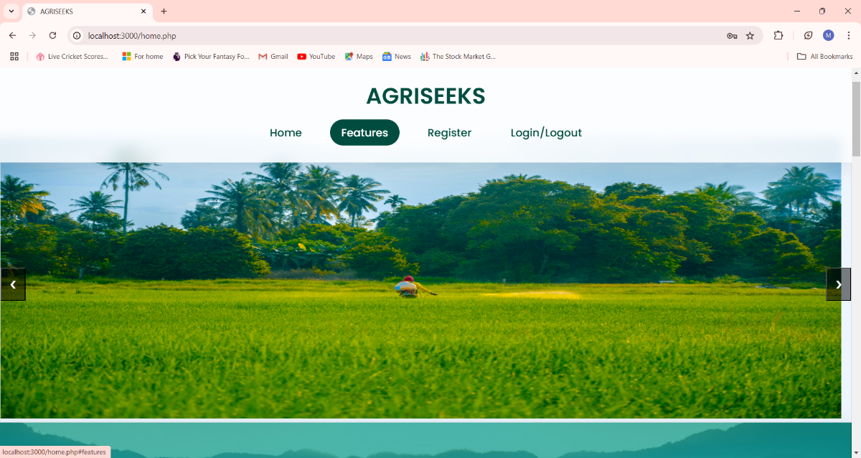

Fig.7.2. Login

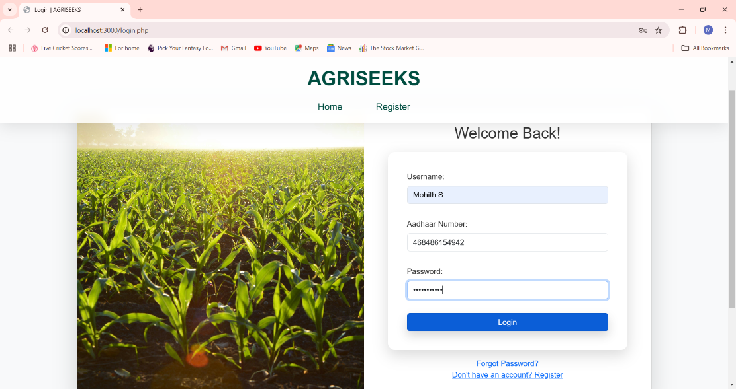

Fig. 7.3 Farmer Dashboard

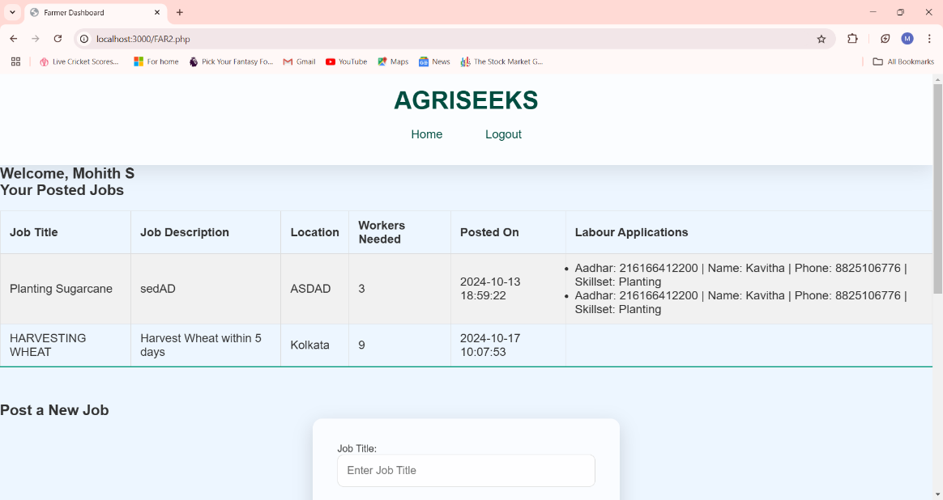

Fig.7.4 Labours Dashboard

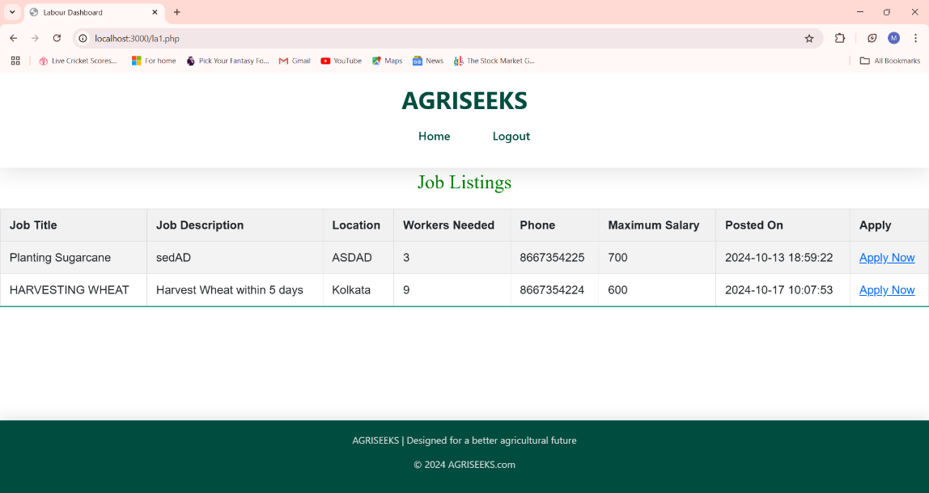

### CHAPTER 8

#### CONCLUSION

## The AGRISEEKS project is a meaningful step towards addressing the agricultural labourers challenges in rural communities by connecting farmers with skilled labourers through a unified, user-friendly digital platform. This project provides a streamlined solution for job posting, job application, and applicant management, ultimately benefiting both farmers who need labour support and labourers seeking employment opportunities.

## Through AGRISEEKS, we aim to promote sustainable agricultural practices by reducing the burden of labour scarcity. By allowing farmers to post job opportunities quickly and labourers to apply conveniently, this platform fosters stronger, more resilient agricultural communities. Additionally, the implementation of secure, verified databases and intuitive dashboards ensures the credibility of both farmers and labourers on the platform, fostering trust and reliability within the user base.

## In the future, AGRISEEKS could expand to include advanced features like real-time job notifications, geolocation-based recommendations, and skill development resources, further enhancing the platform’s utility and reach. In sum, AGRISEEKS stands as a testament to the power of technology in transforming traditional sectors, driving efficiency, and empowering communities for a more prosperous agricultural future.

## REFERENCES

1. HTML, CSS, JS – [www.w3schools.com](http://www.w3schools.com)
2. PHP– [www.youtube.com](http://www.youtube.com/)
3. Font Awesome Icons – [www.fontawesome.com](http://www.fontawesome.com/)
4. Bootstrap 4 – [www.javatpoint.com/bootstrap-4](http://www.javatpoint.com/bootstrap-4)
5. PHPMYADMIN – <https://demo.phpmyadmin.net/master-config/public/index.php>