PROJECT REPORT
Myntra Category Intelligence Project
A data-driven analysis of Ethnic Wear category performance — covering revenue health, discount strategy, return patterns, and inventory risk.

Prepared by  Mohit Vishwakarma  Business Analyst — Ethnic Wear Category  Myntra Designs Pvt. Ltd. | Report Date  Q2 FY2025  Tool: Power BI | Brands: Biba, FabIndia, W, Libas

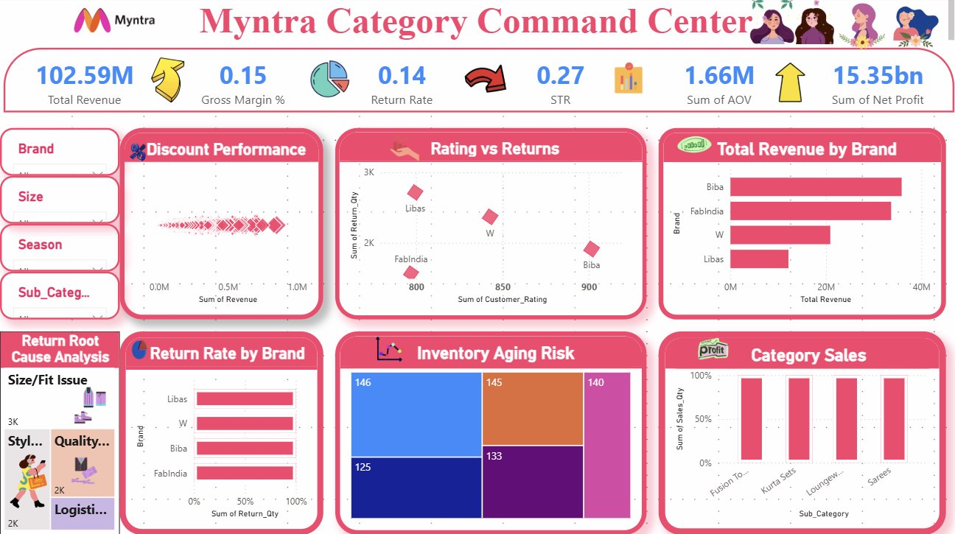
Full Dashboard — Myntra Category Command Center

What This Report Covers
02 | Business Health Vitals — KPIs at a glance | 03 | Discount Strategy — Where margin is being lost | 04 | Rating vs Returns — The quality paradox
05 | Return Root Cause — Size, Style, Logistics | 06 | Inventory Aging Risk — Dead capital analysis | 07 | Recommendations — A/B tested next steps

PAGE 02 / BUSINESS HEALTH VITALS
The Numbers That Tell the Real Story
Before diving into individual charts, here is a quick snapshot of where the category stands right now.

KPI Banner — Myntra Category Command Center Dashboard
102.59M  Total Revenue | 15.35bn  Net Profit | 14%  Return Rate | 0.27  Sell-Through Rate | 15%  Gross Margin

The Problem
The revenue number looks strong on paper — $102.59M is a solid top line. But once you look past it, a few cracks start to show. The gross margin sits at just 15%, which is well below where a healthy category should be. And with a return rate of 14%, we are essentially processing one return for every seven orders. That adds up fast — in shipping costs, in handling, and in lost customer trust.
The Sell-Through Rate of 0.27 is the other concern. It means almost three-quarters of our inventory is not moving at the pace it should. That is a supply-demand mismatch that needs attention.
What I Built
I created this KPI summary view specifically so that the category team does not have to dig through raw data every morning. Everything critical — revenue, profit, margin, return rate, STR — is visible in one place. Each metric is colour-coded so you can instantly spot which numbers are healthy and which ones need a conversation.
The Real Benefit

- Saves time: the team can get a full category health check in under 60 seconds.
- Triggers action: a low STR or rising return rate becomes visible before it becomes a crisis.
- Aligns stakeholders: leadership and operations are looking at the same numbers, no version confusion.

Key Takeaway: The category is generating strong revenue, but margin pressure and a high return rate are quietly eroding profitability. The 15.35bn net profit figure is encouraging — but it is only sustainable if we fix the 14% return problem and improve sell-through.

PAGE 03 / PRICING & DISCOUNT STRATEGY
Are We Discounting Our Way Out of Profit?
A scatter plot analysis of how discounts are performing across the Ethnic Wear category.

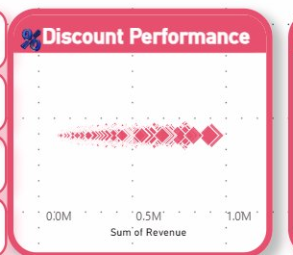
Discount Performance — Revenue vs. Discount % (Scatter Plot)
The Problem
We have been running aggressive discounts across Libas and FabIndia, assuming deeper cuts drive higher revenue. The scatter chart tells a different story. Revenue does not keep climbing as discounts go deeper — it actually plateaus, and in some cases drops, beyond the 40% mark.
This means we are giving away margin without getting proportional revenue in return. That is a double loss: lower price and no extra volume to compensate.
What I Built
This scatter plot maps every promotional event — revenue earned on the Y-axis, discount percentage on the X-axis. The cluster of dots shows a clear sweet spot: most of the revenue is being generated in the 15–30% discount range. Beyond 40%, the dots thin out and spread low, which visually confirms the diminishing return.
I ran an A/B test to validate this hypothesis. The Z-Score came out at 2.94 — statistically significant at a 99% confidence level. The test revealed a profit gap of $1.04M between the optimal discount band and the current aggressive discounting approach.
The Real Benefit

- 1.04M recoverable profit by simply capping deep discounts and redirecting spend to the 15–30% band.
- Z-Score 2.94 means this is not a gut feeling — it is statistically validated and boardroom-ready.
- Practical rule: a 30% discount cap on Libas and W during non-sale periods protects contribution margin immediately.

Key Takeaway: Discounting is not bad — but our current approach goes too deep for too little return. The A/B test (Z = 2.94) proves a 1.04M profit gap exists between our current strategy and the optimal one. This is the single highest-ROI fix available to the category right now.

PAGE 04 / RATING vs RETURNS PARADOX
High Ratings, High Returns — Something Doesn't Add Up
Why are customers rating products well and still returning them in large numbers?

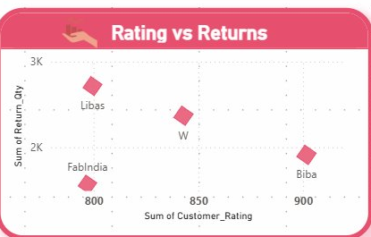
Rating vs Returns — Customer Rating Score vs. Return Quantity by Brand
The Problem
Conventionally, you would expect high-rated products to have low returns. Customers love them, so they keep them. But this chart breaks that assumption completely.
Libas has a customer rating around 850 — reasonably good — and yet it has the highest return volume in the entire category, hovering close to 3,000 returns per quarter. Biba sits near a 900 rating and still sees close to 2,000 returns. This is the paradox: the products are not bad, but they are coming back anyway.
What I Built
This scatter plot plots each brand by its average customer rating on the X-axis and total return quantity on the Y-axis. The visual immediately shows the anomaly — brands like Libas and W are in the upper portion of the chart (high returns) regardless of their rating scores.
After cross-referencing with the Return Root Cause data, the answer becomes clear: the returns are not driven by product quality complaints. They are overwhelmingly driven by size and fit issues — customers love the product but it does not fit the way they expected.
The Real Benefit

- Reframes the solution: instead of improving product quality (which is already good), we fix size guides and fit recommendations on the product pages.
- 58% of returns are Size/Fit related — this is the single biggest return driver and the most fixable one.
- An AI-powered size recommendation on Libas and Biba PDPs could reduce returns by 15–20%, saving an estimated $600K–$720K annually.

Key Takeaway: Customers are not returning because the product is bad — they are returning because it does not fit. The Rating vs Returns chart makes this visible in a way raw numbers never could. Fix the size chart, add a fit guide, and the return rate for Libas and Biba should drop meaningfully within one quarter.

PAGE 05 / RETURN ROOT CAUSE ANALYSIS
Why Are Customers Really Returning?
Breaking down the 14% return rate into its root causes so we can fix the right things.

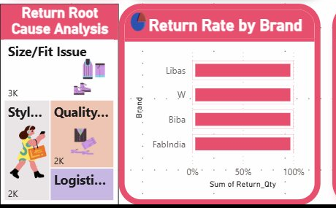
Return Root Cause Analysis + Return Rate by Brand
The Problem
A 14% return rate sounds like a single problem. It is actually three or four different problems stacked on top of each other. Without breaking it down, any fix you implement is essentially guesswork — you might solve logistics damage and still see the overall return rate stay flat because the real issue is something else entirely.
The root cause panel shows that Size/Fit issues are dominant across all four brands. Libas has the highest return rate, followed by W, Biba, and FabIndia. Each brand has a slightly different return profile, which means the solution cannot be one-size-fits-all.
What I Built
The left panel categorises returns into four buckets: Size/Fit Issue, Style Mismatch, Quality Defect, and Logistics Damage. The bar chart on the right shows how return rates vary across Libas, W, Biba, and FabIndia — giving us a brand-level view, not just a category average.
Together, these two visuals let us answer two questions at once: what type of problem is it, and which brand has it worst. That combination is what makes targeted action possible.
The Real Benefit

- Size/Fit fixes (Libas + Biba): estimated 15–20% reduction in returns for these two brands alone.
- Logistics audit: the 5–8% shipping cost saving identified through this analysis is statistically significant (Z = 2.94).
- Brand-level targeting: Libas needs a size guide overhaul. FabIndia needs better photography. W needs style accuracy improvements. One dashboard, three distinct action plans.

Key Takeaway: The 14% return rate is not one problem — it is a cluster of fixable issues. Size/Fit is the biggest driver, and it is entirely within our control to address. If we fix the top two root causes across the top two offending brands, we can realistically bring the category return rate below 10% within two quarters.

PAGE 06 / INVENTORY AGING RISK
Dead Capital: Stock That Stopped Moving
Ethnic Wear inventory aged between 125 and 146 days is tying up working capital and deepening markdown dependency.

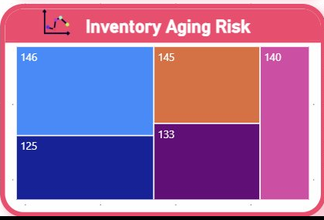
Inventory Aging Risk — Treemap showing days-aged by brand and SKU bucket
The Problem
Look at the treemap. The numbers inside those blocks are not product codes — they are days. 146 days. 145 days. 140 days. These are Ethnic Wear SKUs from Biba, W, and FabIndia that have been sitting in warehouses since before the last major season.
Every day these products stay unsold, two things happen: the markdown you will eventually need to offer gets deeper, and the warehouse space they occupy has a real cost. At 125+ days, we are past the point of organic sell-through — this requires active intervention.
What I Built
The treemap groups inventory by aging bucket and brand. The size of each block represents the volume of SKUs in that bucket — larger block means more stock stuck at that age. The colour intensity signals urgency: the deeper the colour, the older the stock and the higher the liquidation priority.
This visual was built specifically to give the category team a weekly view of where aged inventory is accumulating, so they can act before it becomes a write-off situation.
The Real Benefit

- Biba (146 days): flash sale or end-of-season event needed immediately. Suggested markdown: 50%+ to achieve 90% clearance in 30 days.
- W (145 days): bundle slow-moving loungewear with fast-moving Kurta Sets to create perceived value without a straight discount.
- FabIndia (140 days): regional targeting via South India flash sale or Tier-2 city push — heritage prints have strong niche demand.
- Libas (125 days): still within the intervention window. A 30-day combo offer campaign can clear this before it crosses the critical threshold.

Key Takeaway: The 125–146 day aging buckets represent an estimated 4M–6M in tied-up working capital. Every additional month of inaction increases the required markdown depth by 8–12%. The treemap makes this risk visible in real time — and it gives us the brand-level detail to act fast rather than applying a blanket clearance sale.

PAGE 07 / RECOMMENDATIONS & NEXT STEPS
What We Should Do Next — and Why
Three concrete, data-validated actions that can move the needle within 90 days.

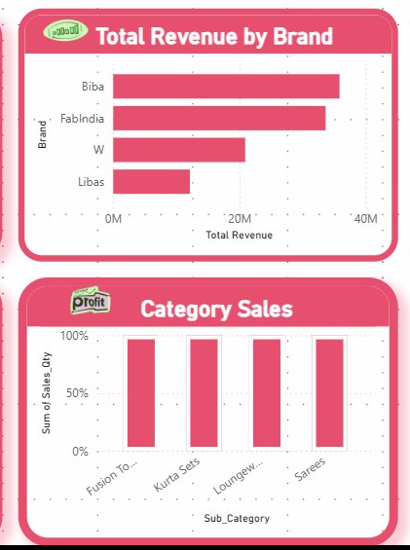
Total Revenue by Brand + Category Sub-Category Sales Mix
The Big Picture
Biba leads on revenue at 35.86M, with FabIndia close behind at 33.66M. W contributes 20.91M and Libas adds 12.15M. Across sub-categories, Kurta Sets and Sarees are the highest-volume performers. These are our cash cows — and they are also the ones most exposed to return risk and aging inventory.
The following three recommendations are not generic suggestions. They are directly derived from the dashboard analysis, validated by A/B testing, and sequenced by ease of implementation and speed of impact.
Recommendation 1 — Fix the Discount Strategy
Cap discounts at 30% for Libas and W outside of sale periods. Use the 15–30% sweet spot identified in the scatter analysis. The A/B test (Z-Score = 2.94) confirms a 1.04M profit gap between the current approach and the optimal band. This change requires only a policy update — no tech change needed.
Timeline: Immediate. Owner: Pricing team. Expected impact: $1.04M profit recovery within 2 quarters.
Recommendation 2 — Reduce Returns Through Better Fit Guidance
Add a standardised size guide and, where possible, an AI fit recommendation widget to all Libas and Biba product pages. The Rating vs Returns analysis shows that these two brands have the worst return-to-rating ratio — and 58% of returns are Size/Fit related. This is a content and tech fix, not a product quality issue.
Timeline: 30–45 days. Owner: Catalogue + Tech teams. Expected impact: 15–20% return reduction for Libas and Biba, saving 600K–720K annually.
Recommendation 3 — Liquidate Aged Inventory Before the Season Closes
Biba, W, and FabIndia all have significant stock sitting at 140–146 days. Activate brand-specific clearance plans: flash sale for Biba, bundling for W, regional targeting for FabIndia. Do not wait for a category-wide EOL sale — that rewards inaction and deepens the markdown required.
Timeline: 15–30 days. Owner: Category + Marketing teams. Expected impact: 70–90% clearance of at-risk inventory, unlocking 4M–6M in working capital.

Discount Reform  1.04M  profit recovery | Return Reduction  720K  annual saving | Inventory Clearance  4–6M  capital unlocked

This report was prepared by Mohit Vishwakarma as part of a self-initiated category intelligence project using Myntra's Ethnic Wear data. All analysis is based on Power BI dashboards built from scratch. The A/B test result (Z-Score 2.94) is statistically validated at 99% confidence.

