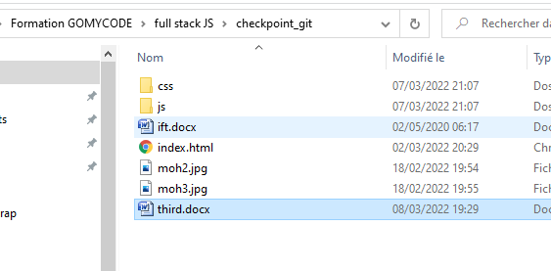

1🡺ouvrir le dossier chekpoint_git

# 2🡺 new repository

3🡺 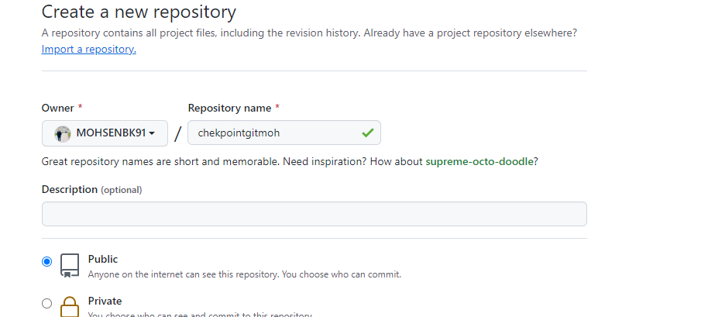

4 🡺 git init 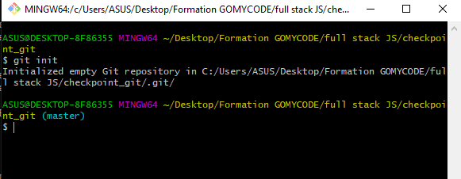

5🡺git init

6🡺git add README.md

7🡺git commit -m "first commit"

🡺git branch -M main

git remote add origin

8🡺https://github.com/MOHSENBK91/chekpointgitmoh.git

9🡺git push -u origin main

