# Project tittle :

MA Messenger

## M Mohsin Asghar

## 21-Arid-627(6B-Evening)

### chatwindoi:

Xml code:

*<?***xml version="1.0" encoding="utf-8"***?>*<**RelativeLayout xmlns:android="http://schemas.android.com/apk/res/android"  
 xmlns:app="http://schemas.android.com/apk/res-auto"  
 xmlns:tools="http://schemas.android.com/tools"  
 android:layout_width="match_parent"  
 android:layout_height="match_parent"  
 android:background="@drawable/chatback"  
 tools:context=".chatwindo"**>  
 <**LinearLayout  
 android:layout_width="match_parent"  
 android:layout_height="wrap_content"  
 android:orientation="vertical"  
 android:id="@+id/ll1"  
 android:gravity="center"**>  
  
 <**de.hdodenhof.circleimageview.CircleImageView  
 android:id="@+id/profileimgg"  
 android:layout_width="@dimen/_80sdp"  
 android:layout_height="@dimen/_80sdp"  
 android:src="@drawable/photocamera"  
 app:civ_border_color="@color/white"  
 android:layout_marginTop="@dimen/_7sdp"  
 app:civ_border_width="@dimen/_2sdp"  
 app:layout_constraintBottom_toBottomOf="parent"  
 app:layout_constraintEnd_toEndOf="parent"  
 app:layout_constraintStart_toStartOf="parent"  
 app:layout_constraintTop_toTopOf="parent"  
 app:layout_constraintVertical_bias="0.226"** />  
  
 <**TextView  
 android:id="@+id/recivername"  
 android:layout_width="match_parent"  
 android:layout_height="wrap_content"  
 android:text="Mohsin Malana"  
 android:gravity="center"  
 android:textColor="@color/white"  
 android:fontFamily="@font/poppins_regular"  
 android:textSize="@dimen/_15sdp"  
 android:layout_margin="@dimen/_10sdp"**/>  
 </**LinearLayout**>  
  
 <**androidx.recyclerview.widget.RecyclerView  
 android:id="@+id/msgadpter"  
 android:layout_width="match_parent"  
 android:layout_height="502dp"  
 android:layout_above="@id/ll2"  
 android:layout_below="@+id/ll1"  
 android:layout_marginTop="7dp"  
 android:layout_marginBottom="-7dp"  
 android:padding="@dimen/_10sdp"** />  
  
 <**LinearLayout  
 android:id="@+id/ll2"  
 android:layout_width="match_parent"  
 android:layout_height="@dimen/_45sdp"  
 android:layout_alignParentBottom="true"  
 android:layout_marginStart="@dimen/_2sdp"  
 android:layout_marginTop="@dimen/_2sdp"  
 android:layout_marginEnd="@dimen/_2sdp"  
 android:layout_marginBottom="@dimen/_2sdp"  
 android:orientation="horizontal"**>  
  
 <**androidx.cardview.widget.CardView  
 android:layout_width="match_parent"  
 android:layout_height="@dimen/_35sdp"  
 android:layout_marginStart="@dimen/_4sdp"  
 android:layout_marginTop="@dimen/_5sdp"  
 android:layout_marginEnd="@dimen/_7sdp"  
 android:layout_weight="1"  
 app:cardBackgroundColor="@color/white"  
 app:cardCornerRadius="@dimen/_25sdp"**>  
  
 <**EditText  
 android:id="@+id/textmsg"  
 android:layout_width="338dp"  
 android:layout_height="45dp"  
 android:layout_marginLeft="@dimen/_20sdp"  
 android:layout_gravity="center"  
 android:background="@null"  
 android:fontFamily="@font/poppins_regular"  
 android:hint="Type The Messages..."  
 android:paddingStart="13.00dp"** />  
  
 </**androidx.cardview.widget.CardView**>  
  
 <**androidx.cardview.widget.CardView  
 android:id="@+id/sendbtnn"  
 android:layout_width="@dimen/_35sdp"  
 android:layout_height="@dimen/_35sdp"  
 android:layout_marginTop="@dimen/_5sdp"  
 android:layout_marginEnd="@dimen/_5sdp"  
 app:cardBackgroundColor="@color/white"  
 app:cardCornerRadius="@dimen/_25sdp"**>  
  
 <**ImageView  
 android:layout_width="@dimen/_15sdp"  
 android:layout_height="@dimen/_15sdp"  
 android:layout_gravity="center"  
 android:background="@drawable/sendbut"** />  
  
 </**androidx.cardview.widget.CardView**>  
  
  
 </**LinearLayout**>  
  
</**RelativeLayout**>

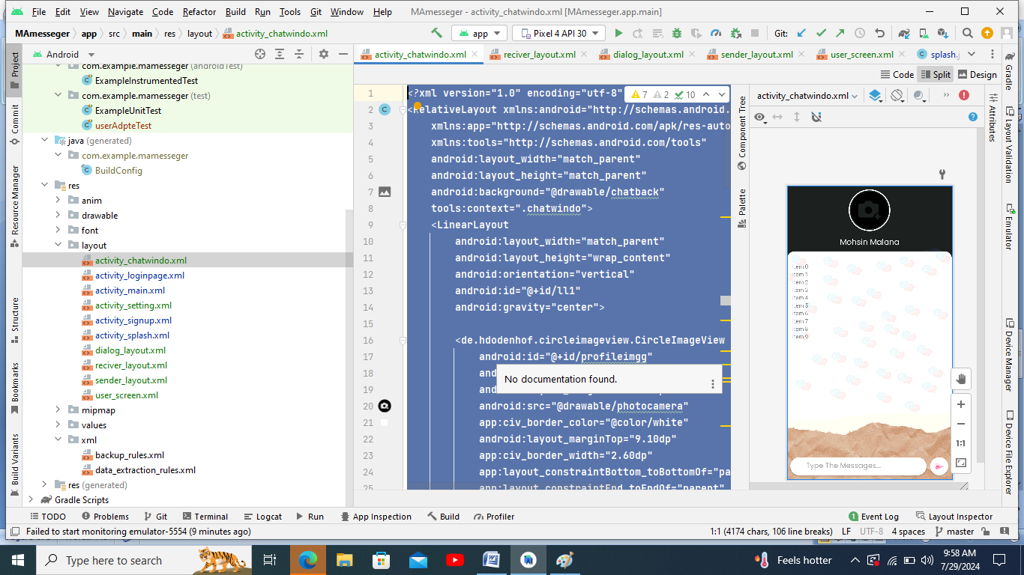

Java code:

**package** com.example.mamesseger;  
**import** androidx.annotation.**NonNull**;  
**import** androidx.appcompat.app.AppCompatActivity;  
**import** androidx.cardview.widget.CardView;  
**import** androidx.recyclerview.widget.LinearLayoutManager;  
**import** androidx.recyclerview.widget.RecyclerView;  
  
**import** android.os.Bundle;  
**import** android.view.View;  
**import** android.widget.EditText;  
**import** android.widget.LinearLayout;  
**import** android.widget.TextView;  
**import** android.widget.Toast;  
  
**import** com.google.android.gms.tasks.OnCompleteListener;  
**import** com.google.android.gms.tasks.Task;  
**import** com.google.firebase.auth.FirebaseAuth;  
**import** com.google.firebase.database.DataSnapshot;  
**import** com.google.firebase.database.DatabaseError;  
**import** com.google.firebase.database.DatabaseReference;  
**import** com.google.firebase.database.FirebaseDatabase;  
**import** com.google.firebase.database.ValueEventListener;  
**import** com.squareup.picasso.Picasso;  
  
**import** java.util.ArrayList;  
**import** java.util.Date;  
  
**import** de.hdodenhof.circleimageview.CircleImageView;  
  
**public class** chatwindo **extends** AppCompatActivity {  
 String **reciverimg**, **reciverUid**,**reciverName**,**SenderUID**;  
 CircleImageView **profile**;  
 TextView **reciverNName**;  
 FirebaseDatabase **database**;  
 FirebaseAuth **firebaseAuth**;  
 **public static** String *senderImg*;  
 **public static** String *reciverIImg*;  
 CardView **sendbtn**;  
 EditText **textmsg**;  
  
 String **senderRoom**,**reciverRoom**;  
 RecyclerView **messageAdpter**;  
 ArrayList<msgModelclass> **messagesArrayList**;  
 messagesAdpter **mmessagesAdpter**;  
 **@Override  
 protected void** onCreate(Bundle savedInstanceState) {  
 **super**.onCreate(savedInstanceState);  
 setContentView(R.layout.***activity_chatwindo***);  
 getSupportActionBar().hide();  
 **database** = FirebaseDatabase.*getInstance*();  
 **firebaseAuth** = FirebaseAuth.*getInstance*();  
  
 **reciverName** = getIntent().getStringExtra(**"nameeee"**);  
 **reciverimg** = getIntent().getStringExtra(**"reciverImg"**);  
 **reciverUid** = getIntent().getStringExtra(**"uid"**);  
  
 **messagesArrayList** = **new** ArrayList<>();  
  
 **sendbtn** = findViewById(R.id.***sendbtnn***);  
 **textmsg** = findViewById(R.id.***textmsg***);  
 **reciverNName** = findViewById(R.id.***recivername***);  
 **profile** = findViewById(R.id.***profileimgg***);  
 **messageAdpter** = findViewById(R.id.***msgadpter***);  
 LinearLayoutManager linearLayoutManager = **new** LinearLayoutManager(**this**);  
 linearLayoutManager.setStackFromEnd(**true**);  
 **messageAdpter**.setLayoutManager(linearLayoutManager);  
 **mmessagesAdpter** = **new** messagesAdpter(chatwindo.**this**,**messagesArrayList**);  
 **messageAdpter**.setAdapter(**mmessagesAdpter**);  
  
  
 Picasso.*get*().load(**reciverimg**).into(**profile**);  
 **reciverNName**.setText(**""**+**reciverName**);  
  
 **SenderUID** = **firebaseAuth**.getUid();  
  
 **senderRoom** = **SenderUID**+**reciverUid**;  
 **reciverRoom** = **reciverUid**+**SenderUID**;  
  
  
  
 DatabaseReference reference = **database**.getReference().child(**"user"**).child(**firebaseAuth**.getUid());  
 DatabaseReference chatreference = **database**.getReference().child(**"chats"**).child(**senderRoom**).child(**"messages"**);  
  
  
 chatreference.addValueEventListener(**new** ValueEventListener() {  
 **@Override  
 public void** onDataChange(**@NonNull** DataSnapshot snapshot) {  
 **messagesArrayList**.clear();  
 **for** (DataSnapshot dataSnapshot:snapshot.getChildren()){  
 msgModelclass messages = dataSnapshot.getValue(msgModelclass.**class**);  
 **messagesArrayList**.add(messages);  
 }  
 **mmessagesAdpter**.notifyDataSetChanged();  
 }  
  
 **@Override  
 public void** onCancelled(**@NonNull** DatabaseError error) {  
  
 }  
 });  
 reference.addValueEventListener(**new** ValueEventListener() {  
 **@Override  
 public void** onDataChange(**@NonNull** DataSnapshot snapshot) {  
 *senderImg*= snapshot.child(**"profilepic"**).getValue().toString();  
 *reciverIImg*=**reciverimg**;  
 }  
  
 **@Override  
 public void** onCancelled(**@NonNull** DatabaseError error) {  
  
 }  
 });  
  
 **sendbtn**.setOnClickListener(**new** View.OnClickListener() {  
 **@Override  
 public void** onClick(View view) {  
 String message = **textmsg**.getText().toString();  
 **if** (message.isEmpty()){  
 Toast.*makeText*(chatwindo.**this**, **"Enter The Message First"**, Toast.***LENGTH_SHORT***).show();  
 **return**;  
 }  
 **textmsg**.setText(**""**);  
 Date date = **new** Date();  
 msgModelclass messagess = **new** msgModelclass(message,**SenderUID**,date.getTime());  
  
 **database**=FirebaseDatabase.*getInstance*();  
 **database**.getReference().child(**"chats"**)  
 .child(**senderRoom**)  
 .child(**"messages"**)  
 .push().setValue(messagess).addOnCompleteListener(**new** OnCompleteListener<Void>() {  
 **@Override  
 public void** onComplete(**@NonNull** Task<Void> task) {  
 **database**.getReference().child(**"chats"**)  
 .child(**reciverRoom**)  
 .child(**"messages"**)  
 .push().setValue(messagess).addOnCompleteListener(**new** OnCompleteListener<Void>() {  
 **@Override  
 public void** onComplete(**@NonNull** Task<Void> task) {  
  
 }  
 });  
 }  
 });  
 }  
 });  
  
 }  
}