**Task 2 Answers**

After adding binarysearch outputfile in /usr/local/bin and execute it from other directories.

When you type a command in the terminal, the system searches for the executable in the directories listed in the PATH. By moving the binary to /usr/local/bin, it becomes accessible from any location because /usr/local/bin is part of the PATH.

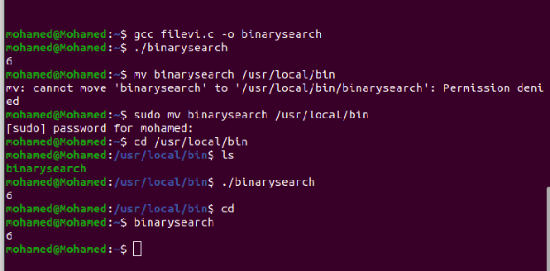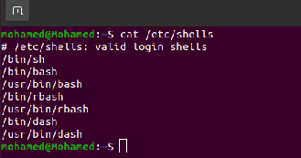

2)

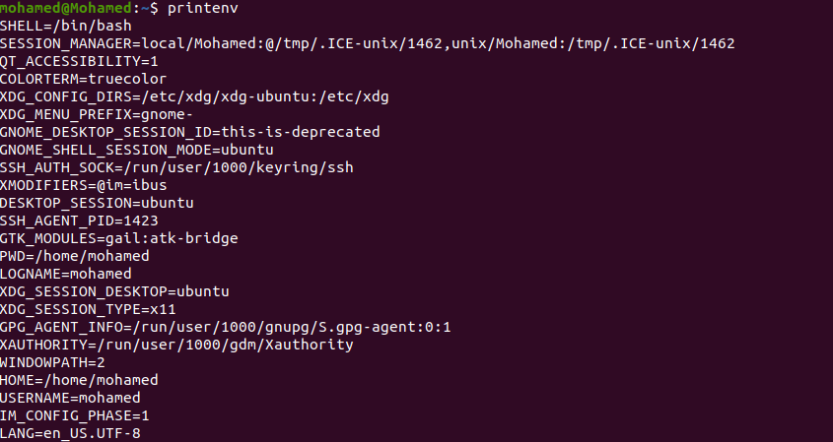

3)



4)

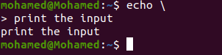

echo \ It is used to indicate that the command should continue on the next line. is used to indicate that the command should continue on the next line.

5)

