**Task 3**

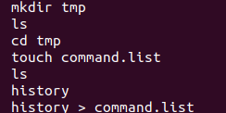

2)

* Open the .profile file in a text editor
* Add the following lines to display the date at login :echo "Login date and time: $(date)"

3)

* To count the words in a file: wc -w filename
* To count the number of files in a directory: ls -1 | wc -l

4)

a)

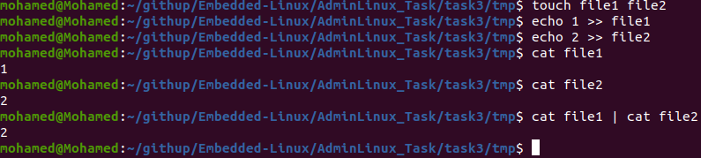

b)



c)



As ls print filename so it is equal 1

5)

* Locate filename
* Find filename

6)

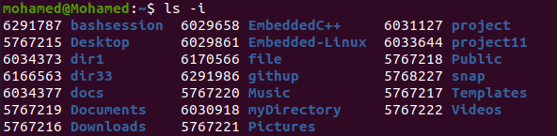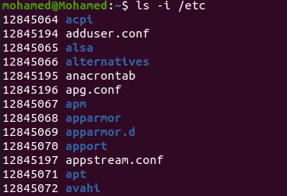

7)

sudo ln -s /etc/passwd /boot/passwd_link

8)

Not allowed to create a hard link of a file to a different filesystem

9)

When you type echo \ and press Enter, the shell expects more input because the backslash (\) is an escape character. The prompt changes to > to indicate that the command is not complete.

To change the continuation prompt from > to ., you can set the PS2 variable :

export PS2="."