Cohort Analysis
Retention, lifetime value and forecasting for a subscription business
Final Project Report

Mohamed Moin Peer
MSc Data Analytics, Queen's University Belfast
Portfolio project | 2026

Abstract
This project analyses customer retention and lifetime value for Crate & Co, a fictional UK meal-kit subscription, using synthetic data on 17,818 subscribers and 134,773 boxes from 2023 to 2025. Cohort retention matrices were built in pandas and SQL (verified identical). 40.3% of customers remain subscribed after 12 months. 'First box free' customers churn far faster than others and contribute less than a third as much over 12 months; 12-month LTV:CAC ranges from 16.64x (organic) to 1.28x (influencer). A price rise doubled established-subscriber churn for one month, and a new onboarding flow raised month-3 retention by about 5.3 points after adjusting for customer mix. A shifted-beta-geometric model, trained on six months of data, forecast the following two years with 7.2% error, against 59.9% for a constant-churn model.

1. Introduction and aims
Subscription businesses acquire customers at a cost and recover it only if customers stay long enough. Understanding retention by cohort, and the value of customers from different channels and offers, is therefore central to marketing and pricing decisions. The aims were to:
- build cohort retention tables and average curves, in both pandas and SQL;
- measure contribution, acquisition cost (CAC), LTV:CAC and payback by channel and offer;
- separate calendar effects (a price rise) from cohort effects;
- evaluate a product change (new onboarding) while accounting for changes in customer mix;
- forecast retention for young cohorts with a probabilistic model, and validate it on held-out data.

2. Data and definitions
The data is synthetic (src/cohort_analysis/generate_data.py, fixed seed) and contains three tables: customers (signup month, channel, plan, first-box offer, region and cancellation month), orders (one row per box with list price, charged price and add-ons) and monthly marketing spend by channel. Known effects were built in: customers differ in their churn risk; 'first box free' produces many cancellations after the first box; channels differ in retention and cost; new onboarding from September 2024 reduces churn; a £3 price rise in April 2025 causes extra cancellations; and loyal customers buy more add-ons.
Term | Definition
Cohort / age | Customers who signed up in the same month / months since signup (signup month = 0)
Activity retention | % of the cohort receiving a box at age N (paused months count as inactive)
Subscription survival | % of the cohort not yet cancelled at age N
Net revenue retention | Revenue at age N as % of revenue at age 1 (age 0 is distorted by discounts)
Contribution | Box + add-on revenue − 65% × (box list price + add-ons); a free box has negative contribution
CAC | Marketing spend ÷ new customers, by channel
Payback month | First age at which cumulative contribution per customer exceeds CAC

Averages across cohorts are weighted by cohort size and use only cohorts that have reached the relevant age, so young cohorts do not bias later months.

3. Retention
Figure 1 shows activity retention for all 36 cohorts. Rows follow one cohort over time; columns compare cohorts at the same age. The empty lower-right triangle contains months that have not yet happened.
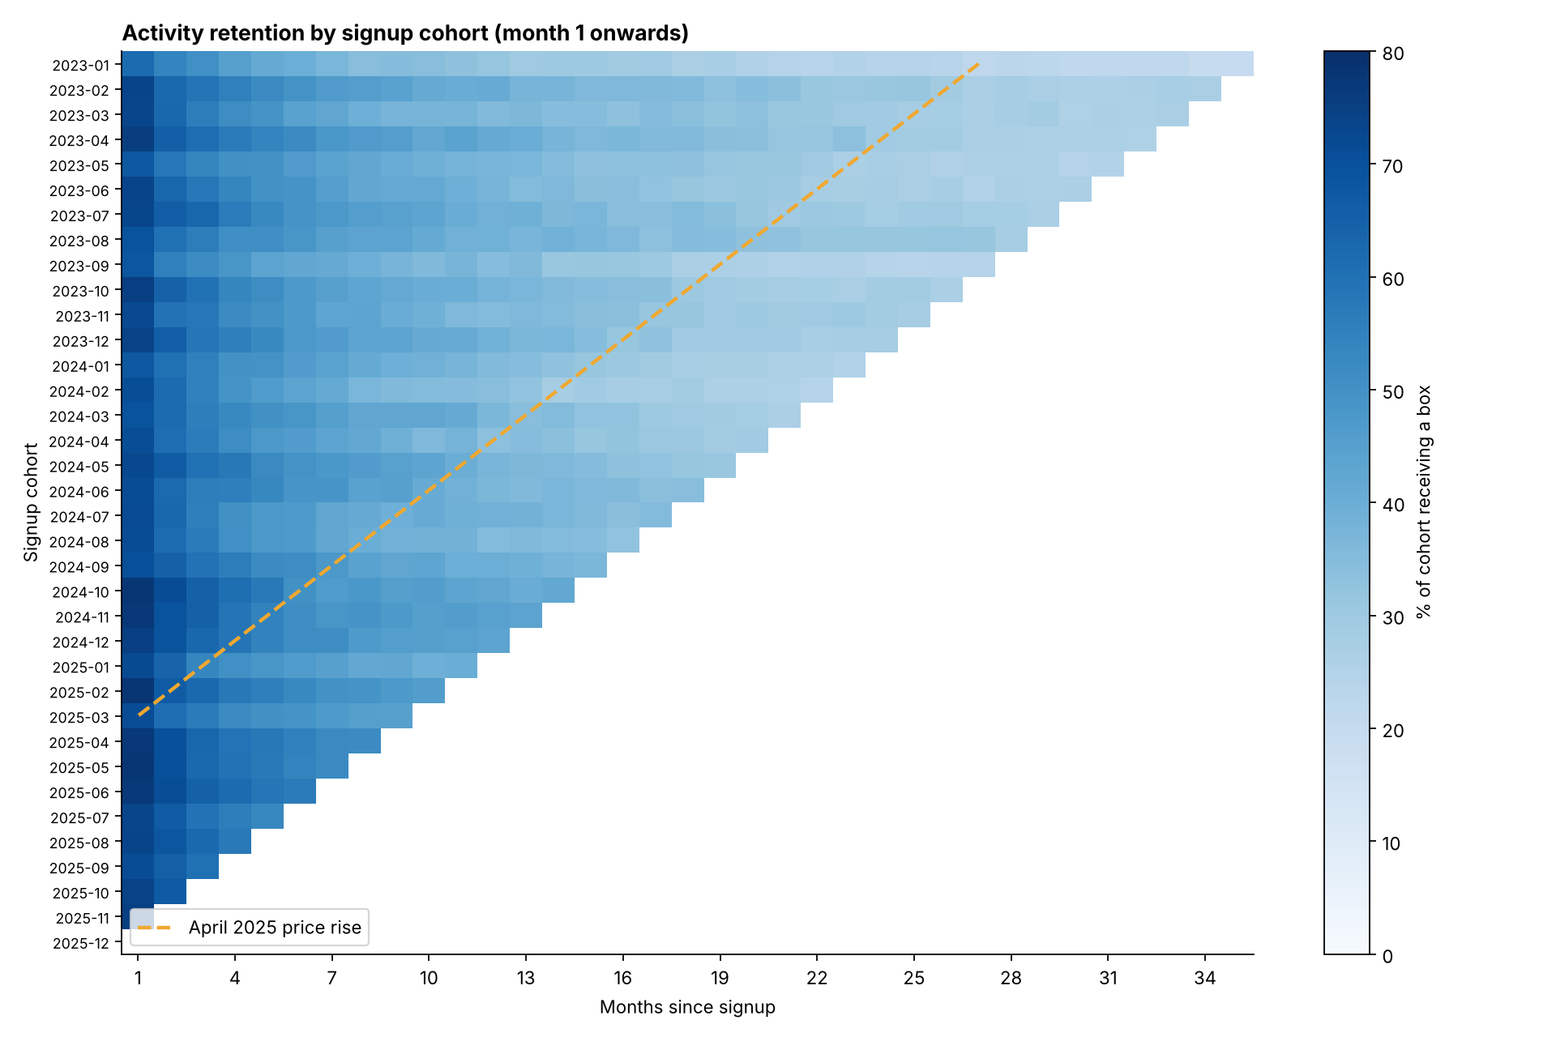
Figure 1. Activity retention by signup cohort; dashed line marks the April 2025 price rise.
Months since signup | 1 | 3 | 6 | 12 | 24
Still subscribed | 77.4% | 62.7% | 51.9% | 40.3% | 29.5%
Revenue vs month 1 (NRR) | 100% | 82.1% | 69.8% | 56.6% | 44.9%

Retention falls steeply in the first months and then flattens: customers prone to leaving go early, leaving an increasingly loyal base. Revenue holds up better than customer numbers (NRR 56.6% at month 12) because long-standing customers buy more add-ons.
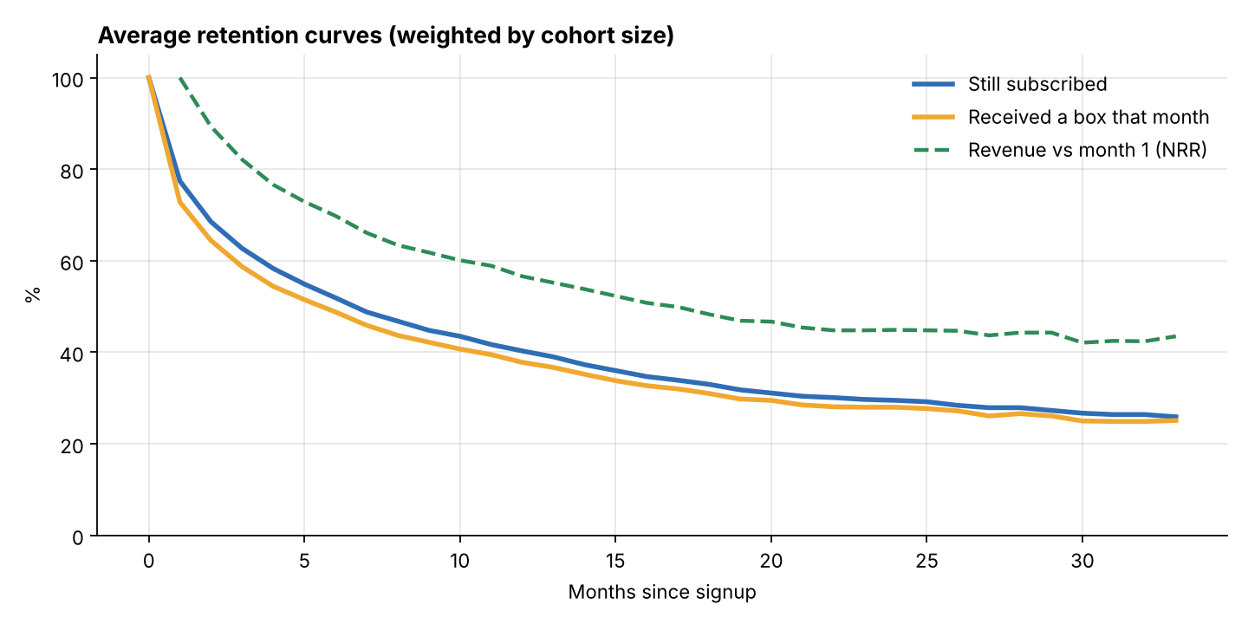
Figure 2. Average retention curves, weighted by cohort size.

3.1 SQL implementation
The activity retention matrix was also written in SQL (sql/cohort_retention.sql) using common table expressions and month arithmetic on the order and signup months. The CSVs are loaded into an in-memory SQLite database and a test confirms that every observed cell matches the pandas result (match: True). A second query (sql/ltv_by_channel.sql) calculates 12-month revenue per customer and CAC by channel:
Channel | Customers | 12-month revenue per customer | CAC | Revenue ÷ CAC
Organic | 1,968 | £320.19 | £6.06 | 52.82x
Referral | 1,222 | £354.01 | £18.12 | 19.54x
Search | 2,350 | £293.62 | £38.33 | 7.66x
Paid social | 2,535 | £263.74 | £46.51 | 5.67x
Influencer | 1,922 | £245.53 | £58.11 | 4.23x

4. Offers and channels
Segment | Customers | Month 1 | Month 3 | Month 6 | Month 12
No offer | 6,697 | 85.9% | 71.0% | 60.4% | 48.8%
50% off first box | 6,818 | 82.3% | 66.4% | 53.7% | 41.3%
First box free | 4,303 | 56.6% | 44.5% | 35.5% | 25.8%
Referral | 2,062 | 83.6% | 73.0% | 65.5% | 56.1%
Organic | 3,370 | 80.9% | 68.3% | 57.1% | 46.6%
Search | 4,069 | 77.6% | 63.5% | 53.3% | 41.4%
Influencer | 3,914 | 74.2% | 57.5% | 44.3% | 30.1%
Paid social | 4,403 | 74.3% | 57.3% | 46.2% | 34.6%
Family (4 people) | 4,482 | 77.9% | 64.3% | 54.0% | 43.6%
Classic (2 people) | 13,336 | 77.2% | 62.2% | 51.1% | 39.3%

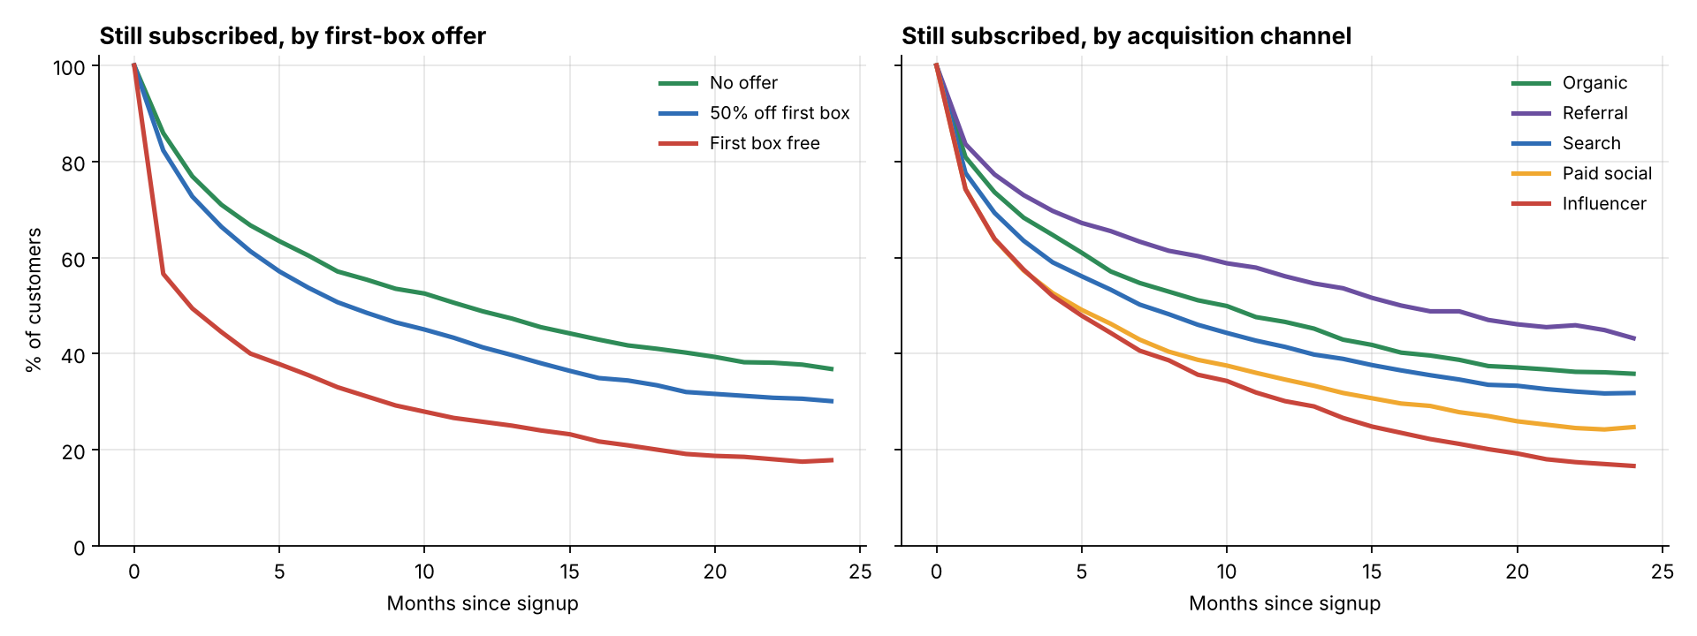
Figure 3. Subscription survival by first-box offer and by acquisition channel.
'First box free' customers cancel heavily after the free box: 56.6% remain after month 1, against 85.9% with no offer. Referral and organic customers retain best; influencer and paid social customers worst. Family-plan customers retain slightly better than Classic.

4.1 Unit economics
First-box offer | First box | After 3 months | After 12 months
No offer | £14.34 | £48.53 | £122.82
50% off first box | −£6.14 | £26.64 | £91.46
First box free | −£26.61 | −£4.41 | £37.07

Because a free box still costs about 65% of its list price to produce and deliver, free-box customers start with negative contribution, and after 12 months contribute £37.07 on average against £122.82 for customers with no offer.
Channel | CAC | 12-month contribution | LTV:CAC (12m) | 24-month contribution | Payback month
Organic | £6.06 | £100.83 | 16.64x | £172.30 | 1
Referral | £18.12 | £112.83 | 6.23x | £199.50 | 2
Search | £38.33 | £91.46 | 2.39x | £155.60 | 5
Paid social | £46.51 | £80.97 | 1.74x | £134.09 | 6
Influencer | £58.11 | £74.65 | 1.28x | £103.03 | 9

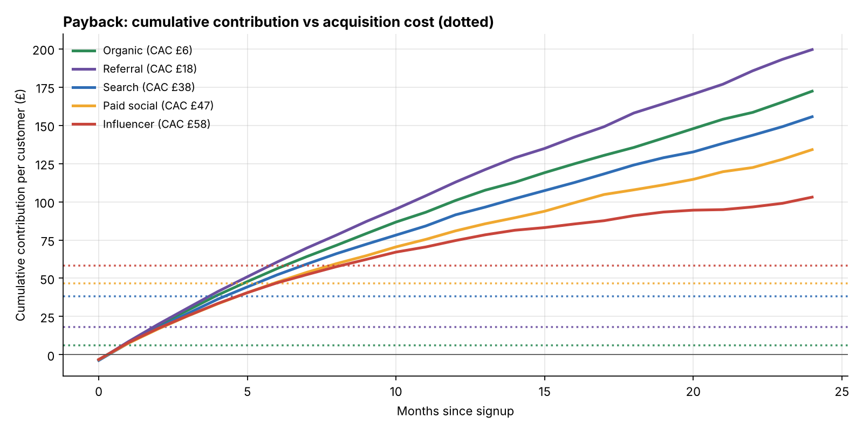
Figure 4. Cumulative contribution per customer by channel; dotted lines show each channel's CAC.
Influencer customers are the most expensive to acquire (£58.11) and the slowest to pay back (month 9.0), with a 12-month LTV:CAC of 1.28x, below the common 3:1 rule of thumb. Referral customers pay back in month 2.0 with 6.23x. Twelve-month figures are conservative because surviving customers continue to contribute.
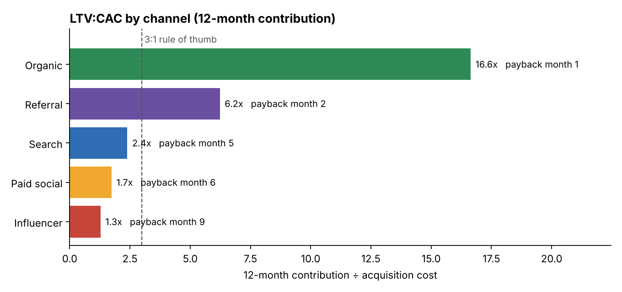
Figure 5. 12-month LTV:CAC and payback month by channel.

5. Events

5.1 Price rise (April 2025): a calendar effect
A calendar event affects every cohort in the same month, so it appears as a diagonal in the cohort heatmap. To size it, churn was measured by calendar month among established subscribers (those past their second month, to exclude first-box effects). Typical monthly churn from mid-2023 was 4.93%; in 2025-04 it reached 9.85%, about 293 extra cancellations, before returning to normal.
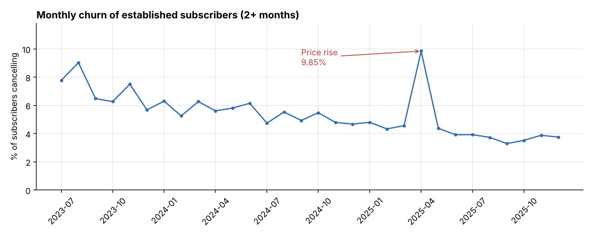
Figure 6. Monthly churn among established subscribers.

5.2 New onboarding (September 2024)
Month-3 survival was compared for the 12 months of cohorts before (5,177 customers) and after (7,132) the change. A two-proportion z-test shows an increase from 60.4% to 65.4% (+5.0 points, 95% CI 3.2 to 6.7, p < 0.001). However, the customer mix changed: the share of influencer customers, who churn more, rose from 19.6% to 24.2%. A logistic regression controlling for channel, offer, plan and signup month-of-year gives an odds ratio of 1.275 (95% CI 1.181-1.376), equivalent to +5.3 points. Using twelve months either side ensures each calendar month appears in both periods, so seasonality can be separated from the change.
This remains an observational before/after comparison rather than a randomised experiment: other changes at the same time could contribute. Future changes should be A/B tested.
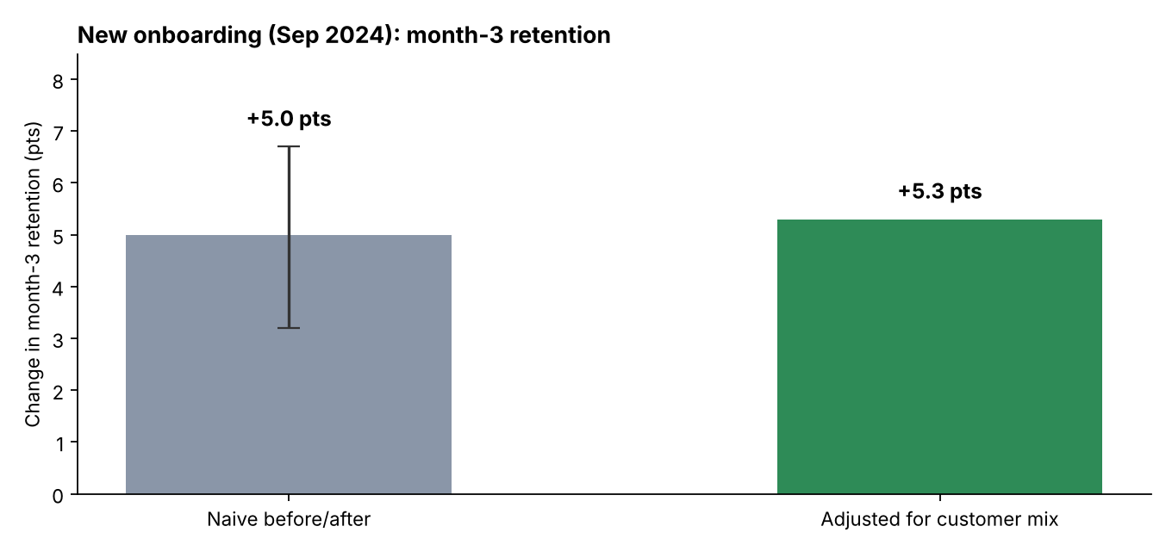
Figure 7. Change in month-3 retention: naive and adjusted estimates.

6. Forecasting with the shifted-beta-geometric model
A constant monthly churn rate implies retention decays geometrically towards zero, which contradicts the flattening seen in Figure 2. The shifted-beta-geometric (sBG) model (Fader & Hardie, 2007) assumes each customer cancels each month with their own probability p, and that p follows a Beta(a, b) distribution across customers. Survival is S(t) = B(a, b + t) / B(a, b). The parameters are estimated by maximum likelihood, using cancelled customers and still-active customers (right-censored):
churned = betaln(a + 1, b + t - 1) - betaln(a, b) # log P(cancel at month t)
alive = betaln(a, b + t) - betaln(a, b) # log P(still subscribed after t)
minimise -sum(where(censored, alive, churned)) over log(a), log(b) (Nelder-Mead)

Backtest: the model was fitted using only the first 6 months of the January-June 2023 cohorts (a = 0.3, b = 0.9099), and the forecast for months 7-30 was compared with what actually happened. The mean absolute percentage error was 7.2%, against 59.9% for a constant-churn model calibrated on the same data. A unit test also confirms the fitting code recovers known parameters from simulated customers.
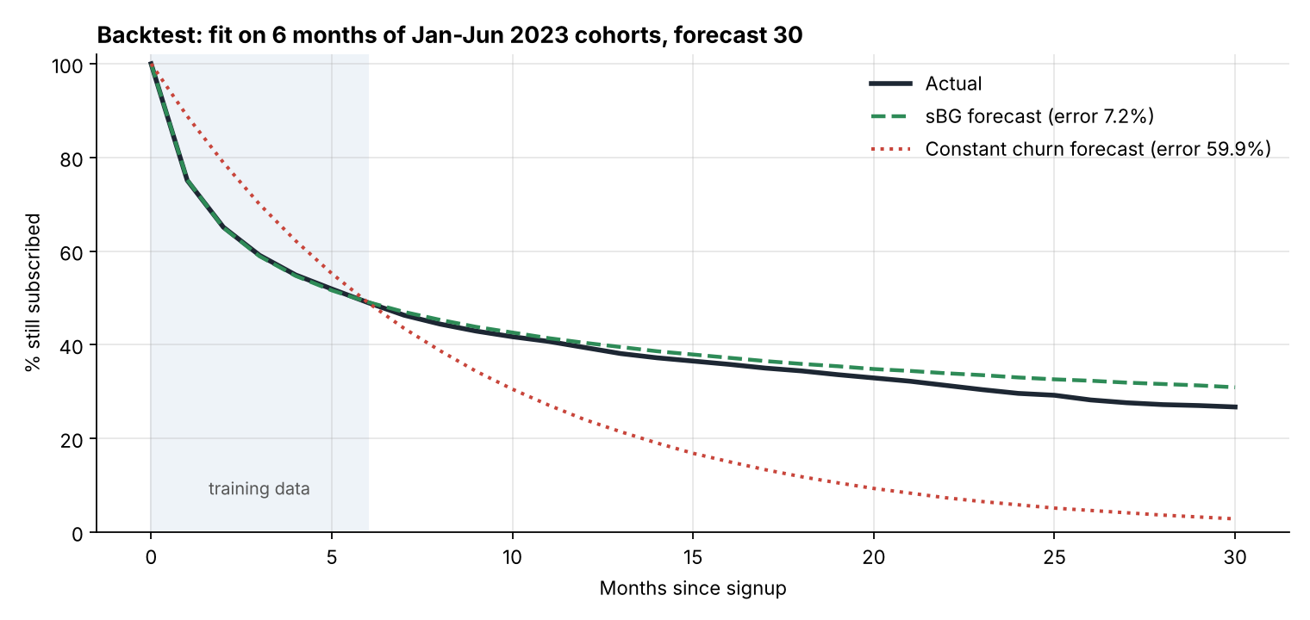
Figure 8. Backtest of the sBG and constant-churn forecasts.
Offer | a | b | Month-1 churn | Projected month 12 | Projected month 24 | Expected months (of 24)
50% off first box | 0.39 | 1.93 | 16.6% | 44.3% | 34.7% | 12.15
First box free | 0.30 | 0.42 | 41.6% | 28.6% | 23.3% | 8.27
No offer | 0.32 | 2.06 | 13.6% | 51.3% | 41.9% | 13.67

Segment-level fits give forward-looking LTV: expected months subscribed multiplied by contribution per active month. The 'first box free' segment has a sharper drop after the first box than the smooth sBG shape allows; a model with a 'one-and-done' share or a beta-discrete-Weibull model would capture this better.

7. Testing
Sixteen pytest tests cover data integrity (including a regression test for a category named 'None' being read back as missing, no orders after cancellation, revenue adding up, spend matching new customers), cohort definitions (month 0 = 100%, unobserved cells blank, survival never increasing), SQL and pandas agreement, the sBG model (recovery of known parameters, curve properties, beating constant churn in the backtest), payback, the two-proportion test against a known value and the onboarding effect.

8. Recommendations
- Replace 'first box free' with 50% off the first box: far better retention and about 2.5 times the 12-month contribution.
- Shift acquisition budget from influencer (1.3x LTV:CAC) towards referral incentives (6.2x) and search (2.4x).
- Keep the new onboarding, and A/B test future product changes.
- Pair future price rises with a loyalty offer for long-standing subscribers.
- Use the sBG model to evaluate new cohorts and channels after a few months rather than waiting a year.

9. Limitations and future work
- The data is synthetic; real data would be noisier.
- Contribution assumes a constant 35% margin and ignores differences in fulfilment cost.
- Twelve-month LTV is conservative; longer-horizon projections depend on the model.
- The onboarding analysis is observational.
- Future work: A/B testing, cohort forecasts feeding the marketing budget, richer survival models for the free-box segment, and running the SQL on a production warehouse with a scheduled refresh.

10. Conclusion
Cohort analysis turns raw subscription data into decisions. Here it shows that retention flattens after the first months, that free first boxes and influencer marketing buy customers who rarely pay back, that the price rise had a short, measurable cost, and that the new onboarding improved retention. The shifted-beta-geometric model allows those conclusions to be reached early for new cohorts, and the SQL implementation and tests make the results reproducible.

Appendix: how to run
python -m venv .venv
.venv\Scripts\activate
pip install -r requirements.txt
pip install -e .
python -m cohort_analysis all
pytest

