Retail Demand Forecasting
Back-tested store-product forecasts and the stock decisions they drive
Final Project Report

Mohamed Moin Peer
MSc Data Analytics, Queen's University Belfast
Portfolio project | 2026

Abstract
This project forecasts daily unit sales 1 to 28 days ahead for 10 stores and 30 products of Harbour Fresh, a fictional grocery chain in Northern Ireland, using 324,550 synthetic store-product-days from 2023 to 2025. Three baselines (the same weekday last week, a four-week same-weekday average and per-series Holt-Winters exponential smoothing) were compared with a global LightGBM model and quantile models in a six-fold rolling-origin back-test. LightGBM achieved a weighted absolute percentage error (WAPE) of 27.4%, against 45.3%, 37.2% and 34.6% for the baselines. A forecast equal to the true mean demand would score 26.7%. On promotion days the baselines under-forecast by more than 40%, while LightGBM's bias was -3.05%. Using the forecasts to order 11 short-life products raised availability from 81.2% to 87.7%, cut waste from 20.0% to 11.6% of stock ordered, and increased profit by £156,160 over 24 weeks. Ordering a forecast quantile at each product's newsvendor critical ratio reached 90.8% availability with the lowest total cost.

1. Introduction and aims
Grocery retailers order stock for each product in each store every day. For short-life food the cost of error is immediate: over-ordering creates waste, and under-ordering leaves empty shelves, lost sales and dissatisfied customers. Many stores base orders on recent sales. The aims of this project were to:
- build a leak-free feature set for forecasting store-product demand up to four weeks ahead;
- compare simple and classical baselines with a gradient-boosted global model in an honest back-test;
- quantify uncertainty with quantile forecasts and check their calibration;
- measure how close the forecasts come to the best achievable accuracy;
- translate forecasts into order quantities and measure the effect on waste, availability and profit.

2. Data
All data is synthetic, generated by src/demand_forecasting/generate_data.py with a fixed random seed. The fictional chain has ten stores from Belfast to Enniskillen, with size factors from 0.65 to 1.6, and 30 products in 10 categories. The sales table holds units, selling price, promotion flag, stockout flag and store-closed flag for every store, product and day (324,550 rows, 13,283,348 units, £21.4m revenue). Supporting tables give product prices, costs and shelf lives, daily temperature by store, and Northern Ireland bank holidays.
Known effects were built in so that the analysis could be checked against the truth:
Effect | Implementation
Day of week | Saturday peak; Sunday low (NI Sunday trading 1–6 pm)
Seasonality | Category-specific yearly cycles; Christmas build-up and January dip
Closures | Stores closed on Christmas Day and Easter Sunday (NI large-shop rules)
Seasonal lines | Mince pies (Nov–Dec), Easter eggs (6 weeks), pancake mix (Shrove Tuesday)
Weather | Multiplicative temperature effects, e.g. ice cream +7.5% per °C, soup −4% per °C
Promotions | 20–33% off for 1–2 weeks; uplift = (price ratio)^elasticity; post-promotion dip for storable goods
Other | Payday uplift, 3% annual growth, a declining product, a product launched in March 2024
Noise and stockouts | Negative-binomial noise; stockouts on 1.59% of days cap sales below demand

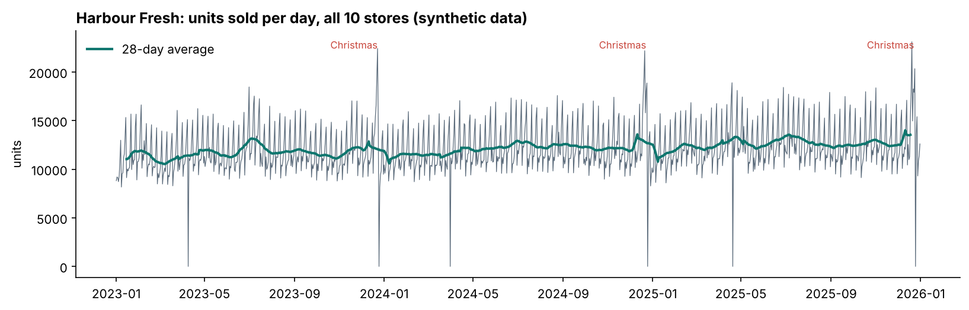
Figure 1. Units sold per day across the chain. Drops to zero are Christmas Day and Easter Sunday.
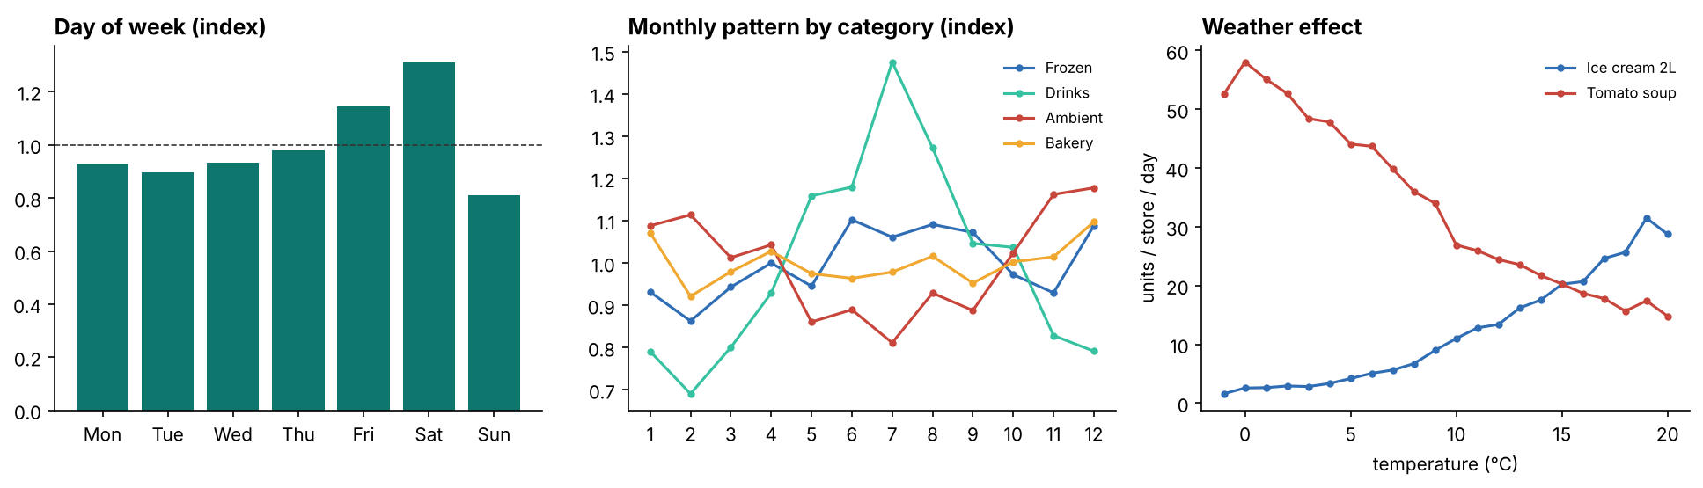
Figure 2. Day-of-week index, monthly pattern by category, and the temperature effect.

3. Method
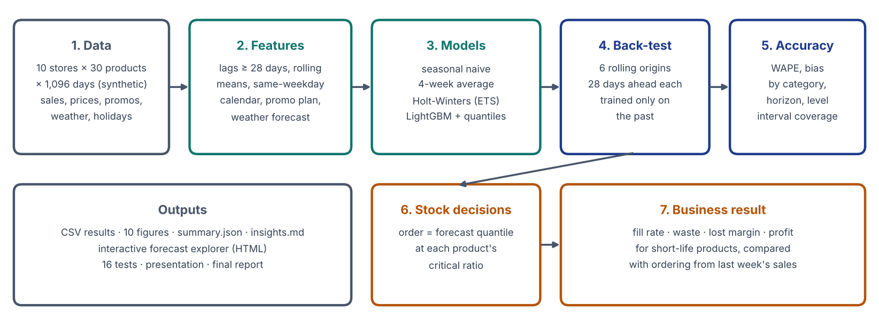
Figure 3. Project pipeline.

3.1 Features
Forecasts are made on an origin date for the following 28 days by a single direct model. Every history-based feature therefore uses data at least 28 days old: lags of 28, 35, 42, 49, 56 and 364 days; rolling means over 7, 28 and 91 days and a 28-day standard deviation, all ending 28 days before the target; the mean of the four latest same-weekday lags; and the chain-wide mean for the product. Information known in advance is used for the target day: calendar fields, NI holidays, days to Christmas and Easter, payday, the promotion plan (flag, discount, day of promotion, post-promotion week), price and store closures. Temperature is used as a forecast: in the test period, noise with a standard deviation of 0.6 + 0.12 × horizon (°C) is added to the observed value. Stockout and closed days are set to missing in the sales history, so lags never treat lost sales as low demand. A unit test multiplies all sales after a cut-off date and confirms that no history feature changes before the cut-off plus 28 days.

3.2 Models
- Seasonal naive: the same weekday in the week before the origin.
- Four-week average: the mean of the last four same weekdays, excluding stockout and closed days.
- Holt-Winters: additive exponential smoothing with weekly seasonality, fitted per store-product series on log(1 + units) over the previous year (statsmodels).
- LightGBM: one global model for all series with a Tweedie objective (variance power 1.2), 500 trees, learning rate 0.05 and 63 leaves, trained on non-stockout open days. Four quantile models (10%, 50%, 75%, 90%) are sorted per row to prevent crossing. Closed days are forecast as zero by every method.

3.3 Back-test and metrics
Six origins four weeks apart (14 July to 1 December 2025) each use an expanding training window and a 28-day test period; the last covers the run-up to Christmas. Scoring excludes stockout and closed days, leaving 49,296 store-product-days. The primary metric is WAPE (Σ|F − A| / ΣA), supported by bias (Σ(F − A) / ΣA), MAE, RMSE, interval coverage and pinball loss. Because the data is synthetic, the noise-free expected demand is also scored as a forecast, giving the best achievable WAPE.

3.4 Inventory policy
For the 11 products with a shelf life of seven days or less, each store-day is treated as a single-period newsvendor decision. The underage cost is the lost margin plus a goodwill cost of 20% of the price. The overage cost is the unit cost less a 20% salvage value from reduced-to-clear sales. The optimal order is the demand quantile at the critical ratio cu / (cu + co), which ranges from 0.55 to 0.72 across products. Four policies were compared: ordering the seasonal naive forecast, the four-week average, the LightGBM mean, and the LightGBM quantile at the critical ratio, interpolated linearly between the modelled quantiles.

4. Results

4.1 Overall accuracy
Method | WAPE | Bias
Seasonal naive | 45.3% | -1.0%
Four-week average | 37.2% | -0.8%
Holt-Winters (ETS) | 34.6% | -7.3%
LightGBM | 27.4% | -1.3%
Best possible (true mean) | 26.7% | 0.5%

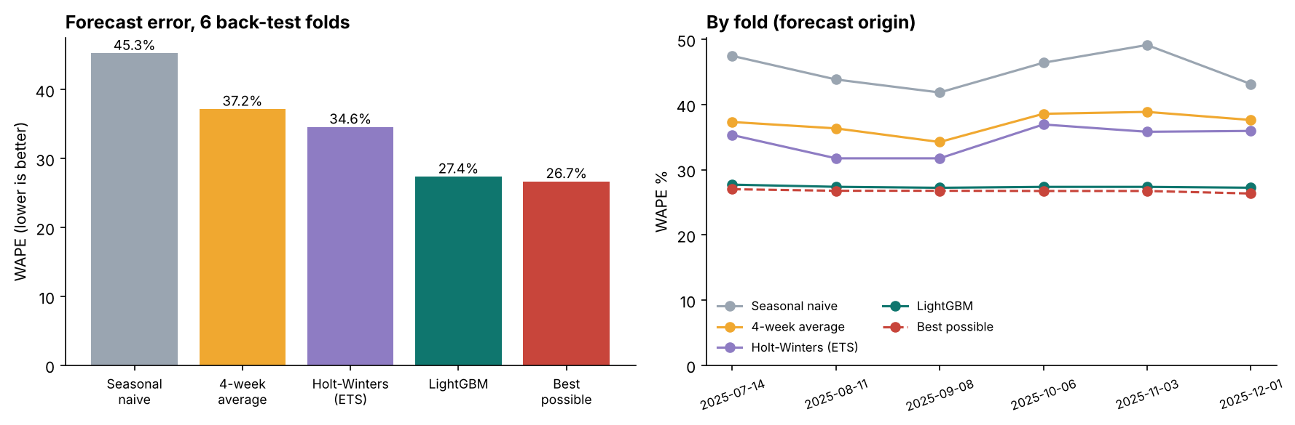
Figure 4. WAPE by method overall and by back-test fold.
LightGBM reduced WAPE by 39.5% relative to the seasonal naive forecast and by 20.8% relative to the best baseline, and the ranking held in every fold. Its error is 0.7 points above the floor of 26.7% set by day-to-day randomness. Holt-Winters was biased low (-7.3%), because back-transforming forecasts made on the log scale estimates the median rather than the mean.

4.2 Promotions
Promotion days | WAPE | Bias
Seasonal naive | 48.8% | -41.1%
Four-week average | 47.0% | -43.9%
Holt-Winters | 47.3% | -44.0%
LightGBM | 27.9% | -3.0%

Methods that only extrapolate past sales cannot anticipate a planned price cut, so they under-forecast promotion days by more than 40%, exactly when shelves empty fastest. LightGBM uses the promotion plan, and its promotion-day error is close to its normal-day error. Figure 5 compares the uplift the model predicts for each product's promotions with the uplift built into the data. The points lie close to the diagonal, so the model learned the price response well. The same figure shows a weakness: the response to temperature is underestimated by about a third (ice cream: 29% more sales for a day 5 °C warmer, against a true 46%). Because warm days and summer coincide, part of the effect is attributed to seasonal features.
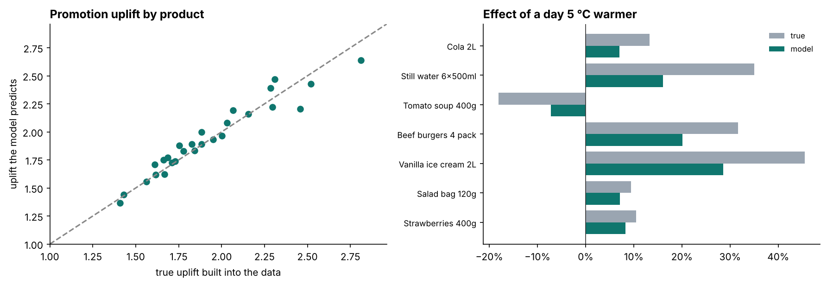
Figure 5. Promotion uplift and temperature effects learned by LightGBM against the true values.

4.3 Examples, categories, horizon and aggregation
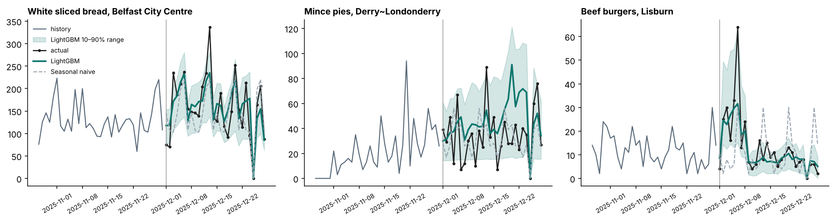
Figure 6. Forecasts from 1 December 2025 with the 10–90% range.
In the December fold, LightGBM follows the Christmas build-up and the Christmas Day closure for bread. It forecasts the burger promotion that begins the day after the origin, which the naive forecast misses entirely. Mince pies are the hardest case: with only two previous seasons, the model over-forecasts in mid-December.
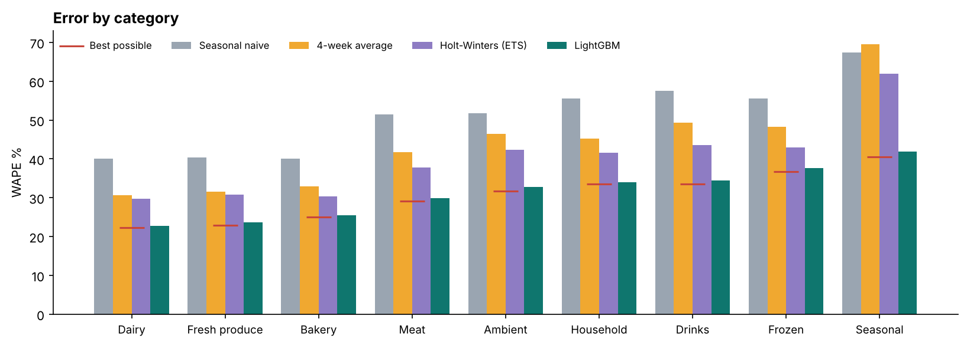
Figure 7. WAPE by category; red markers show the best possible score.
Error ranges from 22.8% for Dairy to 41.8% for Seasonal. LightGBM is close to the best possible score in every category, so the higher errors for frozen, drinks and seasonal lines reflect lower volumes and noisier demand rather than missing signal.
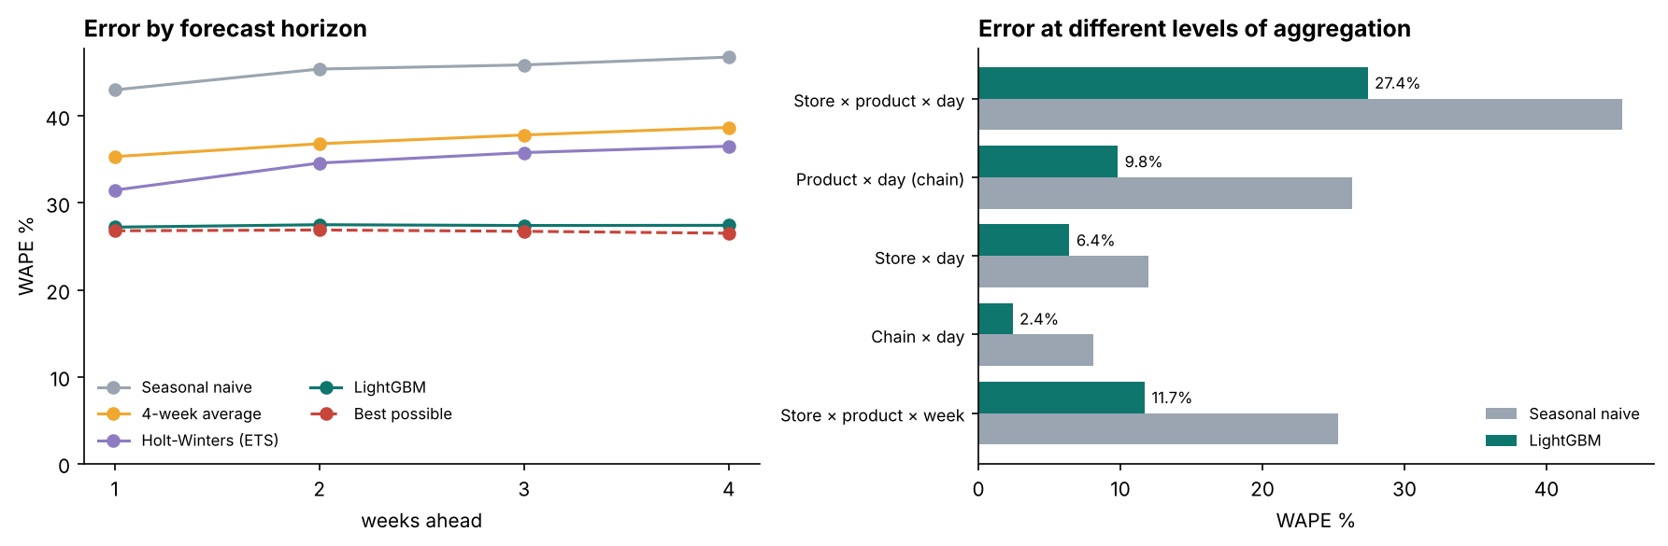
Figure 8. WAPE by weeks ahead and by level of aggregation.
LightGBM's error is flat across the four weeks (27.2–27.5%), while the baselines deteriorate. Aggregation reduces error sharply: 27.4% per store-product-day, 9.8% per product across the chain, 6.4% per store-day and 2.4% for the chain. Staffing and transport can therefore be planned on totals with high confidence, while shelf stock needs product-level ranges.

4.4 Prediction ranges
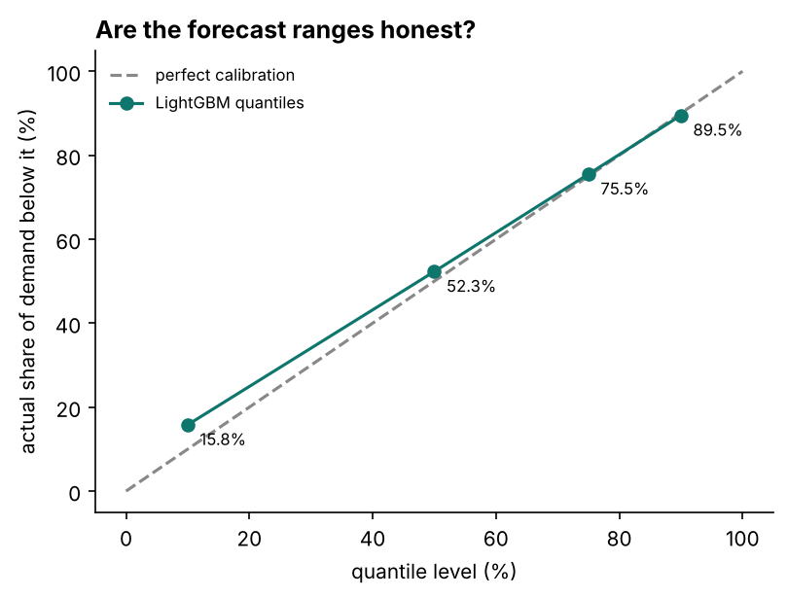
Figure 9. Share of actual demand below each forecast quantile.
The 10–90% range contained 76.0% of actual demand against a nominal 80%. The 50%, 75% and 90% quantiles were well calibrated (52.3%, 75.5% and 89.5% of demand fell below them), but the 10% quantile was too high (15.8%). Post-hoc calibration, for example conformal prediction, is the obvious refinement.

4.5 Stock decisions
Order policy | Fill rate | Waste | Net profit | Mismatch cost
Last week's sales (naive) | 81.2% | 20.0% | £532,997 | £458,205
4-week average | 84.5% | 16.1% | £606,716 | £371,072
LightGBM average forecast | 87.7% | 11.6% | £689,157 | £273,367
LightGBM + target service level | 90.8% | 15.3% | £683,720 | £267,211

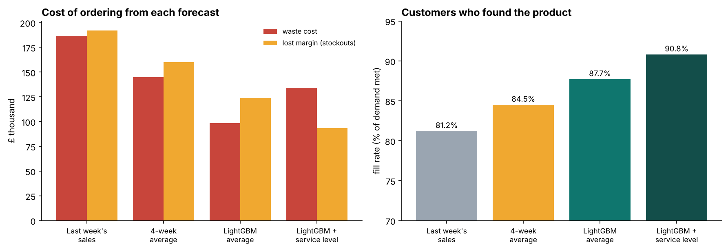
Figure 10. Waste cost, lost margin and fill rate for each order policy.
Ordering from LightGBM rather than last week's sales raised the fill rate from 81.2% to 87.7%, cut waste from 20.0% to 11.6% of units ordered, and increased net profit by £156,160 over 24 weeks for 11 products in 10 stores. The service-level policy increased availability to 90.8%, with slightly more waste and slightly lower booked profit. It achieved the lowest total mismatch cost (waste, lost margin and goodwill), 41.7% below the naive policy. The choice between the two depends on the value the business places on availability. Better-calibrated lower quantiles would improve the service-level policy further.

5. Testing and reproducibility
A single command regenerates the data, runs the back-test and writes every table, figure, the interactive explorer and the insights file. Sixteen pytest tests cover the data (closures, promotion pricing, built-in effects, stockouts), the features (no future leakage, blanked stockouts, calendar and promotion counters), the models (naive definition, LightGBM beating naive, ordered quantiles, closed days at zero, training restricted to the past) and the inventory logic (critical ratios, quantile interpolation and balancing of sold, wasted and lost units).

6. Limitations and future work
- The data is synthetic and the model observes every driver used to generate it; errors on real data would be higher and the gap to the best possible score larger.
- The 10% quantile is too high, so the 10–90% range is narrower than intended.
- Weather sensitivity is underestimated; interaction features or monotonic constraints could help.
- One direct model serves all horizons using lags of at least 28 days; separate models per forecast week could use fresher data for short horizons.
- The inventory model is a one-day newsvendor model without multi-day shelf life, lead times, case sizes or substitution between products.
- Future work: conformal calibration, horizon-specific models, a multi-period inventory simulation, and application to real store data.

7. Conclusion
A global LightGBM model with leak-free features came close to the best accuracy the data allows and clearly outperformed the simple and classical methods that retailers often use, above all on promotion days. Converting those forecasts into newsvendor orders showed the business value directly: higher availability, much less waste and higher profit. Measuring the error floor, checking the learned effects against the truth, and testing the calibration of the ranges kept the conclusions honest and identified the next improvements.

Appendix: how to run
python -m venv .venv
.venv\Scripts\activate
pip install -r requirements.txt
pip install -e .
python -m demand_forecasting all
pytest

