
FACULTY OF SYSTEMS AND INFORMATICS ENGINEERING

DOCTORAL PROGRAM IN DEEP TECH WITH A FOCUS ON ARTIFICIAL INTELLIGENCE AND EMERGING TECHNOLOGIES

COURSE:

RESEARCH METHODS AND SCIENTIFIC INTEGRITY IN AI AND ADVANCED TECHNOLOGIES

RESEARCH TOPIC:

A REPRODUCIBLE TRUSTWORTHY ARTIFICIAL INTELLIGENCE FRAMEWORK FOR TRAFFIC-FLOW FORECASTING USING OPEN DATA FROM PERU’S NATIONAL ROAD NETWORK

Presented by:
Moisés Evangelista Gamarra
Professor:
Dr. Loveleen Gaur

Lima, Perú
2026

TABLE OF CONTENTS
1. Research Topic and Context 2
2. Preliminary Research Question 2
3. Chosen Paradigm and Justification 2
4. Implications of the Choice 3
4.1. Possible publication venues: 4
5. One Doubt / Tension 4
6. Vocabulary 5
REFERENCES 6

PARADIGM JUSTIFICATION STATEMENT

“A Reproducible Trustworthy Artificial Intelligence Framework for Traffic-Flow Forecasting Using Open Data from Peru’s National Road Network”

1. Research Topic and Context
My doctoral research focuses on designing and validating a reproducible Trustworthy Artificial Intelligence framework for traffic-flow forecasting using open data from Peru’s National Road Network. Traffic forecasting is important for Intelligent Transportation Systems because reliable predictions can support traffic management, infrastructure planning, and decision-making.
The study uses official traffic-flow data from toll units of the National Road Network published by the Ministry of Transport and Communications (MTC). This context is relevant to Peru and Latin America because it allows AI methods to be evaluated using real public data.

2. Preliminary Research Question
To what extent can a reproducible Trustworthy AI framework improve the reliability and traceability of traffic-flow forecasting compared with a conventional experimental workflow using open data from Peru’s National Road Network?
The study considers not only prediction accuracy, but also reproducibility, traceability, explainability, and data quality.

3. Chosen Paradigm and Justification
I adopt the Design Science paradigm because the main contribution of my research is the design and validation of a computational artifact: a reproducible Trustworthy AI framework for traffic-flow forecasting.
This paradigm is appropriate because the research involves building and evaluating an artifact to address a real-world problem. (Hevner, Parsons, Brendel, & Roman, 2024)
Design Science Research is a systematic approach that focuses on designing and developing artifacts to solve real-world problems. It also involves evaluating these artifacts to understand their usefulness, effectiveness, and contribution to research. (Peffers, TuunanenThe , Rothenberger, & Chatterjee, 2014)
I don´t choose positivism because quantitative experiments mainly provide evidence to evaluate the framework. I don´t choose interpretivism because the study does not focus on people’s experiences or opinions. I also don´t choose mixed methods because combining quantitative and qualitative methods is not central to the study.
Philosophically, I adopt a pragmatic position because the research focuses on solving a practical problem and using methods that best support the design and evaluation of the framework. Therefore, Design Science is the main research paradigm.

4. Implications of the Choice
The study will use official open traffic-flow data from the MTC and a documented computational pipeline.
The framework will be evaluated using six main dimensions to assess its predictive performance, uncertainty, reproducibility, traceability, explainability, and robustness under changing data conditions.
The NIST AI Risk Management Framework provides guidance for identifying, assessing, and managing risks throughout the AI system life cycle, supporting trustworthy and responsible AI. Similarly, the FAIR principles promote the Findability, Accessibility, Interoperability, and Reusability of data and digital research objects, and their application has been extended to AI research (Tabassi, 2023); (Huerta, Blaiszik, Brinson, & Bouchard, 2023)
The following table shows the main dimensions that will be used to evaluate the proposed framework. For each dimension, it explains how the evaluation will be carried out, what tools and materials will be used, and what evidence is expected. These dimensions will help to assess whether the framework provides accurate, reliable, reproducible, explainable, and robust traffic-flow forecasts.

Tabla 1: Dimensions for Evaluating the Proposed Trustworthy AI Framework
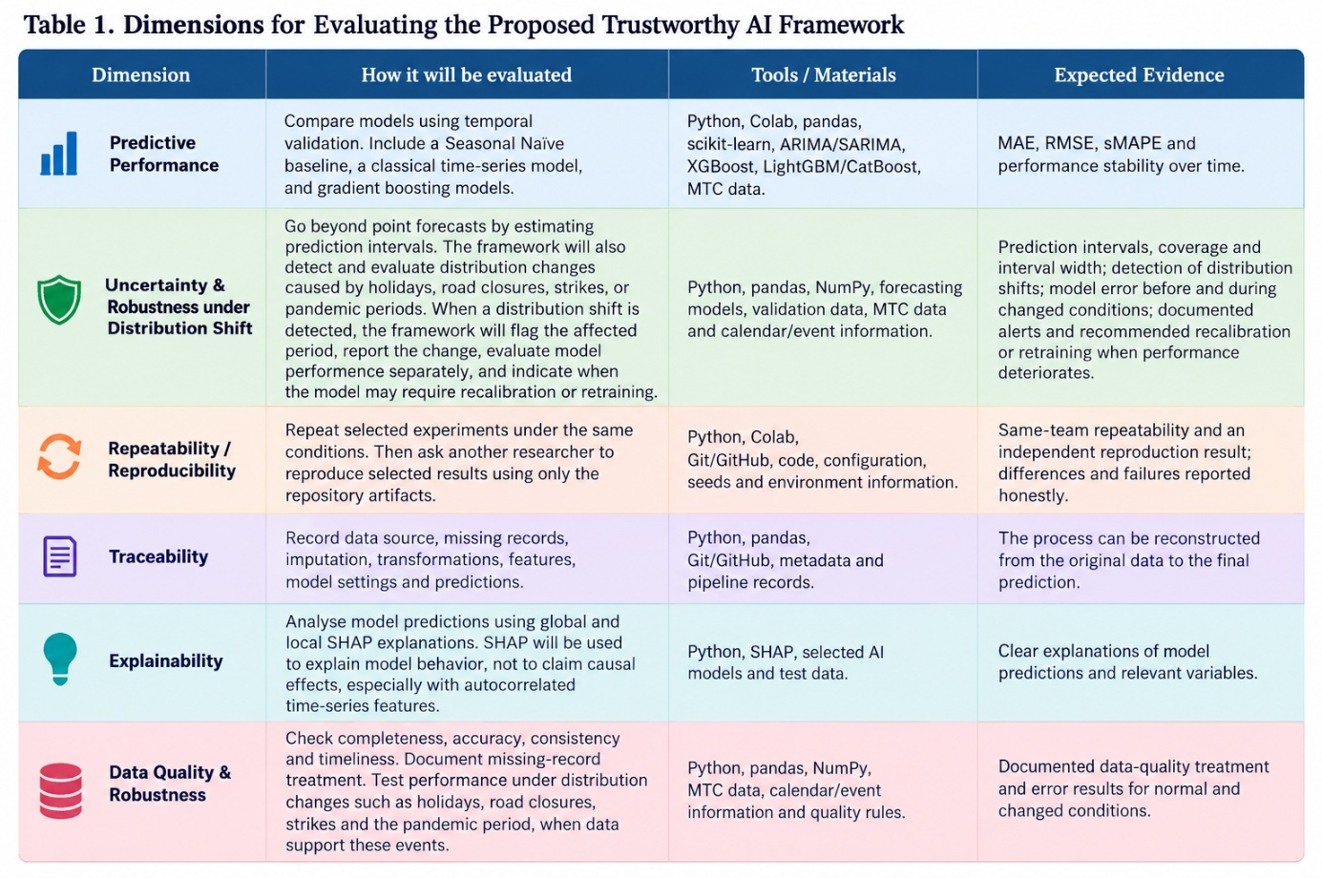
Overall, the study considers repeatability through repeated experiments under the same conditions, reproducibility through the use of the study artifacts by another researcher, and replicability through an independent approach. The main focus is reproducibility, supported by transparent documentation and accessible research artifacts.

4.1. Possible publication venues:
- IEEE Transactions on Intelligent Transportation Systems — Q1 — JIF 9.1
- Transportation Research Part C: Emerging Technologies — Q1 — JIF 8.4
- Frontiers in Artificial Intelligence — Q1 — JIF 6.7

5. One Doubt / Tension
One important concern is that the framework may make the forecasting process more complex without necessarily improving prediction accuracy. To address this, I will compare it with a conventional workflow using the six evaluation dimensions, simple and classical baselines, and uncertainty measures.
I will also include an independent reproduction attempt using the repository. Updated MTC data from new years will be used as a complementary test of temporal robustness, not as the main evidence of reproducibility.

6. Vocabulary
- Repeatability: the same researcher can repeat the experiment under the same conditions.
- Reproducibility: a different researcher can obtain the same result using the study artifacts, such as the repository, code, and documentation.
- Replicability: another research team independently applies the proposed methodology under a different setup to assess whether similar conclusions can be obtained.

REFERENCES

Hevner, A. R., Parsons, , & Benedikt Brende, A. (Julio de 2024). ScienceDirect. Obtenido de https://www.sciencedirect.com/science/article/abs/pii/S0167923624000691?via%3Dihub
Huerta, E., Blaiszik, B., Brinson, L., & Bouchard, K. (2023). Scientific Data. Obtenido de https://www.nature.com/articles/s41597-023-02298-6?utm_source=chatgpt.com
Peffers, K., TuunanenThe , T., Rothenberger, M. A., & Chatterjee, S. (Diciembre de 08 de 2014). Journal of Management Informatios. Obtenido de https://www.tandfonline.com/doi/abs/10.2753/MIS0742-1222240302
Tabassi, E. (Junio de 2023). NIST. Obtenido de https://www.nist.gov/publications/artificial-intelligence-risk-management-framework-ai-rmf-10?utm_source=chatgpt.com

