SESSION 4 DELIVERABLE
Systematic Review + PRISMA 2020 Flow Diagram + Gap Analysis Table
Curso: Metodología de la Investigación e Integridad Científica en IA — Doctorado en Tecnologías Deep Tech,
UNMSM–FISI
Professor : Dr. Loveleen Gaur
Student: Moisés Evangelista Gamarra

Proyecto doctoral: A Reproducible Trustworthy Artificial Intelligence Framework for Traffic-Flow Forecasting Using Open Data from Peru's National Road Network

Search conducted on October 1, 2026 · Lima, Peru

1. Research Question
Which Machine Learning and Deep Learning approaches applied to road traffic forecasting incorporate Trustworthy Artificial Intelligence dimensions—explainability, uncertainty quantification, and robustness—and which combinations of these dimensions, reproducibility conditions, and validation contexts still lack evidence?

2. Materials and Methods

2.1. Study Design and Reporting Guideline
The study follows the PRISMA 2020 statement as the reporting guideline (Page et al., 2021) and the six methodological steps: define the question, build the search string, retrieve records, carry out the initial selection, extract the information, and synthesize the findings. The synthesis is qualitative and does not include a meta-analysis because the studies differ in datasets, forecasting horizons, and metrics.

2.2. Source, Boolean Search String, and Search Date

Database: Semantic Scholar.

Execution date: October 1, 2026. Time filter: 2020 onward. Result: 1,320 records.

Search string in standard Boolean notation:
("traffic flow" OR "traffic speed") AND (forecast* OR predict*) AND (explainable OR uncertainty OR robust)
Literal Semantic Scholar syntax (| = OR; space = AND), for replication:
("traffic flow" | "traffic speed") (forecast* | predict*) (explainable | uncertainty | robust) [year = 2020-]

2.3. Eligibility Criteria (Defined Before Selection)
Table 2 presents the criteria used to determine study inclusion and the codes applied to record the reasons for exclusion.

Table 2. Operational eligibility criteria and exclusion codes.
Code | Inclusion criterion | Associated exclusion code
I1 | Published between 2020 and 2026 | Search filter
I2 | Peer-reviewed journal or conference proceedings article, with a verifiable bibliographic record (DOI) | E5 Ineligible source (preprint, SSRN, source not identified)
I3 | Primary study whose main objective is to forecast road traffic flow, volume, speed, occupancy, or traffic state/congestion over a future horizon | E1 Outside scope; E2 Different objective (crashes, control, emissions, estimation without a forecast horizon); E6 Secondary study
I4 | ML or DL model as the core of the method | E3 No ML/DL as the core
I5 | At least one Trustworthy AI dimension addressed through a specific mechanism or dedicated evaluation (not only as a label) | E4 Trustworthiness only stated

2.4. Review and Selection Procedure
The 1,320 records were kept in their original order. The initial selection was carried out by reviewing the titles and abstracts of the first block of 30 records. That block produced 7 included studies; therefore, according to the stopping rule defined before selection, the review continued record by record until the tenth included study was reached (record 74). Records without an abstract or with an uncertain decision were moved to eligibility assessment using the full text or the publisher's page.
An AI assistant (Claude, Anthropic) applied criteria I1–I5 to each record and wrote the reason for each decision (Appendix A). To ensure that AI supports rather than replaces the researcher, the researcher verifies 100% of the included records and at least 10% of the excluded records before submission. Discrepancies are resolved in favor of the written criterion, without changing it.

2.5. Data Extraction
For each included study, the authors, year, source, DOI, objective, model, data, Trustworthy AI dimension, type of evidence (mechanism or evaluation), code availability, and limitation relevant to the gap analysis were recorded (Tables 4 and 5; Figure 2).

3. PRISMA 2020 Flow Diagram
Figure 1 summarizes the stages followed to identify, review, assess, and select the studies for the systematic review.

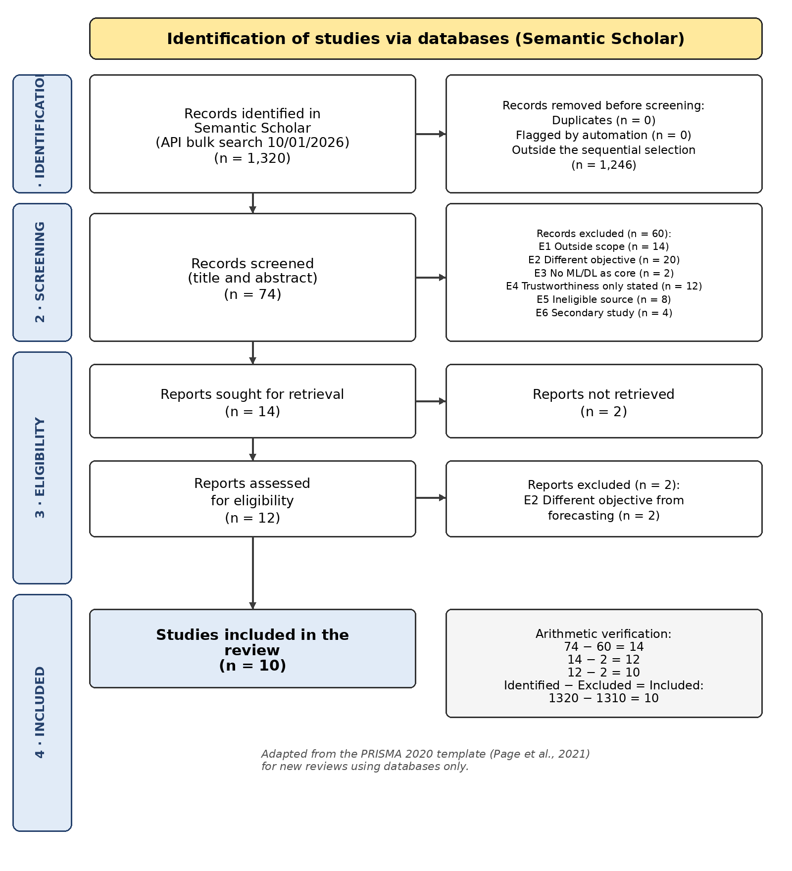
Figure 1. PRISMA 2020 flow diagram of the review (four numbered phases). Source: author's own elaboration using data from Semantic Scholar (10/01/2026).

Tables 3a and 3b summarize the identification, review, eligibility assessment, and selection process for the included studies. They also detail the main reasons for exclusion applied at the different stages of the review.

Table 3a. Diagram values. Consistency: 1320 − (1246 + 60 + 2 + 2) = 10.
Phase | PRISMA 2020 field | n
1 · Identification | Records identified (Semantic Scholar) | 1320
1 · Identification | Duplicates removed / flagged by automation | 0 / 0
1 · Identification | Records not reviewed under the predefined sequential selection | 1246
2 · Initial review | Records reviewed (title and abstract) | 74
2 · Initial review | Records excluded | 60
3 · Eligibility | Reports sought for retrieval | 14
3 · Eligibility | Reports not retrieved | 2
3 · Eligibility | Reports assessed for eligibility | 12
3 · Eligibility | Reports excluded | 2
4 · Included | Studies included in the review | 10

Table 3b. Reasons for exclusion by phase (record-by-record detail in Appendix A).
Code | Reason for exclusion | Initial review | Eligibility | Total
E1 | Outside scope (not road traffic) | 14 | 0 | 14
E2 | Different objective from road traffic forecasting | 20 | 2 | 22
E3 | No ML/DL model as the core | 2 | 0 | 2
E4 | Trustworthiness only stated (without mechanism/evaluation) | 12 | 0 | 12
E5 | Ineligible source (preprint/SSRN/source not identified) | 8 | 0 | 8
E6 | Secondary study (review) | 4 | 0 | 4
NR | Report not retrieved (no abstract or accessible full text) | 0 | 0 | 2
 | Total | 60 | 2 | 64

4. 10 Key Selected Articles
Table 4 presents the 10 studies selected for the final corpus. It summarizes their authors, publication year, title, source, and DOI, which allow each study to be identified and verified.

Table 4. Final corpus. The 10 DOIs were verified in Semantic Scholar and on the publisher's website.
# | Authors | Year | Title | Source | DOI
1 | Zhu, Wu, Wang, Chen & Zhan | 2026 | Multisource urban sensing data fusion and dynamic causal graph modeling for explainable traffic state prediction | Sensors | 10.3390/s26144547
2 | Tan, Zhou, Huang, Dou, Song & Lin | 2024 | A noise-immune and attention-based multi-modal framework for short-term traffic flow forecasting | Soft Computing | 10.1007/s00500-023-09173-x
3 | Hemavathi & Sumathi | 2026 | Modelling predictive uncertainty for reliable traffic flow forecasting using UA-STTFF framework | ICKECS 2026 (IEEE) | 10.1109/ICKECS70176.2026.11527702
4 | Zou, Wang & Liu | 2026 | Depth modeling and congestion prediction algorithm of large-scale spatio-temporal data of urban traffic flow | Proc. SPIE (PCAAI 2026) | 10.1117/12.3113016
5 | Li, Zhou, Hu, Cai & Zhou | 2026 | Coarse-to-fine latent guidance: A multi-scale diffusion transformer for traffic flow forecasting | IJCAI-26 | 10.24963/ijcai.2026/311
6 | Tang, Chen, Cao, Zang & Sun | 2024 | Lane-level short-term travel speed prediction for urban expressways: An attentive spatio-temporal deep learning approach | IET Intelligent Transport Systems | 10.1049/itr2.12464
7 | Xu, Wang, Xin & Hua | 2026 | A study on urban traffic speed prediction using spatiotemporal attention-based convolutional neural networks | Electronics | 10.3390/electronics15184128
8 | Zou | 2025 | Combination of multiple transformer models for short-term freeway traffic speed prediction based on Bayesian model averaging | Multidisciplinary Science Journal | 10.31893/multiscience.2025468
9 | Sun, Chen, Xu, Xie, Blum & Venkitasubramaniam | 2024 | On the generalization discrepancy of spatiotemporal dynamics-informed graph convolutional networks | Frontiers of Mechanical Engineering | 10.3389/fmech.2024.1397131
10 | Yan, Dong, Qu & Gao | 2026 | Bi-STDGCN: A bidirectional spatiotemporal diffusion graph convolutional network with multiscale anomaly-guided attention for traffic forecasting | IEEE Internet of Things Journal | 10.1109/JIOT.2026.3652408
.

5. Corpus Extraction Matrix
Table 5 organizes the variables used to compare the selected studies and analyze Trustworthy AI dimensions, the methods used, and the relevant limitations for identifying research gaps.

Table 5. Extraction Matrix
Study | Problem / objective | Method / model | Trustworthy AI dimension (evidence) | Limitation useful for the gap
Zhu et al. (2026) | Predict traffic state and congestion (15–60 min) using multi-source fusion | Dynamic spatiotemporal causal graph + reliability-aware attention | Causal explainability; robustness to missing or low-quality modalities | Single case (Hangzhou); fixed 5-minute aggregation; no open-data statement
Tan et al. (2024) | Short-term traffic flow forecasting | NIAMNet: flow converted into an image + dual-attention blocks | Robustness to non-Gaussian noise and outliers (noise-immune loss) | Robustness without uncertainty quantification or explanations
Hemavathi & Sumathi (2026) | Traffic flow forecasting with uncertainty | UA-STTFF: GCN + GRU, probabilistic heads, MC dropout | Incertidumbre (PICP = 93,7 %) | Validated only with simulated data
Zou, Wang & Liu (2026) | Large-scale congestion prediction (15–60 min) | DSTGN: dynamic graph + Transformer + text fusion (BERT) | Interpretability (visual analysis of learned associations); degradation at longer horizons | Qualitative interpretability; no uncertainty
Li et al. (2026) | Multi-scale traffic flow forecasting | MS-STDT: diffusion Transformer with coarse-to-fine latent guidance | Zero-shot robustness to sensor failures; public code and data | Only study with reproducible artifacts; no explanations or calibrated uncertainty
Tang et al. (2024) | Lane-level travel speed (urban expressways) | 3D convolution with dual attention | Explainability: interpretation of attention coefficients | Attention-based explainability, without expert validation
Xu et al. (2026) | Multi-horizon traffic speed | AT-GCN-GRU with temporal attention | Robustness to missing data; visualization of attention weights | Classic benchmarks (SZ-taxi, METR-LA); no code reported
Zou (2025) | Freeway speed (5–60 min) | Bayesian model averaging (BMA) of three Transformers | Model uncertainty | No calibrated intervals reported; single corridor (Minnesota)
Sun et al. (2024) | Spatiotemporal generalization (traffic speed and epidemics) | RDGCN: GCN informed by reaction-diffusion equations | Robustness to distribution shift with theoretical conditions; physical interpretability | Limited domain validation; no uncertainty
Yan et al. (2026) | Traffic flow forecasting with non-stationary anomalies | Bi-STDGCN: bidirectional diffusion + anomaly-guided attention | Robustness to anomalies and sudden disruptions | Explainability only through visualization; no code reported

Figure 2 summarizes the evidence extracted from the 10 studies, linking the problem addressed, the model used, the Trustworthy AI dimension assessed, and the main limitation relevant to the gap analysis.

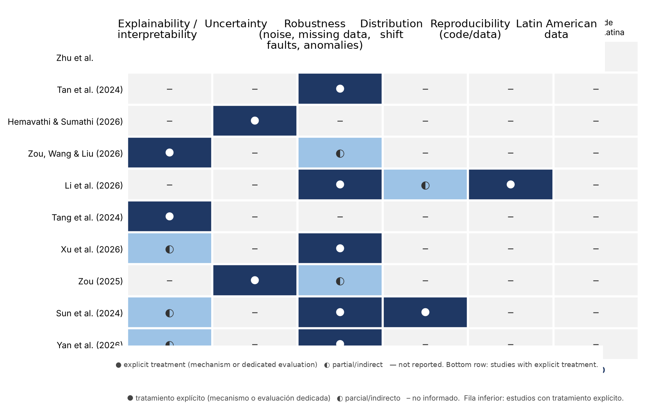
Figure 2. Coverage of Trustworthy AI dimensions in the corpus (n = 10). No study explicitly addresses more than two dimensions.

6. Synthesis of Findings

Robustness is the dominant dimension, but it is fragmented. Six of the ten studies explicitly address robustness, although each one focuses on a different perturbation: non-Gaussian noise (Tan et al., 2024), missing modalities (Zhu et al., 2026), missing data (Xu et al., 2026), sensor failures (Li et al., 2026), non-stationary anomalies (Yan et al., 2026), and distribution shift (Sun et al., 2024). This heterogeneity indicates that there is no common stress-testing protocol for comparing robustness across models.
Explainability and uncertainty appear in isolation. Three studies provide explicit explainability, mainly through attention mechanisms or visual analysis (Tang et al., 2024; Zou, Wang & Liu, 2026; Zhu et al., 2026), and only two quantify uncertainty (Hemavathi & Sumathi, 2026; Zou, 2025). Of these two, only the first reports interval coverage, and it does so using simulated data. No study combines explainability and uncertainty.

Reproducibility is the exception. Only Li et al. (2026) publish code and data; the others do not report research artifacts. Validation is concentrated on urban benchmarks from China and the United States (e.g., PeMS, METR-LA, SZ-taxi), and no study uses data from Latin America or interurban road networks with toll stations.
Overall, the corpus suggests that the field is advancing through individual components—one Trustworthy AI mechanism per study—rather than through frameworks that integrate and jointly evaluate explainability, uncertainty, robustness, and reproducibility.

7. Gap Analysis Table

Table 6 summarizes the four types of gaps identified from the corpus: knowledge, methodological, contextual, and theoretical. For each one, the evidence found, the candidate gap, and its relationship to the doctoral project are indicated.

Gap type | What the corpus shows | Candidate gap | Evidence (corpus citations) | Relationship to the doctoral research
Knowledge gap (question not asked) | Each study optimizes one trustworthiness dimension; none explicitly addresses more than two (Figure 2). | It is not known whether improving robustness or explainability degrades uncertainty calibration, or how these dimensions interact within the same road traffic forecasting model. | Tan et al. (2024); Hemavathi & Sumathi (2026); Tang et al. (2024); Yan et al. (2026) | Formulate questions about trade-offs between dimensions within the framework
Methodological gap (method not applied here) | Robustness is tested with ad hoc and different perturbations in each study; uncertainty is rarely calibrated with real data; only 1 of 10 studies publishes code. | An integrated evaluation protocol is lacking: temporal validation, standardized stress tests, uncertainty calibrated with real data, and reproducible artifacts. | Li et al. (2026); Xu et al. (2026); Zou (2025); Hemavathi & Sumathi (2026) | Design of the framework's experimental evaluation (Design Science)
Contextual gap (population or setting not studied) | All evidence comes from urban networks or freeways in China, the United States, and other high-income countries. | There is no evidence on trustworthy forecasting using open data from toll stations on an interurban Latin American national road network, such as Peru's National Road Network (MTC). | Zhu et al. (2026); Tang et al. (2024); Zou (2025); Xu et al. (2026) | Defines the Peruvian setting as the validation context (the type of gap in Quick Check #4)
Theoretical gap (framework that does not explain the phenomenon) | Only Sun et al. (2024) derive theoretical conditions, and only for robustness to distribution shift. | A conceptual framework is lacking that links Trustworthy AI dimensions with traffic forecasting properties (non-stationarity, sensor failures, regime changes). | Sun et al. (2024); Li et al. (2026); Zhu et al. (2026) | Supports the conceptual artifact: Trustworthy AI Framework for road traffic forecasting

Table 6. Gap analysis with at least one candidate gap for each type.

8. Main Gap Proposed for the Doctoral Research

Main candidate gap: methodological-contextual. The corpus shows isolated mechanisms for robustness, explainability, or uncertainty evaluated on urban benchmarks from high-income settings and with very few reproducible artifacts. There is limited evidence of a reproducible framework that integrates these dimensions in the same lifecycle, evaluates them through temporal validation and standardized stress tests, and is validated using open data from Peru's National Road Network.

This formulation is cautious: it does not claim that trustworthy models do not exist; rather, it identifies a combination, an evaluation protocol, and a context for which evidence is still limited. It is falsifiable: it would no longer be a gap if an expanded search (Scopus/WoS and reference searching (snowballing)) found studies that integrate at least three dimensions with open-source code and Latin American data.

9. References
Hemavathi, N., & Sumathi, R. (2026). Modelling predictive uncertainty for reliable traffic flow forecasting using UA-STTFF framework. En 2026 4th International Conference on Knowledge Engineering and Communication Systems (ICKECS). IEEE. https://doi.org/10.1109/ICKECS70176.2026.11527702
Li, Z., Zhou, S., Hu, Z., Cai, S., & Zhou, T. (2026). Coarse-to-fine latent guidance: A multi-scale diffusion transformer for traffic flow forecasting. En Proceedings of the Thirty-Fifth International Joint Conference on Artificial Intelligence (IJCAI-26). https://doi.org/10.24963/ijcai.2026/311
Page, M. J., McKenzie, J. E., Bossuyt, P. M., Boutron, I., Hoffmann, T. C., Mulrow, C. D., et al. (2021). The PRISMA 2020 statement: An updated guideline for reporting systematic reviews. BMJ, 372, n71. https://doi.org/10.1136/bmj.n71
Sun, Y., Chen, C., Xu, Y., Xie, S., Blum, R. S., & Venkitasubramaniam, P. (2024). On the generalization discrepancy of spatiotemporal dynamics-informed graph convolutional networks. Frontiers in Mechanical Engineering. https://doi.org/10.3389/fmech.2024.1397131
Tan, G., Zhou, T., Huang, B., Dou, H., Song, Y., & Lin, Z. (2024). A noise-immune and attention-based multi-modal framework for short-term traffic flow forecasting. Soft Computing, 28, 4775–4790. https://doi.org/10.1007/s00500-023-09173-x
Tang, K., Chen, S., Cao, Y., Zang, D., & Sun, J. (2024). Lane-level short-term travel speed prediction for urban expressways: An attentive spatio-temporal deep learning approach. IET Intelligent Transport Systems. https://doi.org/10.1049/itr2.12464
Uddin, K. N., Ghose, P., Njie, E., Mahmood, N., Kumar, N., Haque, M. N., Gaur, L., Li, A., & Mallik, S. (2026). Machine learning and deep learning for neurological disease analysis: A systematic review across five major disorders. Neuroscience, 610, 55–90.
Uygun, E., & Demir, B. (2026). A PRISMA-based systematic review of artificial intelligence in English as a foreign and second language education (2023–2025). Discover Education, 5, 478. https://doi.org/10.1007/s44217-026-01504-y
Wohlin, C. (2014). Guidelines for reference searching (snowballing) in systematic literature studies and a replication in software engineering. In Proceedings of EASE '14 (Art. 38). ACM. https://doi.org/10.1145/2601248.2601268
Xu, Z., Wang, S., Xin, H., & Hua, Z. (2026). A study on urban traffic speed prediction using spatiotemporal attention-based convolutional neural networks. Electronics, 15(18), 4128. https://doi.org/10.3390/electronics15184128
Yan, J., Dong, B., Qu, B., & Gao, Y. (2026). Bi-STDGCN: A bidirectional spatiotemporal diffusion graph convolutional network with multiscale anomaly-guided attention for traffic forecasting. IEEE Internet of Things Journal. https://doi.org/10.1109/JIOT.2026.3652408
Zhu, R., Wu, Y., Wang, X., Chen, L., & Zhan, Y. (2026). Multisource urban sensing data fusion and dynamic causal graph modeling for explainable traffic state prediction. Sensors, 26(14), 4547. https://doi.org/10.3390/s26144547
Zou, J., Wang, Y., & Liu, Y. (2026). Depth modeling and congestion prediction algorithm of large-scale spatio-temporal data of urban traffic flow. En Proceedings of SPIE (International Conference on Photon Computing, Algorithm and Artificial Intelligence). https://doi.org/10.1117/12.3113016
Zou, Y. (2025). Combination of multiple transformer models for short-term freeway traffic speed prediction based on Bayesian model averaging. Multidisciplinary Science Journal, 7(12), 2025468. https://doi.org/10.31893/multiscience.2025468

Appendix A. Screening Record (74 records, API order)
Decision: S = excluded during screening; R = not retrieved; E = excluded at eligibility; I = included. Reason codes are listed in Table 2. Records 1–30 form the workshop screening block; records 31–74 correspond to the sequential extension until 10 studies were included.
The term “screening” refers to the initial selection stage based on title and abstract. For clarity, this document uses “initial selection (screening)” when explaining the procedure.

# | paperId | Title | Year | Decision | Code | Justification
1 | 0018ace3 | Optimal Traffic Signal Control of Isolated Oversaturated Intersections Using Predicted Demand | 2023 | S | E2 | Analytical traffic signal control; does not forecast traffic state with ML
2 | 0021d4eb | Development of Naive ML-based Crash Prediction for Transport Safety | 2026 | S | E2 | Crash prediction
3 | 005dff4d | Traffic Flow Prediction for UTM Application: A Deep Learning Approach | 2022 | S | E1 | Drone air traffic (UTM)
4 | 008eff5e | From Travel Times to Lane-Based Hourly Traffic Flow: An Explainable Machine Learning Framework | 2025 | E | E2 | Cross-sectional flow estimation from travel times; no forecasting horizon
5 | 00a458bc | FARSEC: A Reproducible Framework for Automatic Real-Time Vehicle Speed Estimation Using Traffic… | 2023 | S | E2 | Individual vehicle speed estimation using vision; not forecasting (also a preprint)
6 | 01183c63 | Road Risk Prediction for Vehicle-Road Collaboration Based on Machine Learning Algorithms | 2026 | S | E2 | Road risk classification
7 | 013828b2 | Evaluación de la vulnerabilidad sísmica del puente de carretera Moche | 2022 | S | E1 | Bridge seismic engineering
8 | 0150f25d | On the stochastic representation of a physics–data hybrid driven car-following model framework | 2026 | S | E2 | Microscopic car-following model
9 | 0192481b | Multisource Urban Sensing Data Fusion and Dynamic Causal Graph Modeling for Explainable Traffic… | 2026 | I | — | Causal explainability + reliability-aware attention
10 | 019440e4 | Improving the Maritime Traffic Evaluation with the Course and Speed Model | 2023 | S | E1 | Maritime traffic
11 | 01f75155 | A noise-immune and attention-based multi-modal framework for short-term traffic flow forecastin… | 2024 | I | — | Robustness to non-Gaussian noise (noise-immune loss function)
12 | 02786caa | The Optimization of Traffic Flow and Resource Allocation in Urban Infrastructures Using Predict… | 2025 | S | E2 | Optimization/control with reinforcement learning
13 | 027ce129 | STGC-GNNs: A GNN-based traffic prediction framework with a spatial-temporal Granger causality g… | 2022 | S | E4 | Uncertainty only as motivation; no trustworthiness mechanism or evaluation
14 | 02f13455 | Improve Smart City Operations through the Use of AI and the Internet of Things | 2026 | S | E2 | General urban infrastructure management
15 | 0317c311 | Modelling Predictive Uncertainty for Reliable Traffic Flow Forecasting Using UA-STTFF Framework | 2026 | I | — | Uncertainty: MC dropout, probabilistic heads, PICP
16 | 032f5dd9 | LCA-STGNet: A Multimodal Dynamic Adjacency Spatiotemporal Graph Neural Network for Traffic Pred… | 2025 | S | E4 | Robustness only stated
17 | 03957506 | Depth modeling and congestion prediction algorithm of large-scale spatio-temporal data of urban… | 2026 | I | — | Interpretability (visual analysis of learned associations) and degradation at longer horizons
18 | 03a1e03f | A Hybrid SSA-VMD-GRU Model for Real-Time Traffic-Related Air Quality Index Prediction | 2025 | S | E2 | Air quality prediction
19 | 03df7071 | Temporal feature-enhanced graph Convolutional Recurrent Network for traffic forecasting | 2025 | R | — | No abstract in the record; full text not retrieved
20 | 0410ebb5 | Accident-Prone Road Segment Prediction and Traffic Forecasting Using Machine Learning | 2025 | E | E2 | Main objective: crash-prone road segments
21 | 045dd955 | Coarse-to-Fine Latent Guidance: A Multi-Scale Diffusion Transformer for Traffic Flow Forecastin… | 2026 | I | — | Zero-shot robustness to sensor failures; open code and data
22 | 046994c4 | Lane-level short-term travel speed prediction for urban expressways: An attentive spatio-tempor… | 2024 | I | — | Explainability: interpretation of attention coefficients
23 | 047b146a | Study on Traffic Accident Forecast of Urban Excess Tunnel Considering Missing Data Filling | 2023 | S | E2 | Tunnel incident conditions and duration
24 | 04ae5b25 | An Efficient Network Classification based on Various-Widths Clustering and Semi-supervised Stac… | 2021 | S | E1 | Computer network traffic classification
25 | 04b917c5 | О внедрении искусственного интеллекта ... в международном девелопменте | 2025 | S | E1 | Real estate development economics
26 | 04f6b0c5 | Bayesian Calibration for Activity Based Models | 2022 | S | E5 | SSRN preprint
27 | 04f8bbeb | Urban Traffic Flow Prediction, a Spatial-Temporal Approach | 2021 | S | E5 | No identifiable source or publisher
28 | 0553f45f | Uncertainty Quantification of the Traffic Assignment Model | 2020 | S | E5 | No identifiable source or publisher
29 | 0574bd5c | Camera-Distributed Fiber Optic Sensing Fusion-Based Vehicle Behavior Estimation for Safe Onramp… | 2026 | S | E2 | Vehicle behavior estimation
30 | 05b08bd1 | A Study on Urban Traffic Speed Prediction Using Spatiotemporal Attention-Based Convolutional Ne… | 2026 | I | — | Robustness to missing data + attention visualization
31 | 05b983d5 | Virtual WIM datasets for the assessment of bridge-specific traffic load effects | 2025 | S | E2 | Traffic loads on bridges
32 | 05bf313e | Multi-lane Traffic Flow Model: Speed Versus Density Difference as Lane Change Incentive | 2020 | S | E3 | Physical flow model; no ML/DL
33 | 05f77dcc | Forecasting time trend of road traffic crashes in Iran using the macro-scale traffic flow chara… | 2023 | S | E2 | Crash forecasting
34 | 067f9e24 | A Graph Neural Network-based Traffic Flow Prediction System with Enhanced Accuracy and Urban Ef… | 2023 | S | E4 | Robustness only stated
35 | 06e4361f | Spatial multi-attention conditional neural processes | 2024 | S | E2 | Generic spatial prediction; traffic only as secondary validation
36 | 07e5b88d | A novel CNN-GRU-LSTM based deep learning model for accurate traffic prediction | 2025 | R | — | Abstract and full text not retrieved
37 | 08c531b2 | Optimized cascade chaotic fuzzy system (OCCFS) and its application to function approximation | 2023 | S | E1 | Function approximation / chaotic systems
38 | 08f6f0b7 | Graph-Based Deep Learning and Multi-Source Data to Provide Safety-Actionable Insights for Rural… | 2025 | S | E2 | Traffic state estimation (TSE), no forecasting horizon
39 | 0918b7a1 | A Survey of Deep Learning for Time Series Forecasting: Theories, Datasets, and State-of-the-Art… | 2025 | S | E6 | Initial review (estudio secundario)
40 | 0a027358 | MixModel: A Hybrid TimesNet–Informer Architecture with 11-Dimensional Time Features for Enhance… | 2025 | S | E4 | Robustness/stability only stated
41 | 0a1d9453 | Predictive Model for Long-Term Lane Occupancy Rate Based on CT-Transformer and Variational Mode… | 2024 | S | E4 | Generalization only stated
42 | 0a2baa6c | Multi-Scale Temporal Modeling with Adaptive Multi-Graph Attention for Short-Term Traffic Flow F… | 2025 | S | E4 | Trustworthiness only stated
43 | 0a4531f1 | Flexibility-Based Traffic Flow Optimisation in Lifelong Multi-Agent Path Finding | 2026 | S | E1 | Robotics / multi-agent route planning
44 | 0a72d6d7 | CALPP: Congestion Aware Lifelong Multi-Agent Path Finding in Warehouse Environments | 2025 | S | E1 | Warehouse robotics
45 | 0a9469fc | Adversarially-Resilient Deep Learning Framework for Detecting Evasive Cyber Threats in Network … | 2026 | S | E1 | Cybersecurity (network traffic)
46 | 0aa60232 | Real-time Robust State Estimation for Large-scale Low-observability Power-transportation System | 2025 | S | E2 | State estimation of the electric power-transportation system
47 | 0adca075 | Combination of multiple transformer models for short-term freeway traffic speed prediction base… | 2025 | I | — | Model uncertainty through Bayesian model averaging (BMA)
48 | 0b3ec0b0 | Traffic Modelling and Prediction via Symbolic Regression on Road Sensor Data | 2020 | S | E5 | Preprint
49 | 0b561548 | A joint temporal-spatial ensemble model for short-term traffic prediction | 2021 | S | E4 | Robustness only stated in the conclusions
50 | 0baac64c | Advances in intelligent transportation systems: ML and DL techniques for traffic congestion for… | 2026 | S | E6 | Initial review
51 | 0c2d27a7 | Exploring Solitons and Modulation Instability in the Nonlinear Fractional Coupled Painlevé–Burg… | 2025 | S | E1 | Mathematical physics
52 | 0c39ec42 | Traffic Flow Forecast using Time Series Analysis based on Machine Learning Algorithm | 2023 | S | E4 | Trustworthiness only stated
53 | 0c539dc8 | Unlocking Dynamic Inter-Client Spatial Dependencies: A Federated Spatio-Temporal Graph Learning… | 2025 | S | E5 | Preprint
54 | 0c5755d7 | TFSG: A Self-Supervised Guided Graph Learning Method for Traffic Flow Prediction | 2025 | S | E4 | Incertidumbre solo como motivación
55 | 0cd598b0 | Electric Vehicle Participated Electricity Market Model Considering Flexible Ramping Product Pro… | 2020 | S | E1 | Electricity market
56 | 0cda1424 | Graph Neural Networks for Urban Traffic Flow Forecasting: A Comprehensive Review and Future Per… | 2025 | S | E6 | Initial review
57 | 0ce74ab0 | On the generalization discrepancy of spatiotemporal dynamics-informed graph convolutional netwo… | 2024 | I | — | Robustness to distribution shift (domain generalization) and physical interpretability
58 | 0d8a156c | Reconciling spatiotemporal conjunction with digital twin for sequential travel time prediction … | 2024 | S | E2 | Travel time and routing
59 | 0d9afe80 | Rebúsqueda on Traffic Dynamic Shortest Path Allocation Model Based on Triangular Fuzzy Number Wei… | 2025 | S | E2 | Route assignment
60 | 0db18d78 | Machine Learning Approaches Towards Streetlight Fault Prediction for Smart Infrastructure | 2026 | S | E1 | Street lighting
61 | 0db2ab9a | A Hybrid NMF-AttLSTM Method for Short-term Traffic Flow Prediction | 2021 | S | E4 | Robustness only as motivation
62 | 0dbe7849 | Weaver: Kronecker Product Approximations of Spatiotemporal Attention for Traffic Network Foreca… | 2025 | S | E5 | Preprint
63 | 0e16e7c1 | Impact of Communication Loss on MPC based Cooperative Adaptive Cruise Control and Platooning | 2021 | S | E2 | Cooperative vehicle control
64 | 0e7b0a18 | Traffic Flow Prediction in Smart Cities Using Deep Learning | 2025 | S | E4 | Robustness only as future work
65 | 0e9b16bb | GC-INF: A Novel Adaptive Traffic Control System using Machine Learning for Turning Ratio Predic… | 2023 | S | E2 | Adaptive traffic signal control
66 | 0e9c6b20 | Freeway optimal control based on emission oriented microscopic graph convolutional neural netwo… | 2025 | S | E2 | Emission-oriented control
67 | 0eab2d35 | Rebúsqueda on short-term traffic flow prediction based on the tensor decomposition algorithm | 2020 | S | E3 | Grey model (Verhulst); no ML/DL
68 | 0f67735e | A Pretrained Probabilistic Transformer for City-Scale Traffic Volume Prediction | 2025 | S | E5 | Preprint
69 | 0f9d97b4 | Network Traffic Assignment Model for Vehicle-To-Vehicle Communication | 2025 | S | E1 | V2V communications
70 | 0fedb0e9 | Distributed Stochastic Model Predictive Control for an Urban Traffic Network | 2022 | S | E5 | Preprint
71 | 1047a55e | Artificial-intelligence based prediction of flexible pavement condition deterioration | 2026 | S | E1 | Pavement deterioration
72 | 105887f9 | Recurrent Graph Neural Network Hybrid Model for Spatio-Temporal Traffic Flow Prediction in ITS | 2026 | S | E4 | Robustness = significance of improvements; no trustworthiness mechanism
73 | 1073e305 | A Review of Uncertainty Management in Vehicular Platooning | 2024 | S | E6 | Initial review
74 | 10890e06 | Bi-STDGCN: A Bidirectional Spatiotemporal Diffusion GCN With Multiscale Anomaly-Guided Attentio… | 2026 | I | — | Robustness to non-stationary anomalies (AGFEM module)

Appendix B. Values for the Official PRISMA 2020 Generator
Slide 37 requires generating the diagram with the official tool (prisma-statement.org → PRISMA Flow Diagram Shiny app). To do this, use the “New review — databases and registers only” template and enter the following values:

Generator field | Value
Databases (Semantic Scholar) | 1320
Duplicates removed | 0
Records flagged as ineligible by automation tools | 0
Records removed for other reasons (outside the sequential selection) | 1246
Records screened | 74
Records excluded | 60
Reports sought for retrieval | 14
Reports not retrieved | 2
Reports assessed for eligibility | 12
Reports excluded (Reason: objective different from forecasting) | 2
New studies included in the review | 10
g

